GSQL QUERIES

Open the graph studio and select the graph

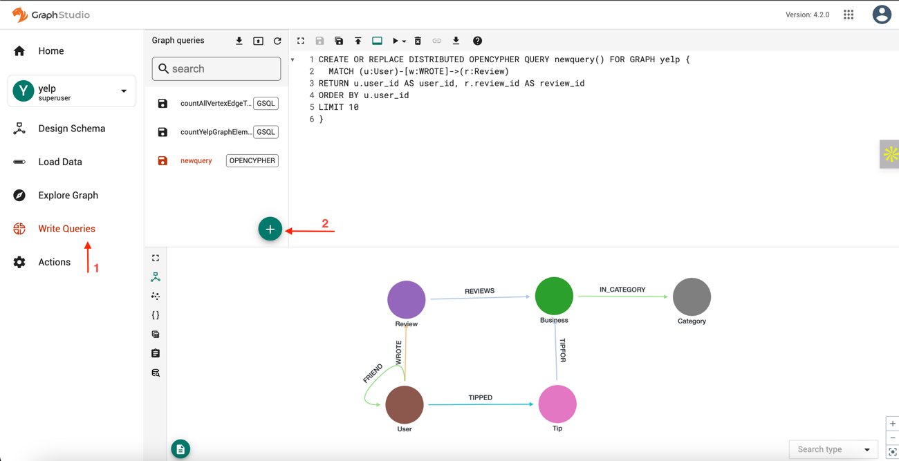

1. Navigate to “Write Queries”
From the left sidebar, click on “Write Queries” to start creating GSQL or openCypher queries.
2. Add a New Query
You’ll see the graph schema and a toolbar at the top.
Click on the “+” icon (plus sign) in the toolbar to add a new query.
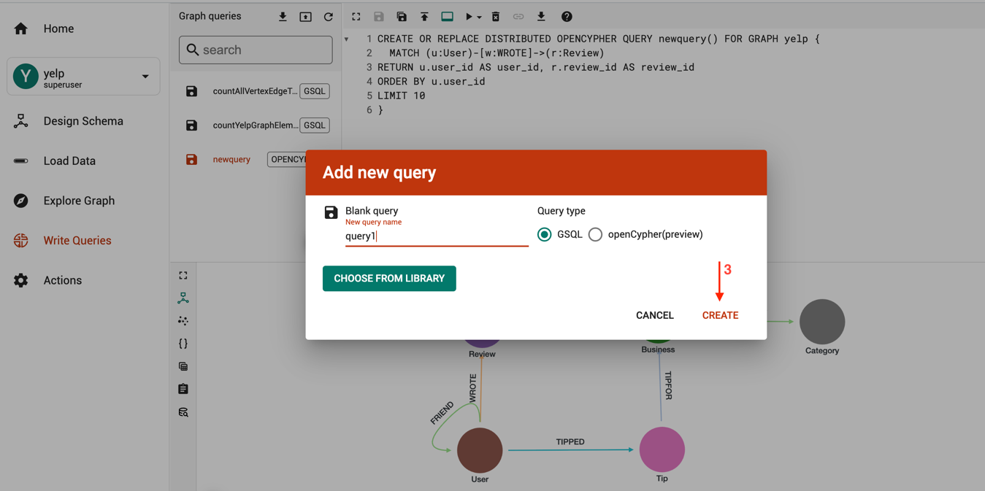

3. Name and Choose Query Type
In the “Add new query” dialog:
- Give your query a meaningful name (e.g., countUserNames).
- Select the Query type:
  - GSQL – for writing in TigerGraph’s native GSQL language.
  - openCypher (preview) – for Neo4j-style Cypher queries (limited support).
- Click “Create” to proceed.

Write the query as you desire to obtain the results.

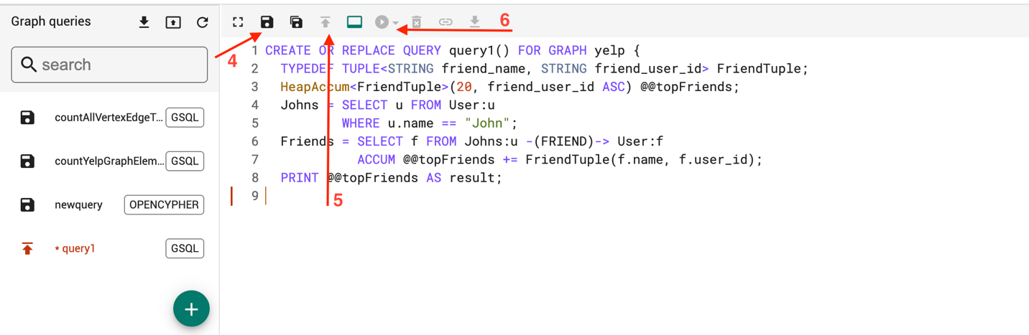

4. Save Query Draft

5. Install Query

6. Run Query

Note: some variable names cannot use reserved words such as Target or count.
To view the time, first save the query and then install and run it.

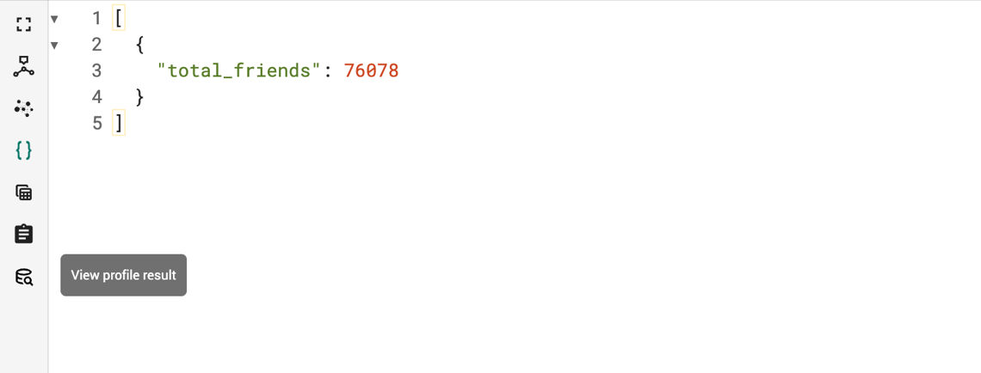

Later, click on the last button (“View profile result”) as shown in the above image, view profile result. You get the result like the below image.

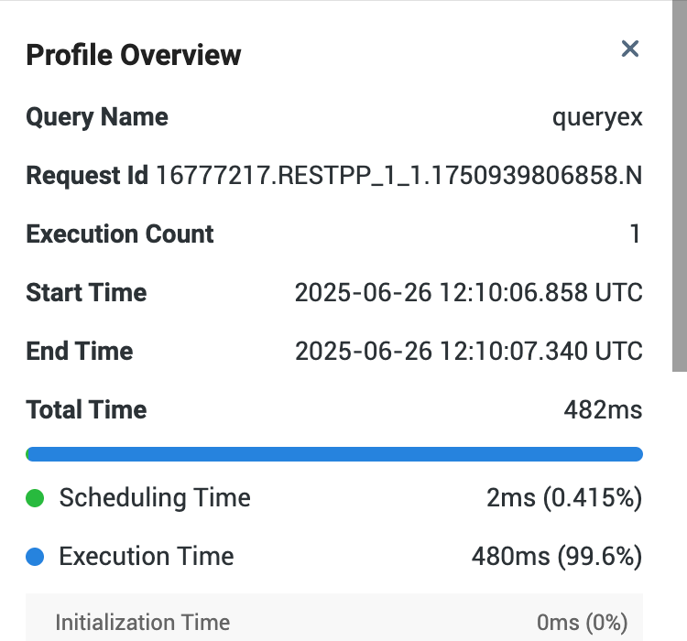

===QUERIES===
====== FRIEND ======

Find the most frequent names:
CREATE OR REPLACE QUERY query1(INT topN = 30) FOR GRAPH yelp {
TYPEDEF TUPLE<STRING name, INT freq> NameFreqTuple;
MapAccum<STRING, INT> @@nameCounts;
HeapAccum<NameFreqTuple>(topN, freq DESC) @@topNames;
// Count names
Users = {User.*};
Users = SELECT u FROM Users:u
ACCUM @@nameCounts += (u.name -> 1);
// iterate through MapAccum
FOREACH (name, cnt) IN @@nameCounts DO
@@topNames += NameFreqTuple(name, cnt);
END;
PRINT @@topNames;
}
Total Time 714ms
rewrite queries? Logic closer to cypher, no heap or map enforced
CREATE OR REPLACE QUERY query1(INT topN = 30) FOR GRAPH yelp { // Directly select and aggregate Users = SELECT u.name, COUNT(*) AS occurrences FROM User:u GROUP BY u.name ORDER BY occurrences DESC LIMIT topN; PRINT Users; }

Find the friends of all “John”s:
CREATE OR REPLACE QUERY query1() FOR GRAPH yelp {
TYPEDEF TUPLE<STRING friend_name, STRING friend_user_id> FriendTuple;
HeapAccum<FriendTuple>(20, friend_user_id ASC) @@topFriends;
Johns = SELECT u FROM User:u
WHERE u.name == "John";
Friends = SELECT f FROM Johns:u -(FRIEND)-> User:f
ACCUM @@topFriends += FriendTuple(f.name, f.user_id);
PRINT @@topFriends AS result;
}
Total Time 186ms

Fixed 20 friends since friend_user_id ASC is enforced.
CREATE OR REPLACE QUERY query1() FOR GRAPH yelp {

// 1. Find all users named John
Johns = SELECT u FROM User:u
WHERE u.name == "John";

// 2. Find their friends, but limit the final result set to 20
Friends = SELECT f
FROM Johns:u -(FRIEND)-> User:f
LIMIT 20;

PRINT Friends [f.name, f.user_id] AS result;
}

Count the friends of all “John”s:
CREATE OR REPLACE QUERY query1() FOR GRAPH yelp {
SetAccum<STRING> @@uniqueFriendIds;
Johns = SELECT u FROM User:u
WHERE u.name == "John";
Friends = SELECT f FROM Johns:u -(FRIEND)-> User:f
ACCUM @@uniqueFriendIds += f.user_id;
PRINT @@uniqueFriendIds.size() AS total_friends;
}
Total Time 156ms
This one is fine

How many friends each user has:
CREATE OR REPLACE QUERY query2() FOR GRAPH yelp {
TYPEDEF TUPLE<STRING name, STRING user_id, INT num_friends> UserFriendTuple;
HeapAccum<UserFriendTuple>(50, num_friends DESC) @@topUsers;
Start = {User.*};
Start = SELECT u FROM Start:u
ACCUM
@@topUsers += UserFriendTuple(u.name, u.user_id, u.outdegree("FRIEND"));
PRINT @@topUsers AS result;
}
Total Time 481ms
This one is fine

Find mutual friends between Steven and Niki:

CREATE OR REPLACE QUERY query1() FOR GRAPH yelp {
TYPEDEF TUPLE<STRING name, STRING user_id> FriendTuple;
HeapAccum<FriendTuple>(1000, user_id ASC) @@mutuals;
OrAccum @isFriendA = false; // Declaration added here

// Mark friends of user A
SeedA = SELECT u FROM User:u WHERE u.user_id == "Oi1qbcz2m2SnwUeztGYcnQ";
FriendsA = SELECT f FROM SeedA:u -(FRIEND)-> User:f
ACCUM f.@isFriendA = true;

// Find friends of user B who are also friends of A
SeedB = SELECT u FROM User:u WHERE u.user_id == "WwulXySQN8t2hwqH_yWurA";
Mutuals = SELECT f FROM SeedB:u -(FRIEND)-> User:f
WHERE f.@isFriendA == true
ACCUM @@mutuals += FriendTuple(f.name, f.user_id);

PRINT @@mutuals AS mutual_friends;
}
Total Time 217ms

Who has the most mutual friends with a given user:

CREATE OR REPLACE QUERY query1(STRING input_user = "Oi1qbcz2m2SnwUeztGYcnQ", INT topK=50) FOR GRAPH yelp {
TYPEDEF TUPLE<STRING id, STRING name, INT shared_count> FriendCount;
MapAccum<STRING, INT> @@mutualCounts;
MapAccum<STRING, STRING> @@userNames;
HeapAccum<FriendCount>(topK, shared_count DESC) @@results;

TargetUser = SELECT u FROM User:u WHERE u.user_id == input_user;
TargetFriends = SELECT f FROM TargetUser -(FRIEND)-> User:f;

// First pass: Count mutual friends
SecondDegree = SELECT s FROM TargetFriends -(FRIEND)-> User:s
WHERE s.user_id != input_user
ACCUM @@mutualCounts += (s.user_id -> 1);

// Second pass: Store names WITHOUT concatenation
UsersToName = SELECT s FROM User:s
WHERE @@mutualCounts.containsKey(s.user_id)
ACCUM @@userNames += (s.user_id -> s.name);

// Build results
FOREACH (user_id, shared_count) IN @@mutualCounts DO
@@results += FriendCount(user_id, @@userNames.get(user_id), shared_count);
END;

PRINT @@results;
}
This is fine

Get 3rd-hop neighbors of a given user (allowing cycles in the path):

CREATE OR REPLACE QUERY query1() FOR GRAPH yelp {
TYPEDEF TUPLE<STRING name, STRING user_id> UserTuple;
SetAccum<STRING> @@level3Users;
HeapAccum<UserTuple>(1000, user_id ASC) @@results;

// Start from the specified user
Start = SELECT s FROM User:s WHERE s.user_id == "Oi1qbcz2m2SnwUeztGYcnQ";
// Level 1: Direct friends
Level1 = SELECT u1 FROM Start:s -(FRIEND)-> User:u1;
// Level 2: Friends of friends
Level2 = SELECT u2 FROM Level1:u1 -(FRIEND)-> User:u2;
// Level 3: Collect user_ids
Level3 = SELECT u3 FROM Level2:u2 -(FRIEND)-> User:u3
WHERE u3.user_id != "Oi1qbcz2m2SnwUeztGYcnQ"
ACCUM @@level3Users += u3.user_id;

// Final pass to get complete user information
FinalUsers = SELECT u FROM User:u
WHERE @@level3Users.contains(u.user_id)
ACCUM @@results += UserTuple(u.name, u.user_id);

PRINT @@results AS level3_friends;
}
This query in neo4j the path is undirected. Maybe need to fix neo4j one?

Counting version:

CREATE OR REPLACE QUERY query1() FOR GRAPH yelp {
TYPEDEF TUPLE<STRING name, STRING user_id> UserTuple;
SetAccum<STRING> @@level3Users;

// Start from the specified user
Start = SELECT s FROM User:s WHERE s.user_id == "Oi1qbcz2m2SnwUeztGYcnQ";
// Level 1: Direct friends
Level1 = SELECT u1 FROM Start:s -(FRIEND)-> User:u1;
// Level 2: Friends of friends
Level2 = SELECT u2 FROM Level1:u1 -(FRIEND)-> User:u2;
// Level 3: Collect user_ids
Level3 = SELECT u3 FROM Level2:u2 -(FRIEND)-> User:u3
WHERE u3.user_id != "Oi1qbcz2m2SnwUeztGYcnQ"
ACCUM @@level3Users += u3.user_id;

// Final pass to get complete user information
FinalUsers = SELECT u FROM User:u
WHERE @@level3Users.contains(u.user_id);

PRINT FinalUsers.size() AS level3_friends_count;
}
Total Time 3593ms
Same comment as above query

====== FRIEND + Review, Spatial Queries and Indexing ======

For a given user’s friends, find their reviewed businesses along with locations:

CREATE OR REPLACE QUERY query1() FOR GRAPH yelp {
TYPEDEF TUPLE<STRING friend_name, STRING business_name, STRING address,
STRING city, STRING state, DOUBLE latitude, DOUBLE longitude> ResultTuple;
MapAccum<STRING, STRING> @@friendNames;
//ListAccum<ResultTuple> @@results;
HeapAccum<ResultTuple>(1000, friend_name ASC, business_name ASC) @@results;

Start = SELECT s FROM User:s WHERE s.user_id == "Oi1qbcz2m2SnwUeztGYcnQ";

Friends = SELECT f FROM Start:s -(FRIEND)-> User:f
ACCUM @@friendNames += (f.user_id -> f.name);

Reviews = SELECT r FROM Friends:f -(WROTE)-> Review:r;

Businesses = SELECT b FROM Reviews:r -(REVIEWS)-> Business:b
ACCUM @@results += ResultTuple(
@@friendNames.get(r.user_id),
b.name,
b.address,
b.city,
b.state,
b.latitude,
b.longitude
);

PRINT @@results AS result;
}

=> The query result is too large to display (exceeds 10MB). Please download the file to view the complete result.
Total Time 1106ms
This is fine

Counting result number

CREATE OR REPLACE QUERY query1() FOR GRAPH yelp {
TYPEDEF TUPLE<STRING friend_name, STRING business_name, STRING address,
STRING city, STRING state, DOUBLE latitude, DOUBLE longitude> ResultTuple;
Start = SELECT s FROM User:s WHERE s.user_id == "Oi1qbcz2m2SnwUeztGYcnQ";
Friends = SELECT f FROM Start:s -(FRIEND)-> User:f;
Reviews = SELECT r FROM Friends:f -(WROTE)-> Review:r;
Businesses = SELECT b FROM Reviews:r -(REVIEWS)-> Business:b;
PRINT Businesses.size() AS result_count;
}
Total Time 617ms
The neo4j query is conunting (friend, business) pair, but this one is counting only business?
CREATE OR REPLACE QUERY query1() FOR GRAPH yelp {
// Use a SumAccum to count every distinct Friend -> Business combination
SumAccum<INT> @@total_results;

Start = {User.*};
Start = SELECT s FROM Start:s WHERE s.user_id == "Oi1qbcz2m2SnwUeztGYcnQ";
Results = SELECT b
FROM Start:s -(FRIEND)-> User:f -(WROTE)-> Review:r -(REVIEWS)-> Business:b
ACCUM @@total_results += 1;

PRINT @@total_results AS total_results;
}

Find the median of the above locations:

CREATE OR REPLACE QUERY query7() FOR GRAPH yelp {

ListAccum<DOUBLE> @@latitudes;
ListAccum<DOUBLE> @@longitudes;

DOUBLE median_lat = 0.0;
DOUBLE median_lon = 0.0;
INT lat_size;
INT lon_size;

Start = SELECT s FROM User:s WHERE s.user_id == "Oi1qbcz2m2SnwUeztGYcnQ";

Friends = SELECT f FROM Start:s -(FRIEND)-> User:f;

Reviews = SELECT r FROM Friends:f -(WROTE)-> Review:r;

Businesses = SELECT b FROM Reviews:r -(REVIEWS)-> Business:b
WHERE abs(b.latitude) > 0.0001 AND abs(b.longitude) > 0.0001
ACCUM
@@latitudes += b.latitude,
@@longitudes += b.longitude;

lat_size = @@latitudes.size();
lon_size = @@longitudes.size();

IF lat_size > 0 THEN
median_lat = avg(@@latitudes); // Use avg() as a placeholder
END;

IF lon_size > 0 THEN
median_lon = avg(@@longitudes); // Use avg() as a placeholder
END;

PRINT median_lat AS median_latitude, median_lon AS median_longitude;
}
Total Time 211ms
The neo4j query counts median, this seems to be counting average
CREATE OR REPLACE QUERY query7() FOR GRAPH yelp {
ListAccum<DOUBLE> @@latitudes;
ListAccum<DOUBLE> @@longitudes;
DOUBLE median_lat = 0.0;
DOUBLE median_lon = 0.0;
Start = {User.*};
Businesses = SELECT b FROM Start:s -(FRIEND)-> User:f -(WROTE)-> Review:r -(REVIEWS)-> Business:b
WHERE s.user_id == "Oi1qbcz2m2SnwUeztGYcnQ"
AND abs(b.latitude) > 0.0001
ACCUM @@latitudes += b.latitude, @@longitudes += b.longitude;
IF @@latitudes.size() > 0 THEN
@@latitudes.sort(); // Hypothetical or requires a User Defined Function (UDF)
median_lat = @@latitudes.get(@@latitudes.size() / 2);
END;
PRINT median_lat, median_lon;
}

Build point index on business locations:
Not supported by TigerGraph

Find all businesses within 5 miles from the specified location:
CREATE OR REPLACE QUERY query1(
DOUBLE center_lat = 39.877788,
DOUBLE center_lon = -75.69293535784999,
DOUBLE radius_meters = 8046.72
) FOR GRAPH yelp {
TYPEDEF TUPLE<STRING name, STRING address, STRING city, STRING state,
DOUBLE latitude, DOUBLE longitude, DOUBLE dist_meters> BusinessResult;

HeapAccum<BusinessResult>(1000, dist_meters ASC) @@results;

Businesses = {Business.*};

Nearby = SELECT b FROM Businesses:b
ACCUM
// Convert degrees to radians
DOUBLE lat1 = b.latitude * 3.141592653589793 / 180.0,
DOUBLE lon1 = b.longitude * 3.141592653589793 / 180.0,
DOUBLE lat2 = center_lat * 3.141592653589793 / 180.0,
DOUBLE lon2 = center_lon * 3.141592653589793 / 180.0,

// Haversine formula implementation
DOUBLE dlon = lon2 - lon1,
DOUBLE dlat = lat2 - lat1,
DOUBLE a = pow(sin(dlat/2), 2) + cos(lat1) * cos(lat2) * pow(sin(dlon/2), 2),
DOUBLE c = 2 * atan2(sqrt(a), sqrt(1-a)),
DOUBLE dist = 6371 * c * 1000, // Earth radius in km converted to meters

IF dist <= radius_meters THEN
@@results += BusinessResult(
b.name,
b.address,
b.city,
b.state,
b.latitude,
b.longitude,
dist
)
END;

PRINT @@results AS nearby_businesses;
}
This is fine

K-NN Query, find the k=10 nearest businesses to the specified location:
CREATE OR REPLACE QUERY query1(
DOUBLE center_lat = 39.877788,
DOUBLE center_lon = -75.69293535784999
) FOR GRAPH yelp {
TYPEDEF TUPLE<STRING name, STRING address, STRING city, STRING state,
DOUBLE latitude, DOUBLE longitude, DOUBLE dist_meters> BusinessResult;

// HeapAccum with size 10 to automatically keep only the top 10 nearest
HeapAccum<BusinessResult>(10, dist_meters ASC) @@top_results;

Businesses = {Business.*};

Nearby = SELECT b FROM Businesses:b
ACCUM
// Convert degrees to radians
DOUBLE lat1 = b.latitude * 3.141592653589793 / 180.0,
DOUBLE lon1 = b.longitude * 3.141592653589793 / 180.0,
DOUBLE lat2 = center_lat * 3.141592653589793 / 180.0,
DOUBLE lon2 = center_lon * 3.141592653589793 / 180.0,

// Haversine formula implementation
DOUBLE dlon = lon2 - lon1,
DOUBLE dlat = lat2 - lat1,
DOUBLE a = pow(sin(dlat/2), 2) + cos(lat1) * cos(lat2) * pow(sin(dlon/2), 2),
DOUBLE c = 2 * atan2(sqrt(a), sqrt(1-a)),
DOUBLE dist_meters = 6371 * c * 1000, // Earth radius in km converted to meters

// Only keep the top 10 nearest businesses
@@top_results += BusinessResult(
b.name,
b.address,
b.city,
b.state,
b.latitude,
b.longitude,
dist_meters
);

PRINT @@top_results AS top10_nearest_businesses;
}
This is fine

Find all users who commented on the above businesses:

CREATE OR REPLACE QUERY query1(
DOUBLE center_lat = 39.877788,
DOUBLE center_lon = -75.69293535784999,
DOUBLE radius_meters = 8046.72
) FOR GRAPH yelp {
TYPEDEF TUPLE<STRING user_id, STRING name> UserResult;

// First pass: Collect nearby businesses into a vertex set
SetAccum<VERTEX<Business>> @@nearby_businesses;
SetAccum<UserResult> @@user_results;

// Find all businesses within radius
Businesses = {Business.*};

Nearby = SELECT b FROM Businesses:b
ACCUM
// Convert degrees to radians
DOUBLE lat1 = b.latitude * 3.141592653589793 / 180.0,
DOUBLE lon1 = b.longitude * 3.141592653589793 / 180.0,
DOUBLE lat2 = center_lat * 3.141592653589793 / 180.0,
DOUBLE lon2 = center_lon * 3.141592653589793 / 180.0,

// Haversine formula implementation
DOUBLE dlon = lon2 - lon1,
DOUBLE dlat = lat2 - lat1,
DOUBLE a = pow(sin(dlat/2), 2) + cos(lat1) * cos(lat2) * pow(sin(dlon/2), 2),
DOUBLE c = 2 * atan2(sqrt(a), sqrt(1-a)),
DOUBLE dist = 6371 * c * 1000, // Earth radius in km converted to meters

IF dist <= radius_meters THEN
@@nearby_businesses += b
END;

// Second pass: Find users who reviewed nearby businesses
Users = SELECT u FROM User:u-(WROTE>)-:rev-(REVIEWS>)-Business:b
WHERE @@nearby_businesses.contains(b)
ACCUM
@@user_results += UserResult(u.user_id, u.name);

PRINT @@user_results AS users_who_reviewed_nearby_businesses;
}
No name sorting as in neo4j (order by u.name)

Note:
In GSQL, the direction indicators (>, <, or -) are placed after the edge type
Single-Hop Traversal
✅ -(EDGE_TYPE)-> is sometimes allowed (parser leniency in some versions)
Multi-Hop Traversal
❌ -(EDGE_TYPE)-> fails in chained patterns
✅ Must use -(EDGE_TYPE>) or -(EDGE_TYPE<)

====== Review + Tip ======
Find the total number of reviews + tips for each business, and sort by descending order

CREATE QUERY query10() FOR GRAPH yelp {

SumAccum<INT> @num_reviews;
SumAccum<INT> @num_tips;
SumAccum<INT> @total;

# Count reviews linked to each business
ReviewsAccum = SELECT r FROM Review:r - (REVIEWS:e) -> Business:b
ACCUM b.@num_reviews += 1;

# Count tips linked to each business
TipsAccum = SELECT t FROM Tip:t - (TIPFOR:e) -> Business:b
ACCUM b.@num_tips += 1;

# Compute total (post-accum needed for math)
Result = SELECT b FROM Business:b
POST-ACCUM b.@total += b.@num_reviews + b.@num_tips
ORDER BY b.@total DESC
LIMIT 100;

PRINT Result[
Result.name,
Result.@num_reviews AS num_reviews,
Result.@num_tips AS num_tips,
Result.@total AS total
];
}
Total Time 820ms
Neo4j query is not limiting top 100. This query seems not fulfilling the “optional match” in neo4j

Here, we are returning vertices with 4 columns specifically.

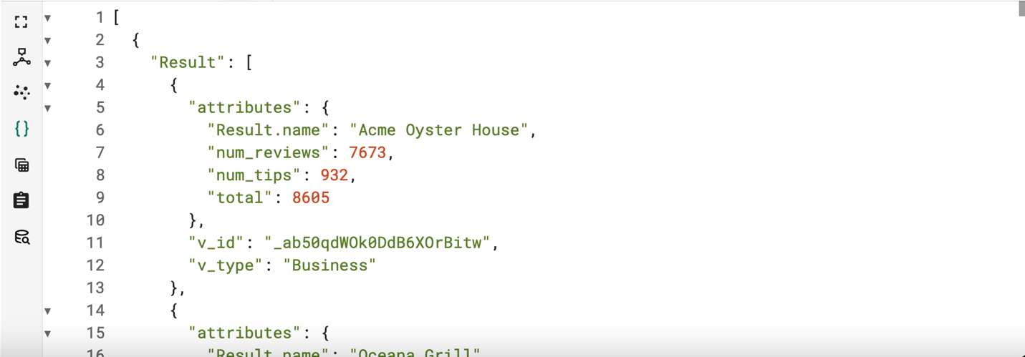

The following is a tuple-version query:

CREATE QUERY query1() FOR GRAPH yelp {
// Define a tuple type for your results
TYPEDEF TUPLE<STRING name, INT num_reviews, INT num_tips, INT total> BusinessStats;

// Accumulator for results
HeapAccum<BusinessStats>(100, total DESC) @@results;

SumAccum<INT> @num_reviews;
SumAccum<INT> @num_tips;

// Count reviews and tips (unchanged)
ReviewsAccum = SELECT r FROM Review:r -(REVIEWS:e)-> Business:b
ACCUM b.@num_reviews += 1;

TipsAccum = SELECT t FROM Tip:t -(TIPFOR:e)-> Business:b
ACCUM b.@num_tips += 1;

// Build results as tuples
Result = SELECT b FROM Business:b
POST-ACCUM
@@results += BusinessStats(
b.name,
b.@num_reviews,
b.@num_tips,
b.@num_reviews + b.@num_tips
)
ORDER BY b.@num_reviews + b.@num_tips DESC
LIMIT 100;

// Print just the tuple data
PRINT @@results;
}

Find the rating of "Acme Oyster House":

CREATE QUERY query1(String name_to_find = "Acme Oyster House") FOR GRAPH yelp {
Start = SELECT b FROM Business:b
WHERE b.name == name_to_find;
PRINT Start[Start.name, Start.stars];
}
Total Time 12ms
Is starts the same as rating? In neo4j used Start.rating

Tuple Version:

CREATE QUERY query1(String name_to_find = "Acme Oyster House") FOR GRAPH yelp {
// 1. Define a tuple type for your results
TYPEDEF TUPLE<STRING name, DOUBLE stars> BusinessInfo;

// 2. Create an accumulator for results
ListAccum<BusinessInfo> @@results;

// 3. Find matching businesses
Start = SELECT b FROM Business:b
WHERE b.name == name_to_find
POST-ACCUM
@@results += BusinessInfo(b.name, b.stars);

// 4. Print the tuple results
PRINT @@results;
}

Print all their text reviews and tips:

CREATE QUERY query12() FOR GRAPH yelp {
STRING target_name = "Acme Oyster House";
ListAccum<STRING> @@combined;

# Reviews
R = SELECT r FROM Review:r - (REVIEWS:e) -> Business:b
WHERE b.name == target_name
ACCUM @@combined += b.business_id + "|" + r.text + "|review";

# Tips
T = SELECT t FROM Tip:t - (TIPFOR:e) -> Business:b
WHERE b.name == target_name
ACCUM @@combined += b.business_id + "|" + t.text + "|tip";

PRINT @@combined AS all_texts;
}
Total Time 1808ms
This is priting a long string, but neo4j is returning a tuple

Find the businesses with both tips and reviews, and return their counts:

CREATE QUERY query13() FOR GRAPH yelp {

SumAccum<INT> @num_reviews;
SumAccum<INT> @num_tips;

# Step 1: Traverse Reviews
R = SELECT b FROM Review:r - (REVIEWS:e) -> Business:b
ACCUM b.@num_reviews += 1;

# Step 2: Traverse Tips
T = SELECT b FROM Tip:t - (TIPFOR:e) -> Business:b
ACCUM b.@num_tips += 1;

# Step 3: Select businesses with any reviews or tips
Result = SELECT b FROM Business:b
WHERE b.@num_reviews > 0 OR b.@num_tips > 0
ORDER BY (b.@num_reviews + b.@num_tips) DESC
LIMIT 100;

PRINT Result [Result.name AS business_name,
Result.@num_reviews AS num_reviews,
Result.@num_tips AS num_tips,
(Result.@num_reviews + Result.@num_tips) AS total];
}
Total Time 443ms
We need both tips and reviews, so shouldn’t be OR. But neo4j seems to be wrong too.

Find reviews with text containing “disgusting”:
CREATE QUERY query14() FOR GRAPH yelp {
TYPEDEF TUPLE<STRING business_id, STRING text> Result;
HeapAccum<Result>(100, text ASC) @@results;

Start =
SELECT r FROM Review:r
WHERE LOWER(r.text) LIKE "%disgusting%"
ACCUM @@results += Result(r.business_id, r.text);

PRINT @@results AS disgusting_reviews;
}
Total Time 1950ms
This is fine

Alternative form using LIMIT:
CREATE QUERY query1() FOR GRAPH yelp {
Start =
SELECT r FROM Review:r
WHERE LOWER(r.text) LIKE "%disgusting%"
LIMIT 100;

PRINT Start[Start.business_id as business_id, Start.text as text];
}

Top-rated businesses with sufficient reviews:

CREATE QUERY query15() FOR GRAPH yelp {
Start =
SELECT b FROM Business:b
WHERE b.review_count > 100
ORDER BY b.stars DESC, b.review_count DESC
LIMIT 20;

PRINT Start[
Start.name,
Start.city,
Start.review_count,
Start.stars
];
}
Total Time 5ms

Most frequently used words in reviews (print top-1000 most frequent words):
Note: To avoid timeout, change from 16 below to 9999:
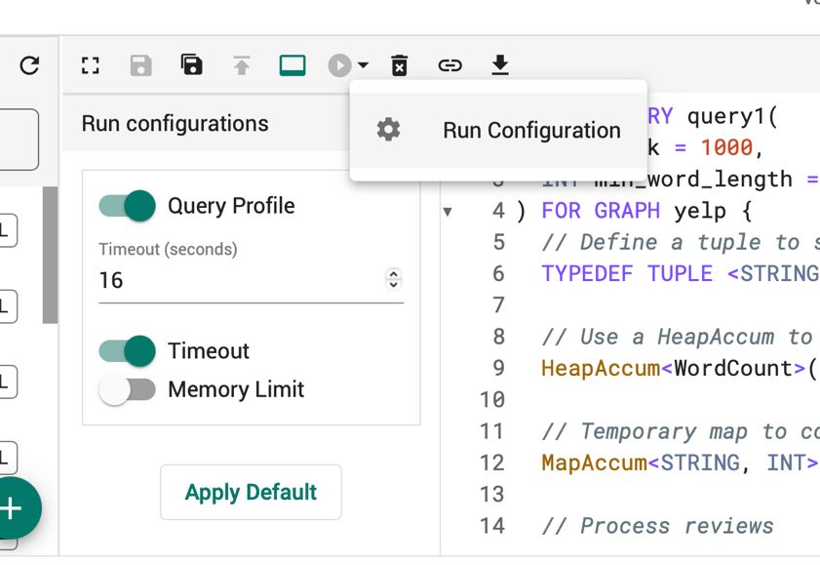

CREATE QUERY query0() FOR GRAPH yelp {
MapAccum<STRING, INT> @@wordFreq;

reviews = SELECT r FROM Review:r
ACCUM
FOREACH w IN split(lower(r.text), " ") DO
IF length(w) > 3 THEN
@@wordFreq += (w -> 1)
END
END;

PRINT @@wordFreq;
}

There is no limit 20 here.

Running forever…

From ChatGPT: Accumulators in GSQL have synchronization overhead that doesn't exist in Neo4j's single-threaded operations

Find businesses with only negative reviews:

CREATE QUERY query18() FOR GRAPH yelp {

SumAccum<INT> @total;
SumAccum<INT> @neg;

# Traverse and accumulate review stats per business
Start =
SELECT b FROM Review:r - (REVIEWS:e) -> Business:b
ACCUM
b.@total += 1,
IF r.stars < 3 THEN
b.@neg += 1
END;

# Select businesses where all reviews are negative
Result =
SELECT b FROM Start:b
WHERE b.@total > 0 AND b.@neg == b.@total
ORDER BY b.@total DESC;
PRINT Result[Result.name, Result.@neg AS negative_reviews];
}
Total Time 1157ms
This is fine, but neo4j uses a different strategy that might be more memory consuming

====== GDS (Graph Algorithms) ======

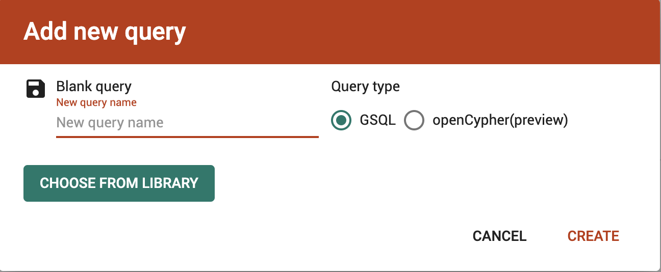
To run graph algorithms, select “CHOOSE FROM LIBRARY” as shown in the above image. This is done in GStudio.

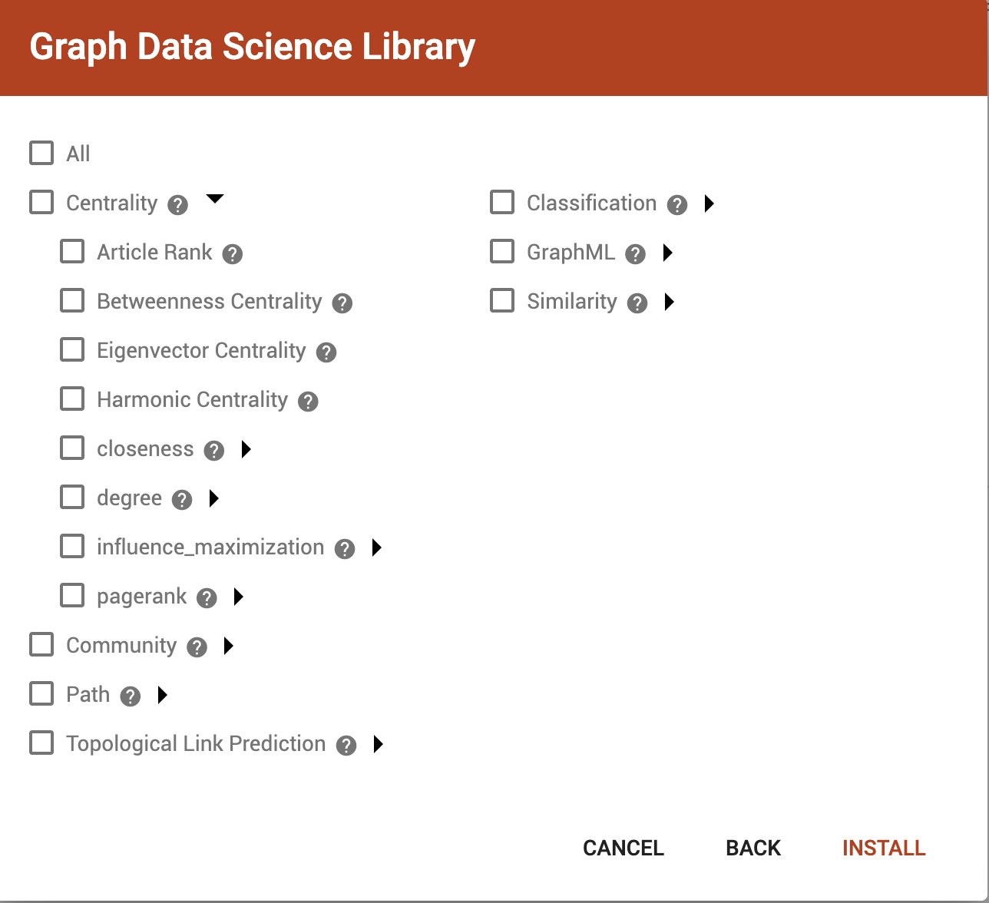

Then we can install the selected algorithms as we need.

- PageRank in TigerGraph

Make sure timeout updated from 16 sec to 9999 sec in AdminPortal (not in GStudio):
[Management] -> [Components] -> [RESTPP]
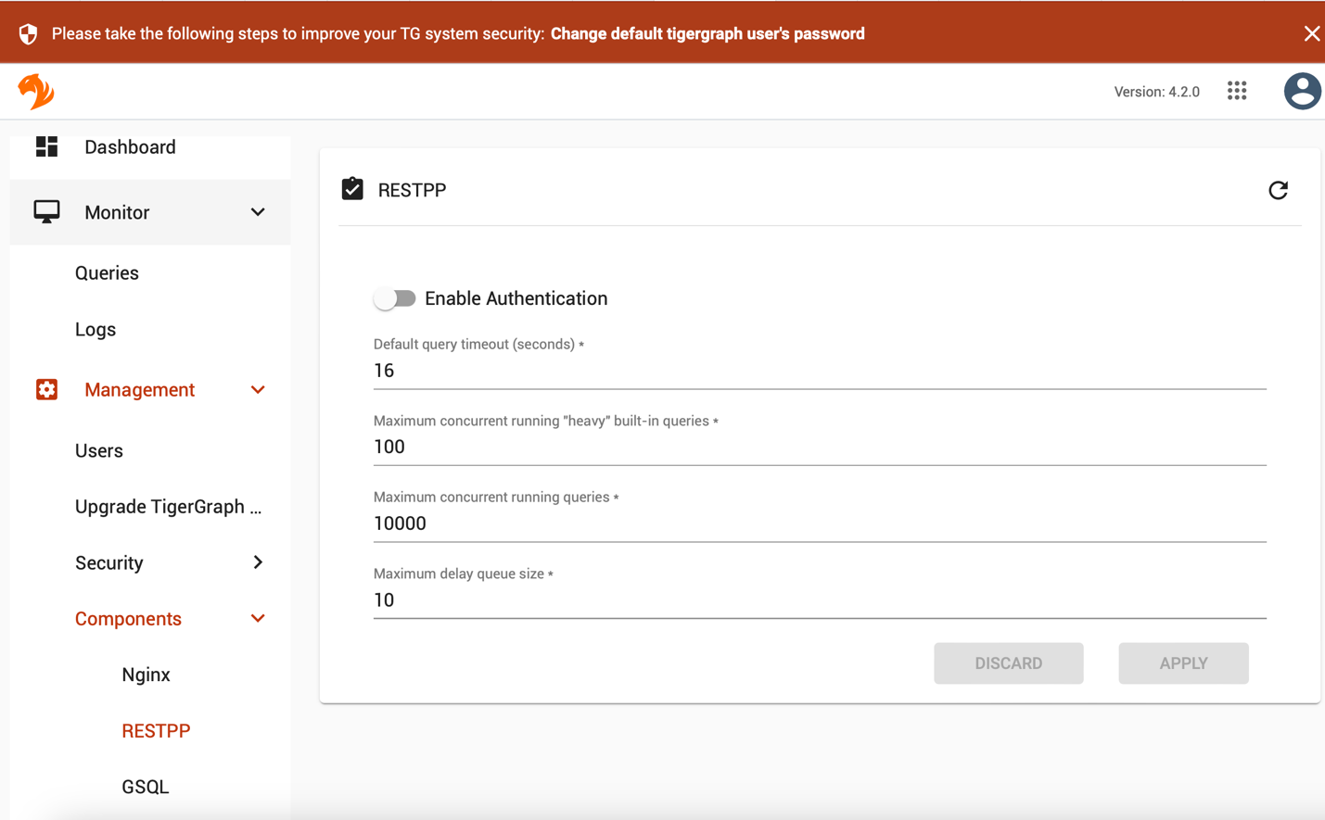

First, create attribute User.pagerank to collect results:
- Access TigerGraph GraphStudio
- Navigate to "Design Schema" of Global View
- Select your vertex type “User”
- Click "Add Attribute"
- Define:
- Attribute name: pagerank
- Data type: FLOAT
- Default value: 0
- Click "Save Schema"
- Click "Publish Schema" to apply changes

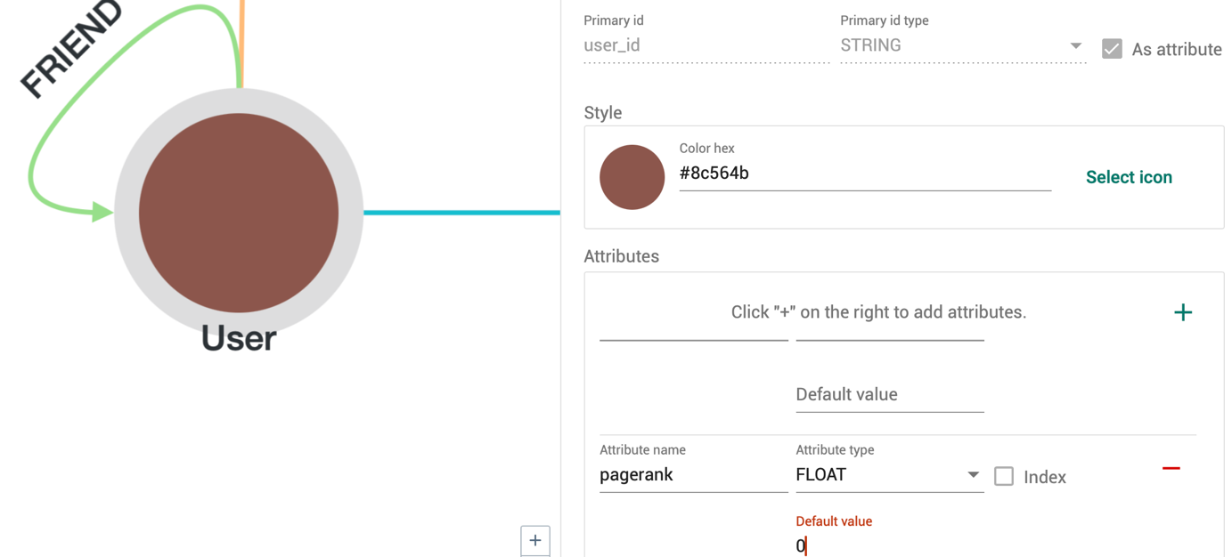

We can similarly create componentId, degree and community, to be used by later GDS functions.

Run the following in GSQLShell (not in GStudio), after choosing the yelp graph on the left:

RUN QUERY tg_pagerank("User", "FRIEND", 0.001, 10, 0.85, 10, True, "pagerank", "", false)

--- check results ---
SELECT user_id, pagerank
FROM User
ORDER BY pagerank DESC
LIMIT 10

Note that we have created a new column “pagerank” to keep the results, before calling tg_pagerank

To learn more about pagerank: https://docs.tigergraph.com/graph-ml/3.10/centrality-algorithms/pagerank

- Degree Centrality in TigerGraph

RUN QUERY tg_degree_cent( ["User"], ["FRIEND"], ["FRIEND"], true, true, 10, true, "degree", "", false)

--- check results ---
SELECT user_id, degree
FROM User
ORDER BY degree DESC
LIMIT 10
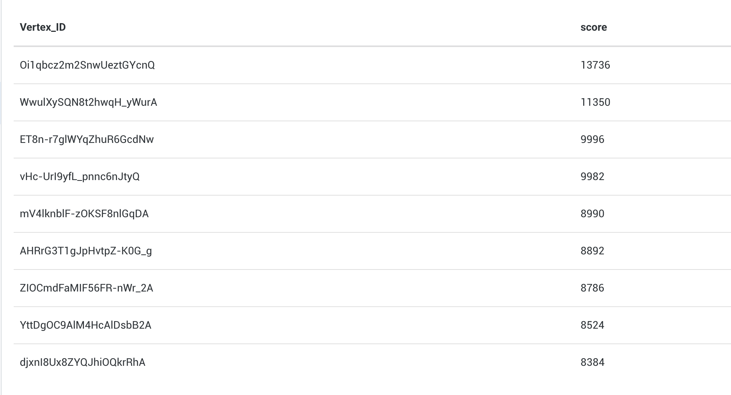

More info: https://docs.tigergraph.com/graph-ml/3.10/centrality-algorithms/degree-centrality

- Weakly Connected Components (WCC)

RUN QUERY tg_wcc(
["User"],
["FRIEND"],
10,
false,
"componentId",
""
)

Use false to avoid printing large components to console (large message transmission)

--- check results ---
INTERPRET QUERY () FOR GRAPH yelp {
TYPEDEF TUPLE <INT component_id, INT size> component_info;
HeapAccum<component_info>(50, size DESC) @@top_components;
MapAccum<INT, INT> @@component_counts;

start = {User.*};

// Count vertices in each component
start = SELECT v FROM start:v
ACCUM @@component_counts += (v.componentId -> 1);

// Extract top 50 largest components
FOREACH (comp_id, size) IN @@component_counts DO
@@top_components += component_info(comp_id, size);
END;

// Print formatted results
FOREACH comp IN @@top_components DO
PRINT comp.component_id AS Component_ID,
comp.size AS Size;
END;
}

More info: https://docs.tigergraph.com/graph-ml/3.10/community-algorithms/connected-components

- Louvain Community Detection

RUN QUERY tg_louvain(
["User"],
["FRIEND"],
"",
10,
"community",
"",
false
)

It runs OOM with this error msg:
Aborted due to timeout or system memory in critical state.System Memory in Critical state. Aborted.

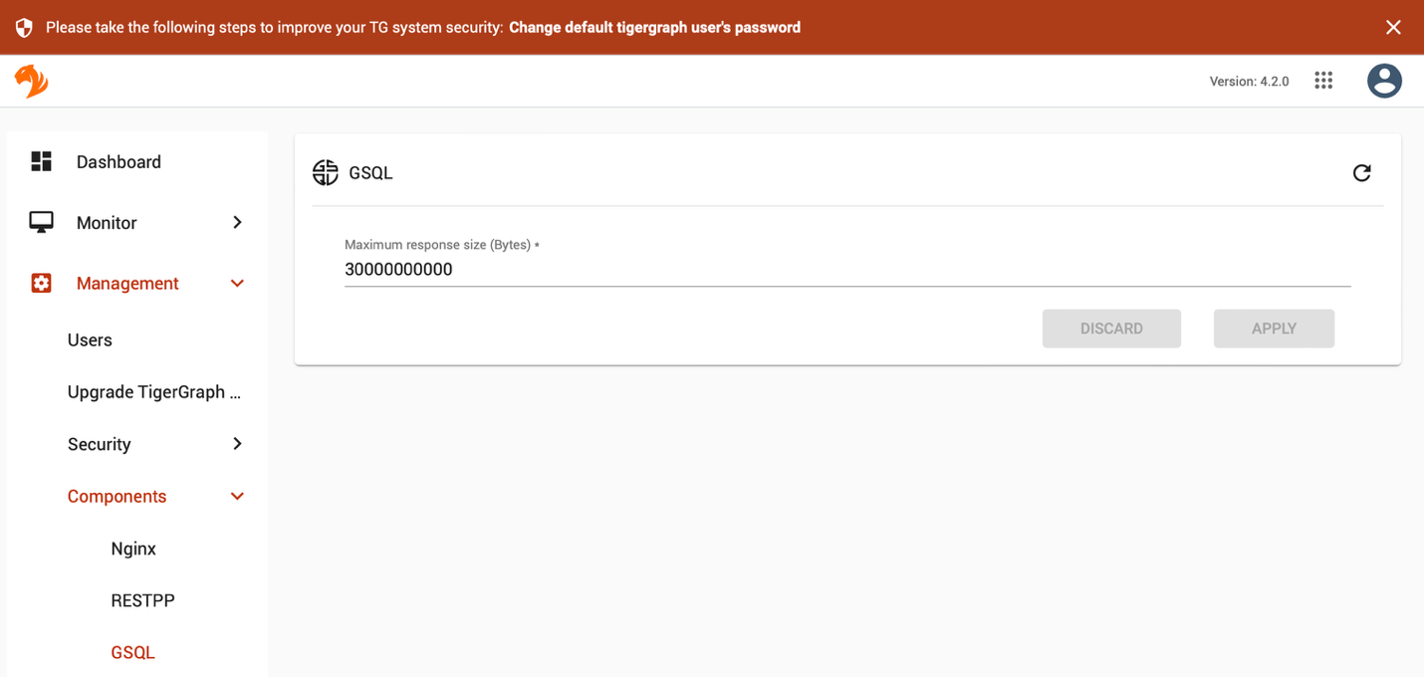
[Management] -> [Components] -> [GSQL]
Now, I see:
task UDFSingleInstance_69_Reduce_396failed: GraphUpdate|Transaction aborted|yelp::GraphUpdate,1593.GPE_1_1.1751087676450.T175108767589534:16973826.RESTPP_1_1.1751087667545.N,NNN,0,0,0,0,S, due to response code 3

This is likely because RAM is almost full, so we should stop neo4j to release memory space
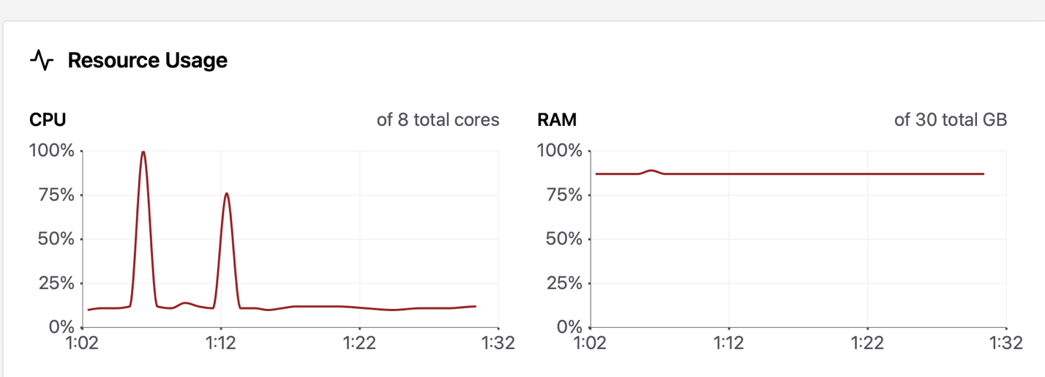

--- check results ---
INTERPRET QUERY () FOR GRAPH yelp {
TYPEDEF TUPLE <INT community_id, INT size> community_info;
HeapAccum<community_info>(50, size DESC) @@top_communities;
MapAccum<INT, INT> @@community_counts;

start = {User.*};

// Count vertices in each community (assuming Louvain saved to "community" attribute)
start = SELECT v FROM start:v
ACCUM @@community_counts += (v.community -> 1);

// Extract top 50 largest communities
FOREACH (comm_id, size) IN @@community_counts DO
@@top_communities += community_info(comm_id, size);
END;

FOREACH comm IN @@top_communities DO
PRINT comm.community_id AS Community_ID,
comm.size AS Size;
END;
}

More info: https://docs.tigergraph.com/graph-ml/3.10/community-algorithms/louvain

