Generation and Preparation of Additional JSON Files from Yelp Dataset

- Category vertices
- IN_CATEGORY edges (business → category)
- Tip vertices with generated tip_id
- FRIEND edges (user → user)
The files were cleaned, saved as flattened JSON files, and moved into TigerGraph’s expected loading directory using Dockerized Tigergraph setup. Below are the steps followed in detail.

category_vertices.json
Extract unique business categories from categories field in the business dataset and prepare a vertex file for TigerGraph.
from pyspark.sql.functions import split, explode, trim, col, lit
business_df = spark.read.json("hdfs://master:9000/yelp/yelp_academic_dataset_business.json")
exploded = business_df.filter(col("categories").isNotNull()) \
.withColumn("category", explode(split("categories", ","))) \
.withColumn("category", trim(col("category")))
.dropDuplicates(["business_id", "category"])
We need to add .dropDuplicates(["business_id", "category"]) during edge extraction because the raw data in yelp_academic_dataset_business.json contains duplicate category entries for the same business (e.g., 'Gas Stations' listed multiple times within a single business's categories). This ensures each business-category relationship is represented by exactly one edge
Eg: business_id: I_Sxmx6puRYyLS51RtLqtQ has “Gas Stations” as category twice
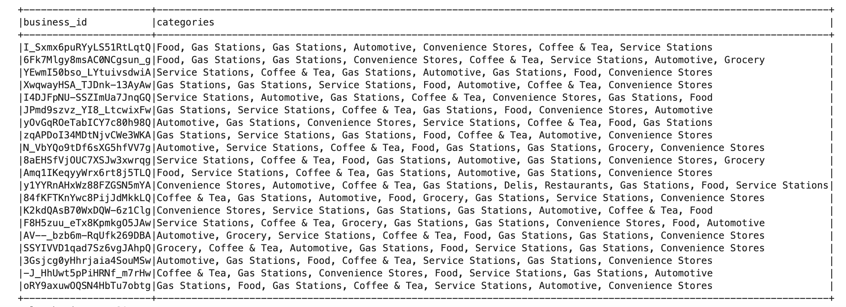
category_vertices = exploded \
.select("category") \
.distinct() \

.withColumnRenamed("category", "id") \

.withColumn("type", lit("category"))

category_vertices.coalesce(1).write.mode("overwrite").json("file:///shared/datasets/yelp/_category_vertices_tmp")

Conversion to Flat File:
cd /shared/datasets/yelp/_category_vertices_tmp
mv part-00000-*.json ../yelp_category.json
rm -r /shared/datasets/yelp/_category_vertices_tmp
Spark writes output as a directory with multiple part files. TigerGraph expects a flat JSON file. This manual rename ensures compatibility.

Copy to TigerGraph:
docker exec -it tigergraph bash
cp /home/tigergraph/datasets/yelp/yelp_category.json /home/tigergraph/tigergraph/data/gui/loading_data/tigergraph/
Then in Tiger graph, choose “Add file” and select the yelp_category.json file

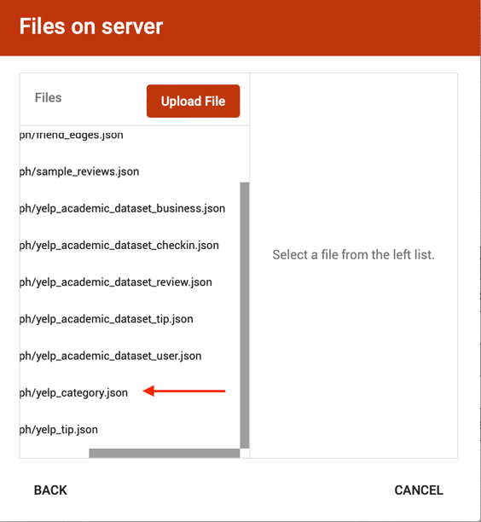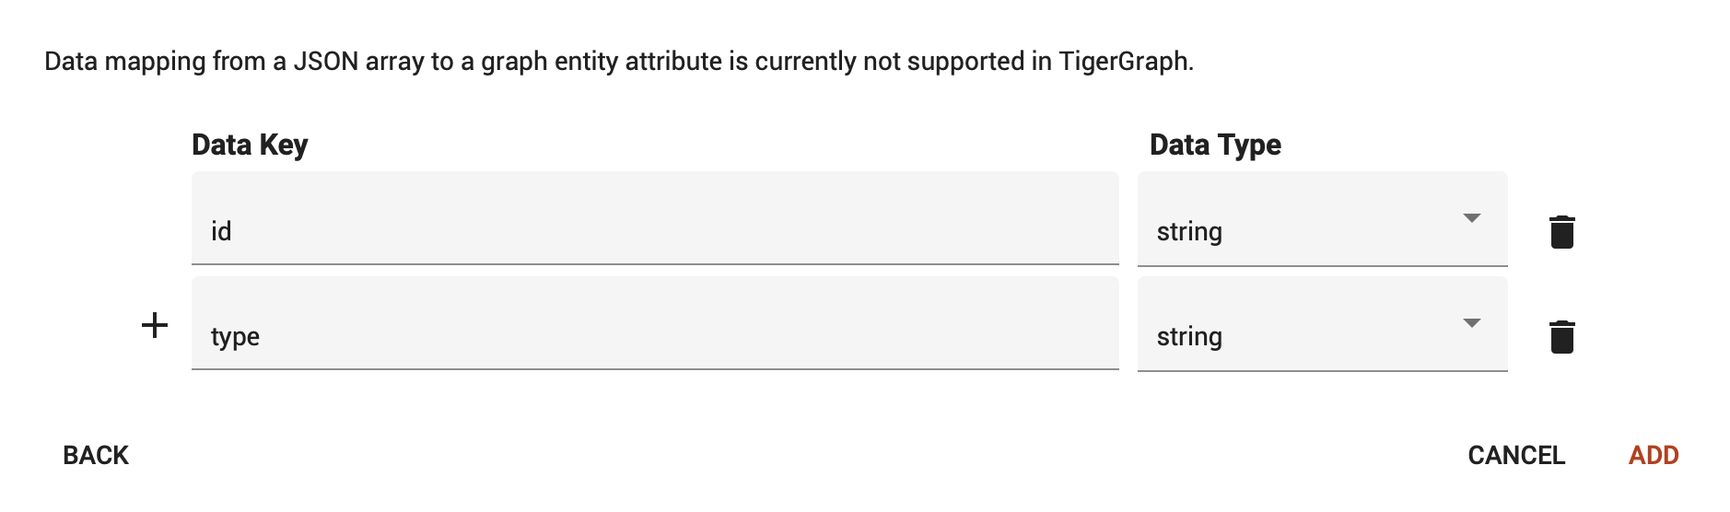
We can delete the “type” data key since it is not required (because it has all its value as “category”), and then click on “Add” button.
We map the yelp_categories.json file to the Category vertex as shown below,
- Click the “Map data file to vertex” icon.
- Select the JSON file and choose the Category vertex.
- Map the id column as the Primary ID.
- Click “Save” to apply the mapping.
- Then “Load” to execute.
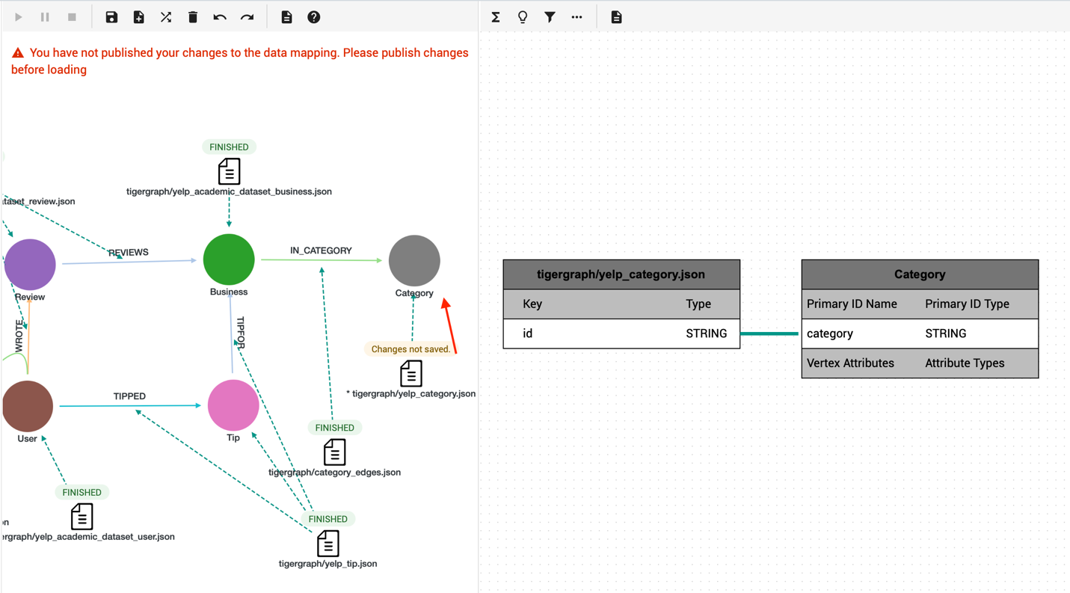

Duration 0.103s

category_edges.json (IN_CATEGORY edge)
Create edges from businesses to each of their associated categories.

category_edges = exploded.selectExpr(

"business_id as src",

"trim(category) as dst",

"'in_category' as relationship"

)

category_edges.coalesce(1).write.mode("overwrite").json("file:///shared/datasets/yelp/_category_edges_tmp")

Conversion to Flat File:
cd /shared/datasets/yelp/_category_edges_tmp
mv part-00000-*.json ../category_edges.json
rm -r /shared/datasets/yelp/_category_edges_tmp

Copy to TigerGraph:
docker exec -it tigergraph bash
cp /home/tigergraph/datasets/yelp/category_edges.json /home/tigergraph/tigergraph/data/gui/loading_data/tigergraph/
Choose category_edges.json by clicking on Add file
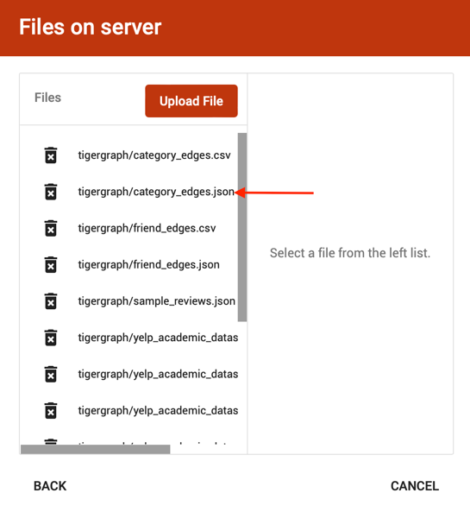
We map the category_edges.json file to the IN_CATEGORY edge as shown below, with source vertex Business (src) and target vertex Category (dst)
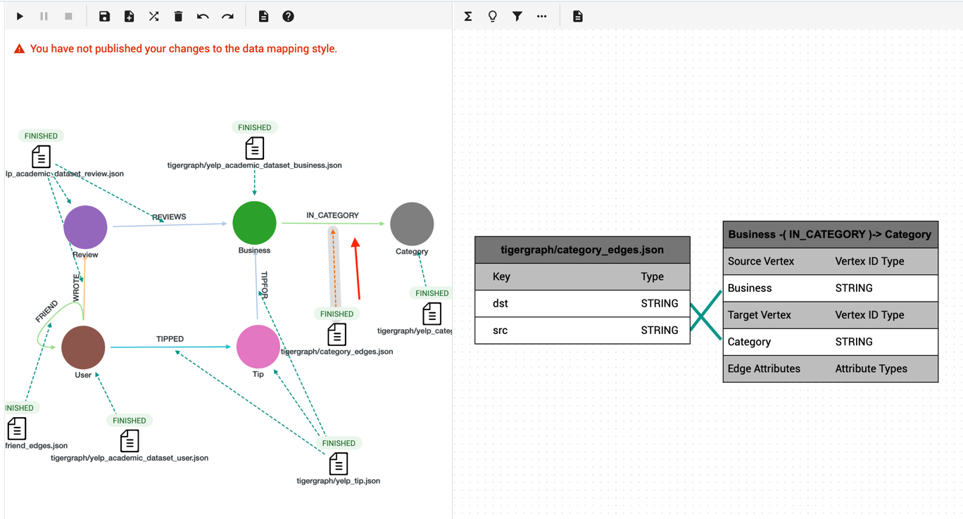
Duration 0.926s

- tip.json with tip_id
Add a unique tip_id to each Tip vertex to support TigerGraph’s primary key requirement.
from pyspark.sql.functions import monotonically_increasing_id

tip_df = spark.read.json("hdfs://master:9000/yelp/yelp_academic_dataset_tip.json")
df_tip_fixed = tip_df.select(
monotonically_increasing_id().cast("string").alias("tip_id"),
col("user_id"),
col("business_id"),
col("text"),
col("compliment_count").cast("int"),
col("date")
)
df_tip_fixed.coalesce(1).write.mode("overwrite").json("file:///shared/datasets/yelp/_tip_data_tmp")
Conversion to Flat File:
cd /shared/datasets/yelp/_tip_data_tmp
mv part-00000-*.json ../yelp_tip.json
rm -r /shared/datasets/yelp/_tip_data_tmp
Copy to TigerGraph:
docker exec -it tigergraph bash
cp /home/tigergraph/datasets/yelp/yelp_tip.json /home/tigergraph/tigergraph/data/gui/loading_data/tigergraph/
Choose yelp_tip.json
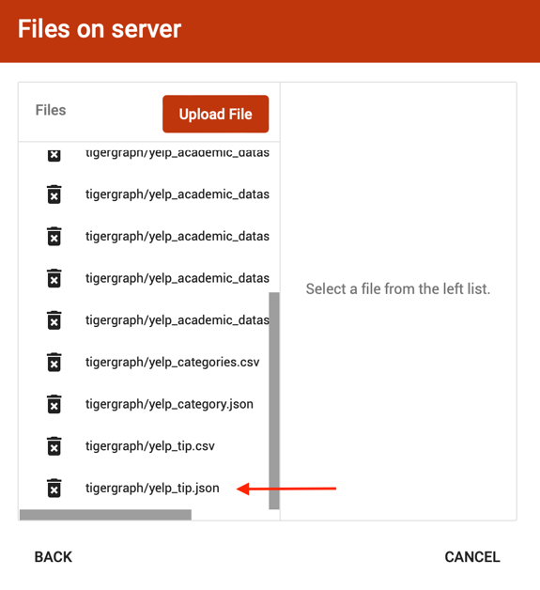
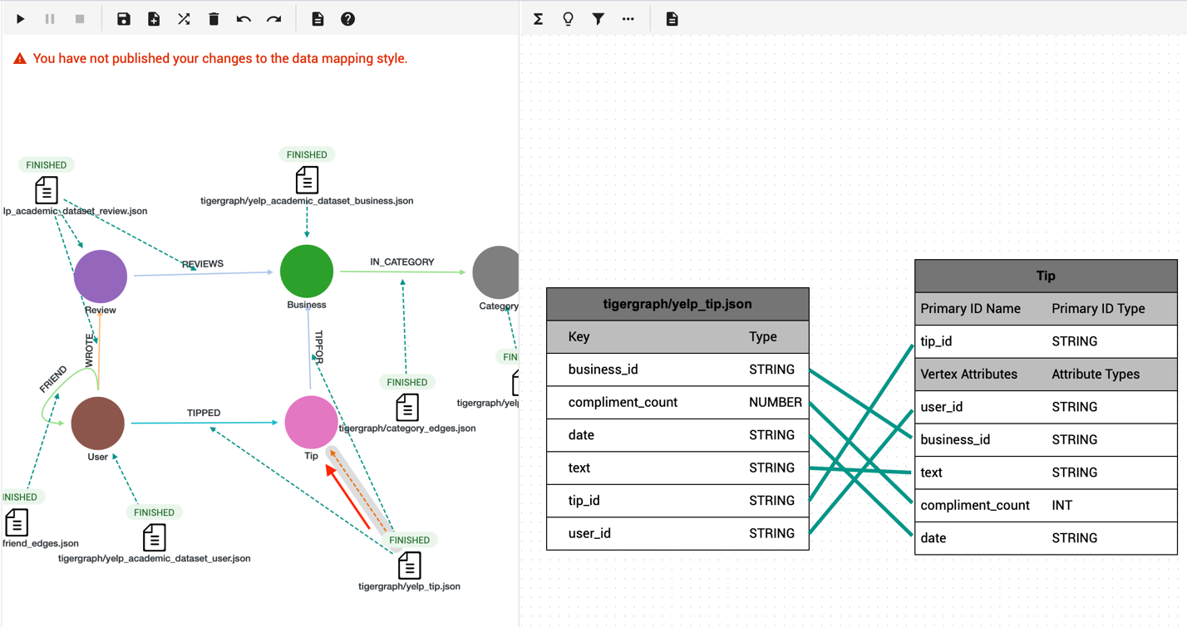
Duration 3s
Mapping the edge “TIPPED” from user to tip vertex:
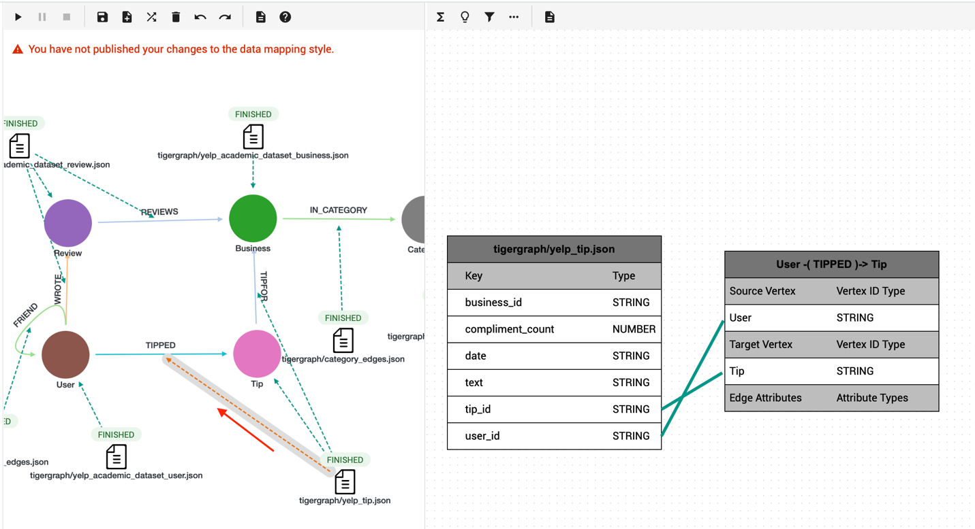
Mapping the edge “TIPFOR” from tip to business vertex:
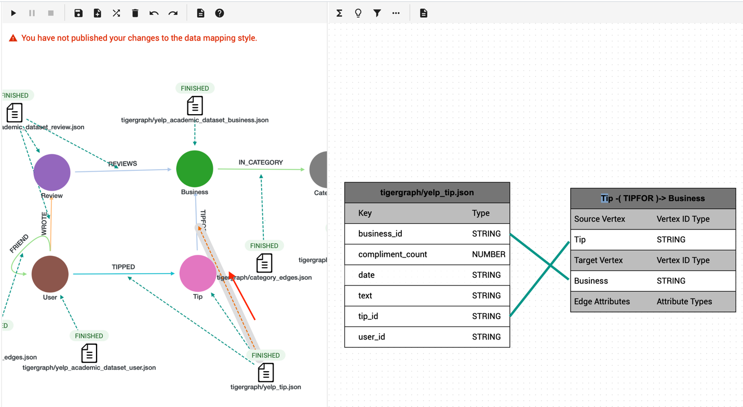

- friend_edges.json (FRIEND edge)
Parse the friends array from each user and create FRIEND edges.
from pyspark.sql.functions import explode
user_df = spark.read.json("hdfs://master:9000/yelp/yelp_academic_dataset_user.json")
friend_edges = user_df.select(
col("user_id").alias("src"),
explode("friends").alias("dst")
).withColumn("relationship", lit("friend"))
friend_edges.coalesce(1).write.mode("overwrite").json("file:///shared/datasets/yelp/_friend_edges_tmp")
Conversion to Flat File:
cd /shared/datasets/yelp/_friend_edges_tmp
mv part-00000-*.json ../friend_edges.json
rm -r /shared/datasets/yelp/_friend_edges_tmp
Copy to TigerGraph:
docker exec -it tigergraph bash
cp /home/tigergraph/datasets/yelp/friend_edges.json /home/tigergraph/tigergraph/data/gui/loading_data/tigergraph/
Choose friend_edges.json file
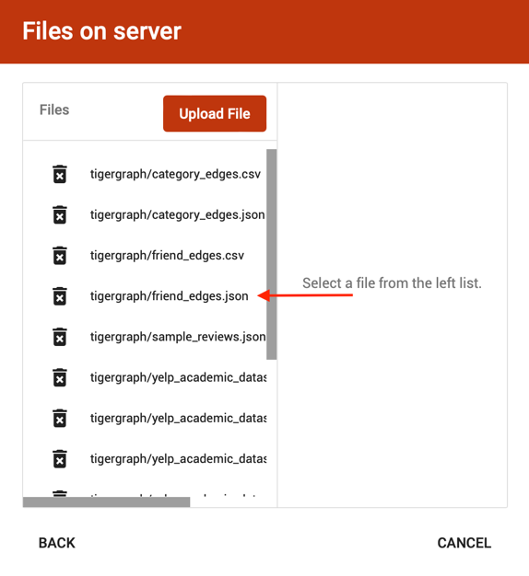
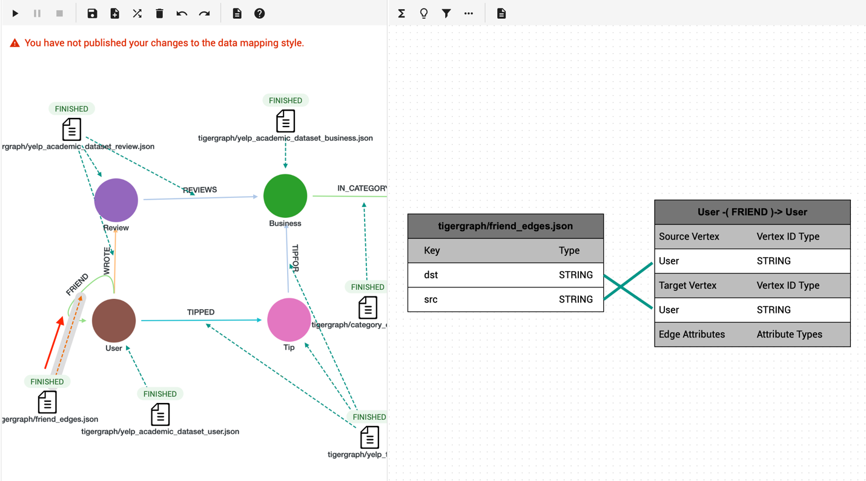
Duration 19s

