Loading Movie Lens dataset to Tigergraph
Load Metadata
=== Movie Vertex
CREATE VERTEX Movie (
PRIMARY_ID item_id INT,
title STRING,
avgRating DOUBLE,
imdbId STRING,
directedBy STRING,
starring STRING
) WITH primary_id_as_attribute="true"

=== User Vertex
CREATE VERTEX User (
PRIMARY_ID user_id INT
) WITH primary_id_as_attribute="true"

=== Tag Vertex
CREATE VERTEX Tag (
PRIMARY_ID tag_id INT,
tag STRING
) WITH primary_id_as_attribute="true"

=== Review Vertex
CREATE VERTEX Review (
PRIMARY_ID review_id INT,
text STRING
) WITH primary_id_as_attribute="true"

=== Survey Vertex
CREATE VERTEX Survey (
PRIMARY_ID survey_id INT,
score INT
) WITH primary_id_as_attribute="true"

=== Director Vertex
CREATE VERTEX Director (
PRIMARY_ID name STRING
) WITH primary_id_as_attribute="true"

=== Actor Vertex
CREATE VERTEX Actor (
PRIMARY_ID name STRING
) WITH primary_id_as_attribute="true"

=== Edges
CREATE DIRECTED EDGE RATED (FROM User, TO Movie, rating DOUBLE)
CREATE DIRECTED EDGE HAS_TAG (FROM Movie, TO Tag, counts INT) // the edge attribute name is set to counts, since ‘count’ is a reserved keyword
CREATE DIRECTED EDGE HAS_REVIEW (FROM Movie, TO Review)
CREATE DIRECTED EDGE ANSWERED (FROM User, TO Survey)
CREATE DIRECTED EDGE ABOUT_MOVIE (FROM Survey, TO Movie)
CREATE DIRECTED EDGE ABOUT_TAG (FROM Survey, TO Tag)
CREATE DIRECTED EDGE DIRECTED (FROM Director, TO Movie)
CREATE DIRECTED EDGE ACTED_IN (FROM Actor, TO Movie)

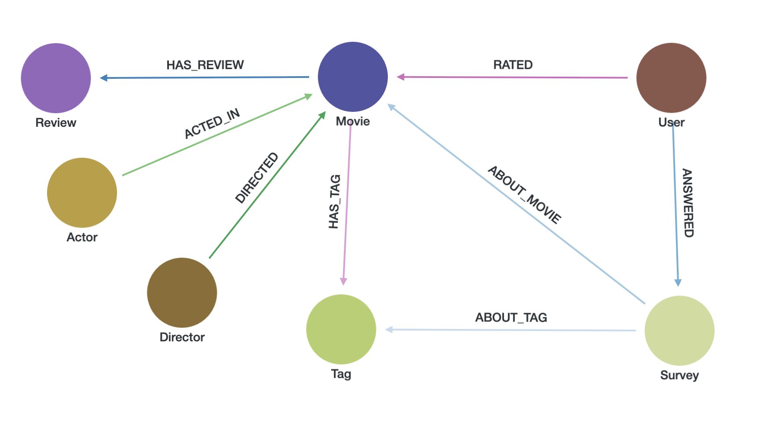
Copying Dataset Files into TigerGraph's Loading Directory (Docker)
To make the MovieLens Genome 2021 dataset available for loading via TigerGraph's GraphStudio, follow the steps below to copy the raw data files into the appropriate loading directory inside the Docker container.
Access the TigerGraph Docker container:
docker exec -it tigergraph bash
Copy all files from the raw folder into TigerGraph’s loading data directory:
cp -r ~/datasets/movielens/genome_2021/raw/* /home/tigergraph/tigergraph/data/gui/loading_data/tigergraph/
This command copies all .json and .csv files from the raw dataset folder into the GraphStudio loading path, making them accessible for use in loading jobs and data mapping.

- Mapping of movie node (metadata.json)
The Movie vertex is created using metadata.json, which contains the core metadata for each movie including:
- item_id: the unique movie identifier
- title, avgRating, imdbId: descriptive attributes
- directedBy and starring: raw string fields that will later be processed to extract related nodes and edges (Director and Actor)

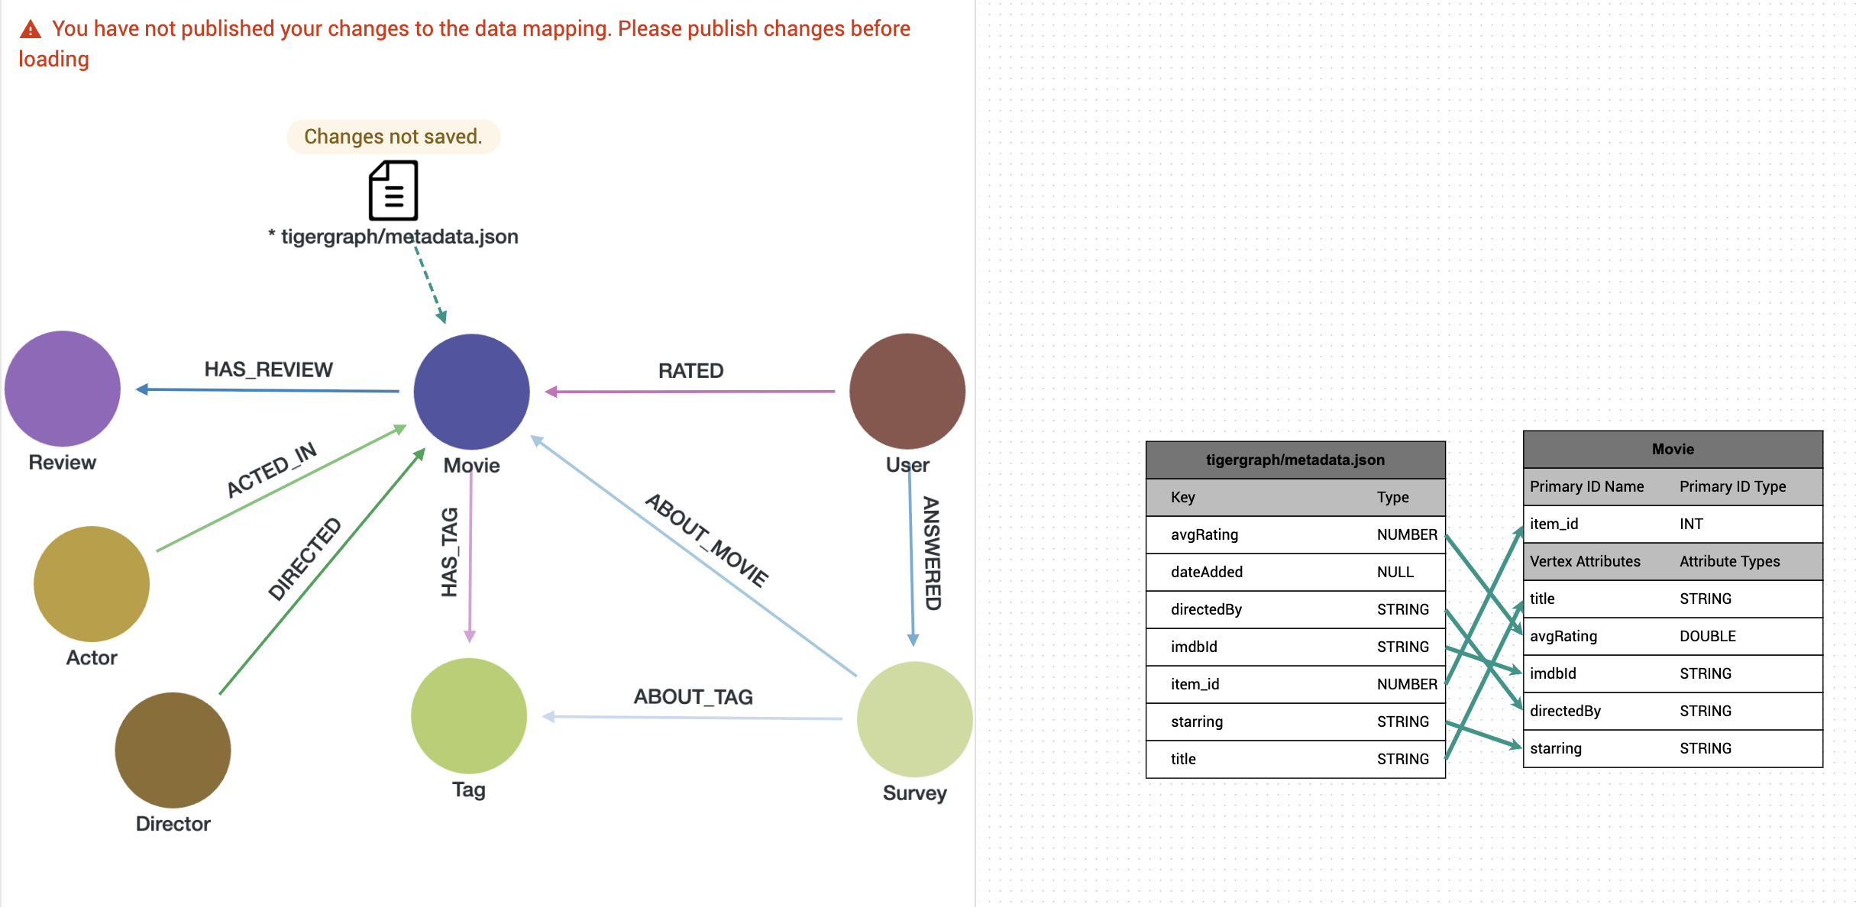

- Mapping of user node + RATED edge
We map the user id from the ratings.json file to the User vertex
The ratings.json file contains user interactions with movies.
- Each row provides a user_id, item_id (movie), and a rating.
- The User vertex is created from the user_id, and
- the RATED edge is created between the User and corresponding Movie with rating as an edge attribute.
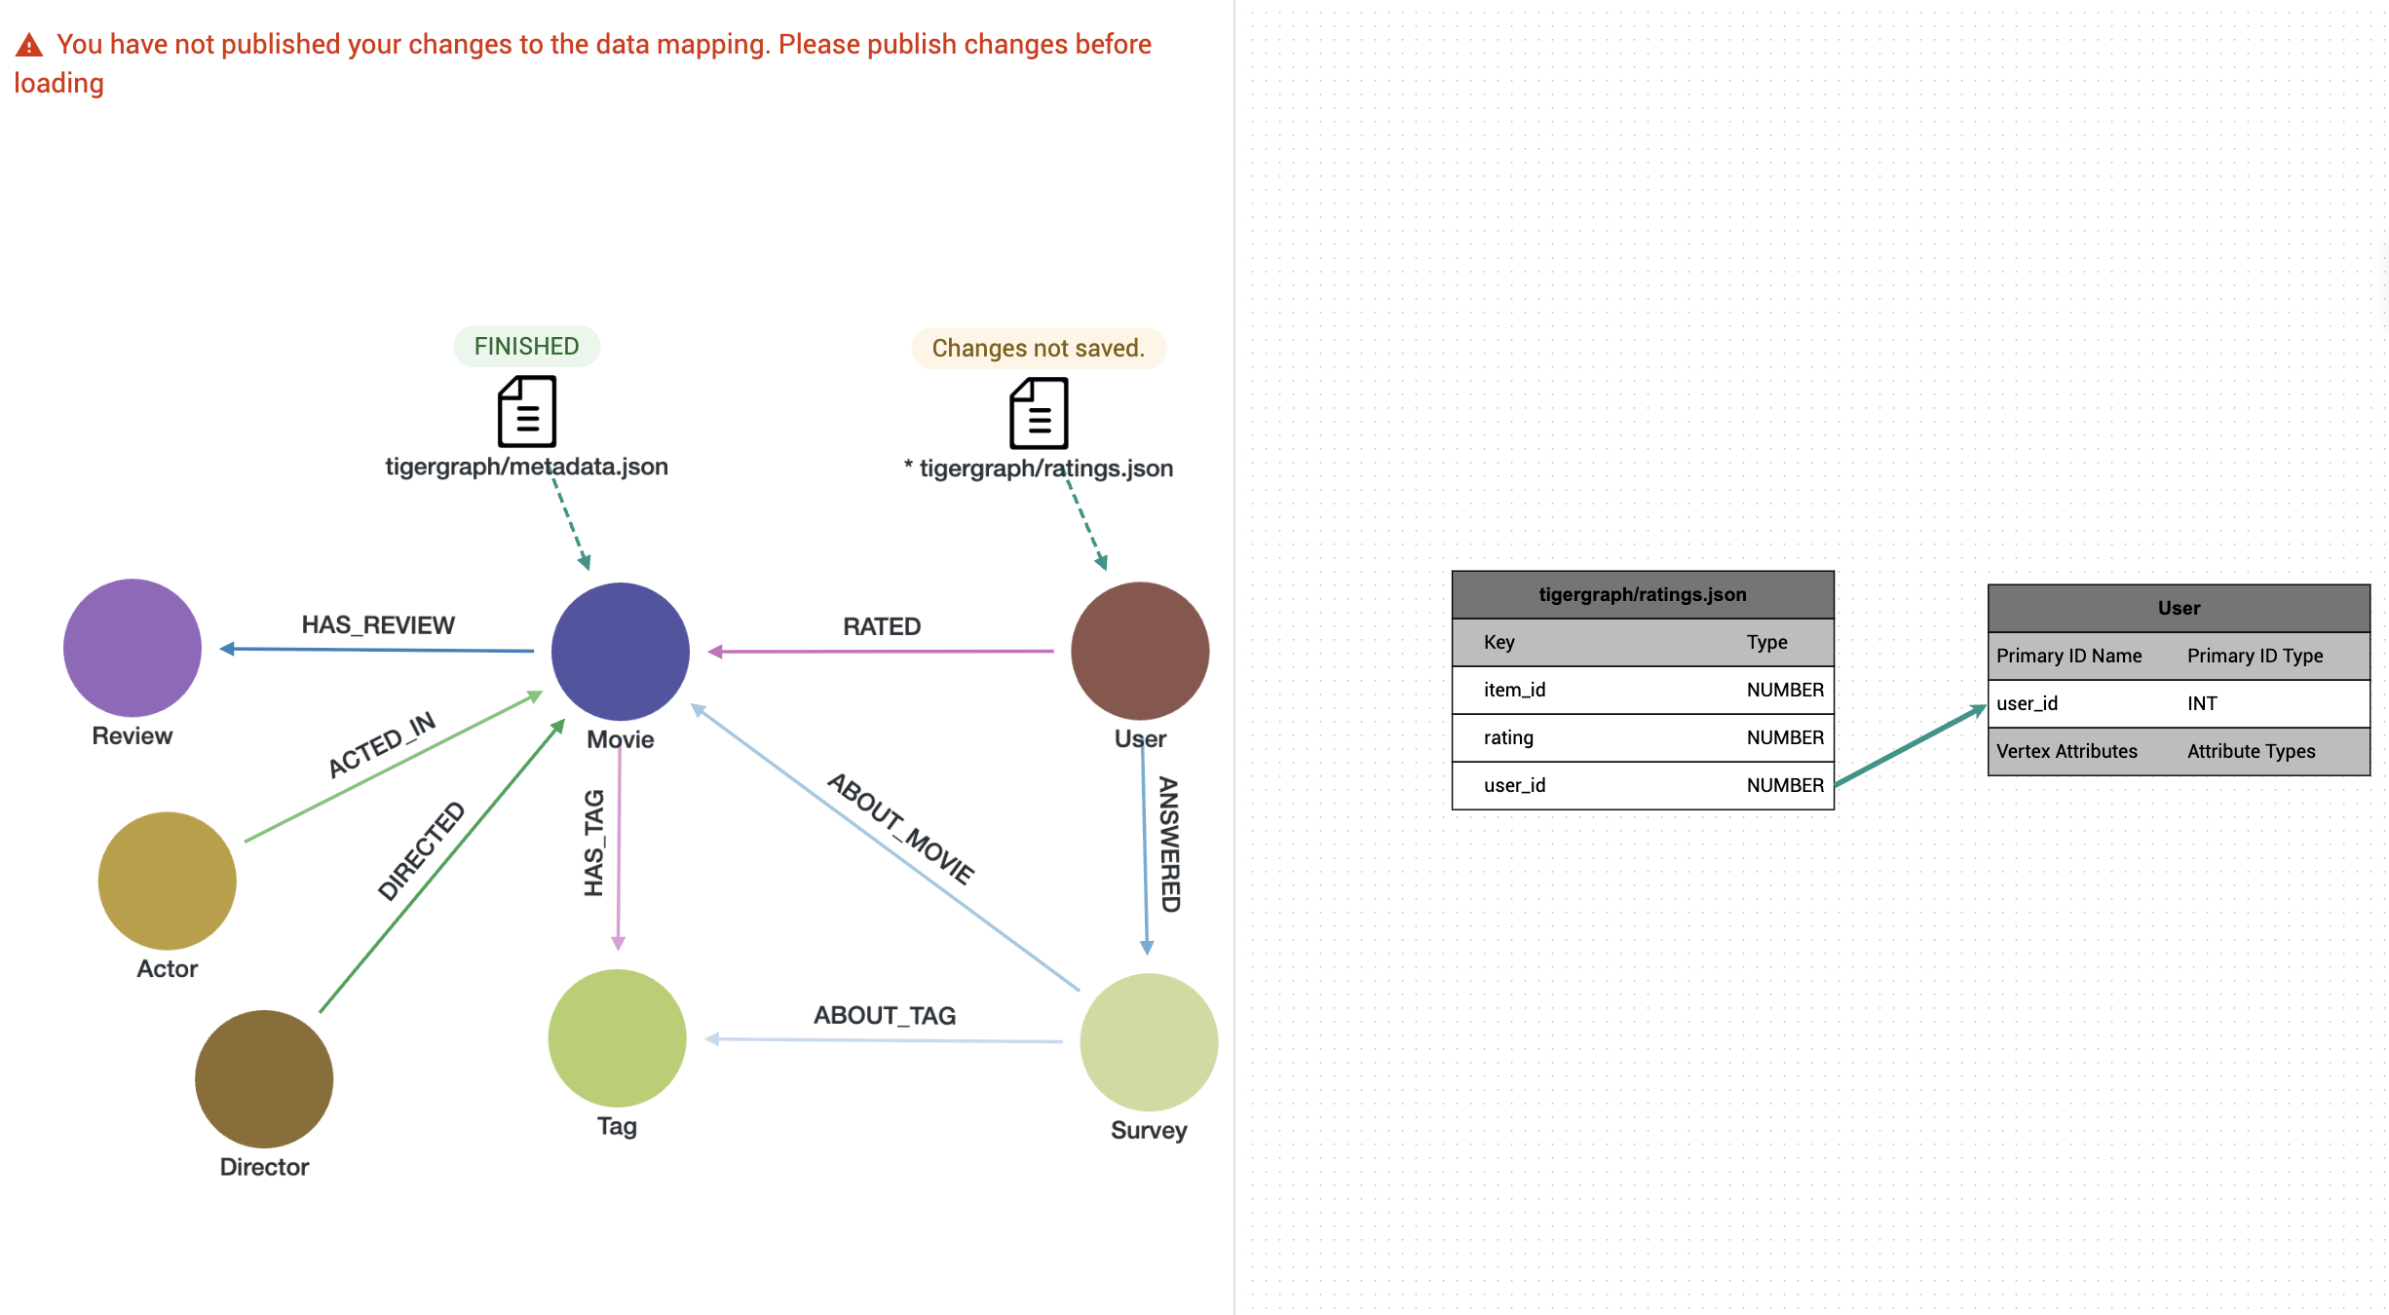
USER VETEX
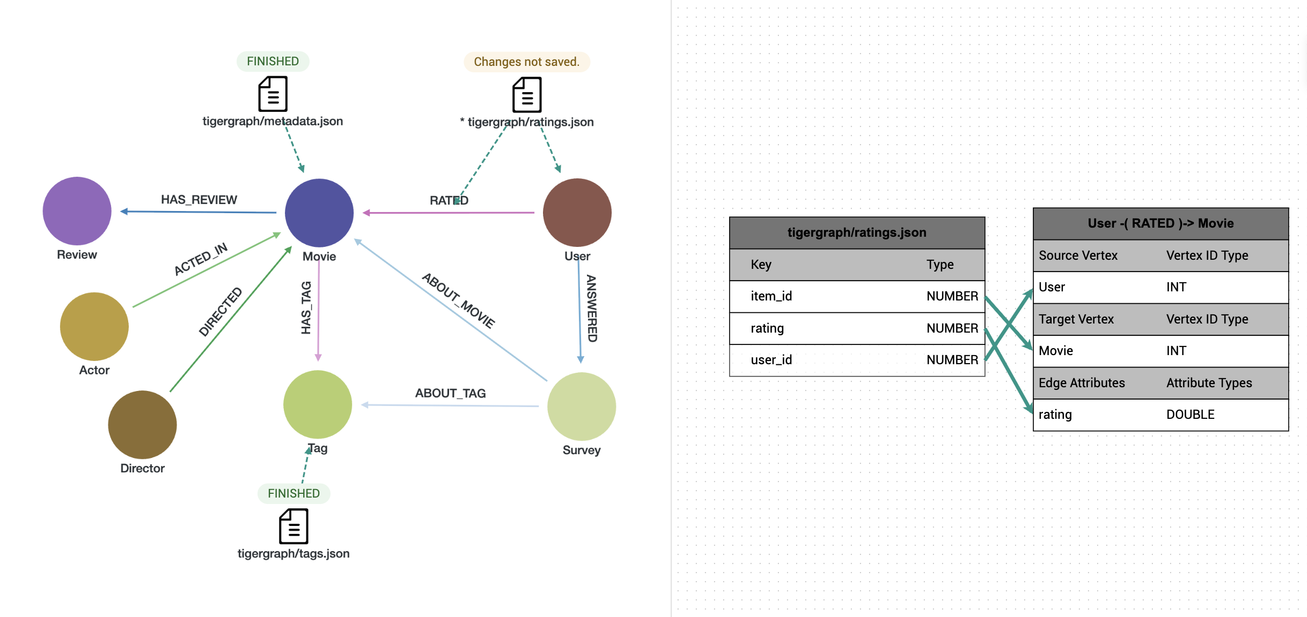
RATED EDGE
- Mapping of tag node (tags.json)
Each record in tags.json represents a unique tag_id and tag label. These are mapped to the Tag vertex.

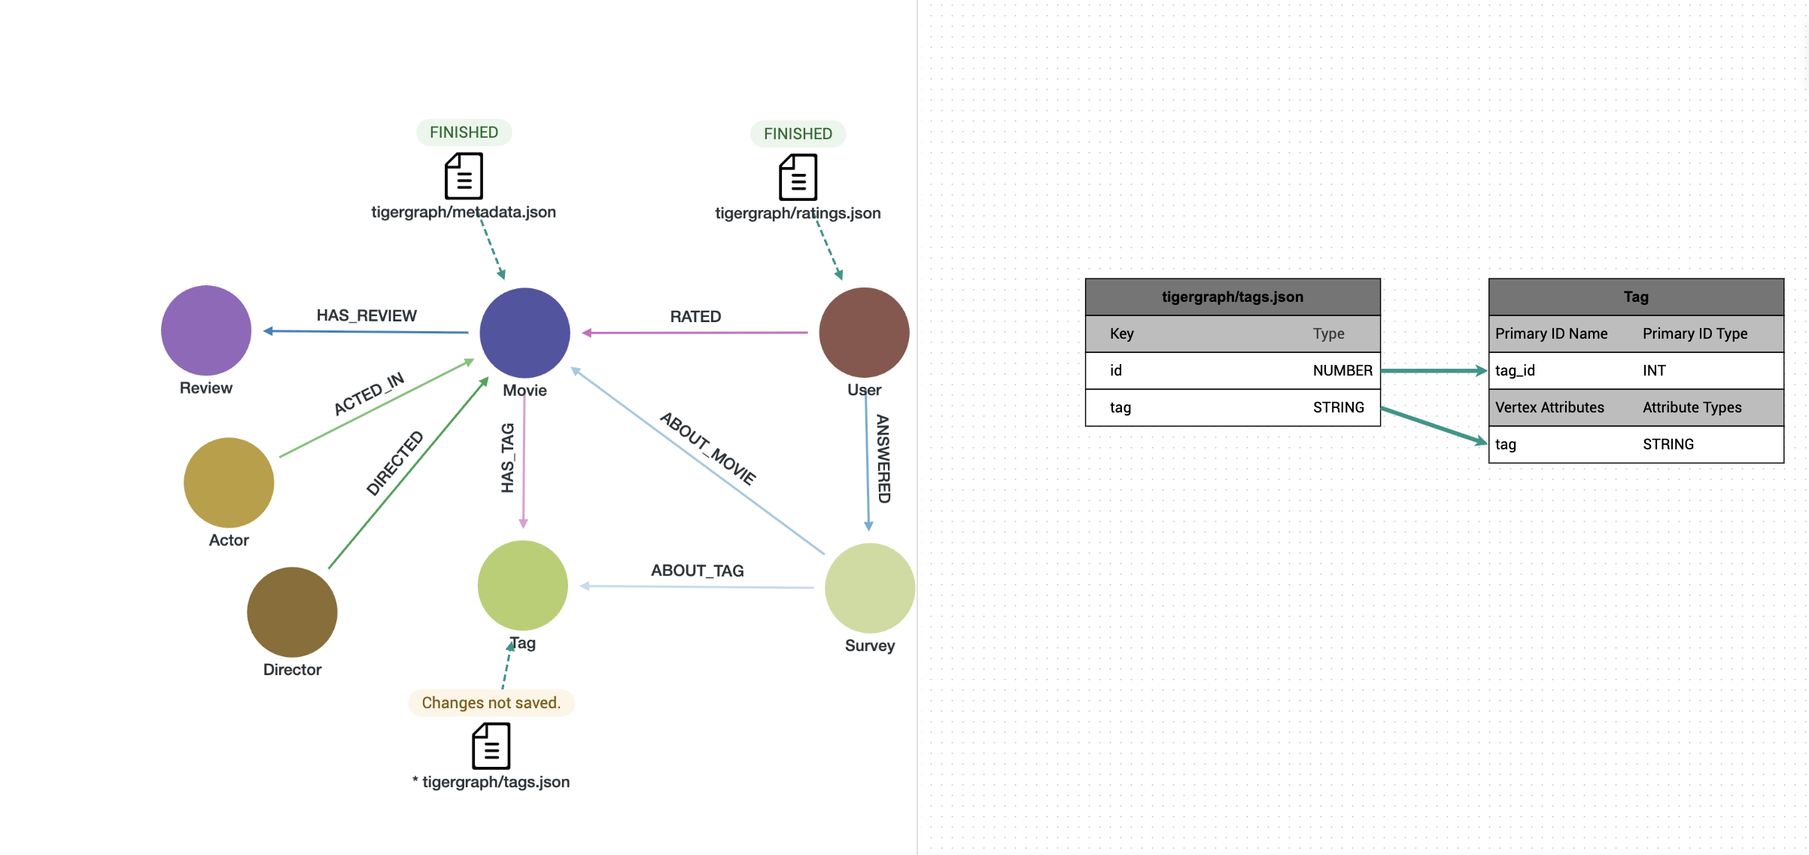
- Mapping of HAS_TAG edge (tag_count.json)
This file links Movie nodes to their respective Tags based on frequency of tagging.
- We map item_id → tag_id with num as an edge attribute (renamed counts to avoid conflict with reserved keywords). This forms the HAS_TAG edge which quantifies tag relevance per movie.
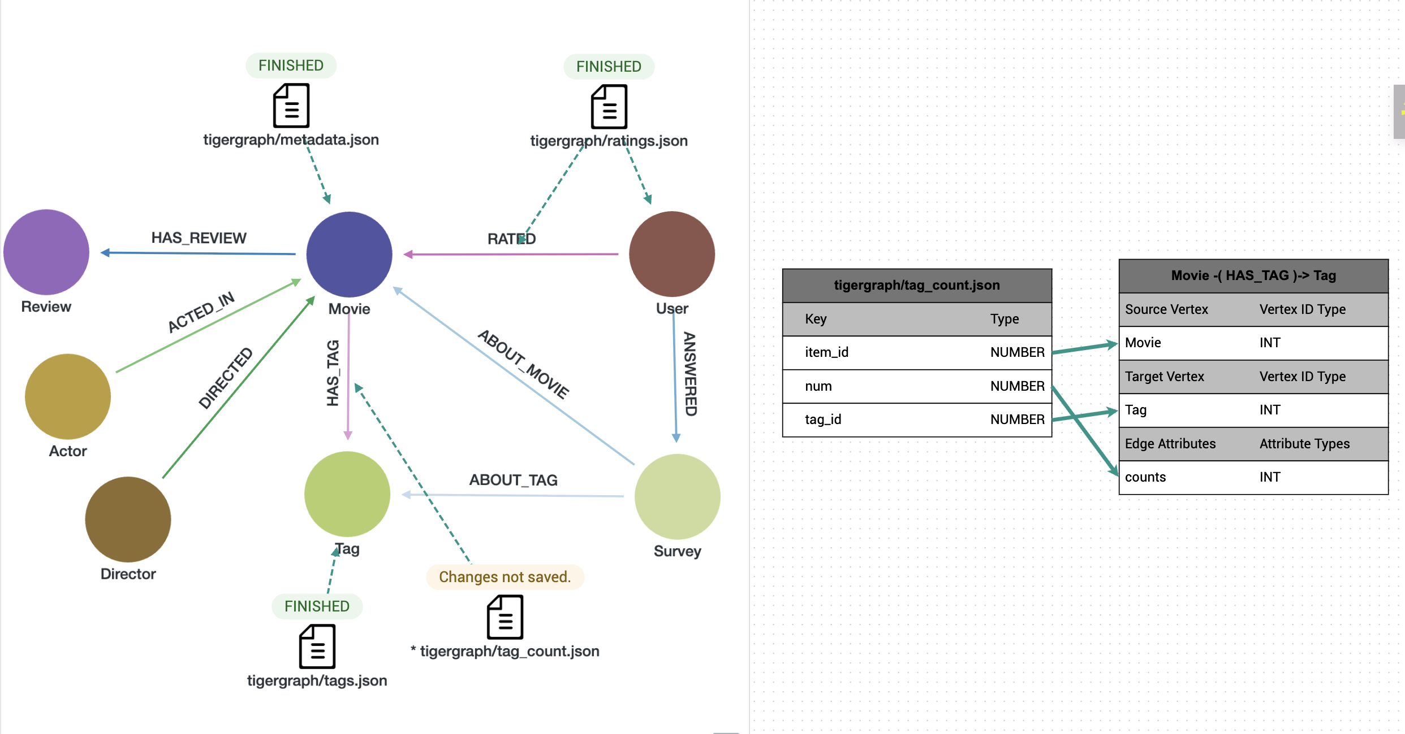

- Mapping of Review node + HAS_REVIEW (review_with_id.json)
We add a monotonically_increasing_id to uniquely represent each review

from pyspark.sql.functions import monotonically_increasing_id
df_reviews = spark.read.json("file:///shared/datasets/movielens/genome_2021/raw/reviews.json")
df_reviews_with_id = df_reviews.withColumn("review_id", monotonically_increasing_id())

df_reviews_with_id.write.mode("overwrite").json("file:///shared/datasets/movielens/genome_2021/raw/review_with_id.json")
Each review record contains:
- review_id: unique review ID
- text: the actual review
- item_id: the movie being reviewed
We create a Review vertex for each entry and a HAS_REVIEW edge from the corresponding Movie.
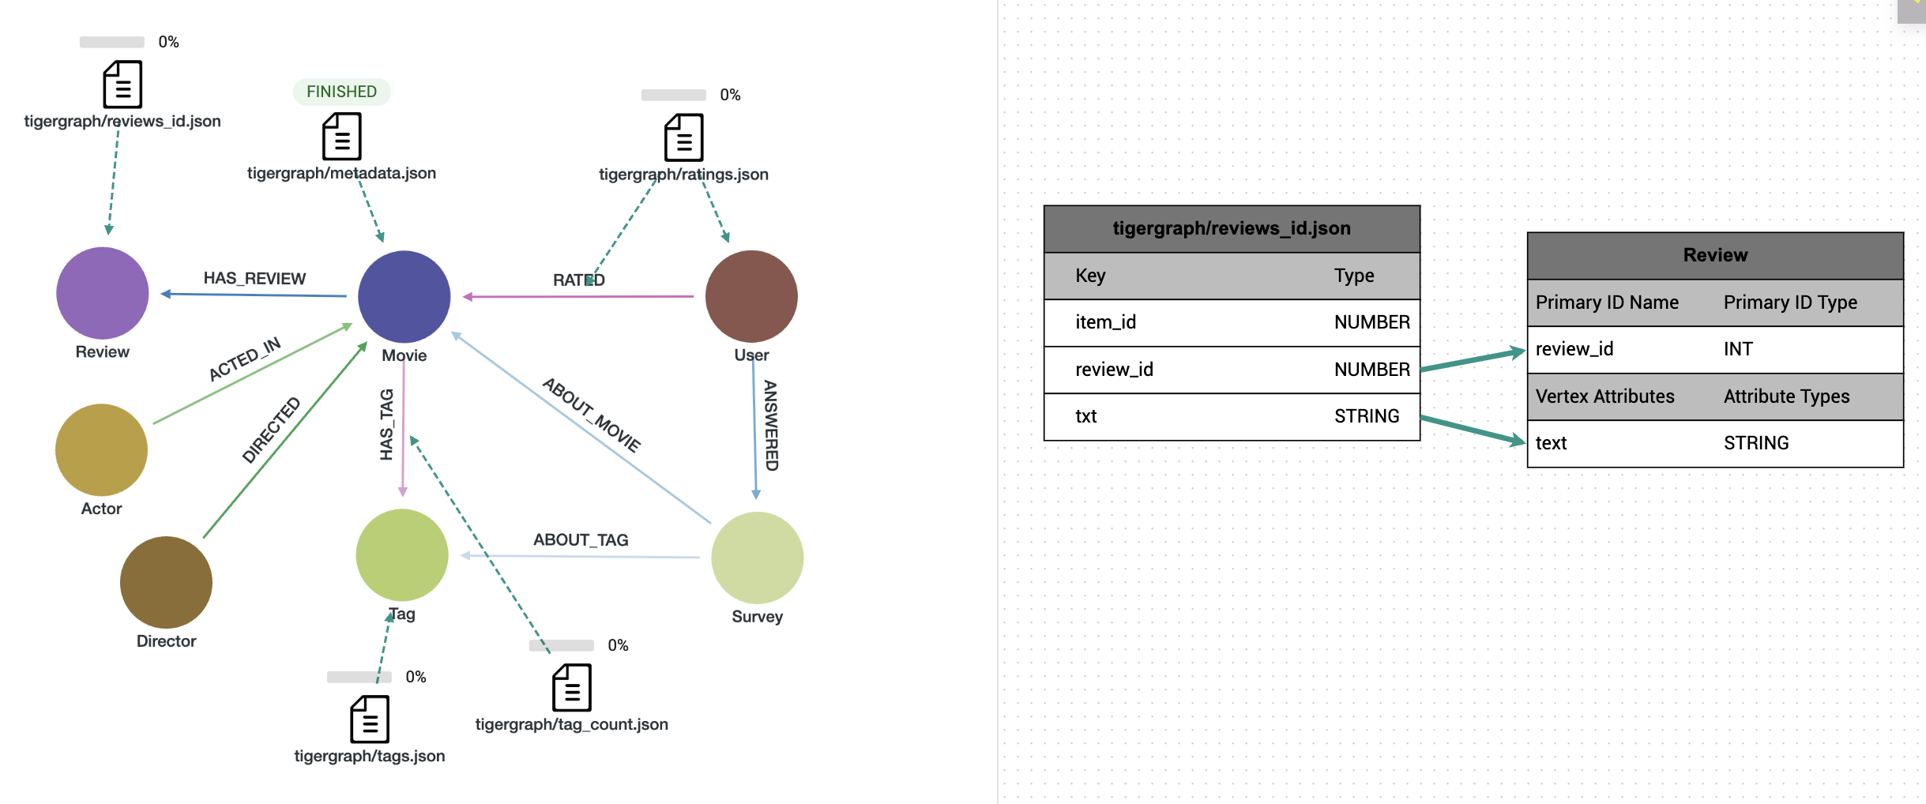
REVIEW VERTEX
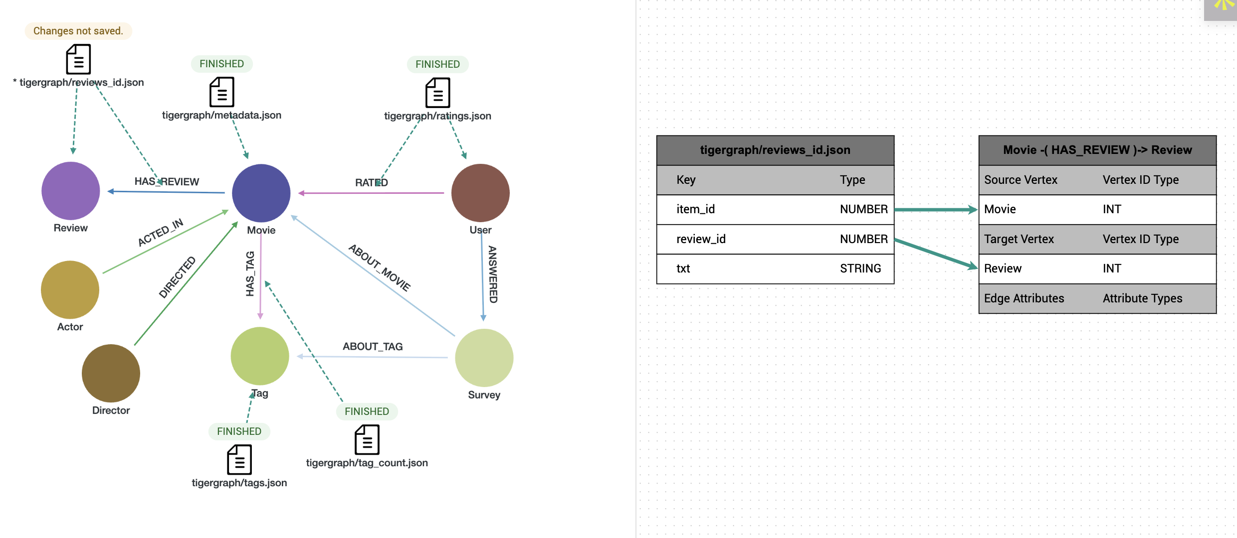
HAS_REVIEW EDGE
- Mapping of Survey nodes and edges (surveys_id.json)
We add a monotonically_increasing_id to uniquely represent each survey answer

from pyspark.sql.functions import monotonically_increasing_id
df_survey = spark.read.json("file:///shared/datasets/movielens/genome_2021/raw/survey_answers.json")
df_survey_with_id = df_survey.withColumn("survey_id", monotonically_increasing_id())
df_survey_with_id.write.mode("overwrite").json("file:///shared/datasets/movielens/genome_2021/raw/surveys_id.json")

This file links users with survey-based ratings for specific movies and tags:
- Survey vertices are created using survey_id and score
- Edges:
  - ANSWERED: connects User to Survey
  - ABOUT_MOVIE: links Survey to Movie
  - ABOUT_TAG: links Survey to Tag
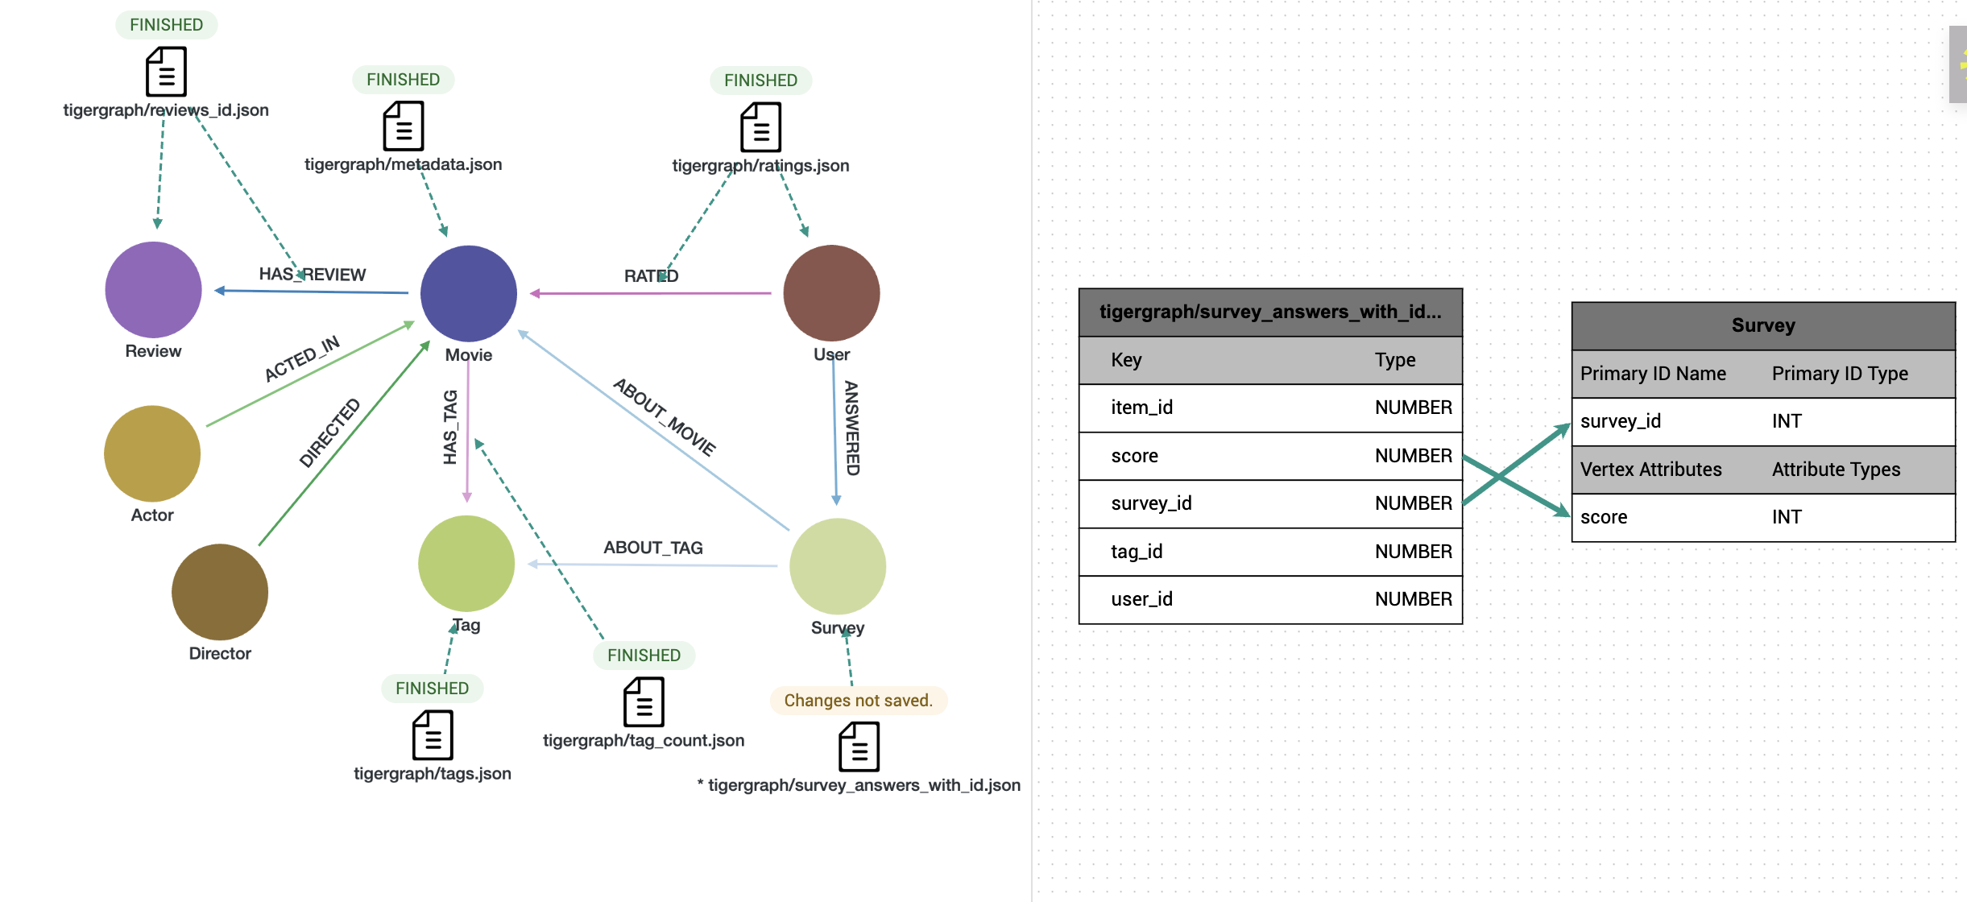
SURVEY VERTEX
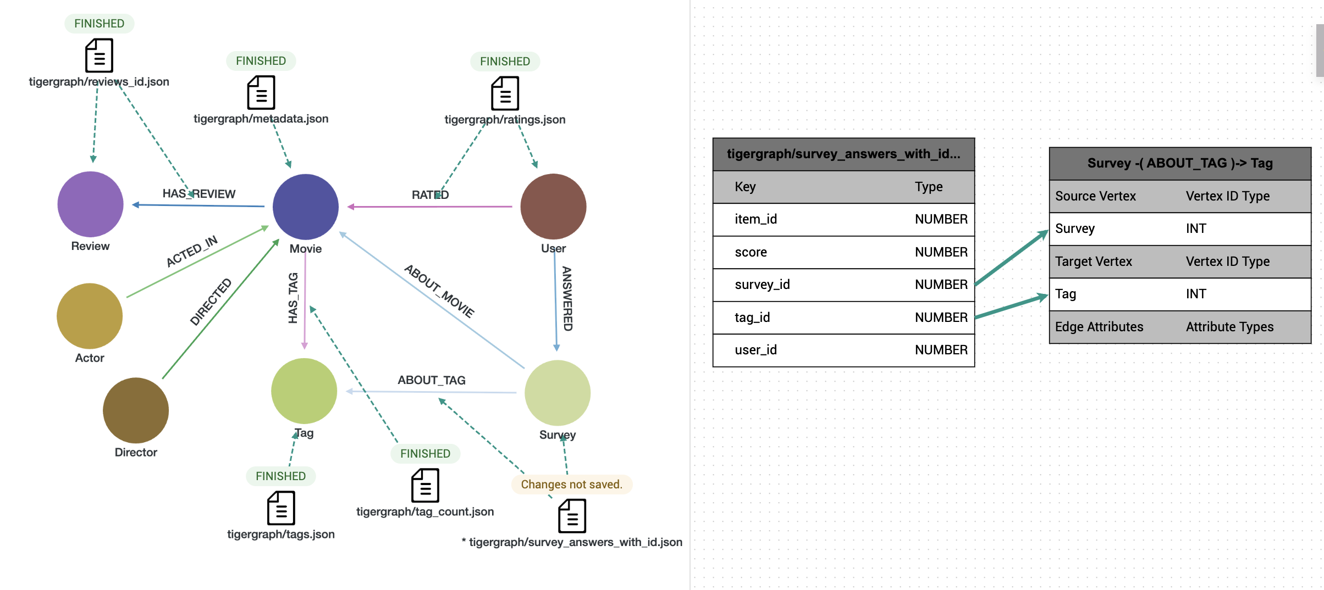
ABOUT_TAG EDGE
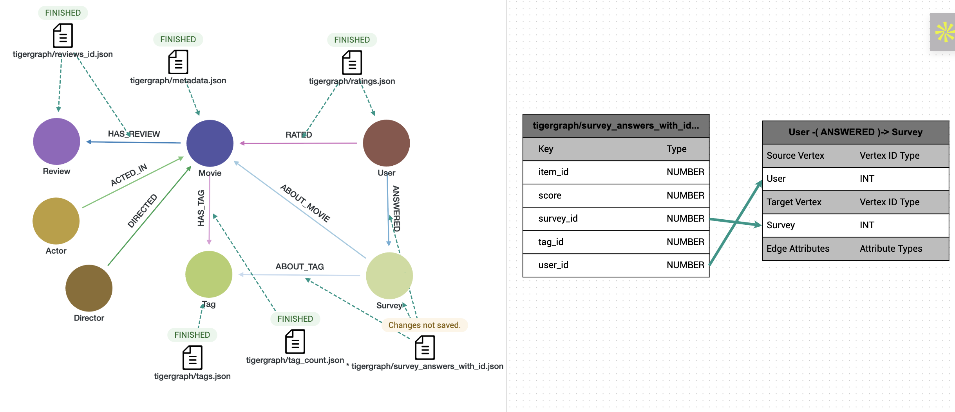

ANSWERED EDGE
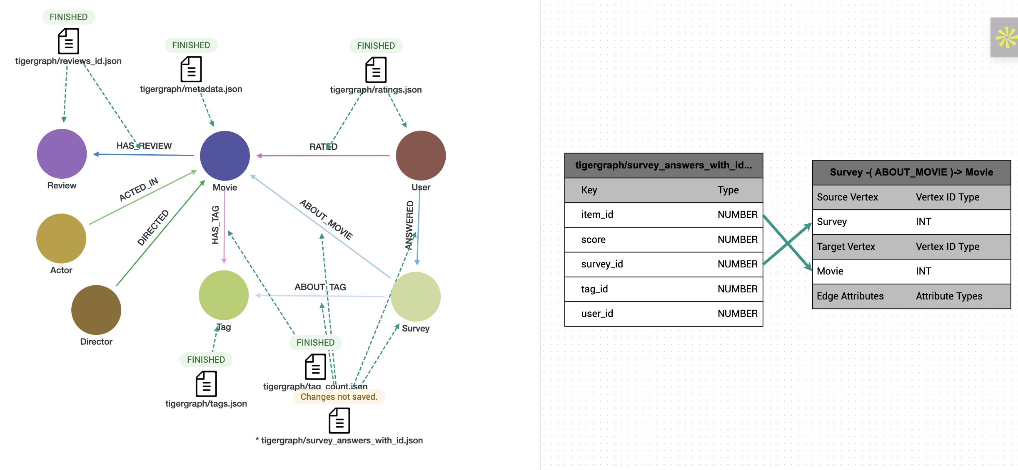
ABOUT_MOVIE EDGE
- Mapping Actor node and edges
The starring field in metadata.json contains a comma-separated list of actors. To build an accurate graph:
- Each actor is extracted as a separate row
- We trim and deduplicate to ensure clean mappings
- We export these as actor_vertices.json and actor_movie_edge.json.

from pyspark.sql import functions as F
# 1) explode `starring` into tidy rows (movie_id, actor_name)
exploded = (
df_meta_original
.filter(F.col("starring").isNotNull())
.withColumn("actor", F.explode(F.split(F.col("starring"), r",\s*")))
.withColumn("actor", F.trim("actor"))
.filter(F.col("actor") != "") # strip empties
.select(F.col("item_id").alias("movie_id"), "actor")
.dropDuplicates(["movie_id", "actor"]) # dedupe per movie
)
# 2) actor vertices (id, type)
actor_vertices = (
exploded
.select("actor")
.distinct()
.withColumnRenamed("actor", "id")
.withColumn("type", F.lit("actor"))
)
# 3) edges (src = actor, dst = movie_id, relationship)
actor_edges = (
exploded
.select(
F.col("actor").alias("src"),
F.col("movie_id").alias("dst")
)
.withColumn("relationship", F.lit("acted_in"))
)
# 4) write to single-file JSONs
actor_vertices.coalesce(1).write.mode("overwrite") \
.json("file:///shared/datasets/movielens/genome_2021/raw/actor_vertices.json")
actor_edges.coalesce(1).write.mode("overwrite") \
.json("file:///shared/datasets/movielens/genome_2021/raw/actor_movie_edge.json")

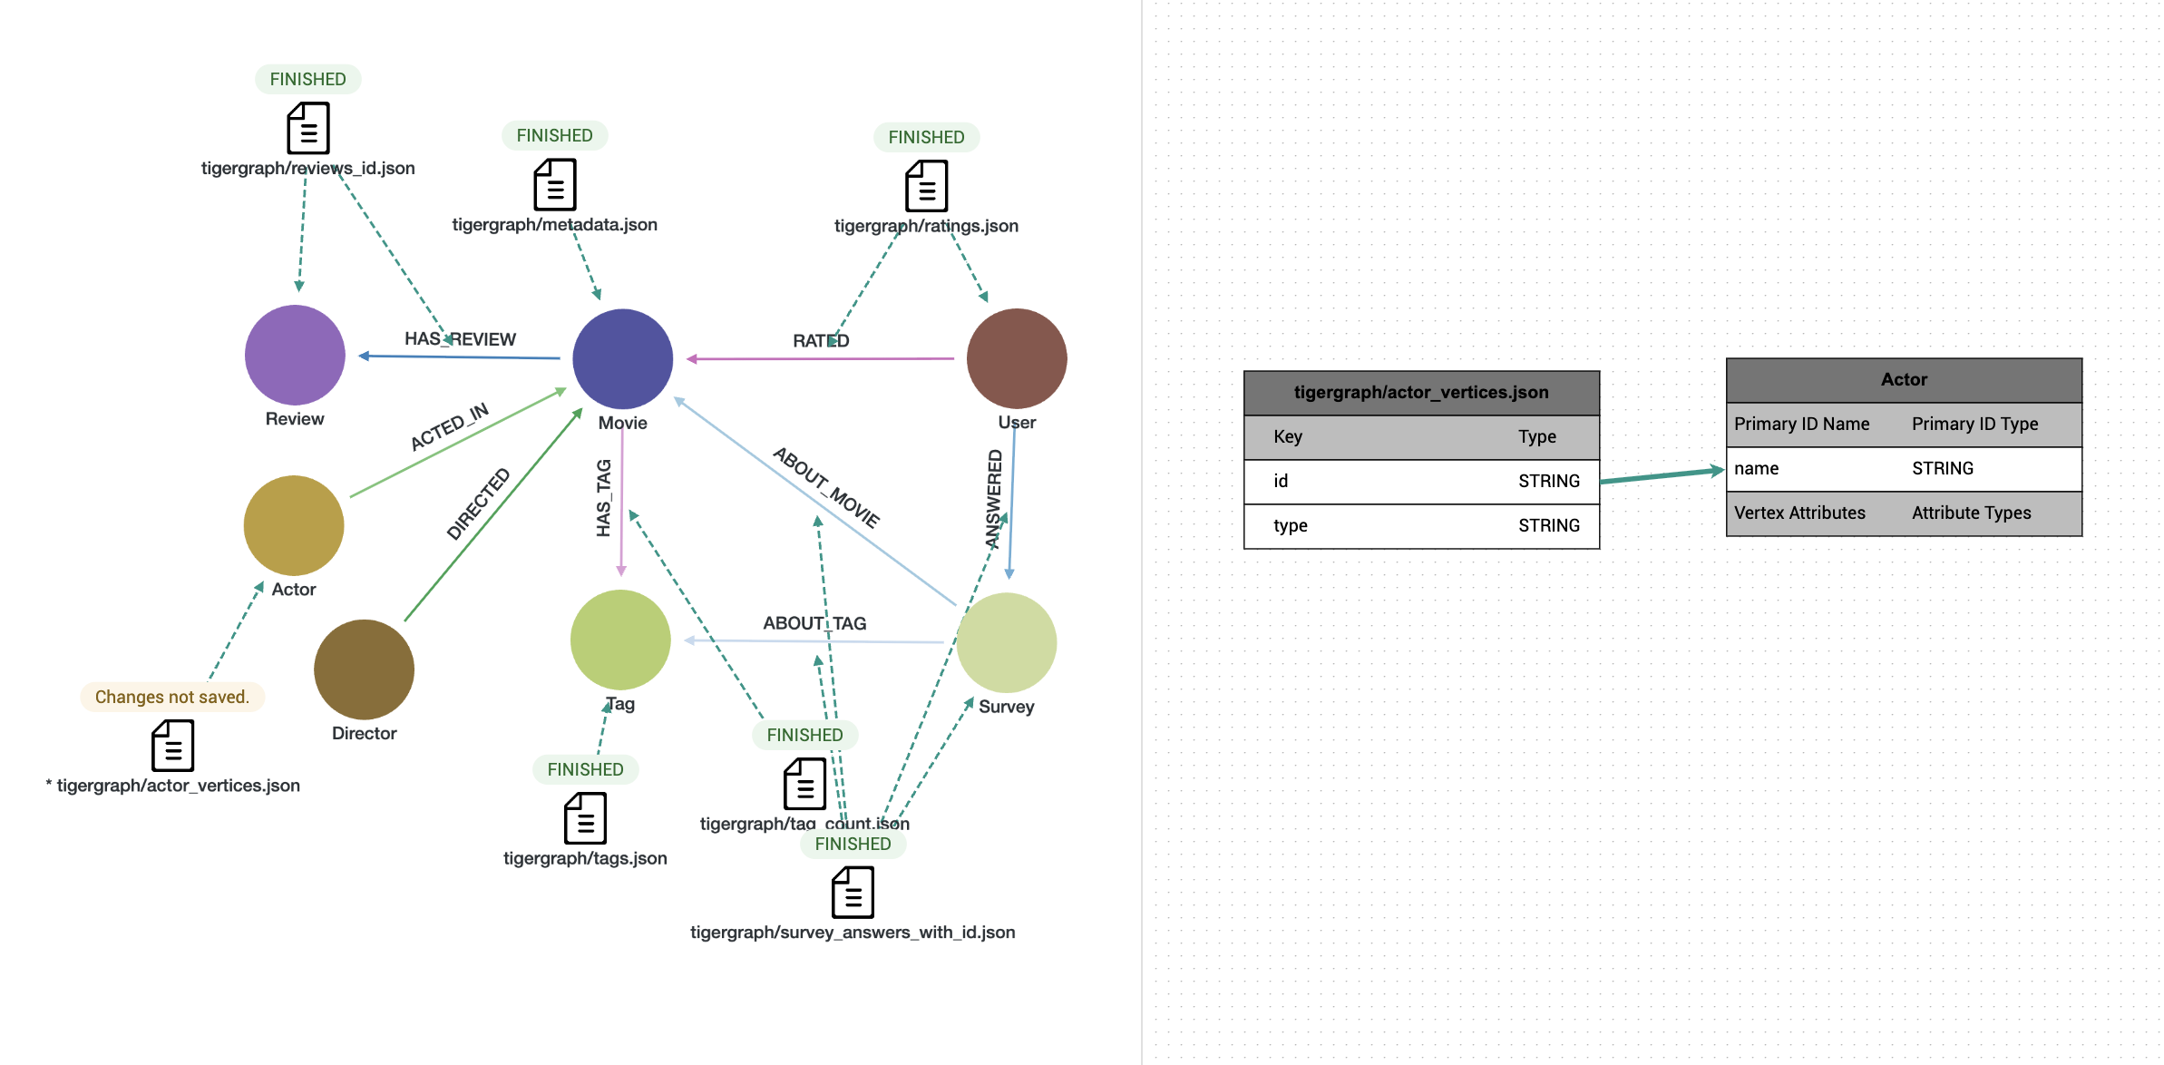
ACTOR VERTEX
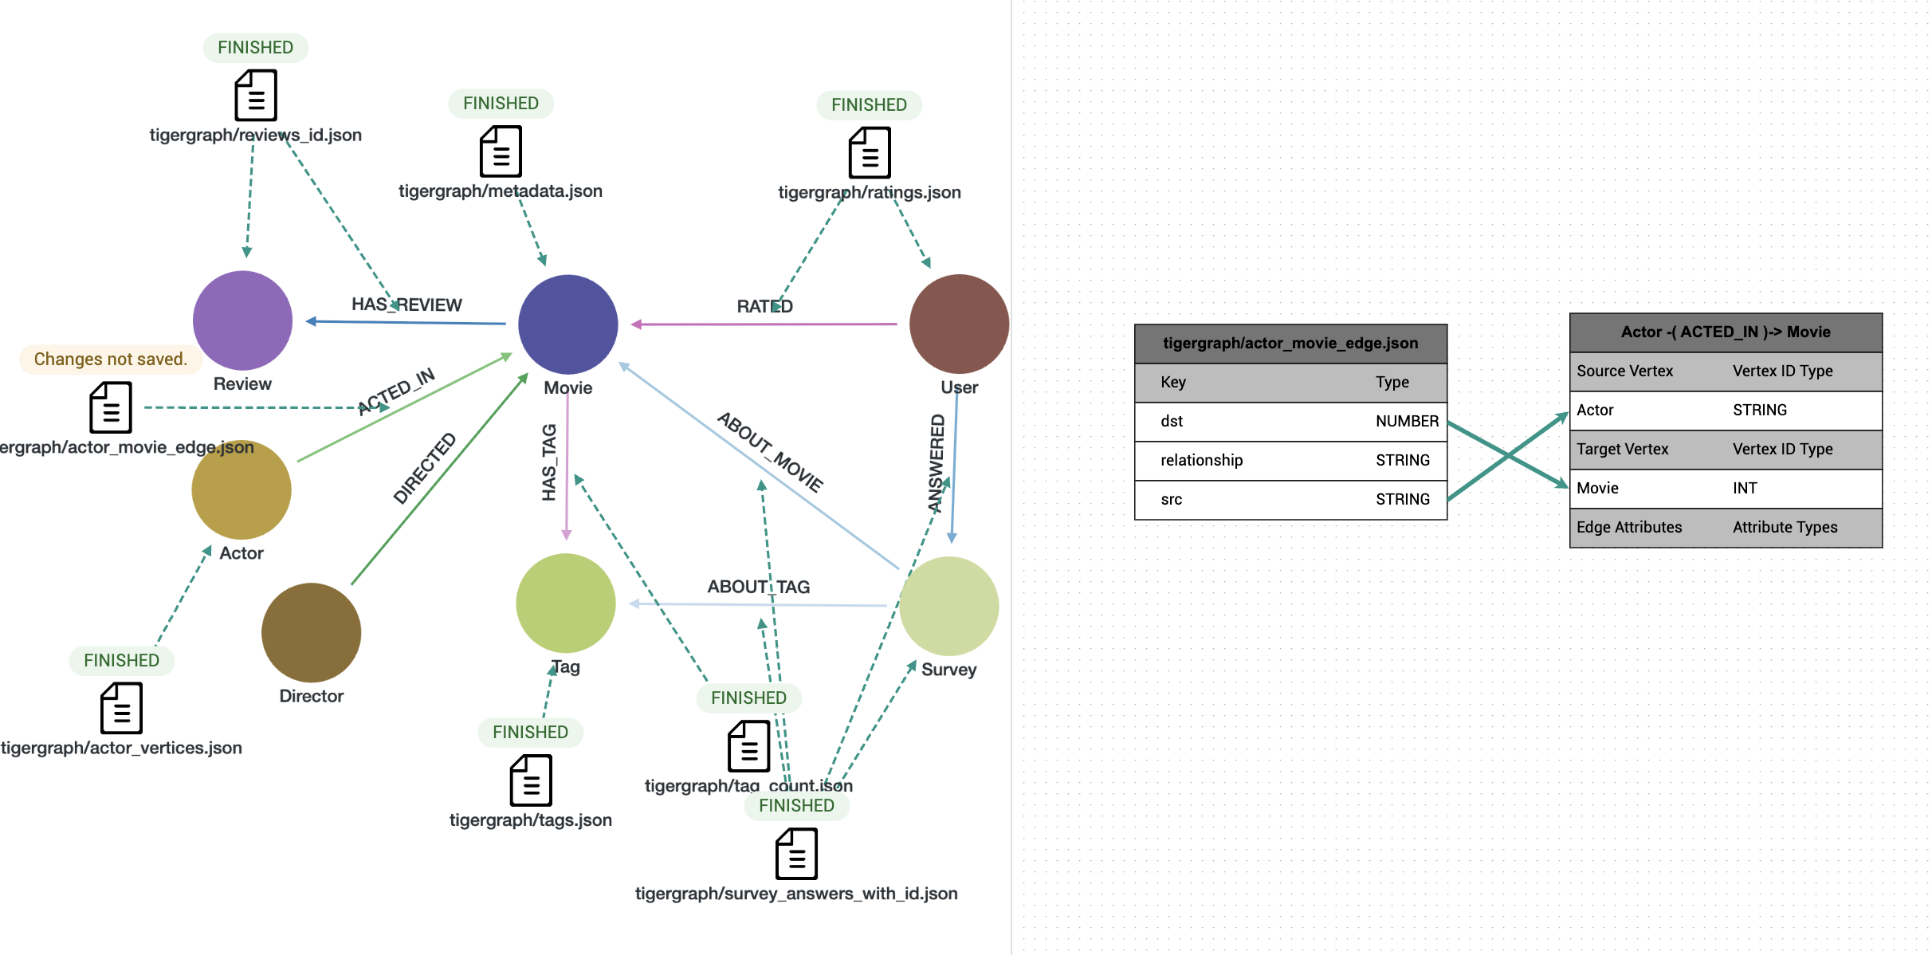
ACTED_IN EDGE
- Mapping Director nodes and edges
Similarly, the directedBy field in metadata.json is processed:
This code:
- Multiple directors
- Extra whitespace
- Duplicate (movie, director) pairs
Exported as director_vertices.json and director_movie_edges.json.

from pyspark.sql import functions as F
# 1) explode `directedBy` → tidy rows (movie_id, director)
exploded_dir = (
df_meta_original
.filter(F.col("directedBy").isNotNull())
# just in case a movie lists two directors, split on commas
.withColumn("director", F.explode(F.split(F.col("directedBy"), r",\s*")))
.withColumn("director", F.trim("director"))
.filter(F.col("director") != "")
.select(F.col("item_id").alias("movie_id"), "director")
.dropDuplicates(["movie_id", "director"]) # 1 edge per (movie, director)
)
# 2) director vertices (id, type)
director_vertices = (
exploded_dir
.select("director")
.distinct()
.withColumnRenamed("director", "id")
.withColumn("type", F.lit("director"))
)
# 3) edges (src = director, dst = movie_id, relationship)
director_edges = (
exploded_dir
.select(
F.col("director").alias("src"),
F.col("movie_id").alias("dst")
)
.withColumn("relationship", F.lit("directed"))
)
# 4) dump to JSON (one file each)
base = "file:///shared/datasets/movielens/genome_2021/raw"
director_vertices.coalesce(1).write.mode("overwrite").json(f"{base}/director.json")
director_edges.coalesce(1).write.mode("overwrite").json(f"{base}/director_movie_edges.json")
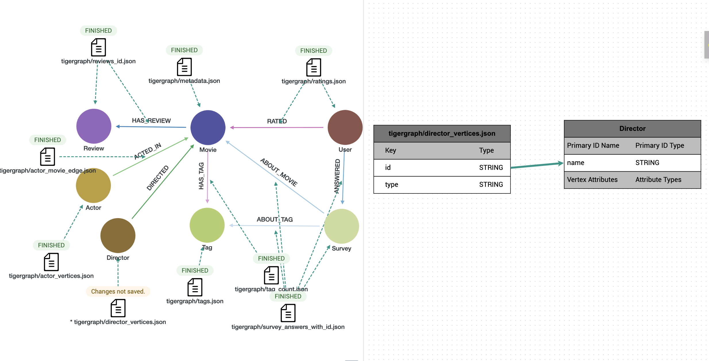
DIRECTOR VERTEX

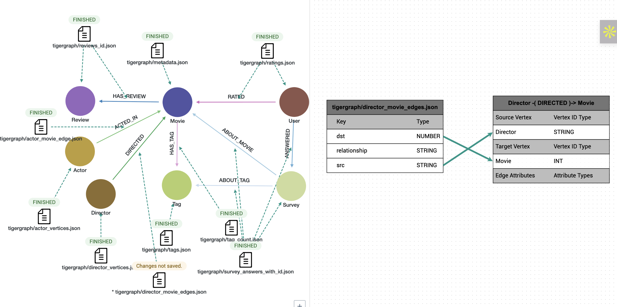
DIRECTED EDGE

===QUERIES===
=== DIRECTOR, ACTOR, MOVIE===
Top 10 Directors by Average Movie Rating (Filtering to avoid bias from 1-hit wonders, so considering movies >= 3):
CREATE OR REPLACE QUERY query1(INT topN = 10) FOR GRAPH movielens_genome {

TYPEDEF TUPLE<STRING Director, FLOAT AvgRating, INT Movies> DirTuple;
// Sort by AvgRating DESC, then Movies DESC, then Director ASC
HeapAccum<DirTuple>(topN, AvgRating DESC, Movies DESC, Director ASC) @@topDirectors;

SumAccum<FLOAT> @ratingSum;
SumAccum<INT> @movieCount;

// Step 1: Traverse and accumulate ratings
Start = SELECT d FROM Director:d -(DIRECTED>)- Movie:m
WHERE m.avgRating > 0
ACCUM d.@ratingSum += m.avgRating,
d.@movieCount += 1;

// Step 2: Filter directors with >= 3 movies and push results into heap
Result = SELECT d FROM Start:d
WHERE d.@movieCount >= 3
POST-ACCUM
@@topDirectors += DirTuple(
d.name,
ROUND(d.@ratingSum / d.@movieCount, 2), // rounded to 2 decimals
d.@movieCount
);

// Step 3: Print top directors
PRINT @@topDirectors;
}

Directors with the Most Movies Above 4.0 Rating (Not just average, how many great movies have they made? Considered minimum of 2 movies)
CREATE OR REPLACE QUERY query1(INT topN = 10) FOR GRAPH movielens_genome{

TYPEDEF TUPLE<STRING Director, INT HighRatedMovies> DirTuple;
HeapAccum<DirTuple>(topN, HighRatedMovies DESC, Director ASC) @@topDirectors;

SumAccum<INT> @highRatedCount;

// Step 1: Count movies >= 4.0 for each director
Start = SELECT d FROM Director:d -(DIRECTED>)- Movie:m
WHERE m.avgRating >= 4.0
ACCUM d.@highRatedCount += 1;

// Step 2: Filter directors with at least 2 such movies
Result = SELECT d FROM Start:d
WHERE d.@highRatedCount >= 2
POST-ACCUM
@@topDirectors += DirTuple(d.name, d.@highRatedCount);

// Step 3: Print top N
PRINT @@topDirectors;
}

Top 10 Actors by Number of Movies Acted In
CREATE OR REPLACE QUERY query1(INT topN = 10) FOR GRAPH movielens_genome {

TYPEDEF TUPLE<STRING Actor, INT TotalMovies> ActorTuple;
HeapAccum<ActorTuple>(topN, TotalMovies DESC, Actor ASC) @@topActors;

SumAccum<INT> @movieCount;

// Step 1: count movies for each actor
Start = SELECT a FROM Actor:a -(ACTED_IN>)- Movie:m
ACCUM a.@movieCount += 1;

// Step 2: push results into heap
Result = SELECT a FROM Start:a
POST-ACCUM
@@topActors += ActorTuple(a.name, a.@movieCount);

// Step 3: return top N
PRINT @@topActors;
}

Top Actors by Average Rating of Movies (Which actors are most associated with successful movies?)
CREATE OR REPLACE QUERY query1()
FOR GRAPH movielens_genome {

SumAccum<DOUBLE> @totalRating;
SumAccum<INT> @movieCount;
SumAccum<DOUBLE> @avgRating;

Start = {Actor.*};

Results =
SELECT a
FROM Start:a -(ACTED_IN:e)-> Movie:m
ACCUM
a.@totalRating += m.avgRating,
a.@movieCount += 1
POST-ACCUM
a.@avgRating = ROUND(a.@totalRating / a.@movieCount, 2)
HAVING a.@movieCount >= 3
ORDER BY a.@avgRating DESC
LIMIT 10;

PRINT Results[Results.name AS Actor,
Results.@avgRating AS AvgRating,
Results.@movieCount AS TotalMovies];
}

Top Actor-Director Pairs by Number of Collaborations
CREATE OR REPLACE QUERY query1(INT topN = 10)
FOR GRAPH movielens_genome SYNTAX v2 {

TYPEDEF TUPLE<STRING Director, STRING Actor, INT Collabs> PairTuple;

// Accumulator to collect final top-N
HeapAccum<PairTuple>(topN, Collabs DESC) @@topPairs;

// Accumulator to count collaborations per pair
MapAccum<PairTuple, INT> @@pairCounts;

// Step 1: Traverse Director -> Movie -> Actor
Start =
SELECT d
FROM Director:d -(DIRECTED>)- Movie:m -(<ACTED_IN)- Actor:a
ACCUM
@@pairCounts += (PairTuple(d.name, a.name, 0) -> 1);

// Step 2: Convert MapAccum into HeapAccum with correct counts
FOREACH (p, c) IN @@pairCounts DO
@@topPairs += PairTuple(p.Director, p.Actor, c);
END;

PRINT @@topPairs;
}

Actor-Director Collaboration Quality (Which pairs consistently produce great movies?)
CREATE OR REPLACE QUERY query1(INT topN = 10) FOR GRAPH movielens_genome {

TYPEDEF TUPLE<STRING Director, STRING Actor, INT Collabs, FLOAT AvgRating> QualityTuple;
HeapAccum<QualityTuple>(topN, AvgRating DESC, Director ASC, Actor ASC) @@topQuality;

MapAccum<STRING, MapAccum<STRING, ListAccum<FLOAT>>> @@ratings;

// Step 1: Start from movies and find director-actor pairs
Start = {Movie.*};

Result = SELECT m FROM Start:m -(<DIRECTED)- Director:d, Start:m -(<ACTED_IN)- Actor:a
WHERE m.avgRating > 0
ACCUM @@ratings += (d.name -> (a.name -> m.avgRating));

// Step 2: Process the accumulated results and calculate averages
FOREACH (director_name, actor_map) IN @@ratings DO
FOREACH (actor_name, rating_list) IN actor_map DO
INT collab_count = rating_list.size();
IF collab_count >= 3 THEN
FLOAT total_rating = 0.0;
FOREACH rating IN rating_list DO
total_rating = total_rating + rating;
END;
FLOAT avg_rating = ROUND(total_rating / collab_count, 2);
@@topQuality += QualityTuple(director_name, actor_name, collab_count, avg_rating);
END;
END;
END;

// Step 3: Print the top quality collaborations
PRINT @@topQuality;
}

Top Actor Groups That Consistently Produce High-Rated Movies
CREATE OR REPLACE QUERY query1(INT topN = 10) FOR GRAPH movielens_genome {

TYPEDEF TUPLE<STRING Actor1, STRING Actor2, STRING Actor3, INT MovieCount, FLOAT AvgRating, STRING Movies> TrioTuple;
HeapAccum<TrioTuple>(topN, AvgRating DESC, Actor1 ASC, Actor2 ASC, Actor3 ASC) @@topTrios;

MapAccum<STRING, MapAccum<STRING, MapAccum<STRING, ListAccum<FLOAT>>>> @@trioRatings;
MapAccum<STRING, MapAccum<STRING, MapAccum<STRING, ListAccum<STRING>>>> @@trioMovies;

// Step 1: Find actor trios through movies
Start = {Actor.*};

// Get all actor-movie-actor combinations
Result = SELECT a1 FROM Start:a1 -(ACTED_IN>)- Movie:m -(<ACTED_IN)- Actor:a2 -(ACTED_IN>)- Movie:m2 -(<ACTED_IN)- Actor:a3
WHERE m == m2
AND m.avgRating > 0
AND a1.name < a2.name
AND a2.name < a3.name
AND a1 != a3
ACCUM
@@trioRatings += (a1.name -> (a2.name -> (a3.name -> m.avgRating))),
@@trioMovies += (a1.name -> (a2.name -> (a3.name -> m.title)));

// Step 2: Process the accumulated results and calculate averages
FOREACH (actor1, actor2_map) IN @@trioRatings DO
FOREACH (actor2, actor3_map) IN actor2_map DO
FOREACH (actor3, rating_list) IN actor3_map DO
INT movie_count = rating_list.size();
IF movie_count >= 3 THEN
FLOAT total_rating = 0.0;
FOREACH rating IN rating_list DO
total_rating = total_rating + rating;
END;
FLOAT avg_rating = ROUND(total_rating / movie_count, 2);

STRING movie_list_str = "";
// Get the movie list and convert to string
FOREACH movie IN @@trioMovies.get(actor1).get(actor2).get(actor3) DO
IF movie_list_str == "" THEN
movie_list_str = movie;
ELSE
movie_list_str = movie_list_str + ", " + movie;
END;
END;

@@topTrios += TrioTuple(actor1, actor2, actor3, movie_count, avg_rating, movie_list_str);
END;
END;
END;
END;

// Step 3: Print the top quality actor trios
PRINT @@topTrios;
}

Actors Frequently Appearing in High-Rated Movies with Different Directors (Highlights high-performing, collaborative actors trusted by many top directors.)
CREATE QUERY query1() FOR GRAPH movielens_genome {

# Global accumulators
MapAccum<STRING, SetAccum<STRING>> @@actorToDirectors;
MapAccum<STRING, SetAccum<STRING>> @@actorToMovies;
MapAccum<STRING, SetAccum<STRING>> @@movieToActors;
MapAccum<STRING, SetAccum<STRING>> @@movieToDirectors;

# Step 1: Collect actors and their high-rated movies
actor_results = SELECT a FROM Actor:a -(ACTED_IN)-> Movie:m
WHERE m.avgRating >= 4.0
ACCUM
@@actorToMovies += (a.name -> m.title),
@@movieToActors += (m.title -> a.name);

# Step 2: Collect directors and their high-rated movies
director_results = SELECT d FROM Director:d -(DIRECTED)-> Movie:m
WHERE m.avgRating >= 4.0
ACCUM @@movieToDirectors += (m.title -> d.name);

# Step 3: Connect actors to directors through shared movies
FOREACH (movie_title, actor_set) IN @@movieToActors DO
FOREACH actor_name IN actor_set DO
FOREACH director_name IN @@movieToDirectors.get(movie_title) DO
@@actorToDirectors += (actor_name -> director_name);
END;
END;
END;

# Create a simple structure to collect and sort results
MapAccum<INT, MapAccum<INT, ListAccum<STRING>>> @@resultsByDirectors;

FOREACH (actor_name, movie_set) IN @@actorToMovies DO
IF movie_set.size() >= 3 THEN
INT uniqueDirectors = @@actorToDirectors.get(actor_name).size();
INT topMovies = movie_set.size();

# Group by directors count, then by movies count
@@resultsByDirectors += (uniqueDirectors -> (topMovies -> actor_name));
END;
END;

# Print results in descending order (manually iterate from high to low)
INT printed = 0;

# Check from 20 directors down to 1
INT dirCount = 20;
WHILE dirCount >= 1 AND printed < 10 DO
IF @@resultsByDirectors.containsKey(dirCount) THEN
# Check from 20 movies down to 1 for this director count
INT movieCount = 20;
WHILE movieCount >= 1 AND printed < 10 DO
IF @@resultsByDirectors.get(dirCount).containsKey(movieCount) THEN
FOREACH actorName IN @@resultsByDirectors.get(dirCount).get(movieCount) DO
IF printed < 10 THEN
PRINT actorName AS Actor,
dirCount AS UniqueTopDirectors,
movieCount AS TopRatedMovies;
printed = printed + 1;
END;
END;
END;
movieCount = movieCount - 1;
END;
END;
dirCount = dirCount - 1;
END;
}

===USER + RATING====
Top 10 Most Active Users by Rating Count
CREATE QUERY query1() FOR GRAPH movielens_genome {

/* Declare a per-vertex accumulator */
SumAccum<INT> @ratedMovies;

Start = {User.*};

Results =
SELECT u
FROM Start:u -(RATED:e)-> Movie:m
ACCUM u.@ratedMovies += 1
ORDER BY u.@ratedMovies DESC
LIMIT 10;

PRINT Results;
}

Users Who Rate Harshly (Lowest Average Rating)
CREATE QUERY query1() FOR GRAPH movielens_genome {

/* Per-vertex accumulators */
SumAccum<INT> @totalRatings;
AvgAccum @avgRating;

Start = {User.*};

Results =
SELECT u
FROM Start:u -(RATED:e)-> Movie:m
ACCUM
u.@totalRatings += 1,
u.@avgRating += e.rating
HAVING u.@totalRatings >= 5
ORDER BY u.@avgRating ASC
LIMIT 10;

PRINT Results;
}

Most Similar Users Based on Ratings for the Same Movies (Find pairs of users with overlapping movie preferences. (Collaborative filtering foundation))
CREATE QUERY query1(VERTEX<User> u1, VERTEX<User> u2, INT topK) FOR GRAPH movielens_genome {

// Per-movie flags for whether u1 or u2 rated it
OrAccum<BOOL> @fromU1;
OrAccum<BOOL> @fromU2;

// Global result set
SetAccum<STRING> @@shared;

Start1 = {u1};
Start2 = {u2};

// Mark movies rated >= 4 by u1
MoviesU1 =
SELECT m
FROM Start1:s -(RATED:e)-> Movie:m
WHERE e.rating >= 4
ACCUM m.@fromU1 += true;

// Mark movies rated >= 4 by u2
MoviesU2 =
SELECT m
FROM Start2:s -(RATED:e)-> Movie:m
WHERE e.rating >= 4
ACCUM m.@fromU2 += true;

// Movies that both users rated >= 4
Shared =
SELECT m
FROM MoviesU1:m
WHERE m.@fromU1 AND m.@fromU2
ACCUM @@shared += m.title
ORDER BY m.title ASC
LIMIT topK;

PRINT @@shared;
}
RUN QUERY query1(159192, 294177, 10)

Users Whose Ratings Most Closely Match Movie Averages
CREATE QUERY query1(INT topK = 10) FOR GRAPH movielens_genome {

// Per-user accumulators
SumAccum<INT> @ratingCount;
AvgAccum @avgDeviation;

Results =
SELECT u
FROM User:u -(RATED:e)-> Movie:m
// No need for IS NOT NULL, attributes are always defined
ACCUM
u.@ratingCount += 1,
u.@avgDeviation += abs(e.rating - m.avgRating)
HAVING u.@ratingCount >= 5
ORDER BY u.@avgDeviation ASC
LIMIT topK;

PRINT Results[
Results.user_id AS UserID,
Results.@ratingCount AS RatingCount,
Results.@avgDeviation AS AvgDeviation
];
}
===REVIEW===

Movies with the Most Reviews
CREATE OR REPLACE QUERY query1(INT topN = 10) FOR GRAPH movielens_genome {

// Define tuple for results
TYPEDEF TUPLE<STRING Movie, INT ReviewCount> MovieReviewTuple;

// Heap accumulator to collect top N movies by review count, sorted DESC
HeapAccum<MovieReviewTuple>(topN, ReviewCount DESC, Movie ASC) @@topMovies;

// Per-movie accumulator to count reviews
SumAccum<INT> @reviewCount;

// Step 1: Traverse from Movie to Review and count
Start = SELECT m FROM Movie:m -(HAS_REVIEW>)- Review:r
ACCUM m.@reviewCount += 1;

// Step 2: Push results into heap for top-N sorting
Result = SELECT m FROM Start:m
POST-ACCUM @@topMovies += MovieReviewTuple(m.title, m.@reviewCount);

// Step 3: Print top movies
PRINT @@topMovies;
}

High-Rated Movies That Also Have Many Reviews
CREATE OR REPLACE QUERY query1(INT topN = 10) FOR GRAPH movielens_genome {

// Define tuple for results
TYPEDEF TUPLE<STRING Movie, DOUBLE Rating, INT ReviewCount> MovieTuple;

// Heap accumulator to collect top N movies by review count, sorted DESC
HeapAccum<MovieTuple>(topN, ReviewCount DESC, Movie ASC) @@topMovies;

// Per-movie accumulator to count reviews
SumAccum<INT> @reviewCount;

// Step 1: Traverse from Movie to Review and count reviews
Start = SELECT m FROM Movie:m -(HAS_REVIEW>)- Review:r
WHERE m.avgRating > 0 // Since avgRating is DOUBLE (non-nullable), check > 0 instead of IS NOT NULL
ACCUM m.@reviewCount += 1;

// Step 2: Filter movies that meet criteria and collect results
Result = SELECT m FROM Start:m
WHERE m.@reviewCount >= 10 AND m.avgRating >= 4.0
POST-ACCUM @@topMovies += MovieTuple(m.title, m.avgRating, m.@reviewCount);

// Step 3: Print top movies
PRINT @@topMovies;
}

Directors Whose Movies Collect the Most Reviews
CREATE OR REPLACE QUERY query1(INT topN = 10) FOR GRAPH movielens_genome {

// Define tuple for results
TYPEDEF TUPLE<STRING Director, INT TotalReviews> DirectorReviewTuple;

// Heap accumulator to collect top N directors by review count, sorted DESC
HeapAccum<DirectorReviewTuple>(topN, TotalReviews DESC, Director ASC) @@topDirectors;

// Per-director accumulator to count total reviews
SumAccum<INT> @totalReviews;

// Step 1: Traverse Director -> Movie -> Review and count reviews per director
Start = SELECT d FROM Director:d -(DIRECTED>)- Movie:m -(HAS_REVIEW>)- Review:r
ACCUM d.@totalReviews += 1;

// Step 2: Push results into heap for top-N sorting
Result = SELECT d FROM Start:d
POST-ACCUM @@topDirectors += DirectorReviewTuple(d.name, d.@totalReviews);

// Step 3: Print top directors
PRINT @@topDirectors;
}

Most frequently used words in reviews:
CREATE OR REPLACE QUERY query1(INT topN = 20) FOR GRAPH movielens_genome {

// Define tuple for results
TYPEDEF TUPLE<STRING word, INT freq> WordFreqTuple;

// Heap accumulator to collect top N words by frequency, sorted DESC
HeapAccum<WordFreqTuple>(topN, freq DESC, word ASC) @@topWords;

// Map accumulator to count word frequencies
MapAccum<STRING, INT> @@wordCounts;

// Define stop words to exclude
SetAccum<STRING> @@stopWords;

// Initialize stop words
@@stopWords += "this";
@@stopWords += "that";
@@stopWords += "with";
@@stopWords += "from";
@@stopWords += "have";
@@stopWords += "your";
@@stopWords += "just";
@@stopWords += "what";
@@stopWords += "when";
@@stopWords += "they";
@@stopWords += "were";
@@stopWords += "then";
@@stopWords += "there";
@@stopWords += "would";
@@stopWords += "which";
@@stopWords += "could";
@@stopWords += "really";

// Step 1: Process all reviews and extract words
Start = SELECT r FROM Review:r
WHERE r.text != ""
ACCUM
// Split text into words using space as delimiter
FOREACH word IN split(lower(r.text), " ") DO
// Check word length and if it's not a stop word (skip cleaning for now)
IF length(word) > 3 AND NOT @@stopWords.contains(word) THEN
@@wordCounts += (word -> 1)
END
END;

// Step 2: Convert MapAccum results to HeapAccum for top-N sorting
FOREACH (word, frequency) IN @@wordCounts DO
@@topWords += WordFreqTuple(word, frequency);
END;

// Step 3: Print top words
PRINT @@topWords;
}
The query is running out of memory

Average Review Length per Movie (Which movies received the most detailed (or terse) reviews?)
CREATE OR REPLACE QUERY query1(INT topN = 10) FOR GRAPH movielens_genome {

// Define tuple for results
TYPEDEF TUPLE<STRING Movie, DOUBLE AvgReviewLength, INT ReviewCount> MovieReviewLengthTuple;

// Heap accumulator to collect top N movies by average review length, sorted DESC
HeapAccum<MovieReviewLengthTuple>(topN, AvgReviewLength DESC, Movie ASC) @@topMovies;

// Per-movie accumulators
SumAccum<INT> @totalLength;
SumAccum<INT> @reviewCount;
AvgAccum @avgLength;

// Step 1: Traverse Movie -> Review and calculate lengths
Start = SELECT m FROM Movie:m -(HAS_REVIEW>)- Review:r
WHERE r.text != "" // Ensure text is not empty
ACCUM
m.@totalLength += length(r.text),
m.@reviewCount += 1;

// Step 2: Calculate average length and filter movies with >= 5 reviews
Result = SELECT m FROM Start:m
WHERE m.@reviewCount >= 5
POST-ACCUM
m.@avgLength = m.@totalLength * 1.0 / m.@reviewCount, // Calculate average as DOUBLE
@@topMovies += MovieReviewLengthTuple(
m.title,
ROUND(m.@avgLength, 2),
m.@reviewCount
);

// Step 3: Print top movies by average review length
PRINT @@topMovies;
}

Movies Most Frequently Called "Boring", "Disgusting", etc.
CREATE OR REPLACE QUERY query1(INT topN = 10) FOR GRAPH movielens_genome {

// Define tuple for results
TYPEDEF TUPLE<STRING Movie, INT NegativeMentions> MovieNegativeTuple;

// Heap accumulator to collect top N movies by negative mentions, sorted DESC
HeapAccum<MovieNegativeTuple>(topN, NegativeMentions DESC, Movie ASC) @@topMovies;

// Per-movie accumulator to count negative mentions
SumAccum<INT> @negativeMentions;

// Step 1: Traverse Movie -> Review and check for negative terms
Start = SELECT m FROM Movie:m -(HAS_REVIEW>)- Review:r
WHERE r.text != ""
AND (
LOWER(r.text) LIKE "%boring%"
OR LOWER(r.text) LIKE "%disgusting%"
OR LOWER(r.text) LIKE "%waste%"
OR LOWER(r.text) LIKE "%terrible%"
OR LOWER(r.text) LIKE "%bad%"
)
ACCUM m.@negativeMentions += 1;

// Step 2: Collect results into heap for top-N sorting
Result = SELECT m FROM Start:m
POST-ACCUM @@topMovies += MovieNegativeTuple(m.title, m.@negativeMentions);

// Step 3: Print top movies with most negative mentions
PRINT @@topMovies;
}

===SURVEY + TAG===

Top Tags by Frequency in Surveys (Which tags are evaluated most often by users?)
CREATE OR REPLACE QUERY query1(INT topN = 10) FOR GRAPH movielens_genome {

TYPEDEF TUPLE<STRING Tag, INT SurveyCount> TagTuple;

// Heap accumulator to collect top tags by frequency
HeapAccum<TagTuple>(topN, SurveyCount DESC, Tag ASC) @@topTags;

SumAccum<INT> @surveyCount;

// Step 1: Traverse Survey -> Tag
Start = SELECT t
FROM Survey:s -(ABOUT_TAG>)- Tag:t
ACCUM t.@surveyCount += 1;

// Step 2: Push results into heap
Result = SELECT t
FROM Start:t
POST-ACCUM
@@topTags += TagTuple(t.tag, t.@surveyCount);

// Step 3: Print top tags
PRINT @@topTags;
}

Tags Most Frequently Scored Highly in Surveys (Which tags do users consistently agree are applicable to movies (score ≥ 4)?)
CREATE OR REPLACE QUERY query1(INT topN = 10) FOR GRAPH movielens_genome {

TYPEDEF TUPLE<STRING Tag, INT HighScoreCount> TagTuple;

// Heap to keep the top-N tags by high score frequency
HeapAccum<TagTuple>(topN, HighScoreCount DESC, Tag ASC) @@topTags;

SumAccum<INT> @highScoreCount;

// Step 1: Traverse Survey -> Tag only when score >= 4
Start = SELECT t
FROM Survey:s -(ABOUT_TAG>)- Tag:t
WHERE s.score >= 4
ACCUM t.@highScoreCount += 1;

// Step 2: Collect results into heap
Result = SELECT t
FROM Start:t
POST-ACCUM
@@topTags += TagTuple(t.tag, t.@highScoreCount);

// Step 3: Print top tags
PRINT @@topTags;
}

Movies With Most Tagged Survey Feedback (Which movies have been analyzed most often in surveys?)
CREATE OR REPLACE QUERY query1(INT topN = 10) FOR GRAPH movielens_genome {

TYPEDEF TUPLE<STRING Movie, INT SurveyMentions> MovieTuple;

// Heap to keep top-N movies by survey mentions
HeapAccum<MovieTuple>(topN, SurveyMentions DESC, Movie ASC) @@topMovies;

SumAccum<INT> @surveyMentions;

// Step 1: Traverse Survey -> Movie
Start = SELECT m
FROM Survey:s -(ABOUT_MOVIE>)- Movie:m
ACCUM m.@surveyMentions += 1;

// Step 2: Push results into heap
Result = SELECT m
FROM Start:m
POST-ACCUM
@@topMovies += MovieTuple(m.title, m.@surveyMentions);

// Step 3: Print top movies
PRINT @@topMovies;
}
Users Who Participated in the Most Surveys
CREATE OR REPLACE QUERY query1(INT topN = 10) FOR GRAPH movielens_genome {

TYPEDEF TUPLE<INT User, INT TotalSurveys> UserSurveyTuple;

// Heap accumulator to keep top-N users by survey count
HeapAccum<UserSurveyTuple>(topN, TotalSurveys DESC, User ASC) @@topUsers;

SumAccum<INT> @surveyCount;

// Traverse User → Survey via ANSWERED edge
Start = SELECT u
FROM User:u -(ANSWERED>)- Survey:s
ACCUM u.@surveyCount += 1;

// Push results into heap
Result = SELECT u
FROM Start:u
POST-ACCUM
@@topUsers += UserSurveyTuple(u.user_id, u.@surveyCount);

// Print top users
PRINT @@topUsers;
}

Tag-Movie Associations with High Confidence (Which movie-tag pairs were most confidently agreed upon by users?)
CREATE OR REPLACE QUERY query1(INT topN = 10) FOR GRAPH movielens_genome {

// Define tuple for results
TYPEDEF TUPLE<STRING Movie, STRING Tag, INT HighScoreCount> ResultTuple;

// Heap accumulator to collect top N results, sorted by HighScoreCount DESC
HeapAccum<ResultTuple>(topN, HighScoreCount DESC, Movie ASC, Tag ASC) @@topResults;

// MapAccum to count occurrences of each (movie, tag) pair
MapAccum<STRING, MapAccum<STRING, INT>> @@movieTagCounts;

// Step 1: Traverse from Survey to both Movie and Tag where score >= 4
Start = SELECT s FROM Survey:s -(ABOUT_MOVIE>)- Movie:m, Survey:s -(ABOUT_TAG>)- Tag:t
WHERE s.score >= 4
ACCUM @@movieTagCounts += (m.title -> (t.tag -> 1));

// Step 2: Process the nested MapAccum and build results
FOREACH (movie_title, tag_map) IN @@movieTagCounts DO
FOREACH (tag_name, high_score_count) IN tag_map DO
@@topResults += ResultTuple(movie_title, tag_name, high_score_count);
END;
END;

// Step 3: Print top results
PRINT @@topResults;
}

Users Who Did NOT Participate in Any Survey
CREATE OR REPLACE QUERY query1(INT limitCount = 20) FOR GRAPH movielens_genome {

// SetAccum to track users who participated in surveys
SetAccum<INT> @@usersWithSurveys;

// Step 1: Find all users who have answered surveys
SurveyUsers = SELECT u FROM User:u -(ANSWERED>)- Survey:s
ACCUM @@usersWithSurveys += u.user_id;

// Step 2: Find users who are NOT in the survey participants set
NonSurveyUsers = SELECT u FROM User:u
WHERE NOT @@usersWithSurveys.contains(u.user_id)
LIMIT limitCount;

// Step 3: Print results
PRINT NonSurveyUsers[NonSurveyUsers.user_id AS UserID];
}
Users With Highest Survey Agreement Accuracy (Measures users whose survey scores closely align with consensus (like those who gave 5 when others did too)).
CREATE OR REPLACE QUERY query1(INT topN = 10) FOR GRAPH movielens_genome {

// Define tuple for final results
TYPEDEF TUPLE<INT User, FLOAT AvgTagDisagreement, INT ResponseCount> ResultTuple;

// Heap accumulator for top N results, sorted by AvgTagDisagreement ASC
HeapAccum<ResultTuple>(topN, AvgTagDisagreement ASC, User ASC) @@topUsers;

// MapAccum to store tag consensus scores (average score per tag)
MapAccum<INT, AvgAccum> @@tagConsensus;

// MapAccum to store user-tag pairs with their scores and deviations
MapAccum<INT, ListAccum<FLOAT>> @@userDeviations;

// Step 1: Calculate consensus (average score) for each tag
ConsensusCalc = SELECT s FROM Survey:s -(ABOUT_TAG>)- Tag:t
ACCUM @@tagConsensus += (t.tag_id -> s.score);

// Step 2: For each user's survey responses, calculate deviation from consensus
UserSurveys = SELECT u FROM User:u -(ANSWERED>)- Survey:s -(ABOUT_TAG>)- Tag:t
ACCUM
FLOAT consensus = @@tagConsensus.get(t.tag_id),
FLOAT deviation = abs(s.score - consensus),
@@userDeviations += (u.user_id -> deviation);

// Step 3: Calculate average deviation per user and filter those with >= 10 responses
FOREACH (user_id, deviation_list) IN @@userDeviations DO
INT response_count = deviation_list.size();
IF response_count >= 10 THEN
FLOAT total_deviation = 0.0;
FOREACH dev IN deviation_list DO
total_deviation = total_deviation + dev;
END;
FLOAT avg_deviation = total_deviation / response_count;
@@topUsers += ResultTuple(user_id, ROUND(avg_deviation, 2), response_count);
END;
END;

// Step 4: Print results
PRINT @@topUsers;
}

