Loading Movie Lens ml-32m dataset to Tigergraph
Load Metadata
=== Movie Vertex
CREATE VERTEX Movie (
PRIMARY_ID movie_id INT,
title STRING
) WITH primary_id_as_attribute="true"

=== Genre Vertex
CREATE VERTEX Genre (
PRIMARY_ID name STRING
) WITH primary_id_as_attribute="true"

=== User Vertex
CREATE VERTEX User (
PRIMARY_ID user_id INT
) WITH primary_id_as_attribute="true"

=== Tag Vertex
CREATE VERTEX Tag (
PRIMARY_ID tag_id INT,
tag STRING,
timestamp STRING
) WITH primary_id_as_attribute="true"

=== Edges
CREATE DIRECTED EDGE RATED (FROM User, TO Movie, rating DOUBLE, timestamp STRING)
CREATE DIRECTED EDGE HAS_GENRE (FROM Movie, TO Genre)
CREATE DIRECTED EDGE TAGGED (FROM User, TO Tag)
CREATE DIRECTED EDGE TAGGED_MOVIE (FROM Tag, TO Movie)
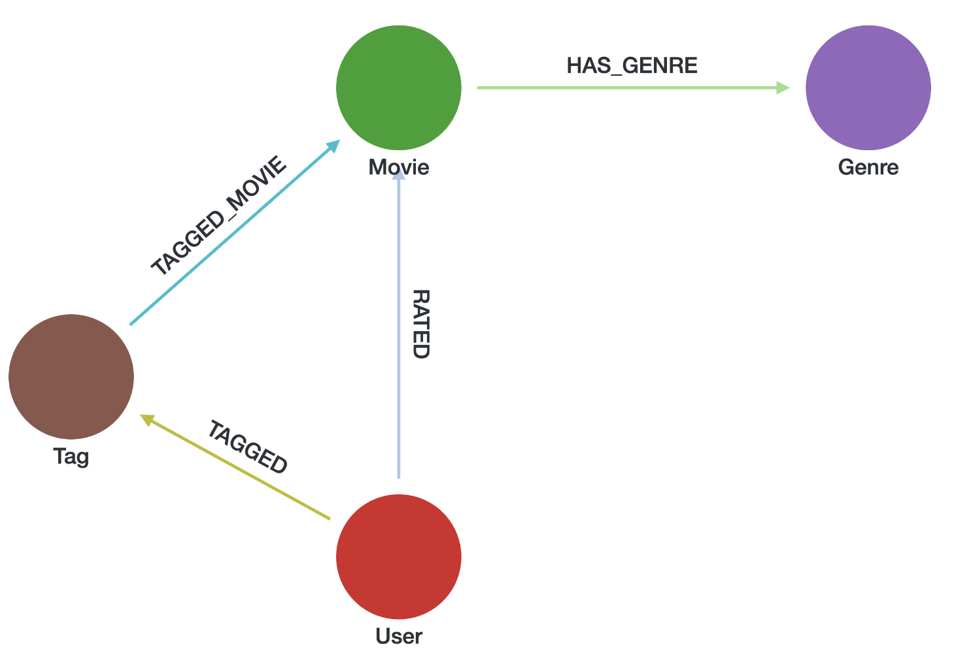
Copying Dataset Files into TigerGraph's Loading Directory (Docker)
To make the MovieLens Genome 2021 dataset available for loading via TigerGraph's GraphStudio, follow the steps below to copy the raw data files into the appropriate loading directory inside the Docker container.
Access the TigerGraph Docker container:
docker exec -it tigergraph bash
Copy all files from the raw folder into TigerGraph’s loading data directory:
cp -r ~/datasets/movielens/ml-32m/* /home/tigergraph/tigergraph/data/gui/loading_data/tigergraph/
This command copies all .json and .csv files from the raw dataset folder into the GraphStudio loading path, making them accessible for use in loading jobs and data mapping.

- Mapping of movie node (movies.csv)
Each movie in the dataset is defined by its unique movie_id and title.
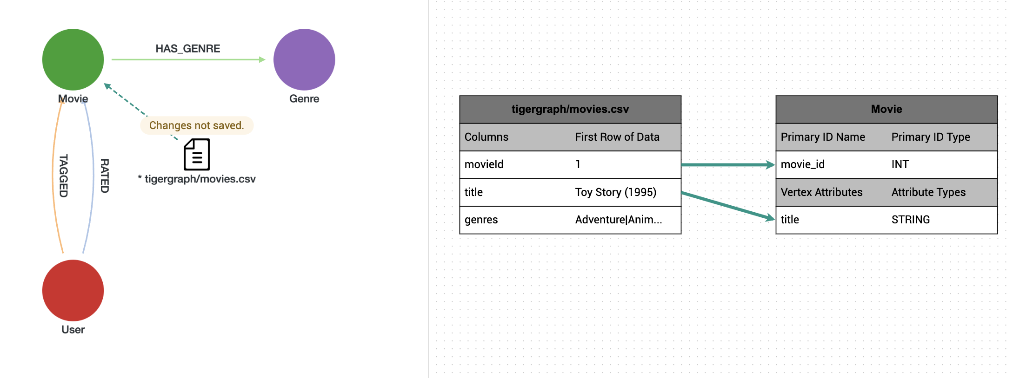
Movie Node

- Mapping of Genre Node and HAS_GENRE Edge
Genres were extracted from the genres column in movies.csv by splitting the pipe-delimited string into multiple rows. Each genre is stored as a separate vertex, and the association is stored as a HAS_GENRE edge.

from pyspark.sql.functions import col, explode, split, trim
# Step 1: Extract distinct genre names
genre_vertices_df = movies_df \
.filter(col("genres").isNotNull()) \
.withColumn("genre", explode(split(col("genres"), "\\|"))) \
.withColumn("genre", trim(col("genre"))) \
.filter((col("genre") != "") & col("genre").isNotNull()) \
.select("genre") \
.distinct()
# Save genre vertices to CSV (TigerGraph vertex file)
genre_vertices_df.coalesce(1).write.mode("overwrite") \
.option("header", True) \
.csv("file:///shared/datasets/movielens/ml-32m/genre_vertices.csv")
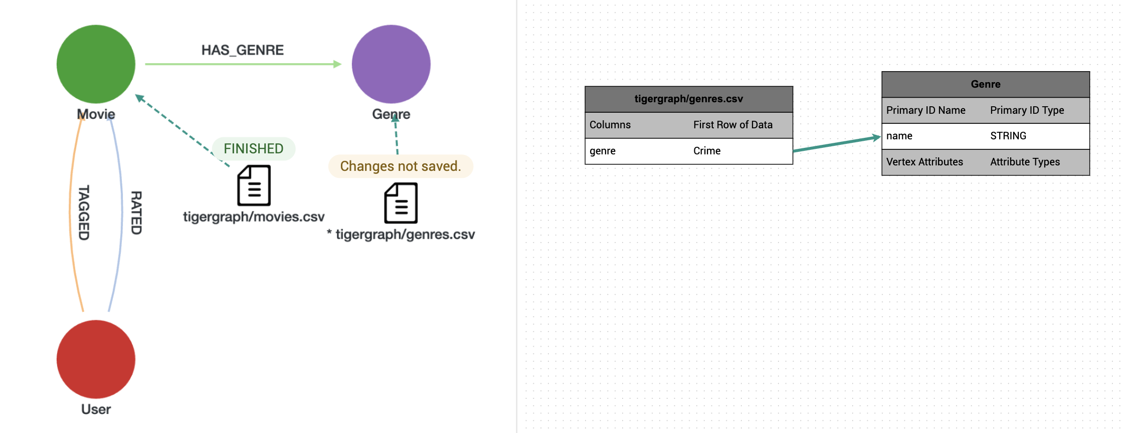
Genre Node

# Step 2: Extract HAS_GENRE edge pairs
has_genre_edges_df = movies_df \
.filter(col("genres").isNotNull() & col("movieId").isNotNull()) \
.withColumn("genre", explode(split(col("genres"), "\\|"))) \
.withColumn("genre", trim(col("genre"))) \
.filter((col("genre") != "") & col("genre").isNotNull()) \
.select(col("movieId").alias("src"), col("genre").alias("dst"))

# Save edges to CSV (TigerGraph edge file)
has_genre_edges_df.coalesce(1).write.mode("overwrite") \
.option("header", True) \
.csv("file:///shared/datasets/movielens/ml-32m/has_genre.csv")
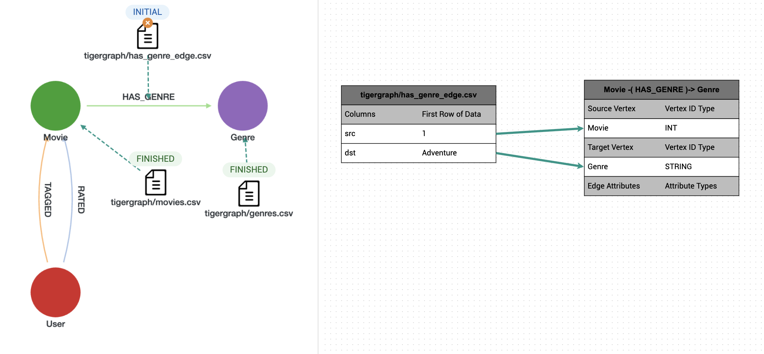
HAS_GENRE Edge

- Mapping of User Node + RATED Edge (ratings.csv)
The User vertex was created by extracting unique, non-null userIds from ratings.csv
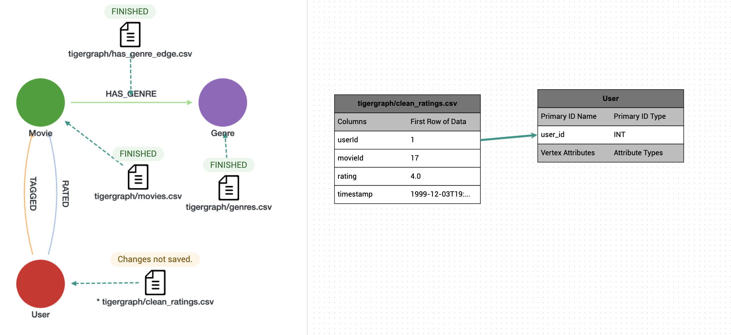
User Node
The RATED edge captures each user’s rating of a movie along with the associated timestamp, converted from UNIX format using the code below in pyspark.

# non null entries of ratings
from pyspark.sql.functions import to_timestamp
clean_ratings_df = ratings_df \
.filter(col("userId").isNotNull() & col("movieId").isNotNull() & col("rating").isNotNull()) \
.withColumn("userId", col("userId").cast("int")) \
.withColumn("movieId", col("movieId").cast("int")) \
.withColumn("rating", col("rating").cast("float")) \
.withColumn("timestamp", to_timestamp(col("timestamp").cast("long")))
clean_ratings_df.coalesce(1).write.mode("overwrite") \
.option("header", True) \
.csv("file:///shared/datasets/movielens/ml-32m/clean_ratings_df.csv")
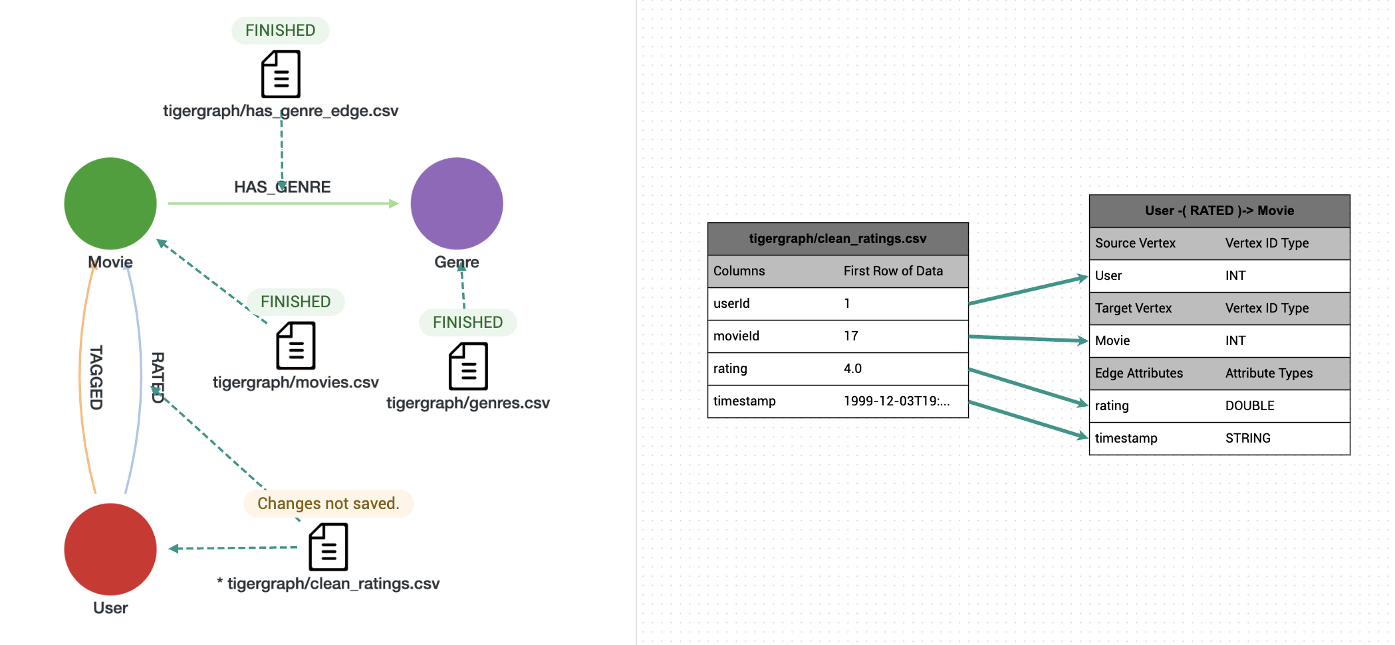
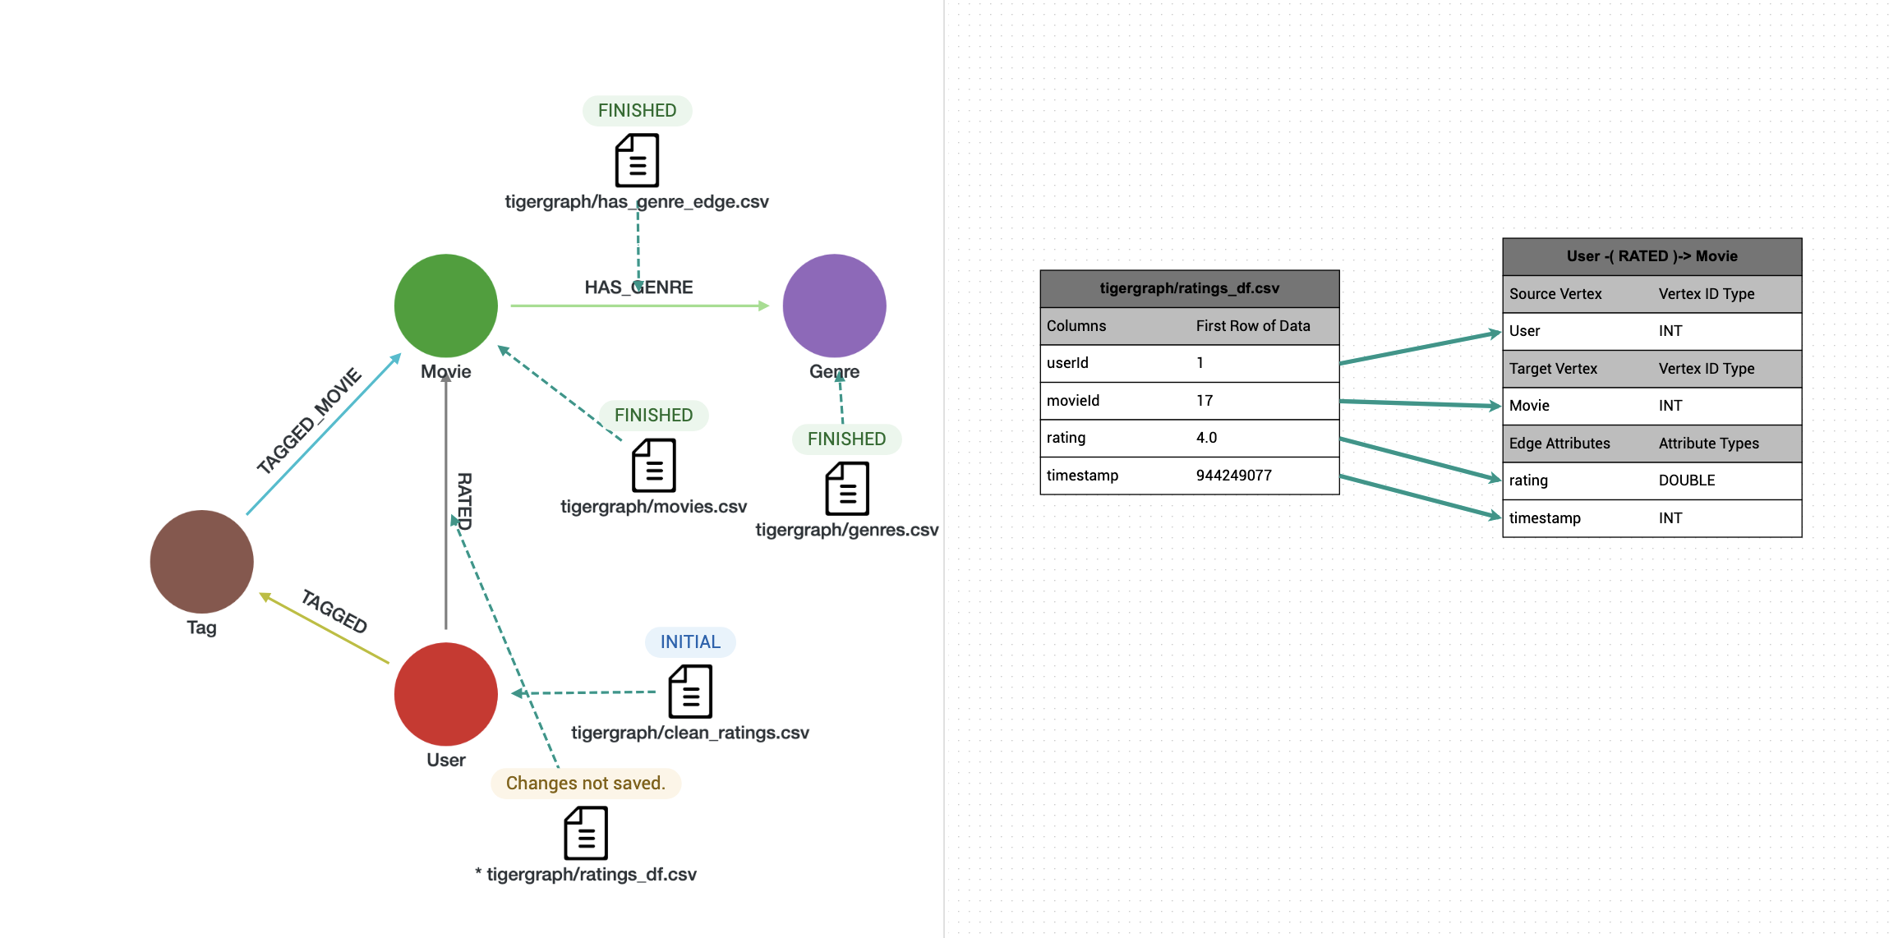
RATED Edge

- Mapping of Tag Vertex (tags.csv)
Each row in tags.csv contains a user’s textual tag for a movie. In Neo4j, this is modeled as a direct edge with tag attributes. However, TigerGraph does not allow multiple identical edges between the same (User → Movie) pair.
To preserve this semantics, we introduce a Tag vertex for each tagging event, containing the tag string and timestamp. A safe 32-bit tag_id is assigned using zipWithIndex().
To uniquely identify all the rows, we are adding a tag id for the existing tags.csv file using the below code in pyspark.

from pyspark.sql.functions import col, trim, to_timestamp
from pyspark.sql import Row
# Step 1: Filter out rows with missing userId/movieId/tag only
filtered_tags_df = tags_df \
.filter(col("userId").isNotNull() & col("movieId").isNotNull() & col("tag").isNotNull()) \
.filter(trim(col("tag")) != "") \
.withColumn("userId", col("userId").cast("int")) \
.withColumn("movieId", col("movieId").cast("int")) \
.withColumn("timestamp", to_timestamp(col("timestamp").cast("long")))

# Step 2: Assign safe 32-bit tag_id using zipWithIndex
rdd_with_index = filtered_tags_df.rdd.zipWithIndex()
clean_tags_df = rdd_with_index.map(lambda row: Row(**row[0].asDict(), tag_id=int(row[1]))).toDF()

# Step 3: Rearrange and write to CSV (null timestamps allowed)
clean_tags_df.select("userId", "movieId", "tag_id", "tag", "timestamp") \
.coalesce(1).write.mode("overwrite") \
.option("header", True) \
.csv("file:///shared/datasets/movielens/ml-32m/tags_with_id.csv")
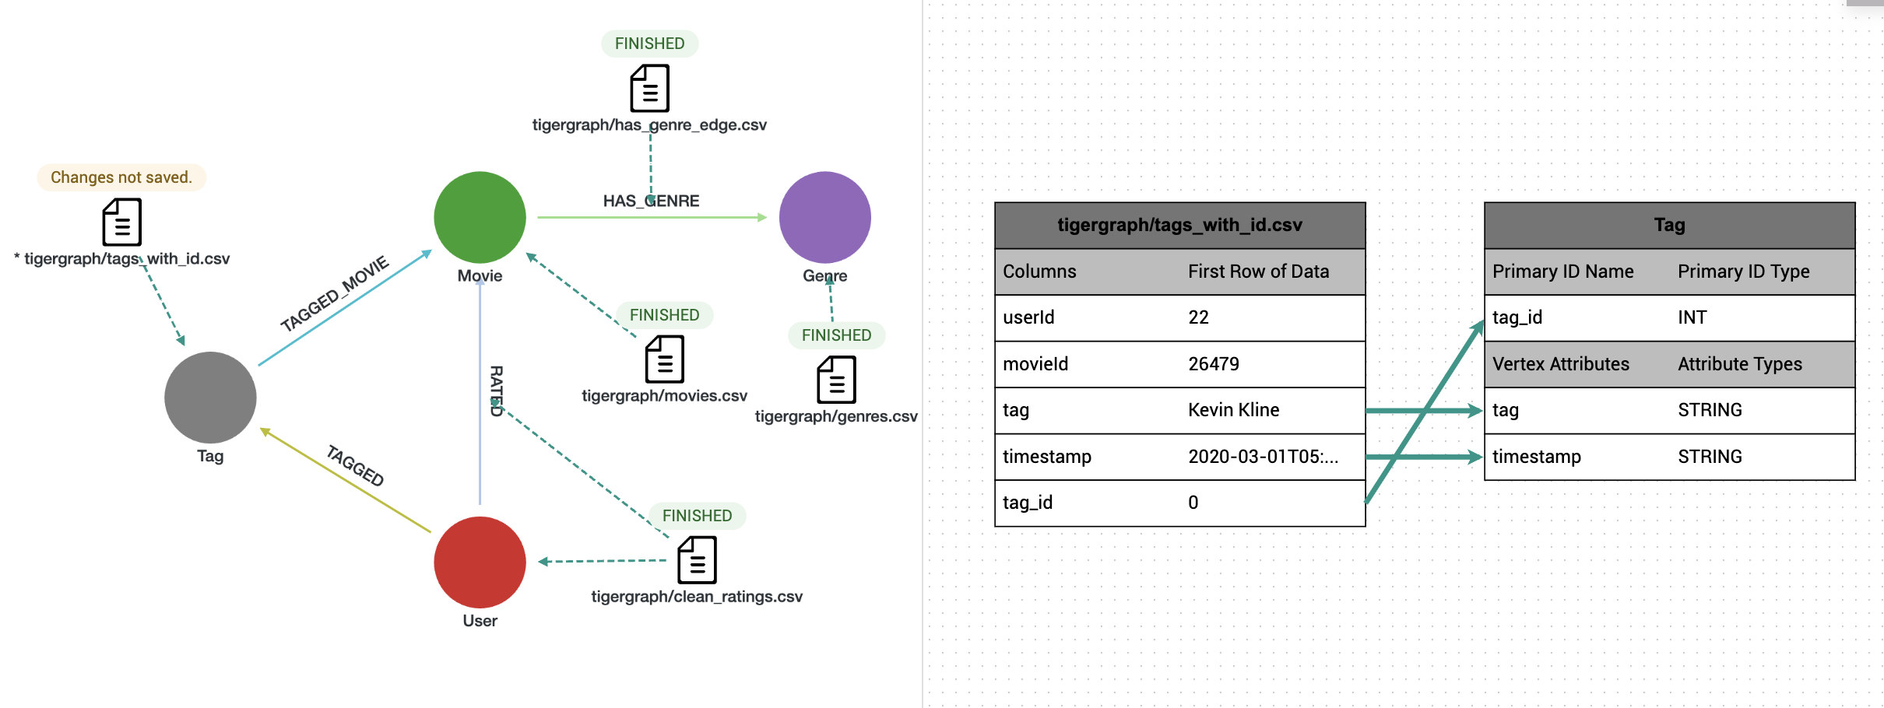
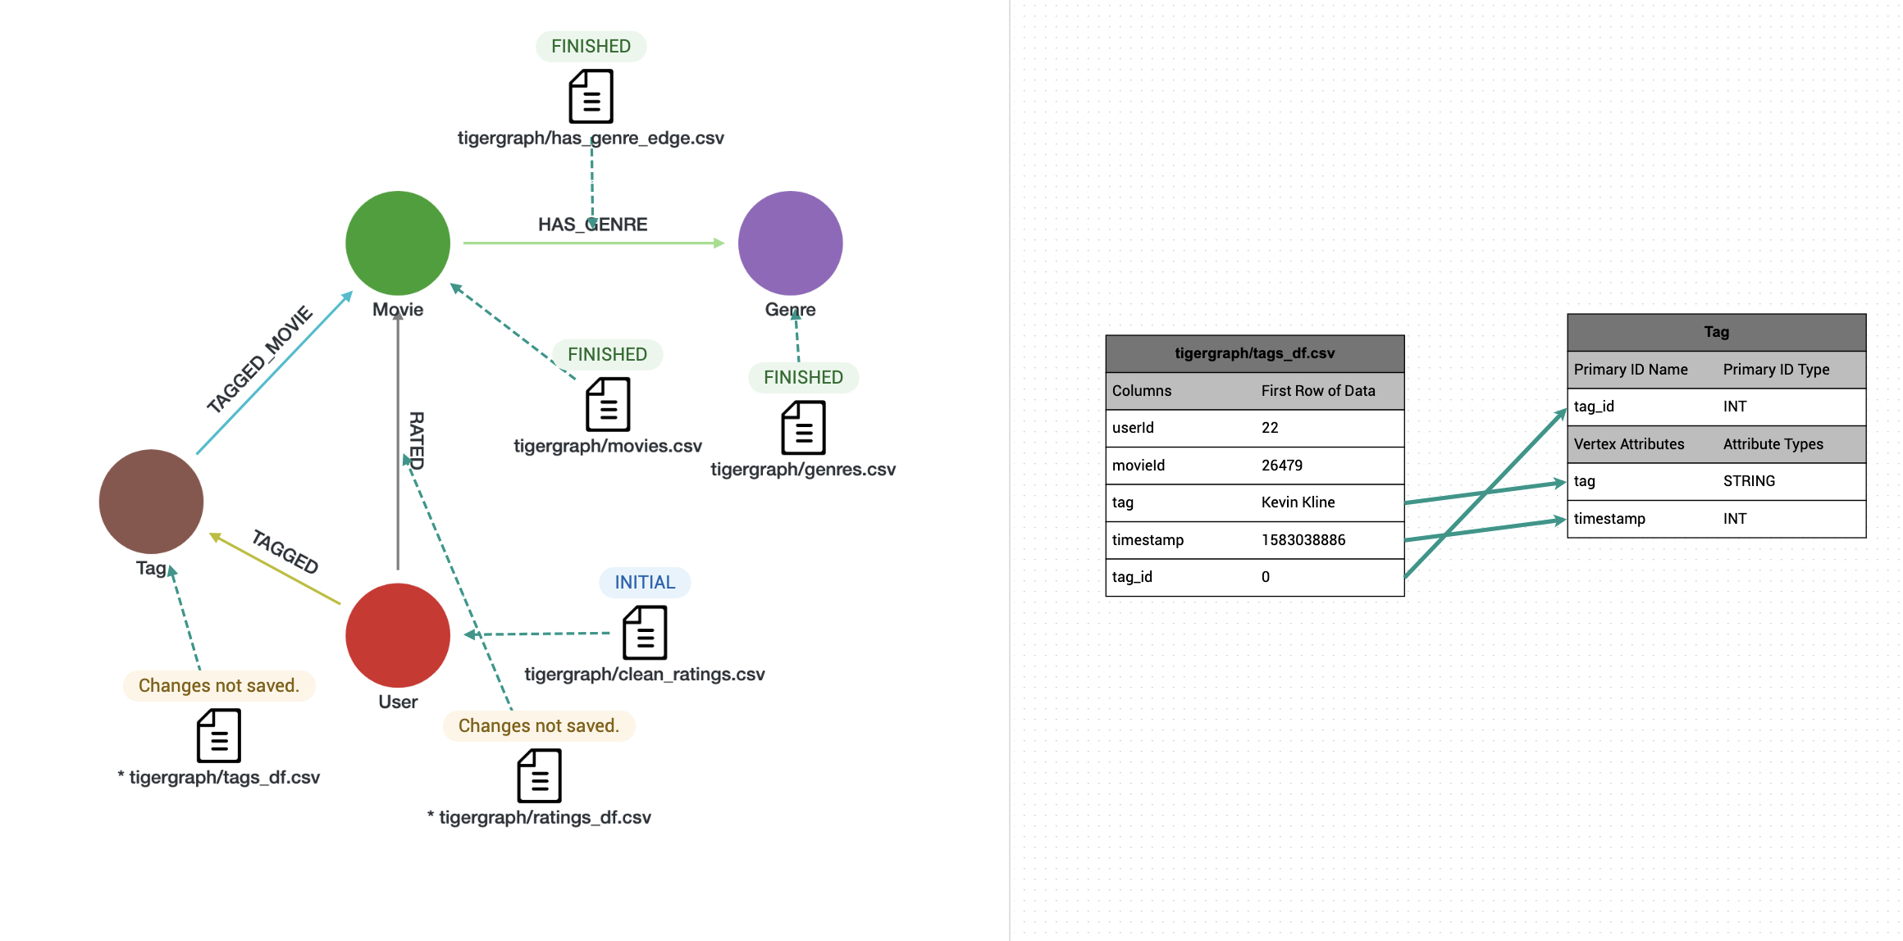
Tag Node

- Mapping of TAGGED and TAGGED_MOVIE Edges (tags_with_id.csv)
Two edges are derived from the cleaned tag data:
- TAGGED: connects a User to the Tag, indicating who created the tag.
- TAGGED_MOVIE: connects the Tag to the Movie, indicating what movie the tag refers to.
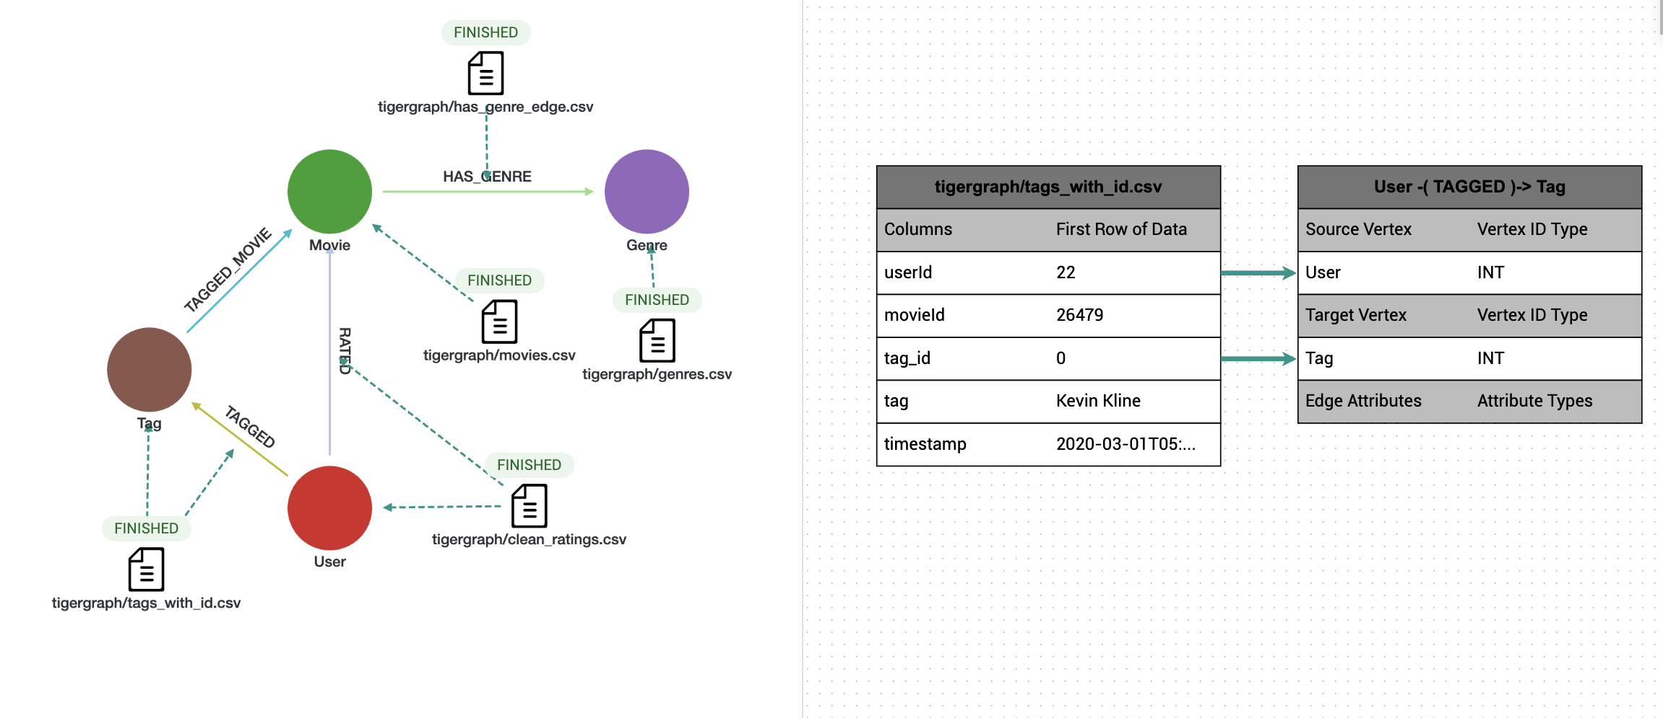
TAGGED Edge
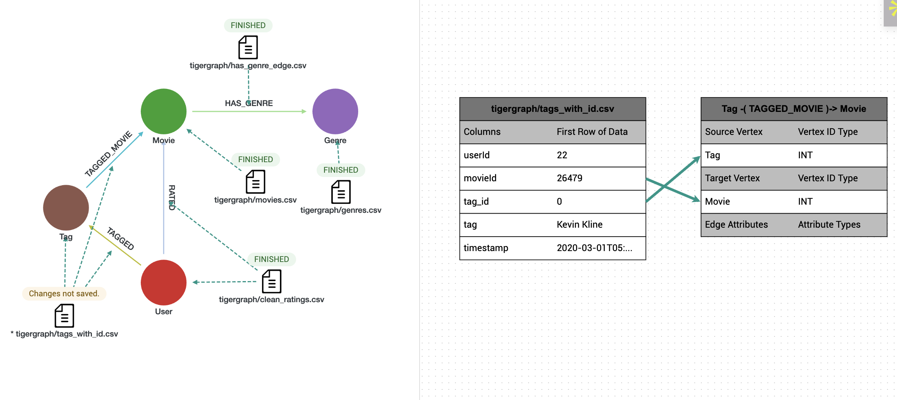
TAGGED_MOVIE Edge

Queries
Check different rating values and their occurrence frequencies
CREATE OR REPLACE QUERY query1() FOR GRAPH movielens_ml32m {
TYPEDEF TUPLE<FLOAT rating, INT frequency> RatingFreq;
MapAccum<FLOAT, INT> @@ratingCounts;
HeapAccum<RatingFreq>(100, rating ASC) @@sortedFrequencies;

Start = SELECT u FROM User:u -(RATED:r)-> Movie:m
ACCUM @@ratingCounts += (r.rating -> 1);

// Convert MapAccum to sorted HeapAccum
FOREACH (r_val, freq) IN @@ratingCounts DO
@@sortedFrequencies += RatingFreq(r_val, freq);
END;

PRINT @@sortedFrequencies AS RatingFrequencies;
}
List users and the movies they rated that belong to the specific genre "Comedy", find top-20 results in descending order of ratings:
CREATE QUERY query1() FOR GRAPH movielens_ml32m {
TYPEDEF TUPLE<INT user_id, STRING title, STRING genre, DOUBLE rating> ResultTuple; HeapAccum<ResultTuple>(20, rating DESC) @@results;
Start = {User.*};
Results = SELECT u FROM Start:u -(RATED>:r)- Movie:m -(HAS_GENRE>)- Genre:g WHERE g.name == "Comedy" ACCUM @@results += ResultTuple(u.user_id, m.title, g.name, r.rating);
PRINT @@results;
}
43610ms

Find the title of the movies that belong to multiple genres, e.g., "Comedy" and "Romance" and sort the movie names in descending order:
CREATE QUERY query1() FOR GRAPH movielens_ml32m {
TYPEDEF TUPLE<STRING title> ResultTuple;
HeapAccum<ResultTuple>(10, title DESC) @@results;
Start = {Movie.*};
// Find movies that have both Comedy and Romance genres
ComedyMovies = SELECT m FROM Start:m -(HAS_GENRE>)- Genre:g1
WHERE g1.name == "Comedy";
Results = SELECT m FROM ComedyMovies:m -(HAS_GENRE>)- Genre:g2
WHERE g2.name == "Romance"
ACCUM @@results += ResultTuple(m.title);
PRINT @@results;
}
Find users who have rated movies in both "Action" and "Romance" genres, list 10 userIds:
CREATE OR REPLACE QUERY query1(INT limit_n = 10) FOR GRAPH movielens_ml32m {
TYPEDEF TUPLE<INT userId> UserTuple;

OrAccum @hasAction = false;
OrAccum @hasRomance = false;
HeapAccum<UserTuple>(limit_n, userId ASC) @@topUsers;

// Step 1: Traverse User -> Movie -> Genre and mark flags
UsersGenreFlagged = SELECT u
FROM User:u -(RATED>)- Movie:m -(HAS_GENRE>)- Genre:g
ACCUM
CASE
WHEN g.name == "Action" THEN
u.@hasAction = true
WHEN g.name == "Romance" THEN
u.@hasRomance = true
END;

// Step 2: Collect users who rated both Action and Romance
Filtered = SELECT u
FROM UsersGenreFlagged:u
WHERE u.@hasAction AND u.@hasRomance
ACCUM @@topUsers += UserTuple(u.user_id);

PRINT @@topUsers AS UsersRatedBothGenres;
}
10894ms
Find users who have rated movies from at least 3 distinct genres, list the top-10 in descending order of the genre count.
CREATE OR REPLACE QUERY query1(INT limit_n = 10) FOR GRAPH movielens_ml32m {

TYPEDEF TUPLE<INT userId, INT genreCount> UserGenreCount;
HeapAccum<UserGenreCount>(limit_n, genreCount DESC) @@topUsers;

MapAccum<STRING, BOOL> @userGenres;

// Step 1: For each user, collect distinct genres from rated movies
RatedGenres = SELECT u
FROM User:u -(RATED>)- Movie:m -(HAS_GENRE>)- Genre:g
ACCUM
u.@userGenres += (g.name -> true);

// Step 2: Only keep users with at least 3 unique genres and add to heap
Final = SELECT u
FROM RatedGenres:u
WHERE u.@userGenres.size() >= 3
ACCUM @@topUsers += UserGenreCount(u.user_id, u.@userGenres.size());

PRINT @@topUsers AS TopUsersByGenreCount;
}
35067ms
Find users who have rated movies from at least 3 distinct genres, list 10 such users along with the corresponding list of genres in descending order of genre count.
CREATE QUERY query2() FOR GRAPH movielens_ml32m {

TYPEDEF TUPLE<INT userId, INT genreCount> ResultTuple;
HeapAccum<ResultTuple>(10, genreCount DESC) @@results;
SetAccum<STRING> @genres;

Start = {User.*};

// Collect distinct genres for each user
Users = SELECT u FROM Start:u -(RATED>)- Movie:m -(HAS_GENRE>)- Genre:g
ACCUM u.@genres += g.name
POST-ACCUM
IF u.@genres.size() >= 3 THEN
@@results += ResultTuple(u.user_id, u.@genres.size())
END;

// Print individual genre details for top users
TopUsers = SELECT u FROM Start:u
WHERE u.@genres.size() >= 3
ORDER BY u.@genres.size() DESC
LIMIT 10;

PRINT TopUsers[TopUsers.user_id, TopUsers.@genres];
}
20728ms
Find movies that span at least 3 genres and have at least 50 user ratings, return top-10 movies in descending order of their rating count, along with the list of genres and the rating count.
CREATE OR REPLACE QUERY query1() FOR GRAPH movielens_ml32m {
// 1. Result structure
TYPEDEF TUPLE<STRING title, STRING genres_str, INT ratingCount> MovieResult;
HeapAccum<MovieResult>(10, ratingCount DESC) @@topMovies;

// 2. Movie-side accumulators
SetAccum<STRING> @genreSet;
SumAccum<INT> @ratingCount;

// 3. Global rating counter (for distributed counting)
MapAccum<VERTEX<Movie>, SumAccum<INT>> @@movieRatings;

// ===== PHASE 1: Collect genres =====
GenreStep = SELECT m
FROM Movie:m -(HAS_GENRE>)- Genre:g
ACCUM m.@genreSet += g.name;

// ===== PHASE 2: Count ratings via USER traversal =====
Users = SELECT u
FROM User:u -(RATED>)- Movie:m
WHERE m.@genreSet.size() > 0 // Only movies with genres
ACCUM
@@movieRatings += (m -> 1); // Map-based counting

// ===== PHASE 3: Transfer counts to movies =====
MoviesWithRatings = SELECT m
FROM GenreStep:m
POST-ACCUM
m.@ratingCount = @@movieRatings.get(m);

// ===== PHASE 4: Filter and format results =====
Final = SELECT m
FROM MoviesWithRatings:m
WHERE m.@genreSet.size() >= 3
AND m.@ratingCount >= 50
POST-ACCUM
STRING genre_str = "",
FOREACH g IN m.@genreSet DO
genre_str = genre_str + g + "|"
END,
@@topMovies += MovieResult(m.title, genre_str, m.@ratingCount);

PRINT @@topMovies AS TopMultiGenreMovies;
}
Find (user, movie) pairs where the movie is first rated by the user, and then tagged by the user, return 10 such user-movie pairs with the latest timestamps, along with the rating and the list of tags (tagged after the rating).

CREATE OR REPLACE QUERY query2() FOR GRAPH movielens_ml32m SYNTAX V2 {

// compact tuple for top-10; no strings built in POST-ACCUM
TYPEDEF TUPLE<
INT userId,
STRING movieTitle,
DOUBLE rating,
INT ratingTimestamp,
INT latestTagTimestamp,
INT tagCount
> Pair;

// top 10 by rating timestamp (most recent ratings first)
HeapAccum<Pair>(10, ratingTimestamp DESC) @@top;

// users who have both rated and tagged something
CandidateUsers =
SELECT u
FROM User:u
WHERE u.outdegree("RATED") > 0 AND u.outdegree("TAGGED") > 0;

// per-user accumulators keyed by Movie
MapAccum<VERTEX<Movie>, DOUBLE> @movieRating; // rating value
MapAccum<VERTEX<Movie>, INT> @movieRatingTime; // rating timestamp (INT)
MapAccum<VERTEX<Movie>, SetAccum<STRING>> @movieTags; // unique tags after rating
MapAccum<VERTEX<Movie>, INT> @movieTagCount; // count of unique tags
MapAccum<VERTEX<Movie>, INT> @movieLatestTagTime; // latest tag time

// collect ratings
Rated =
SELECT m
FROM CandidateUsers:u-(RATED>:r)-Movie:m
ACCUM
u.@movieRating += (m -> r.rating),
u.@movieRatingTime += (m -> r.timestamp);

// collect tags that happened AFTER the rating (tag time is on Tag vertex)
Tagged =
SELECT m
FROM CandidateUsers:u-(TAGGED>:te)-Tag:tg-(TAGGED_MOVIE>:e)-Movie:m
WHERE u.@movieRatingTime.containsKey(m)
AND tg.timestamp > u.@movieRatingTime.get(m)
ACCUM
// add unique tag
IF NOT u.@movieTags.containsKey(m) OR NOT u.@movieTags.get(m).contains(tg.tag) THEN
u.@movieTags += (m -> tg.tag),
u.@movieTagCount += (m -> u.@movieTagCount.get(m) + 1)
END,
// track latest tag time
IF tg.timestamp > u.@movieLatestTagTime.get(m) THEN
u.@movieLatestTagTime += (m -> tg.timestamp)
END;

// push top-10 pairs
Result =
SELECT u
FROM CandidateUsers:u
POST-ACCUM
FOREACH (m, rVal) IN u.@movieRating DO
IF u.@movieTagCount.get(m) > 0 THEN
@@top += Pair(u.user_id, m.title, rVal, u.@movieRatingTime.get(m), u.@movieLatestTagTime.get(m), u.@movieTagCount.get(m))
END
END;

PRINT @@top AS UserMoviePairs;
}

Find the top-50 most frequent tags, return the tags along with their frequencies.
CREATE OR REPLACE QUERY query2() FOR GRAPH movielens_ml32m SYNTAX V2 {

TYPEDEF TUPLE<STRING tag, INT frequency> TagFreq;
MapAccum<STRING, INT> @@tagCounts;
HeapAccum<TagFreq>(50, frequency DESC) @@topTags;

Start = {User.*};

// Count tags that actually attach to a movie
S1 = SELECT t
FROM Start:u -(TAGGED>:e1)- Tag:t -(TAGGED_MOVIE>:e2)- Movie:m
ACCUM
// If you want to ignore empty strings, uncomment next line and remove the one after.
// IF t.tag != "" THEN @@tagCounts += (t.tag -> 1) END
@@tagCounts += (t.tag -> 1);

// Map -> sorted heap (top 50 by frequency desc)
FOREACH (k, v) IN @@tagCounts DO
@@topTags += TagFreq(k, v);
END;

PRINT @@topTags AS Top50Tags;
}
Find top-20 movies with the highest number of genres + tags, return this number, list of their genres, and list of their tags
CREATE OR REPLACE QUERY query2()
FOR GRAPH movielens_ml32m SYNTAX V2 {

// Distinct collectors per movie (like COLLECT(DISTINCT ...))
SetAccum<STRING> @genres;
SetAccum<STRING> @tags;

// 1) Collect genres per movie (Movie -> Genre)
G = SELECT m
FROM Movie:m -(HAS_GENRE>)- Genre:g
ACCUM m.@genres += g.name;

// 2) Collect tags per movie via Tag -> Movie (forward direction)
T = SELECT m
FROM Tag:t -(TAGGED_MOVIE>)- Movie:m
ACCUM m.@tags += t.tag;

// 3) Order by combined size and keep top 20
Top = SELECT m
FROM Movie:m
ORDER BY (m.@genres.size() + m.@tags.size()) DESC
LIMIT 20;

// 4) Print: title, total, genres set, tags set
PRINT Top[
Top.title,
(Top.@genres.size() + Top.@tags.size()),
Top.@genres,
Top.@tags
];
}

Find top-20 movies with the highest number of 5-ratings, return the movies and this rating number.
CREATE OR REPLACE QUERY query2()
FOR GRAPH movielens_ml32m SYNTAX V1 {

SumAccum<INT> @fiveStarCount;
FLOAT epsilon = 0.0001;

Rated = SELECT m
FROM User:u -(RATED:r)-> Movie:m
WHERE abs(r.rating - 5.0) < epsilon
ACCUM m.@fiveStarCount += 1;

Top = SELECT m
FROM Rated:m
ORDER BY m.@fiveStarCount DESC
LIMIT 20;

PRINT Top[Top.title AS movieTitle, Top.@fiveStarCount AS fiveStarCount];
}

