Puppy Graph

Step 1: Create Business, User and Review nodes
We are building a graph to link users, their reviews, and businesses based on data extracted from Hive
BUSINESS NODE
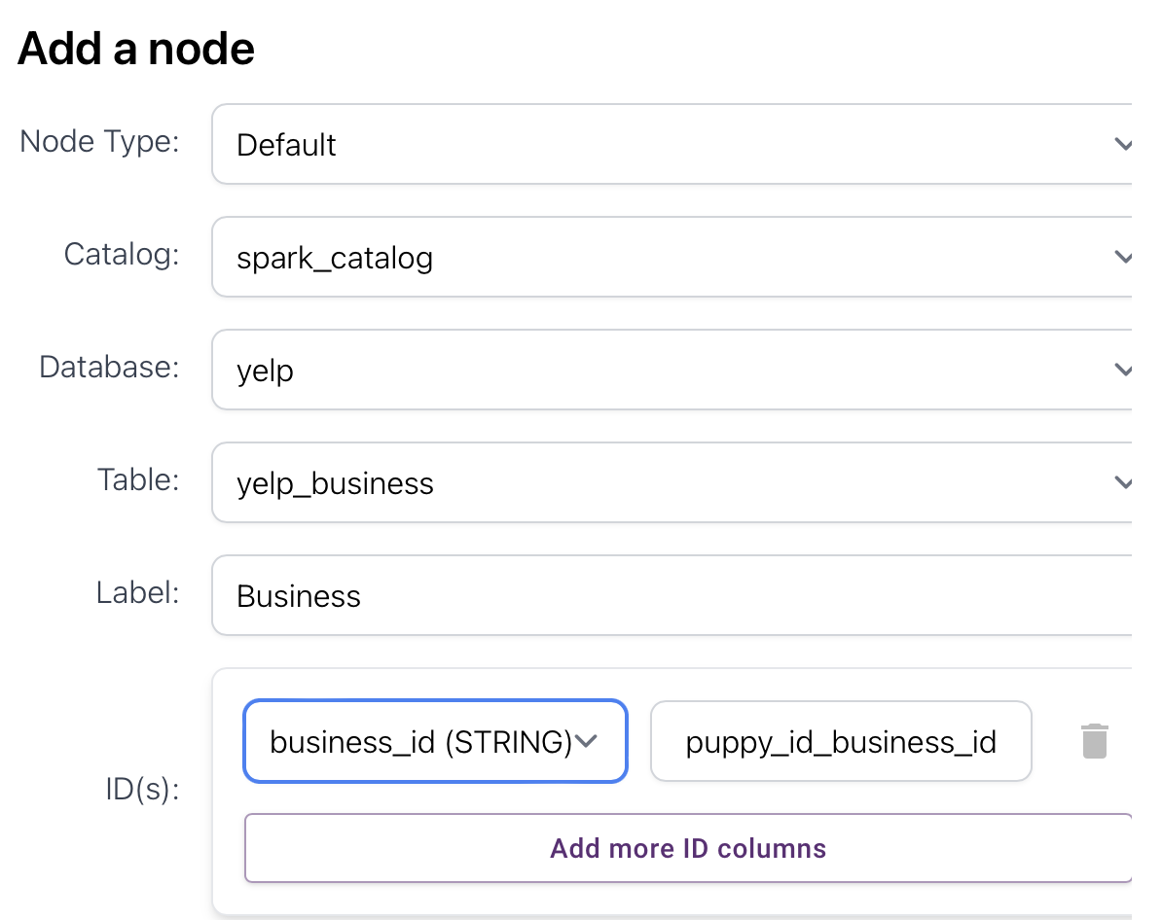
The attributes are:
ID: business_id
address, attributes, business_id, categories, city, hours, is_open, latitude, longitude, name, postal_code, review_count, stars, state
USER NODE
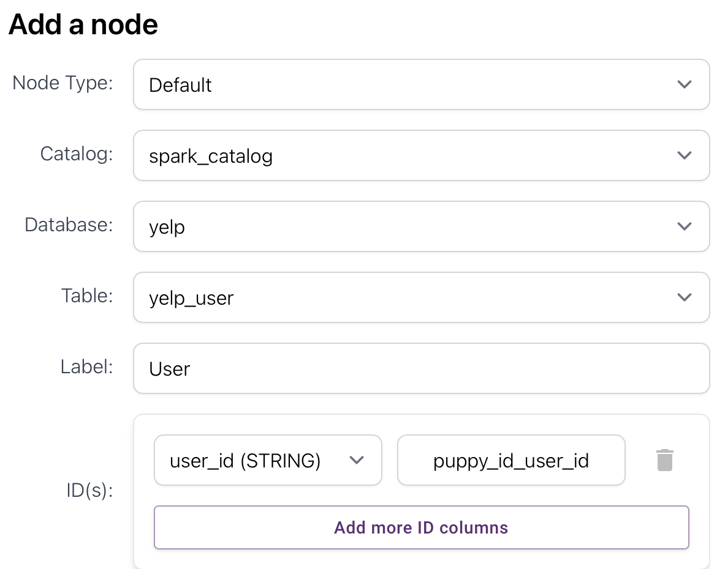
ID: user_id
average_stars, compliment_cool, compliment_cute, compliment_funny, compliment_hot, compliment_list, compliment_more, compliment_note, compliment_photos, compliment_plain, compliment_profile, compliment_writer, cool, elite, fans, friends, funny, name, review_count, useful, user_id, yelping_since
REVIEW NODE
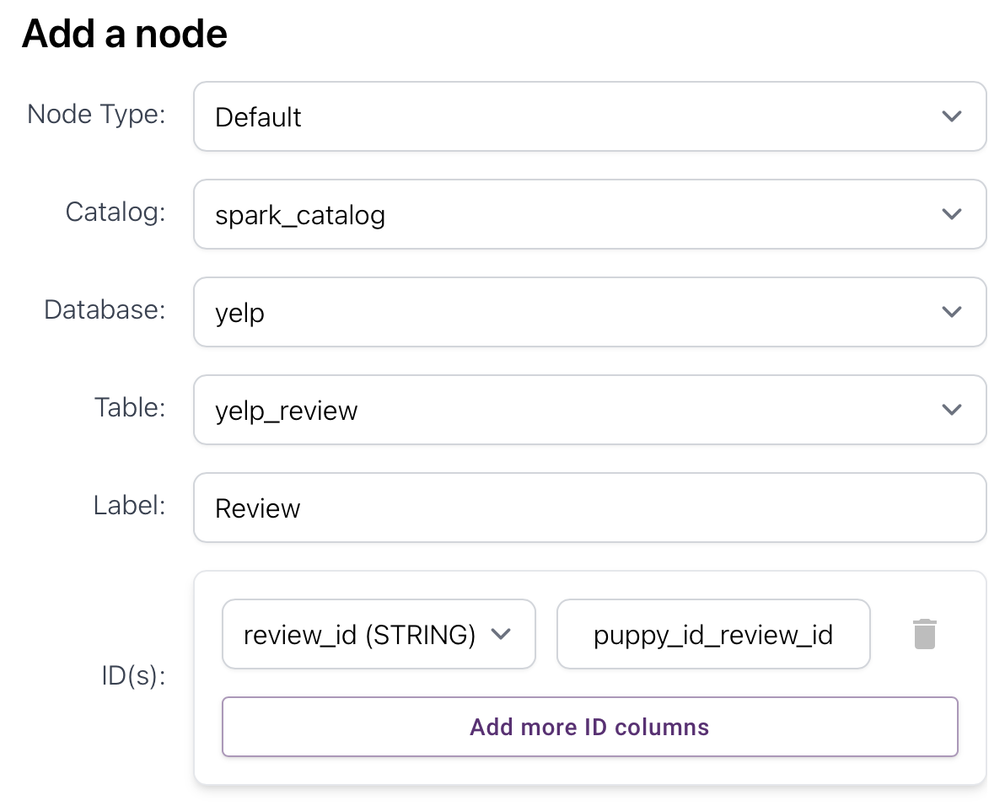
The attributes are:
ID: review_id
business_id, cool, date, funny, review_id, stars, text, useful, user_id
Step 2: Create “review” related edges
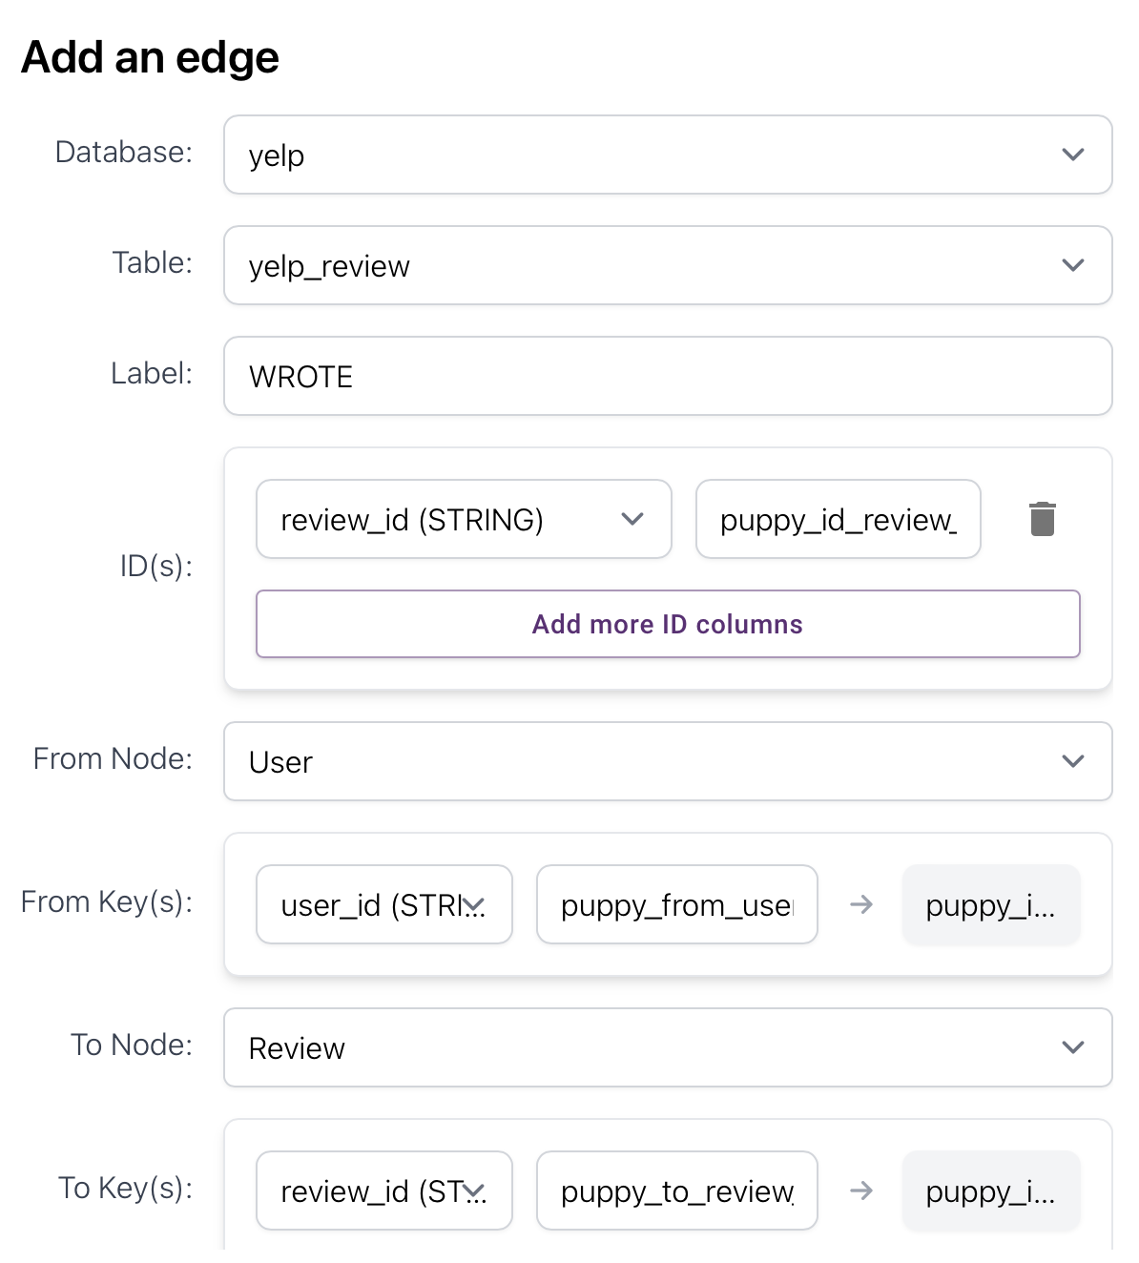
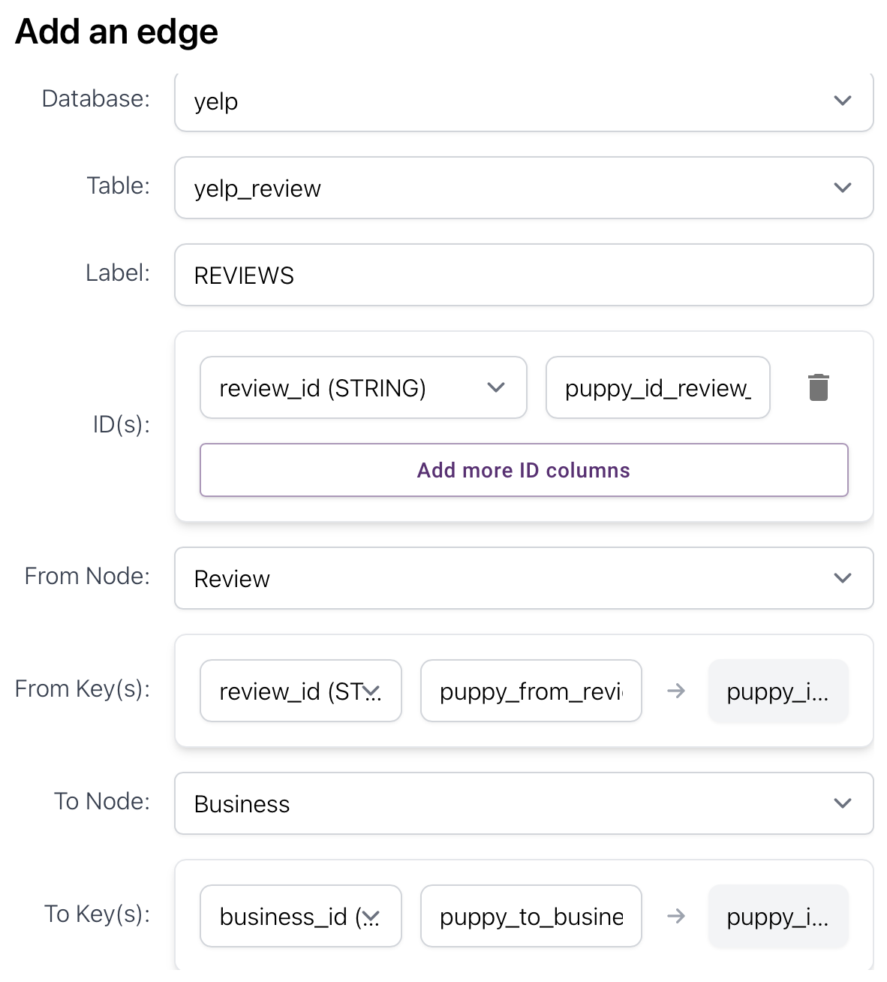
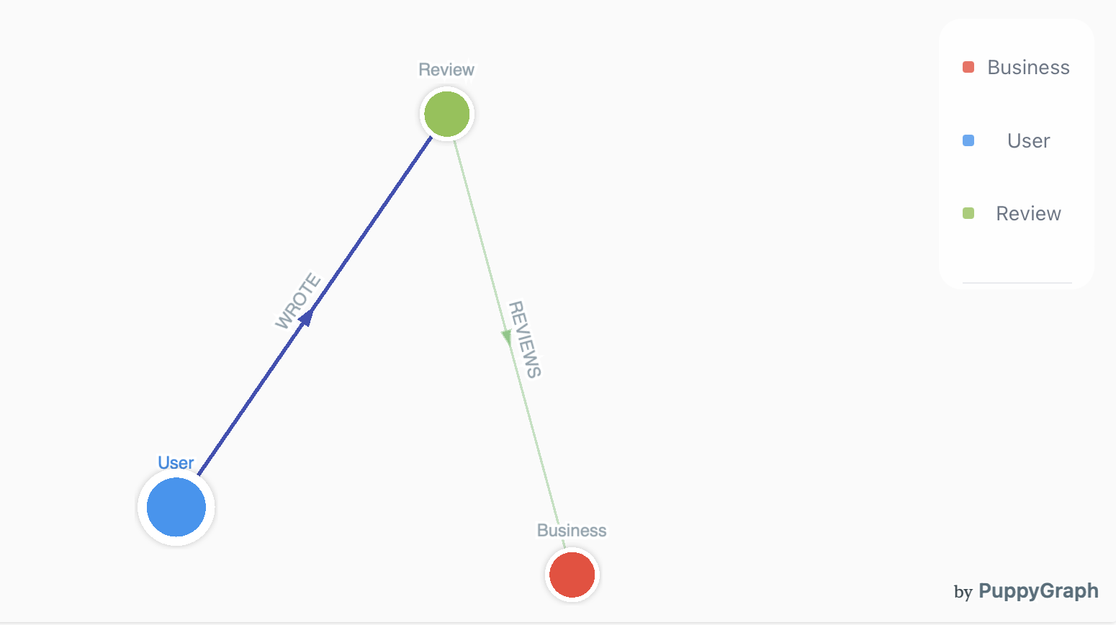
Step3: Create “tip” related edges
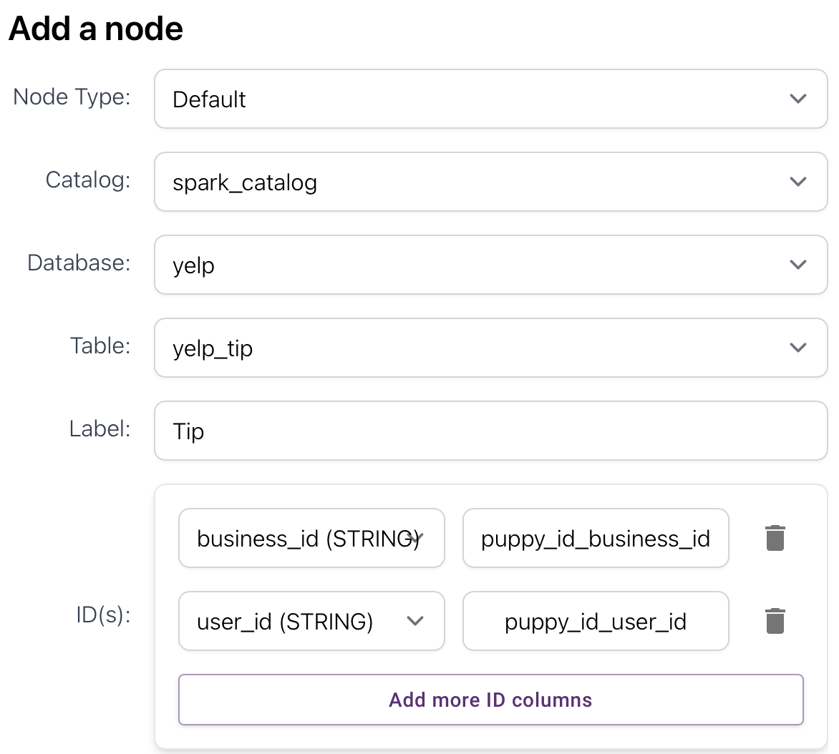
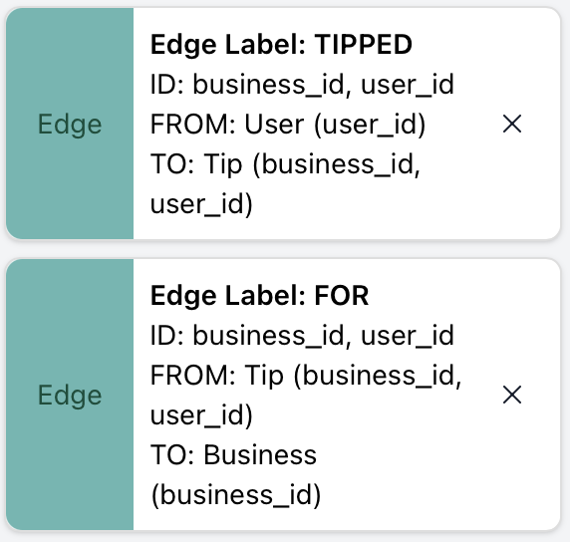
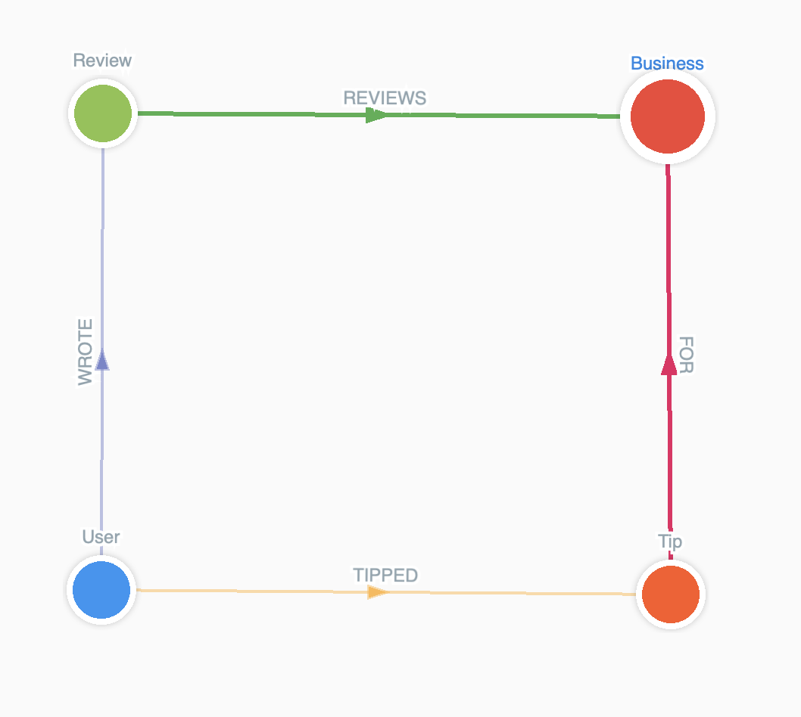
MATCH (b:Business)
RETURN count(DISTINCT b.city) AS num_cities;
This returns 1416 rows
MATCH (b:Business)
RETURN b.city, count(*) AS businesses_in_city
ORDER BY businesses_in_city DESC;
MATCH (b:Business)
WHERE b.city = "Philadelphia"
RETURN b.name, b.address, b.rating, b.review_count
ORDER BY b.rating DESC, b.review_count DESC
Categories make sense since it is a one-to-many relationship for business-categories.
In the Yelp academic dataset, the categories field is embedded as a comma-separated string inside each Business JSON object.
Unlike other relationships such as WROTE, REVIEWS, and TIPPED which were explicitly structured (one record per relationship), the Business to Category relationship is embedded inside a single text field and not normalized.
PuppyGraph requires nodes and edges to be sourced from structured tables. Therefore, to properly model Businesses and Categories, we had to pre-process the data to create:
- A table for Category nodes
- A table for IN_CATEGORY edges connecting Businesses to Categories

The goal was to extract and normalize the embedded category information into two clean tables:
- A Category node table (yelp_category) containing distinct categories.
- An IN_CATEGORY edge table (yelp_in_category_edges) mapping each Business to its associated Categories.
This was necessary to build a clean and queryable graph inside PuppyGraph, similar to the structures already created for Users, Reviews, and Tips.

We used PySpark to process the raw Business data, split the category strings, and save the required tables into Hive Metastore, from where PuppyGraph could access them.

Load the Business Data
We first loaded the Business JSON file into a Spark DataFrame.
from pyspark.sql import SparkSession

spark = SparkSession.builder \
.appName('yelp') \
.config("spark.executor.memory", "4g") \
.config("spark.driver.memory", "4g") \
.config("spark.executor.instances", "4") \
.getOrCreate()

business_df = spark.read.json("hdfs://master:9000/yelp/yelp_academic_dataset_business.json")

Explode the Categories Field
We exploded the categories string into individual rows so that each Business-Category pair could be represented separately.
from pyspark.sql.functions import split, explode, trim, col

exploded = business_df.filter(col("categories").isNotNull()) \
.withColumn("category", explode(split("categories", ","))) \
.withColumn("category", trim(col("category")))

Create the Category Nodes Table
We selected unique categories to create the yelp_category table, which would serve as the source of Category nodes in PuppyGraph.
from pyspark.sql.functions import lit

category_vertices = exploded \
.select("category") \
.distinct() \
.withColumnRenamed("category", "id")

category_vertices.write.format("delta").mode("overwrite").saveAsTable("yelp.yelp_category")
- Each record has a single field id, representing the category name.

Create the IN_CATEGORY Edges Table
We created a separate table linking each Business to each of its Categories.
in_category_edges = exploded.select(
col("business_id").alias("src"),
col("category").alias("dst")
)

in_category_edges.write.format("delta").mode("overwrite").saveAsTable("yelp.yelp_in_category_edges")
- src field contains the business_id.
- dst field contains the corresponding exploded and trimmed category name.
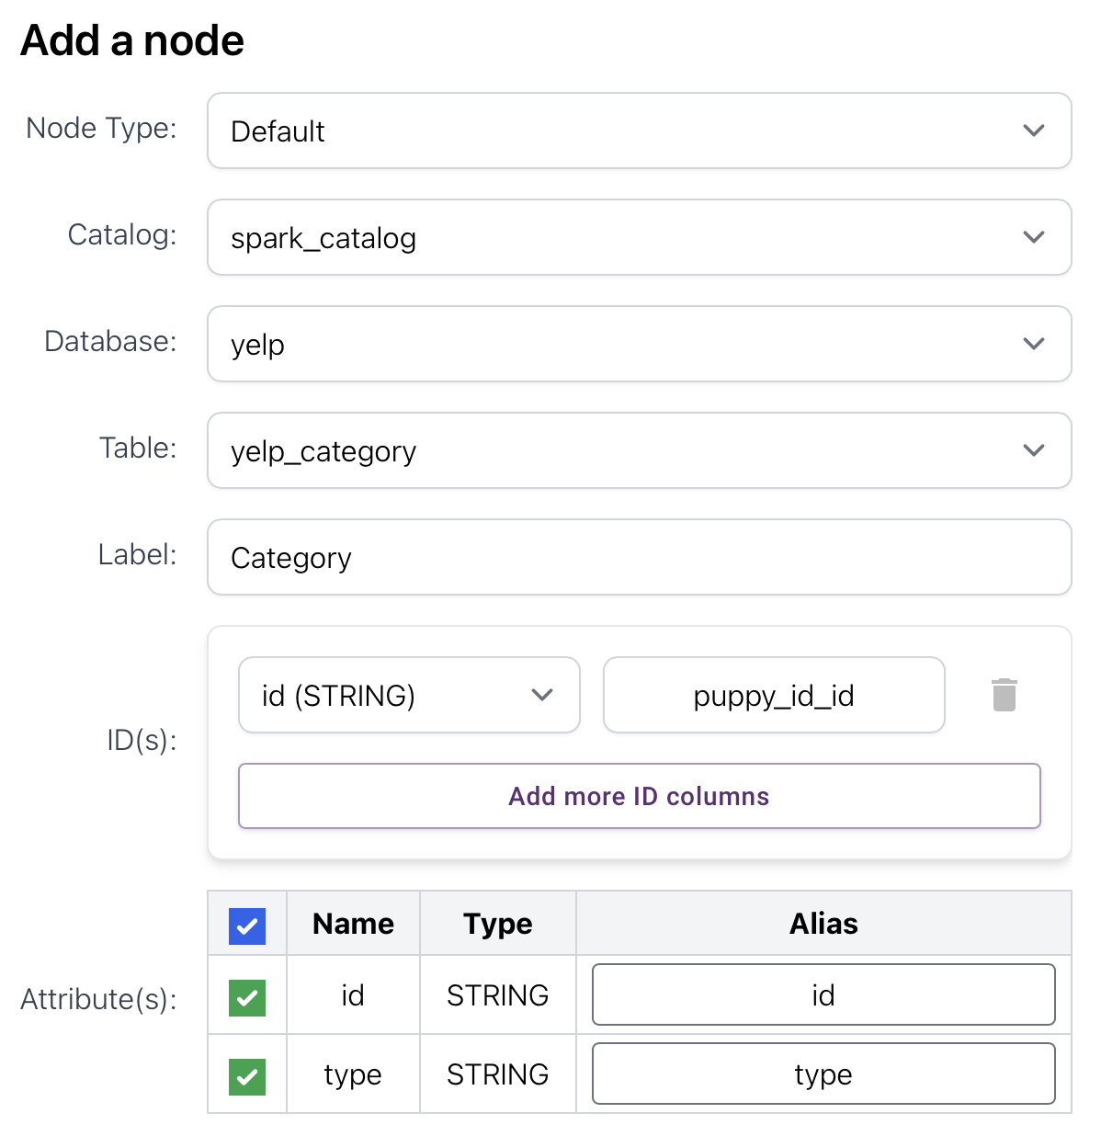
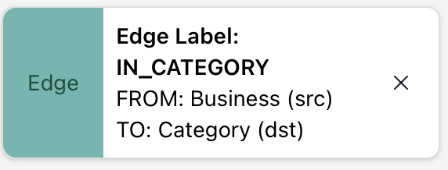

Friend-edges:
In the Yelp dataset, each User's friends field contains a comma-separated list of other user IDs representing their friendships.
To correctly model these User-to-User relationships in PuppyGraph,
the friends field needed to be exploded into a proper edge table format, ensuring only valid existing users were connected.
Unlike Business ➔ Category mapping (where different types of nodes were involved),
friendship connects Users to Users, both source and destination nodes are of the same type.
Thus:
- Only a clean edge table linking user_id to friend_id needed to be created.
- It was necessary to filter to keep only valid existing friends.

The following steps were performed in Spark:

Explode the Friends Field
from pyspark.sql.functions import split, explode, col, trim, lit

friend_edges = user_df \
.filter(col("friends").isNotNull()) \
.withColumn("friend_id", explode(split(col("friends"), ", "))) \
.withColumn("friend_id", trim(col("friend_id"))) \
.selectExpr("user_id as src", "friend_id as dst") \
.withColumn("relationship", lit("friend"))
- Each friends list was exploded into multiple rows.
- Each row now represents a User ➔ Friend mapping.

Filter Only Valid Friendships
existing_users = user_df.select("user_id").distinct()

friend_edges_filtered = friend_edges.join(
existing_users,
friend_edges.dst == existing_users.user_id,
"inner"
).select(friend_edges.src, friend_edges.dst)
- The exploded friends were joined with the list of existing users.
- Only friendships where the friend_id actually exists in the dataset were kept.

Save the Final Friend Edges Table
friend_edges_filtered.write.format("delta").mode("overwrite").saveAsTable("yelp.yelp_friend_edges")
- A new table yelp_friend_edges was created.
- Columns: src (user_id), dst (friend_id).
- The relationship column was not saved, as PuppyGraph mainly requires src and dst for edge creation.

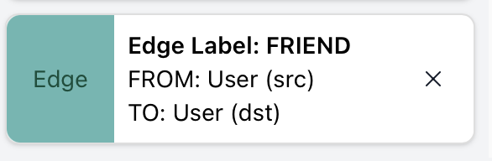
Queries
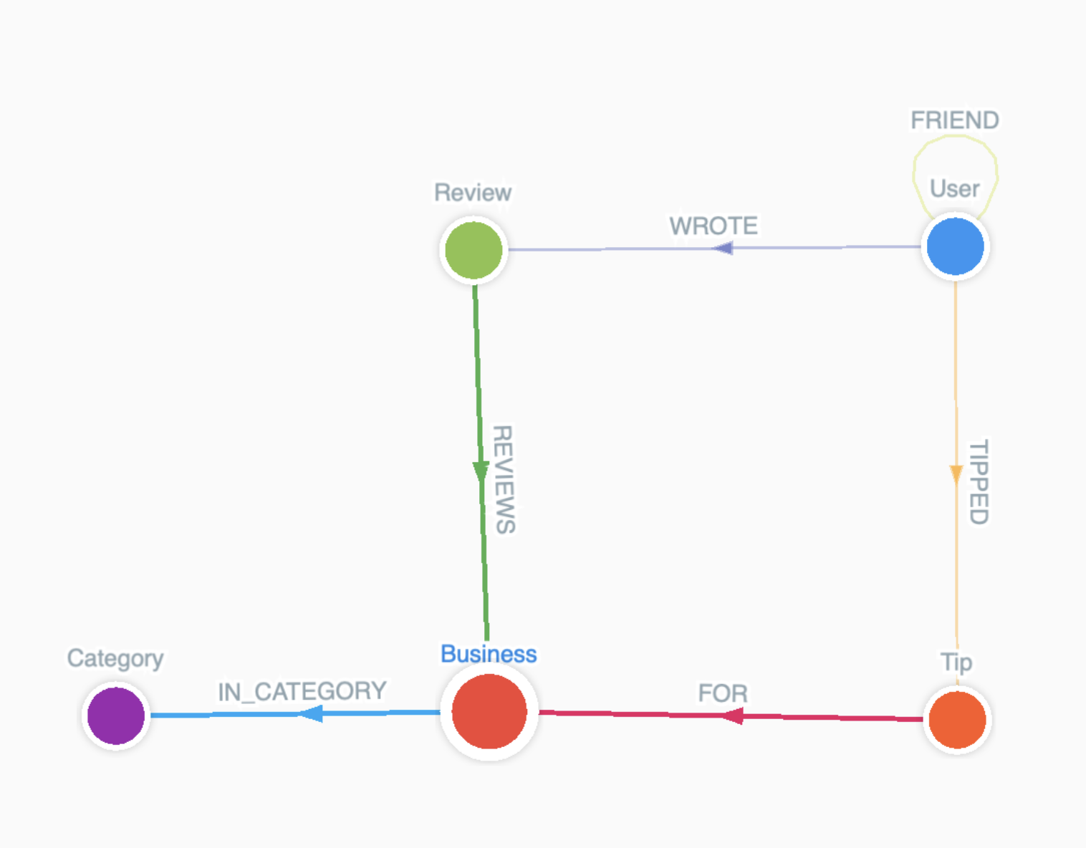
====== FRIEND ======
Find the most frequent names:
MATCH (u:User)
RETURN u.name AS name, count(*) AS occurrences
ORDER BY occurrences DESC
LIMIT 30
------> most frequent name is John, appearing 18719 times, followed by Michael, 16645 times

Find the friends of all “John”s:
MATCH (:User {name: "John"})-[:FRIEND]->(friend)
RETURN friend.name, friend.user_id
LIMIT 20
Count the friends of all “John”s:
MATCH (:User {name: "John"})-[:FRIEND]->(friend)
RETURN count(friend) AS total_friends
----- > 105008 results

How many friends each user has:
MATCH (u:User)-[:FRIEND]->()
RETURN u.name, u.user_id, COUNT(*) AS num_friends
ORDER BY num_friends DESC
LIMIT 50
------> 2 s, Steven (Oi1qbcz2m2SnwUeztGYcnQ) has most friends 6868, followed by Niki (WwulXySQN8t2hwqH_yWurA) with 5675 friends
Neo4j took 14.997s

Find mutual friends between Steven and Niki:
MATCH (a:User {user_id: "Oi1qbcz2m2SnwUeztGYcnQ"})-[:FRIEND]->(mutual)<-[:FRIEND]-(b:User {user_id: "WwulXySQN8t2hwqH_yWurA"})
RETURN DISTINCT mutual.name, mutual.user_id
------> 186 results

Who has the most mutual friends with a given user:
MATCH (me:User {user_id: "Oi1qbcz2m2SnwUeztGYcnQ"})-[:FRIEND]->(f:User)
MATCH (other:User)-[:FRIEND]->(f)
WHERE other <> me
RETURN other.name, COUNT(f) AS mutual_count
ORDER BY mutual_count DESC
LIMIT 50
------> 16132 ms

Get 3-hop neighbors of a given user:
MATCH (start:User {user_id: "Oi1qbcz2m2SnwUeztGYcnQ"})-[:FRIEND*3]-(neighbor)
WHERE neighbor.user_id <> "Oi1qbcz2m2SnwUeztGYcnQ"
RETURN DISTINCT neighbor.name, neighbor.user_id
The original query using [:FRIEND*3] was taking too long because PuppyGraph had to explore every possible 3-hop route in all directions, which puts a lot of pressure on the engine and causes timeouts. To avoid this, I rewrote the query into three fixed FRIEND steps. This new version still finds the exact same 3-hop neighbors, because it is logically the same traversal, but it is much faster since PuppyGraph now follows a clear three-step path instead of trying to search through all possible directions. Changing the query doesn’t change the result — it only makes the computation simpler for PuppyGraph and therefore runs successfully.
MATCH (start:User {user_id:"Oi1qbcz2m2SnwUeztGYcnQ"})-[:FRIEND]->(a)
MATCH (a)-[:FRIEND]->(b)
MATCH (b)-[:FRIEND]->(c)
WHERE c.user_id <> start.user_id
RETURN DISTINCT c.user_id, c.name;

The following query was used to retrieve the count of all 3-hop neighbors of a user:
MATCH (start:User {user_id: "Oi1qbcz2m2SnwUeztGYcnQ"})-[:FRIEND*3]-(neighbor)
WHERE neighbor.user_id <> "Oi1qbcz2m2SnwUeztGYcnQ"
RETURN count(DISTINCT neighbor) AS three_hop_count

However, in PuppyGraph this query resulted in the following error:
Cypher query error: [PEPS-06] Failed to build iterators, changed to below query for the same above reason
MATCH (start:User {user_id:"Oi1qbcz2m2SnwUeztGYcnQ"})-[:FRIEND]->(a)
MATCH (a)-[:FRIEND]->(b)
MATCH (b)-[:FRIEND]->(c)
WHERE c.user_id <> start.user_id
RETURN count(DISTINCT c) AS three_hop_count;
This version produces the same logical result (all 3-hop neighbors) but avoids recursion and undirected expansion, allowing PuppyGraph to execute the query successfully.

====== FRIEND + Review, Spatial Queries and Indexing ======
For a given user’s friends, find their reviewed businesses along with locations:
MATCH (u:User {user_id: "Oi1qbcz2m2SnwUeztGYcnQ"})-[:FRIEND]->(friend:User)-[:WROTE]->(r:Review)-[:REVIEWS]->(b:Business)
RETURN DISTINCT friend.name AS friend_name,
b.name AS business_name,
b.address, b.city, b.state,
b.latitude, b.longitude
ORDER BY friend_name, business_name
------> 13s, 336124 results

Find the median of the above locations:
MATCH (u:User {user_id: "Oi1qbcz2m2SnwUeztGYcnQ"})-[:FRIEND]->(:User)-[:WROTE]->(:Review)-[:REVIEWS]->(b:Business)
WHERE b.latitude IS NOT NULL AND b.longitude IS NOT NULL
RETURN
percentileCont(b.latitude, 0.5) AS median_latitude,
percentileCont(b.longitude, 0.5) AS median_longitude
------> 4414 ms, (lat, lon) = 39.877788, -75.69293535784999
Build point index on business locations:
- create a location property
MATCH (b:Business)
WHERE b.latitude IS NOT NULL AND b.longitude IS NOT NULL
SET b.location = point({latitude: b.latitude, longitude: b.longitude})
Cypher query error: Unsupported Cypher clause: SetClause
The SET clause failed because PuppyGraph does not support updating or adding properties on existing nodes using Cypher. Any query that uses SET is rejected, as PuppyGraph only supports property assignment during data loading, not after the data is already stored.
====== Review + Tip ======
Find the total number of reviews + tips for each business, and sort by descending order
MATCH (b:Business)
OPTIONAL MATCH (b)<-[:REVIEWS]-(r:Review)
OPTIONAL MATCH (b)<-[:TIPPED]-(t:Tip)
WITH b, count(DISTINCT r) AS num_reviews, count(DISTINCT t) AS num_tips
RETURN b.name AS business_name, num_reviews, num_tips, (num_reviews + num_tips) AS total
ORDER BY total DESC
PuppyGraph throws an error because it does not fully support complex Cypher features like:
- Using count(DISTINCT ...) inside a WITH clause, combined with
- Doing calculations (like num_reviews + num_tips) inside the RETURN clause.
PuppyGraph’s Cypher engine currently allows only simple matching, simple counting, and basic returning. It does not support advanced aggregations and arithmetic operations together inside a Cypher query. This caused a NullPointerException error internally.

Find the rating of "Acme Oyster House":
MATCH (b:Business {name: "Acme Oyster House"})
RETURN b.name, b.rating
------> there are 3 branches

Print all their text reviews and tips:
MATCH (b:Business {name: "Acme Oyster House"})
MATCH (b)<-[:REVIEWS]-(r:Review)
RETURN b.id AS business_id, r.text AS text, 'review' AS type
UNION
MATCH (b:Business {name: "Acme Oyster House"})
MATCH (b)<-[: TIPPED]-(t:Tip)
RETURN b.id AS business_id, t.text AS text, 'tip' AS type
Cypher query error: [QT-01] Query type not implemented yet: UNION
Cypher query error: [PEPS-06] Failed to build iterators
The query fails in PuppyGraph with the error “PEPS-06: Failed to build iterators” because PuppyGraph does not support using UNION between two separate MATCH pattern traversals. Each branch of the UNION performs its own graph expansion (MATCH (b)<-[:REVIEWS]-… and MATCH (b)<-[:TIPPED]-…), and PuppyGraph’s Cypher engine is unable to combine these two independent graph traversal plans into a single iterator. Neo4j can handle this, but PuppyGraph cannot, so the iterator construction fails before the query can run.

Find the businesses with both tips and reviews, and return their counts:
MATCH (b:Business)<-[:REVIEWS]-(r:Review)
MATCH (b)<-[:TIPPED]-(t:Tip)
WITH b, count(DISTINCT r) AS num_reviews, count(DISTINCT t) AS num_tips
RETURN b.name AS business_name, num_reviews, num_tips, (num_reviews + num_tips) AS total
ORDER BY total DESC
------> this is empty!!!
(To include only businesses that have both tips and reviews, you should use regular MATCH, not OPTIONAL MATCH)

Find reviews or terms with the word “disgusting”:
MATCH (r:Review)
WHERE toLower(r.text) CONTAINS "disgusting"
RETURN r.id, r.text
LIMIT 100
----- > 3.28s

Top-rated businesses with sufficient reviews:
MATCH (b:Business)
WHERE b.review_count > 100
RETURN b.name, b.city, b.review_count, b.rating
ORDER BY b.rating DESC, b.review_count DESC
LIMIT 20
Most frequently used words in reviews:
MATCH (r:Review)
WITH split(toLower(r.text), " ") AS words
UNWIND words AS word
WITH word, count(*) AS freq
WHERE size(word) > 3
RETURN word, freq
ORDER BY freq DESC
LIMIT 20
------> 11s
very fast compared to Neo4j (3m 15s)
(We only keep words that are longer than 3 characters)

Find businesses with only negative reviews:
MATCH (b:Business)<-[:REVIEWS]-(r:Review)
WITH b, collect(r.stars) AS stars
WHERE ALL(star IN stars WHERE star < 3)
RETURN b.name, stars
ORDER BY size(stars) DESC
Cypher query error: [CPST-32] PuppyEngine only support iterable variable edge_list: stars
PuppyGraph shows an error because it does not support applying conditions like ALL() on collected lists.
While collect() itself is supported, checking conditions inside the collected list is not supported in PuppyGraph's Cypher engine.

====== Graph Algorithms in PuppyGraph ======
The friend graph should be bidirected (i.e., undirected). Check:
MATCH (u1:User)-[:FRIEND]->(u2:User)
WHERE NOT (u2)-[:FRIEND]->(u1)
RETURN u1.user_id AS from, u2.user_id AS to
LIMIT 10
------> Puppy graph took 5s
------> 3 min 38 sec (neo4j), no records (is an undirected graph!)
PuppyGraph supports running graph algorithms directly on the built graph without requiring any in-memory graph projection.
Unlike Neo4j, where gds.graph.project is needed to create a temporary in-memory graph for algorithms,
PuppyGraph operates on the existing graph structure directly.
Algorithms like PageRank, Degree Centrality, Weakly Connected Components (WCC), and Louvain Community Detection can be run using the algo.paral for fast parallel execution on large graphs..
There is no need for a separate projection step.
This makes the process simpler and faster: users can directly execute algorithms after the graph schema is created and loaded.
PageRank (stream results only)
CALL algo.paral.pagerank({
labels: ['User'],
relationshipTypes: ['FRIEND'],
maxIterations: 10,
dampingFactor: 0.8
}) YIELD id, score
RETURN id, score
ORDER BY score DESC
LIMIT 10
------> 1m 40s
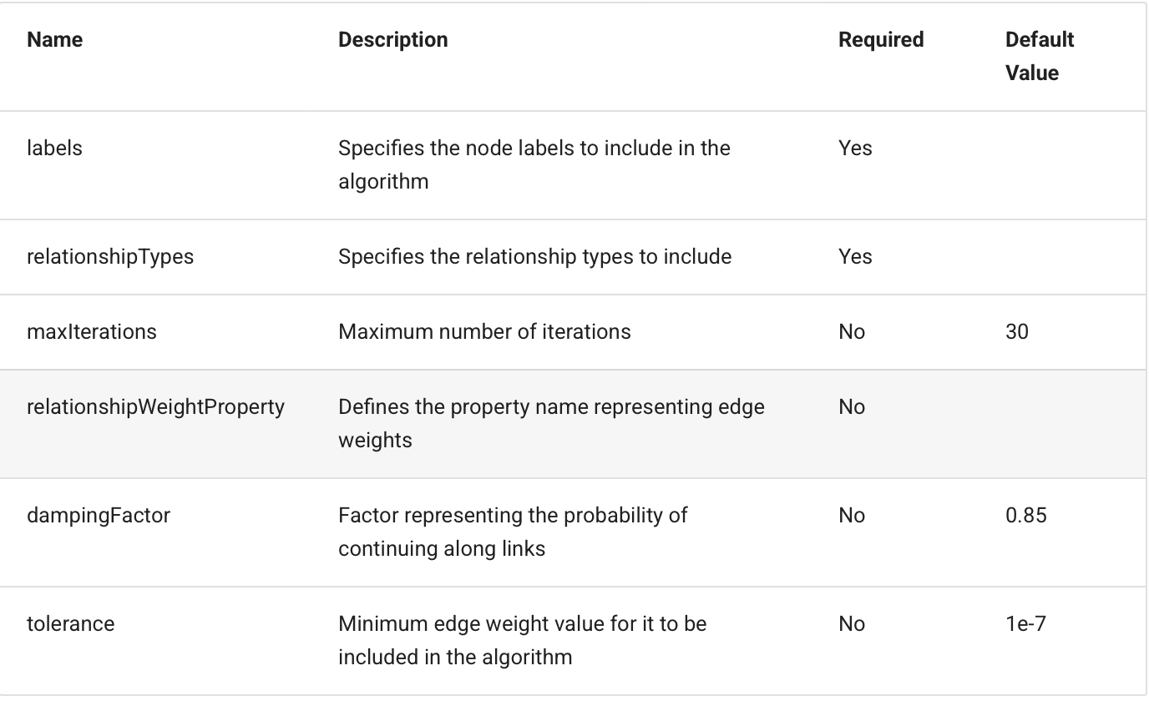
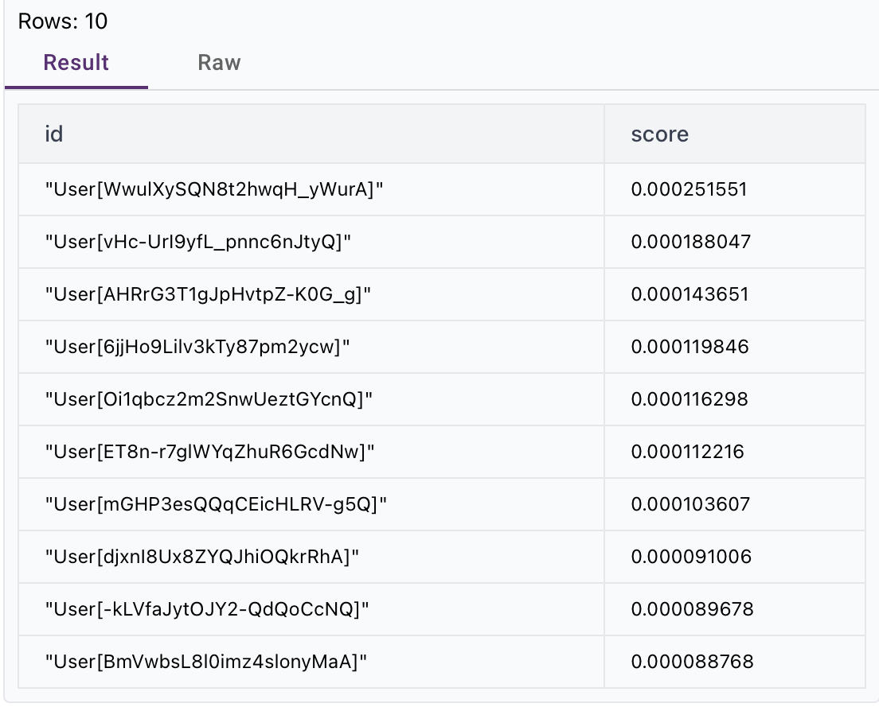

Degree Centrality
CALL gds.degree.write(
'FriendGraph',
{ writeProperty: 'degree' }
)
YIELD nodePropertiesWritten;

MATCH (u:User)
RETURN u.name, u.user_id, u.degree
ORDER BY u.degree DESC
LIMIT 10;
Degree Centrality is currently not mentioned in the puppy graph documentation for graph algorithms
Weakly Connected Components (WCC)
CALL algo.wcc({
labels: ['User'],
relationshipTypes: ['FRIEND'],
threshold: 1.0,
maxIterations: 30,
minComponentSize: 5
}) YIELD id, componentId
RETURN id, componentId
-----> This query is not returning any output, running forever
Running this time
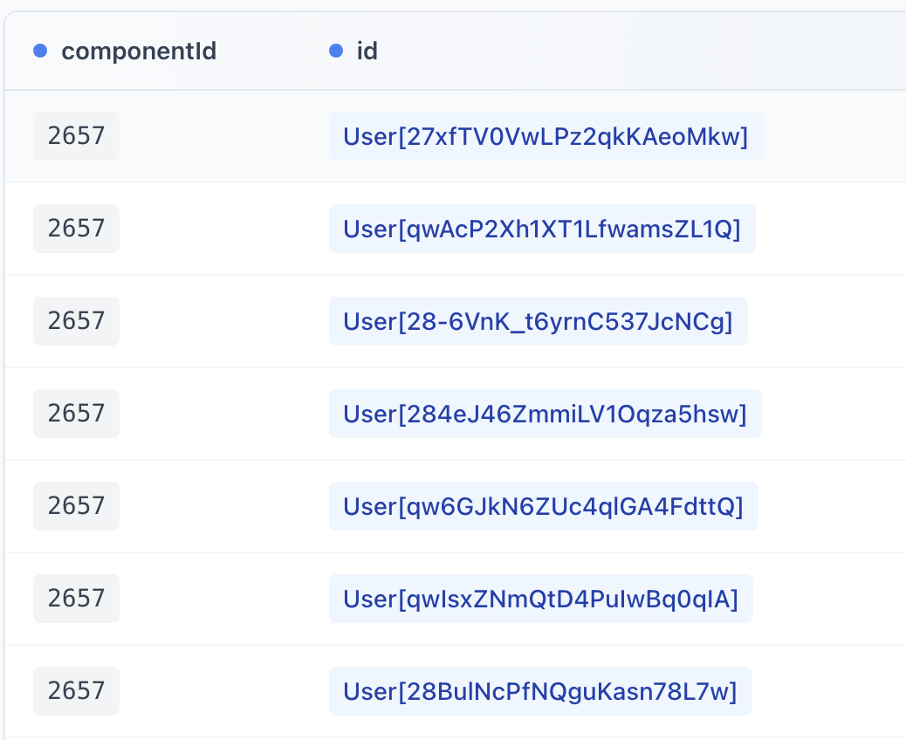
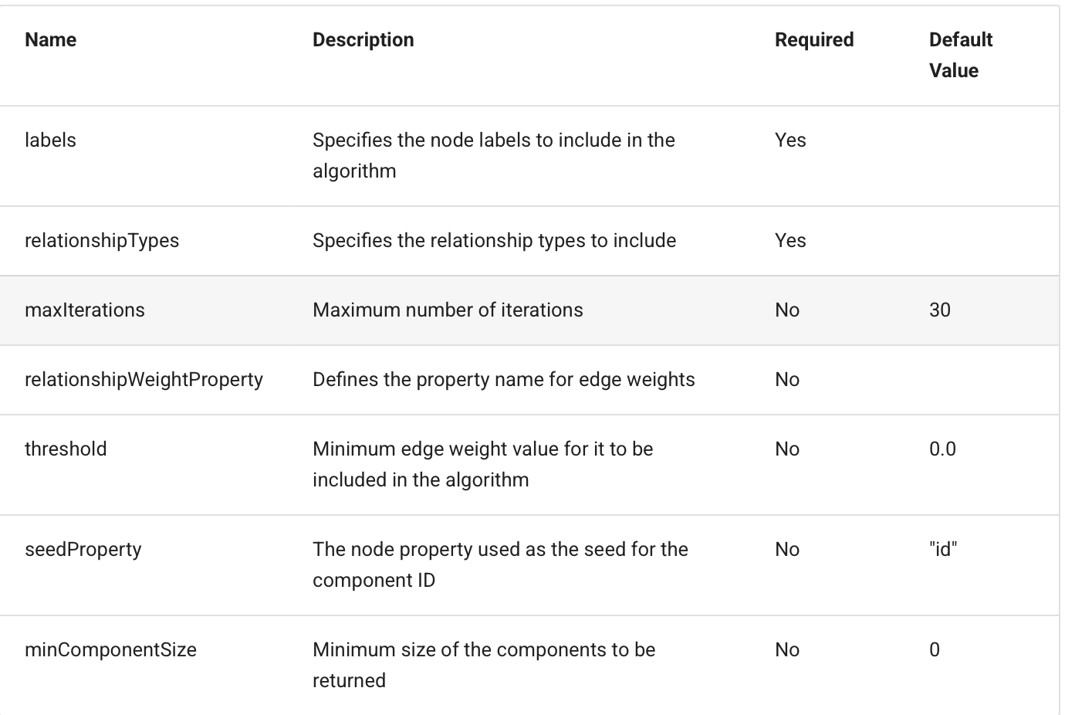

MATCH (u:User)
RETURN u.componentId, count(*) AS size
ORDER BY size DESC
LIMIT 10;

Louvain Community Detection
CALL algo.louvain({
labels: ['User'],
relationshipTypes: ['FRIEND'],
maxIterations: 30
}) YIELD id, communityId
RETURN id, communityId;
------> 42.365 sec

MATCH (u:User)
RETURN u.community, count(*) AS size
ORDER BY size DESC
LIMIT 10;
-----> Running for ever
For more details on graph algorithms: https://docs.puppygraph.com/graph-algorithms/

Connecting to PuppyGraph and Executing Cypher Queries in Python
PuppyGraph supports query execution through the Bolt protocol, using various programming languages like Python, Go, Java, and JavaScript.

Step 1: Install the Neo4j Python Driver
In your terminal or notebook cell, run:
pip install neo4j

Step 2: Connect to PuppyGraph using Python
from neo4j import GraphDatabase

# Initialize connection to the PuppyGraph
uri = "bolt://localhost:7687"
username = "puppygraph"
password = "puppygraph123"
driver = GraphDatabase.driver(uri, auth=(username, password))
session = driver.session()

Step 3: Run a Cypher Query and Measure Execution Time
You can create a reusable function called something like run_query_with_timer(query) that takes any Cypher query string, runs it, prints the result, and reports the time taken, all in one cell. Then you just call it with any new query.
from time import perf_counter
import pandas as pd

def run_query_with_timer(query: str):
"""
Runs a Cypher query on the connected PuppyGraph database,
displays the result as a DataFrame, and prints the execution time.
"""
# Start timer
start_time = perf_counter()

# Run query
result = session.run(query)

# Collect records
records = [record.data() for record in result]

# End timer
end_time = perf_counter()

# Display results as a DataFrame
if records:
df = pd.DataFrame(records)
display(df) # Jupyter-friendly display
else:
print("No results returned.")

# Print execution time
execution_time = end_time - start_time
if execution_time < 1:
print(f"Query executed in {execution_time * 1000:.2f} ms")
elif execution_time < 60:
print(f"Query executed in {execution_time:.2f} seconds")
else:
minutes = int(execution_time // 60)
seconds = execution_time % 60
print(f"Query executed in {minutes} min {seconds:.2f} sec")
run_query_with_timer("""
MATCH (b:Business)
RETURN count(DISTINCT b.city) AS num_cities
""")
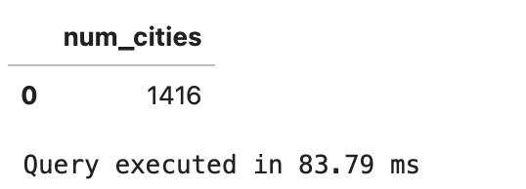
run_query_with_timer("""MATCH (u1:User)-[:FRIEND]->(u2:User)
WHERE NOT (u2)-[:FRIEND]->(u1)
RETURN u1.user_id AS from, u2.user_id AS to LIMIT 10""")
------ > Query executed in 4.71 seconds (no records (is an undirected graph!))
run_query_with_timer("""MATCH (u:User {user_id: "Oi1qbcz2m2SnwUeztGYcnQ"})-[:FRIEND]->(friend:User)-[:WROTE]->(r:Review)-[:REVIEWS]->(b:Business)
RETURN DISTINCT friend.name AS friend_name,
b.name AS business_name,
b.address, b.city, b.state,
b.latitude, b.longitude
ORDER BY friend_name, business_name""")
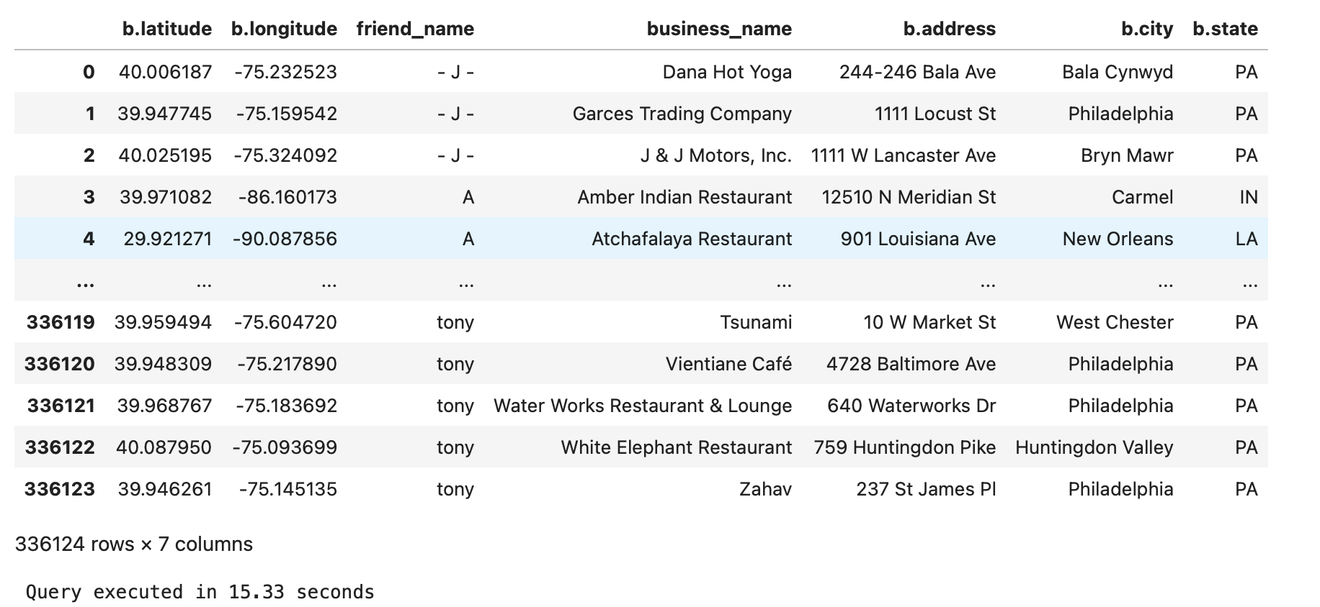
run_query_with_timer("""MATCH (r:Review)
WITH split(toLower(r.text), " ") AS words
UNWIND words AS word WITH word, count(*) AS freq
WHERE size(word) > 3 RETURN word, freq ORDER BY freq DESC LIMIT 20""")
