Puppygraph StackOverflow
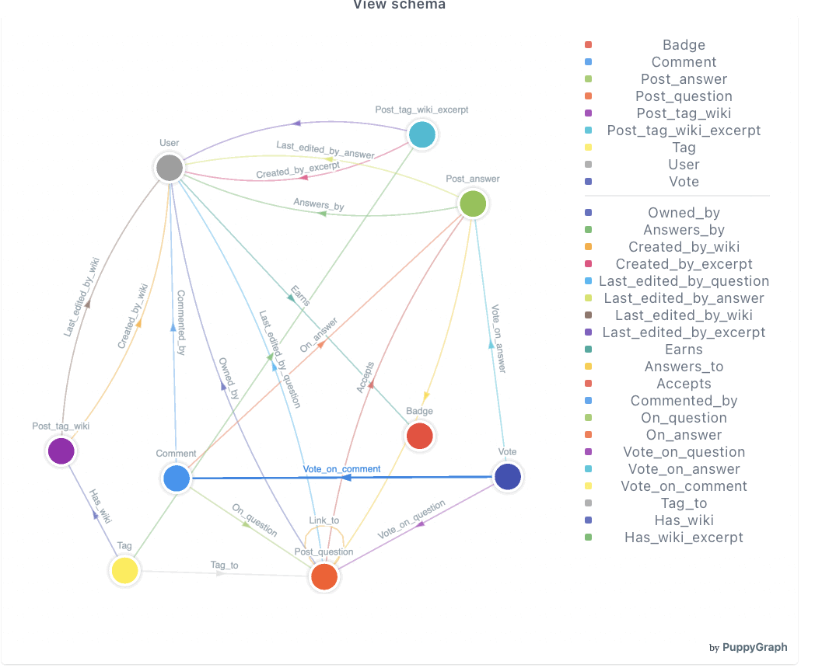
PySpark Initialization, Database Creation, and Table Loading
from pyspark.sql import SparkSession
spark = (
SparkSession.builder
.appName("stackoverflow")
.master("spark://master:7077")
# executors
.config("spark.executor.instances", "2")
.config("spark.executor.cores", "2")
.config("spark.executor.memory", "20g")
.config("spark.driver.memory", "4g")
.config("spark.jars.packages", "io.delta:delta-core_2.12:2.4.0")
.config("spark.sql.extensions", "io.delta.sql.DeltaSparkSessionExtension")
.config("spark.sql.catalog.spark_catalog", "org.apache.spark.sql.delta.catalog.DeltaCatalog")
# --- HDFS —
.config("spark.hadoop.fs.defaultFS", "hdfs://master:9000")
.config("spark.sql.warehouse.dir", "hdfs://master:9000/spark-warehouse")
# --- HIVE METASTORE —
.config("spark.sql.catalogImplementation", "hive")
.config("hive.metastore.uris", "thrift://master:9083")
.getOrCreate()
)
The database was created using the underlying JVM SparkSession:
spark._jsparkSession.sql("CREATE DATABASE IF NOT EXISTS stackoverflow")
Loading StackOverflow Files from HDFS
badge_df = spark.read.option("header", True).csv("hdfs://master:9000/stackoverflow/badges.csv")
comment_df = spark.read.option("header", True).csv("hdfs://master:9000/stackoverflow/comments_final.csv")
post_answer_df = spark.read.option("header", True).csv("hdfs://master:9000/stackoverflow/posts_answers_fixed.csv")
post_question_df = spark.read.option("header", True).csv("hdfs://master:9000/stackoverflow/posts_questions_cleaned1.csv")
post_tag_wiki_df = spark.read.option("header", True).csv("hdfs://master:9000/stackoverflow/posts_tag_wiki_clean.csv")
post_tag_wiki_excerpt_df = spark.read.option("header", True).csv("hdfs://master:9000/stackoverflow/posts_tag_wiki_excerpt_100PCT.csv")
user_df = spark.read.option("header", True).csv("hdfs://master:9000/stackoverflow/users_clean.csv")
tag_df = spark.read.option("header", True).csv("hdfs://master:9000/stackoverflow/tags.csv")
vote_df = spark.read.option("header", True).csv("hdfs://master:9000/stackoverflow/votes.csv")
post_links_df = spark.read.option("header", True).csv("hdfs://master:9000/stackoverflow/posts_links.csv")
Writing Delta Tables into the MovieLens Database
badge_df.write.format("delta").mode("overwrite").saveAsTable("stackoverflow.badges")
comment_df.write.format("delta").mode("overwrite").saveAsTable("stackoverflow.comments")
post_answer_df.write.format("delta").mode("overwrite").saveAsTable("stackoverflow.posts_answers")
post_question_df.write.format("delta").mode("overwrite").saveAsTable("stackoverflow.posts_questions")
post_tag_wiki_df.write.format("delta").mode("overwrite").saveAsTable("stackoverflow.posts_tag_wiki")post_tag_wiki_excerpt_df.write.format("delta").mode("overwrite").saveAsTable("stackoverflow.posts_tag_wiki_excerpt")
user_df.write.format("delta").mode("overwrite").saveAsTable("stackoverflow.users")
tag_df.write.format("delta").mode("overwrite").saveAsTable("stackoverflow.tags")
vote_df.write.format("delta").mode("overwrite").saveAsTable("stackoverflow.votes")
post_links_df.write.format("delta").mode("overwrite").saveAsTable("stackoverflow.posts_links")
Nodes creation on Puppygraph
- Badge:
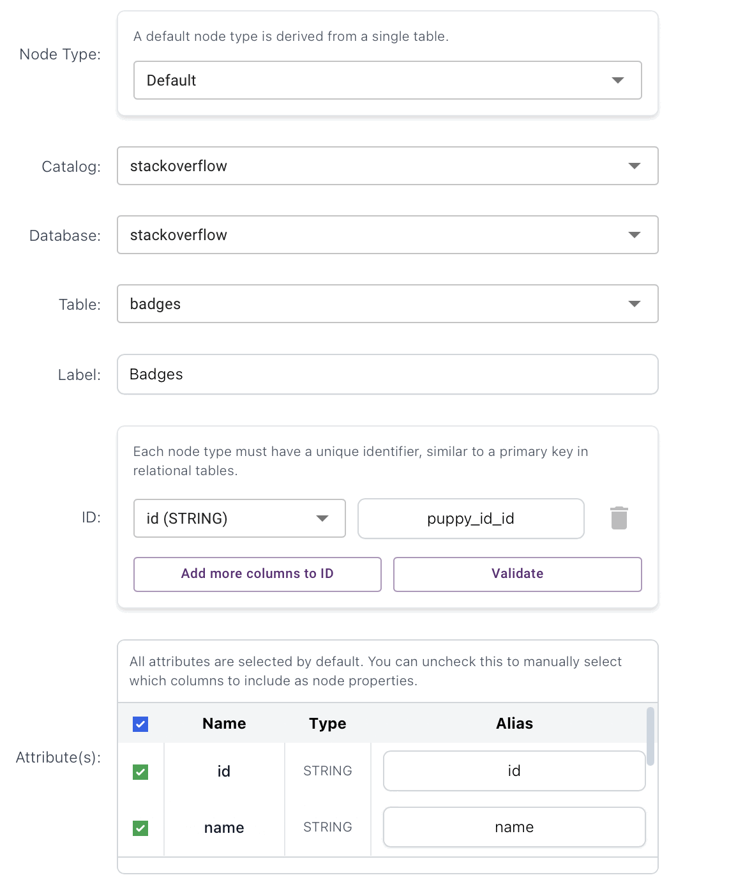
- Comment:
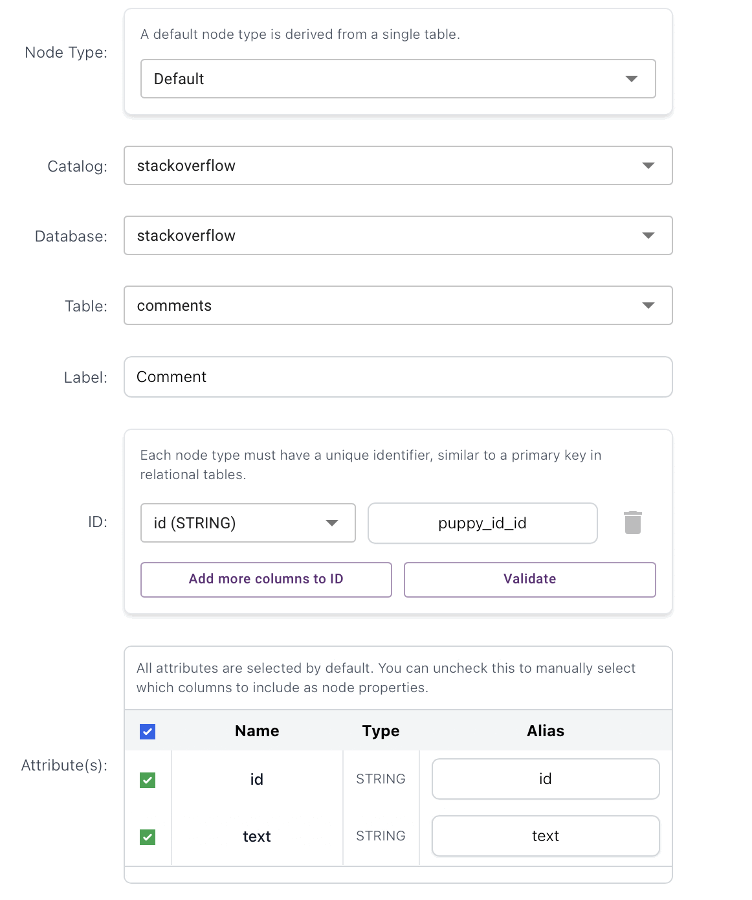
- Post_answer:
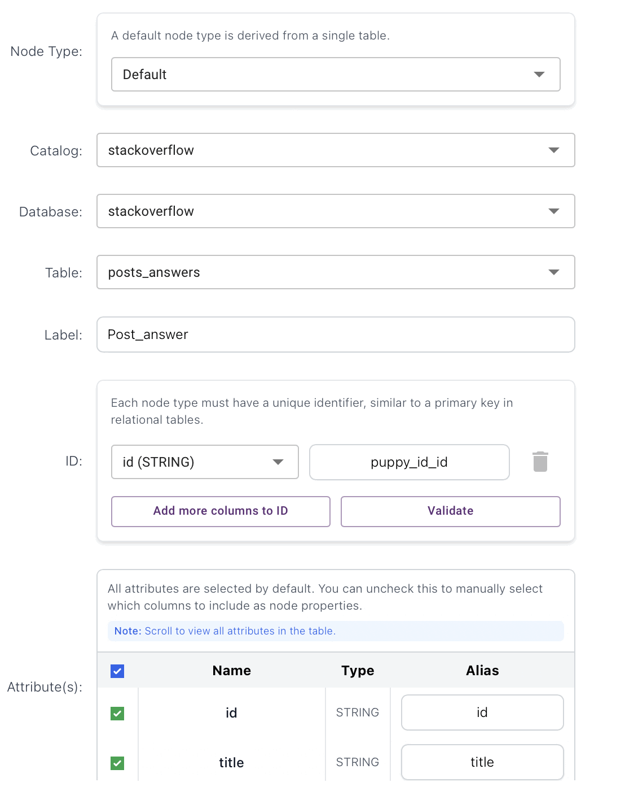
- Post_question:
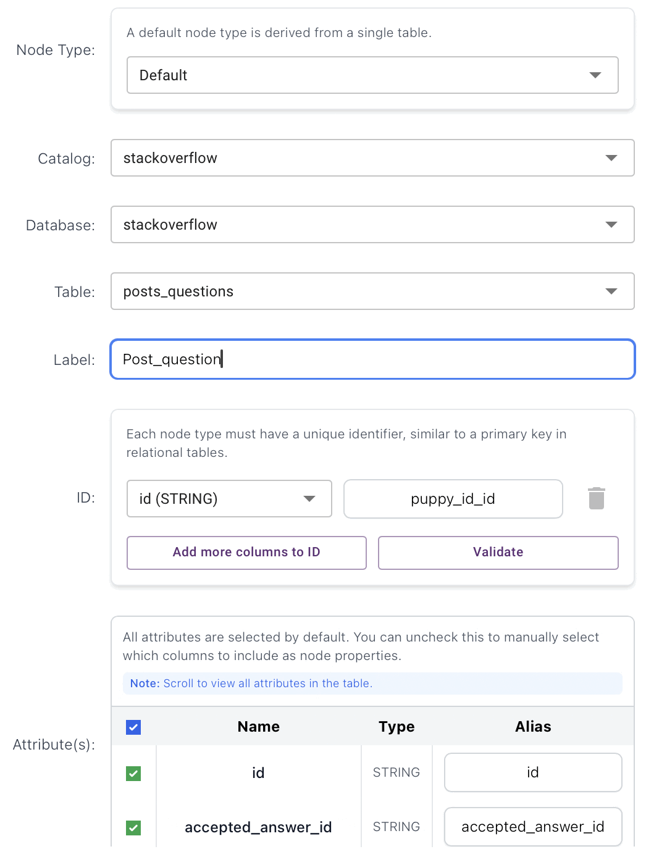
- Post_tag_wiki:
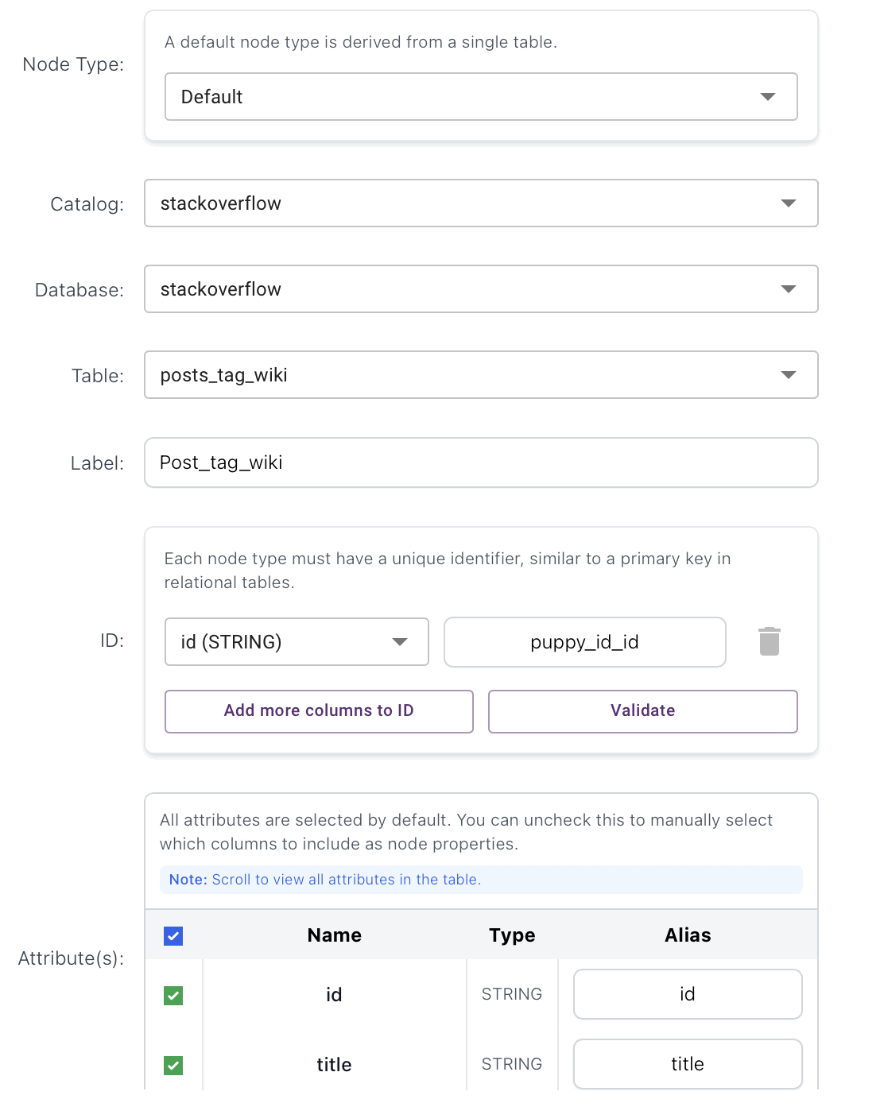
- Post_tag_wiki_excerpt:
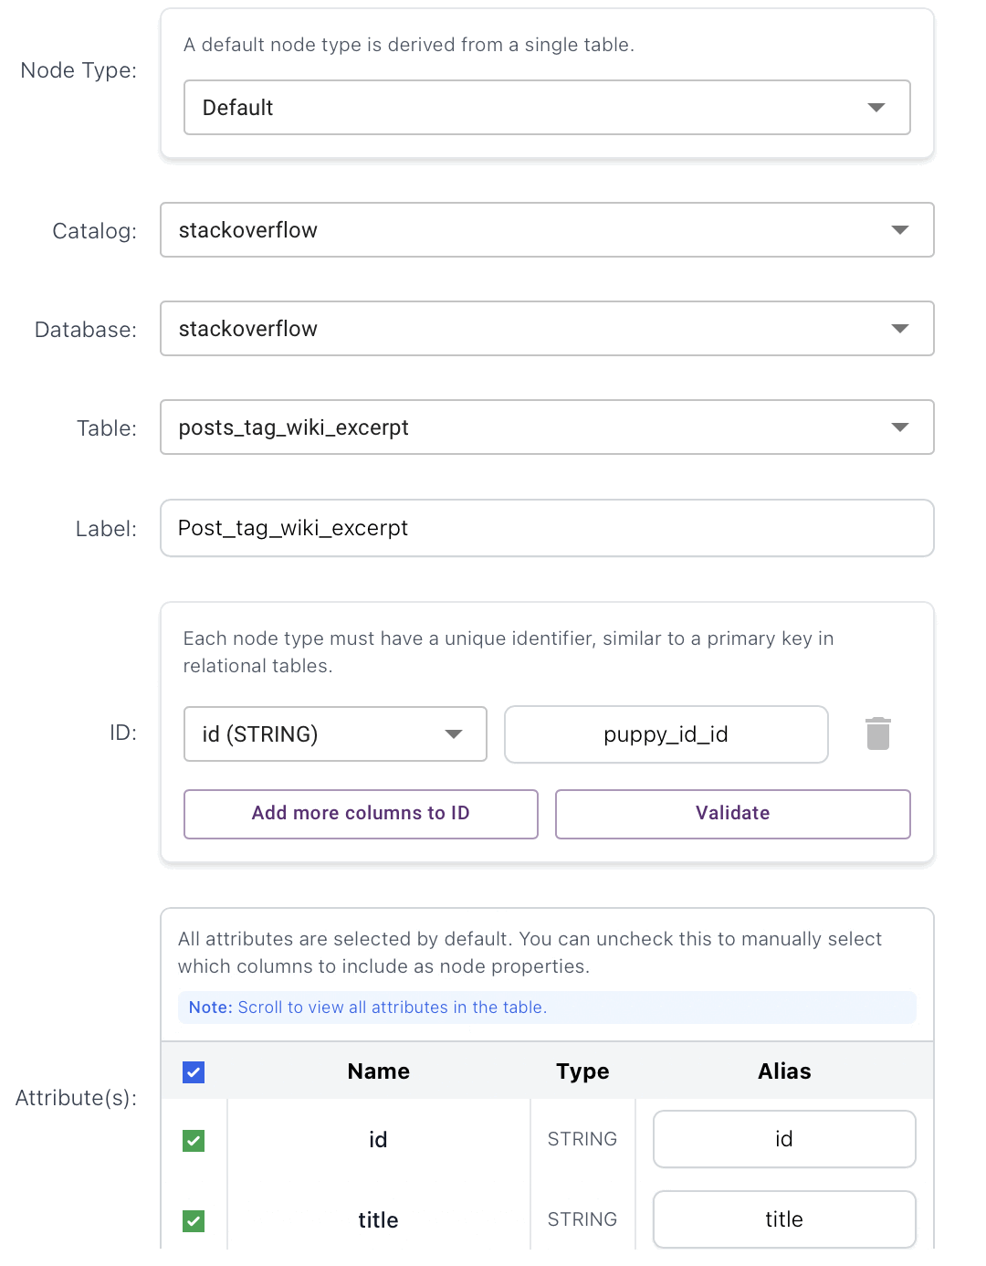
- Tag:
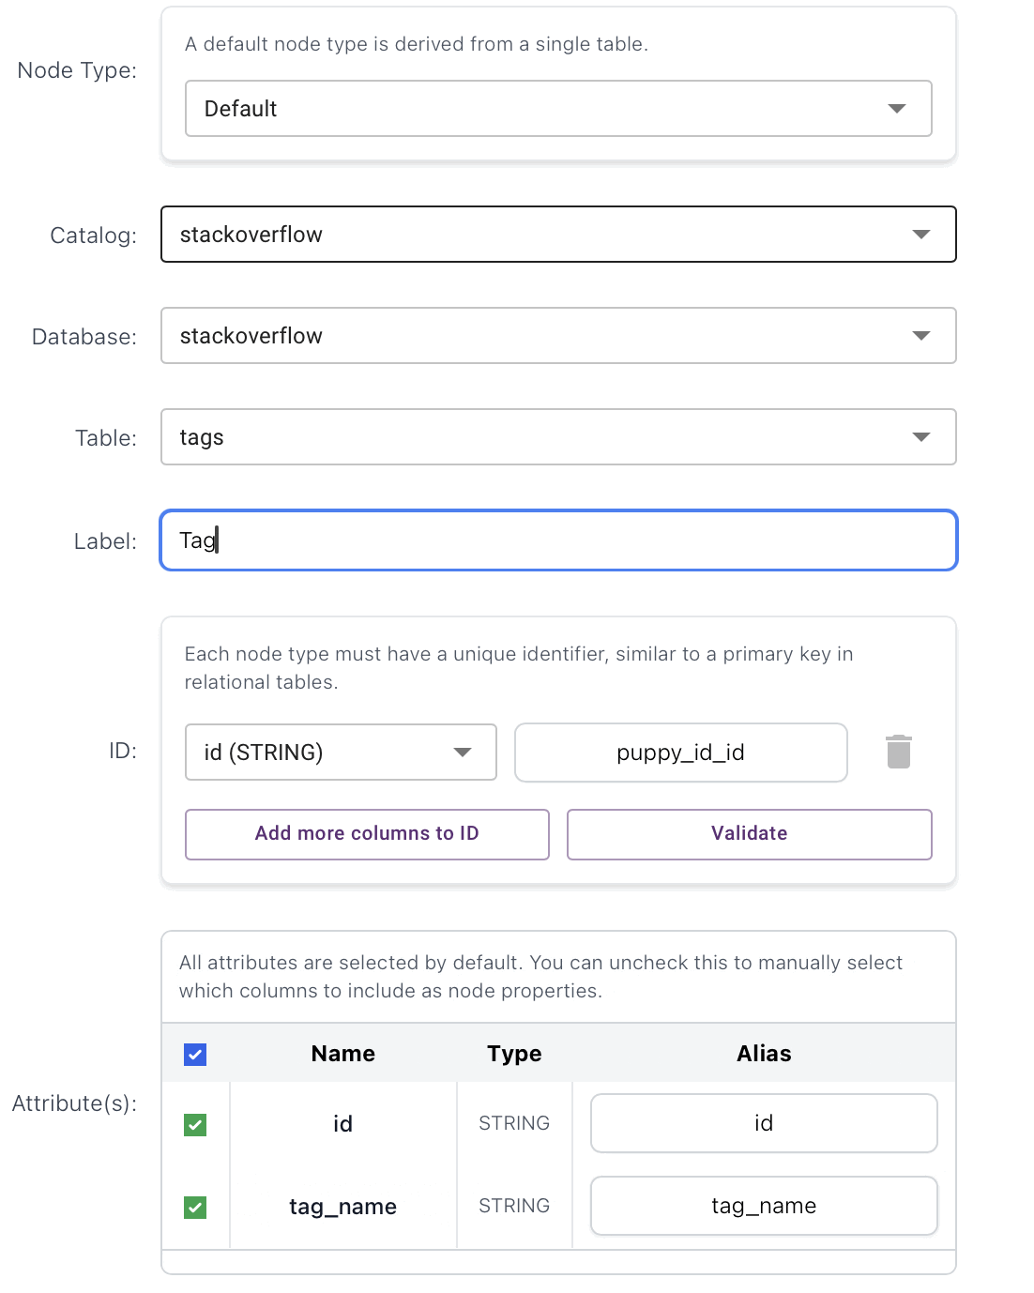
- User:
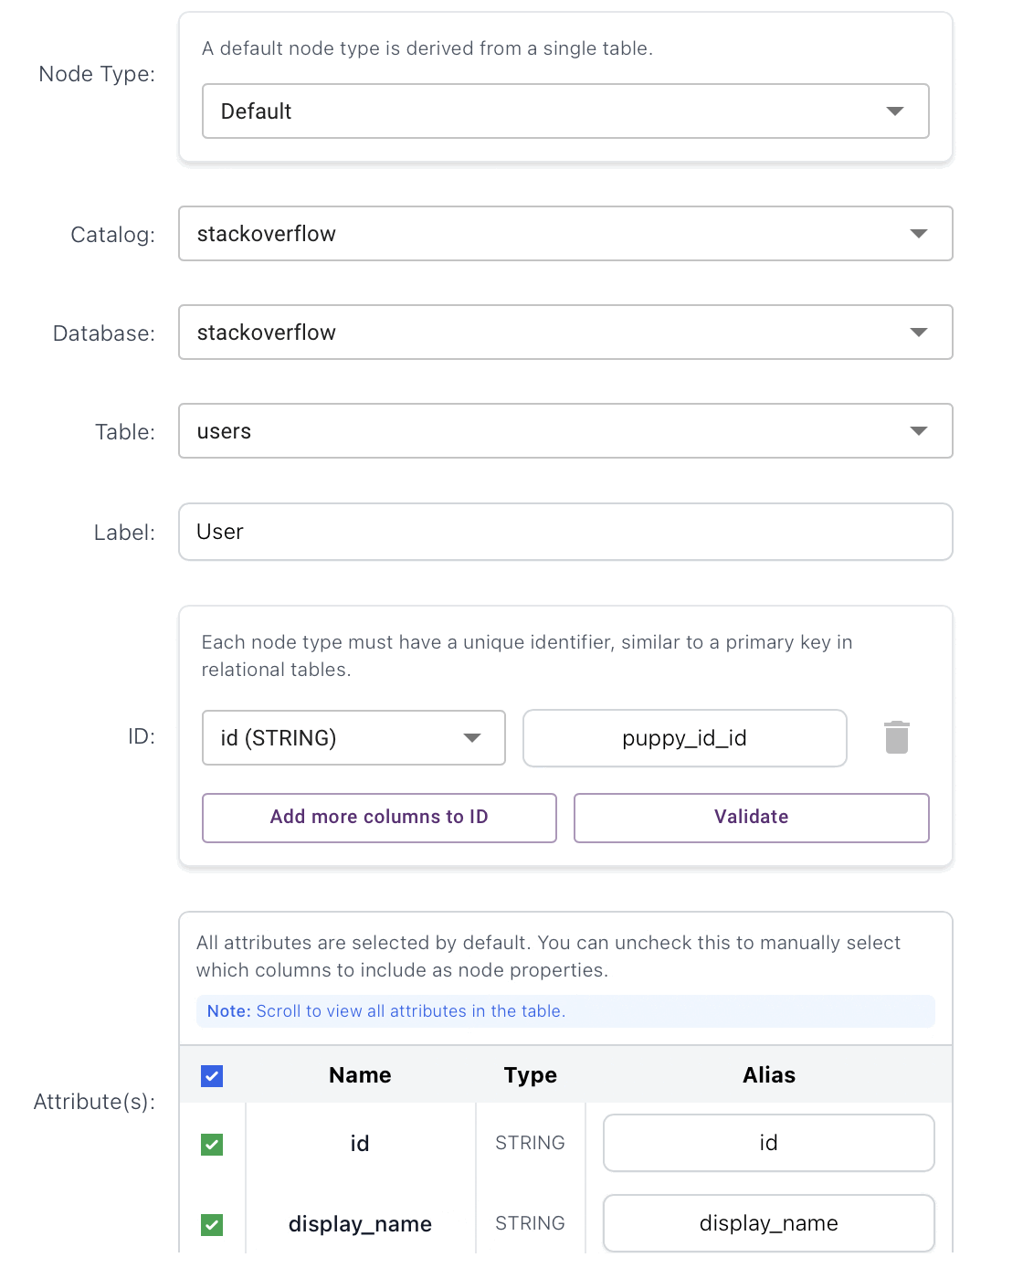
- Vote:
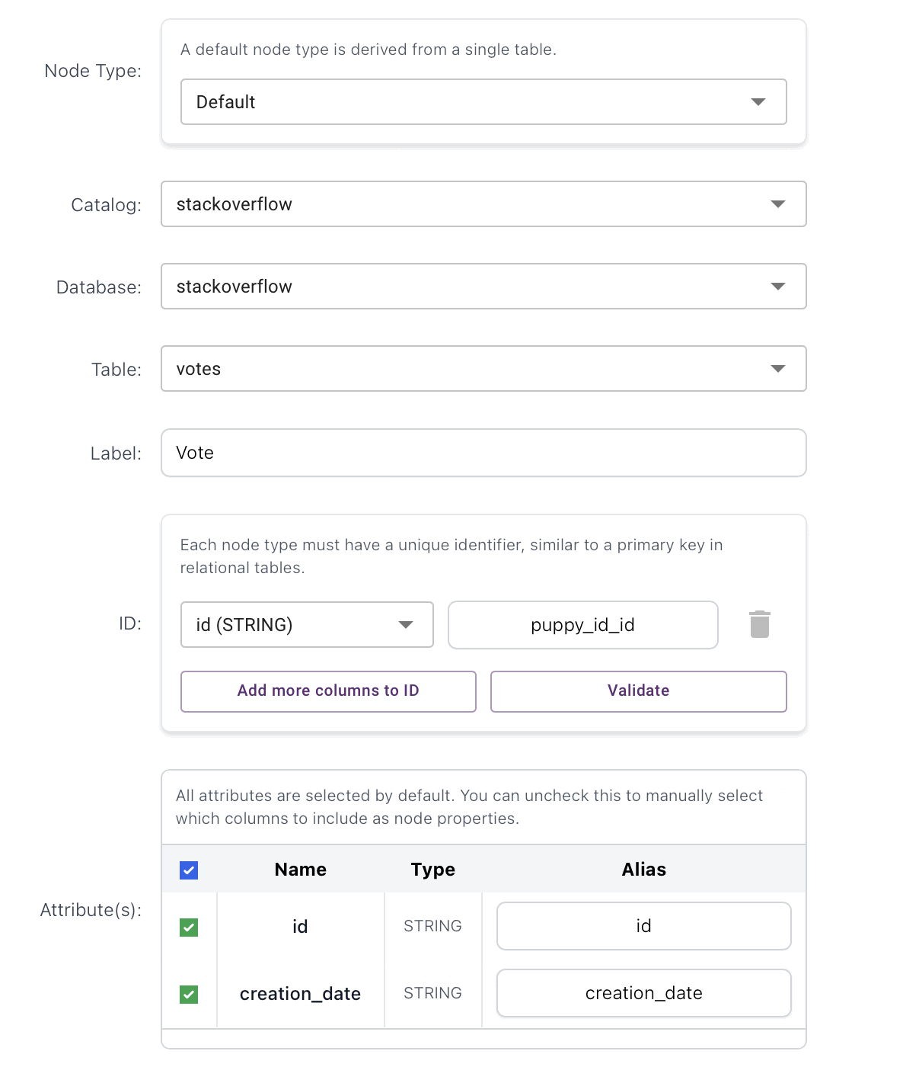

Edge creation on Puppygraph
Owned_by (Post_question -> User):
Preprocessing:
from pyspark.sql import functions as F
pq = (spark.table("stackoverflow.posts_questions")
.select(F.trim(F.col("id")).alias("from_id"),
F.trim(F.col("owner_user_id")).alias("to_id")))
u = (spark.table("stackoverflow.users")
.select(F.trim(F.col("id")).alias("user_id"))
.dropna()
.dropDuplicates(["user_id"]))
owned_by_edges = (pq
.filter(F.col("to_id").isNotNull())
.filter(F.col("to_id") != "")
.filter(F.col("to_id") != "0")
.join(u, F.col("to_id") == F.col("user_id"), "inner")
.select("from_id", "to_id")
)
print("Owned_by edges:", owned_by_edges.count())
owned_by_edges.write.format("delta").mode("overwrite").saveAsTable("stackoverflow.edges_owned_by")
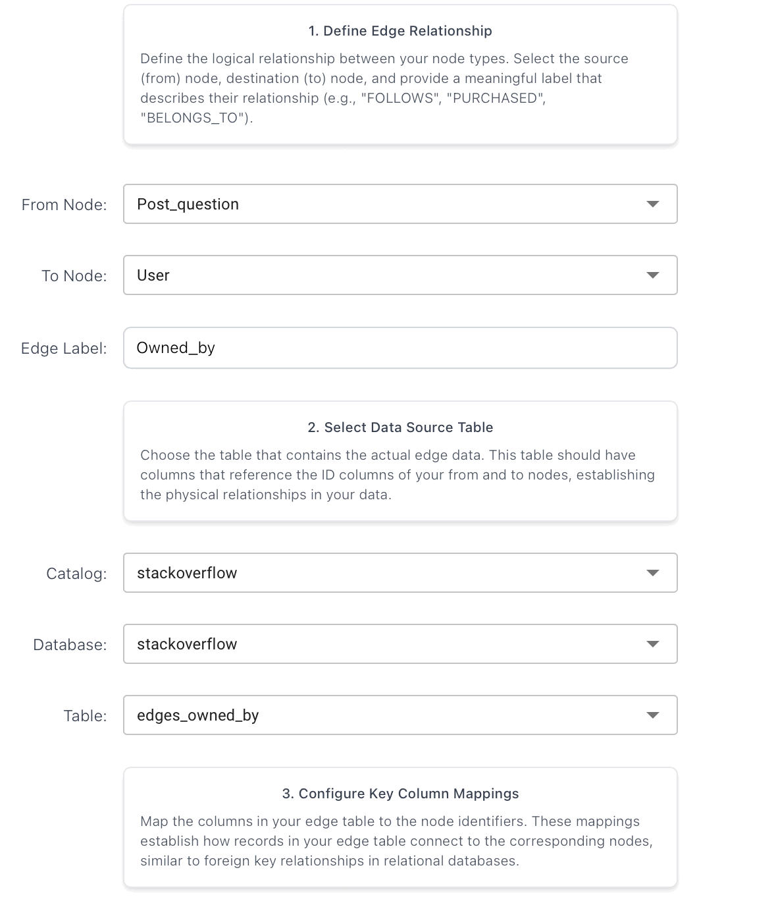 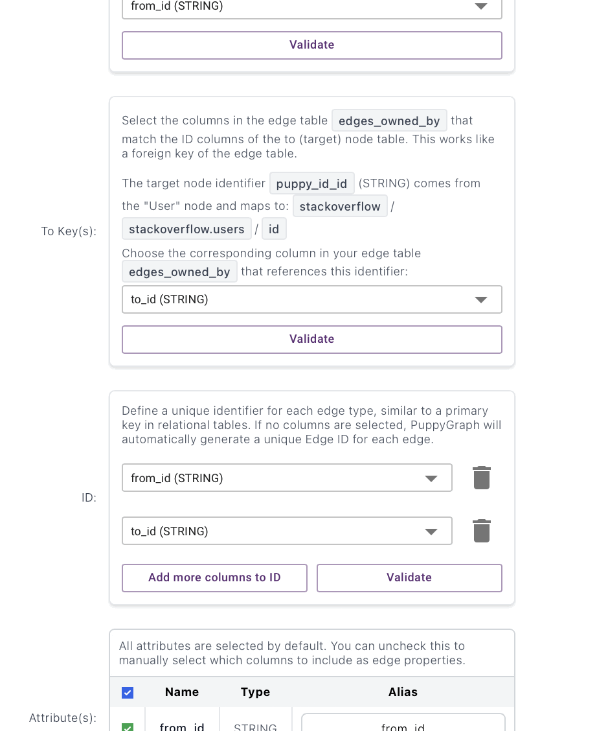

Answers_by (Post_answer -> User):
Preprocessing:
pa = (spark.table("stackoverflow.posts_answers")
.select(F.trim(F.col("id")).alias("from_id"),
F.trim(F.col("owner_user_id")).alias("to_id")))
answers_by_edges = (pa
.filter(F.col("to_id").isNotNull())
.filter(F.col("to_id") != "")
.filter(F.col("to_id") != "0")
.join(u, F.col("to_id") == F.col("user_id"), "inner")
.select("from_id", "to_id")
)
print("Answers_by edges:", answers_by_edges.count())
answers_by_edges.write.format("delta").mode("overwrite").saveAsTable("stackoverflow.edges_answers_by")

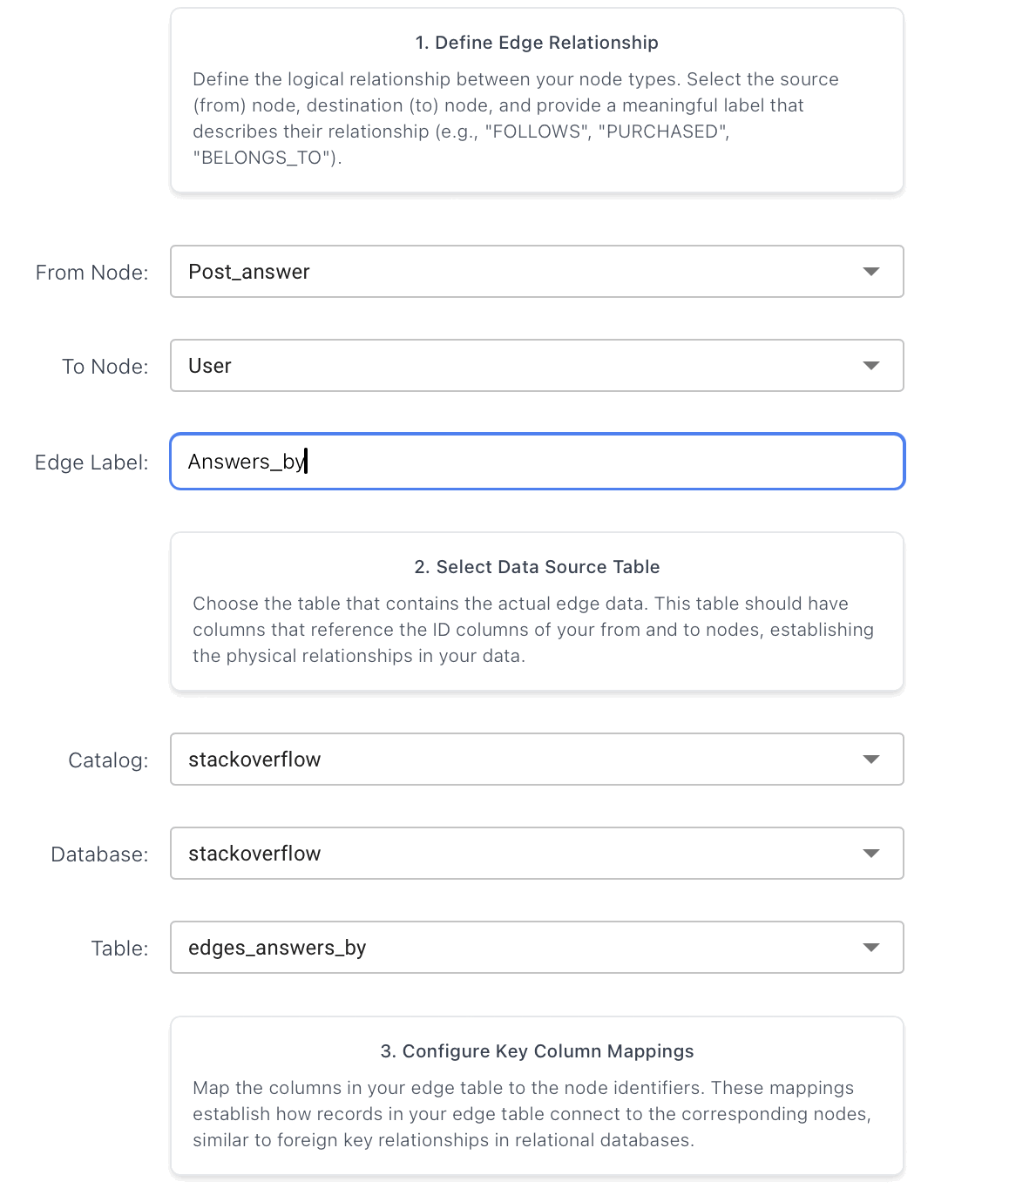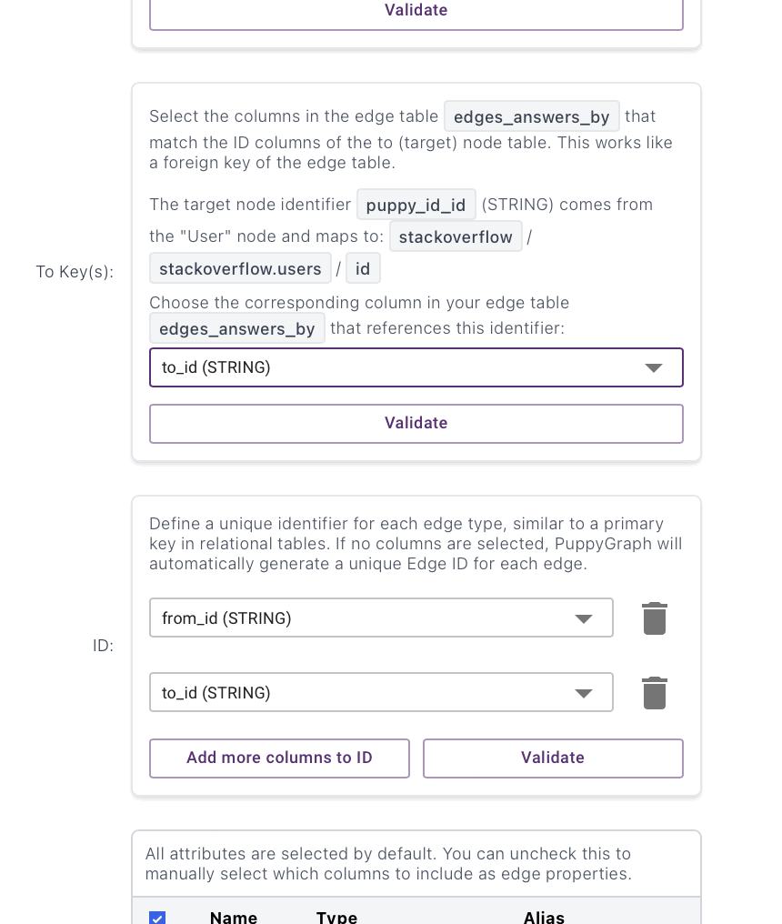
Created_by_wiki (Post_tag_wiki -> User):
Preprocessing:
ptw = (spark.table("stackoverflow.posts_tag_wiki")
.select(F.trim(F.col("id")).alias("from_id"),
F.trim(F.col("owner_user_id")).alias("to_id")))
created_by_wiki_edges = (ptw
.filter(F.col("to_id").isNotNull())
.filter(F.col("to_id") != "")
.filter(F.col("to_id") != "0")
.join(u, F.col("to_id") == F.col("user_id"), "inner")
.select("from_id", "to_id")
)
print("Created_by_wiki edges:", created_by_wiki_edges.count())
created_by_wiki_edges.write.format("delta").mode("overwrite").saveAsTable("stackoverflow.edges_created_by_wiki")

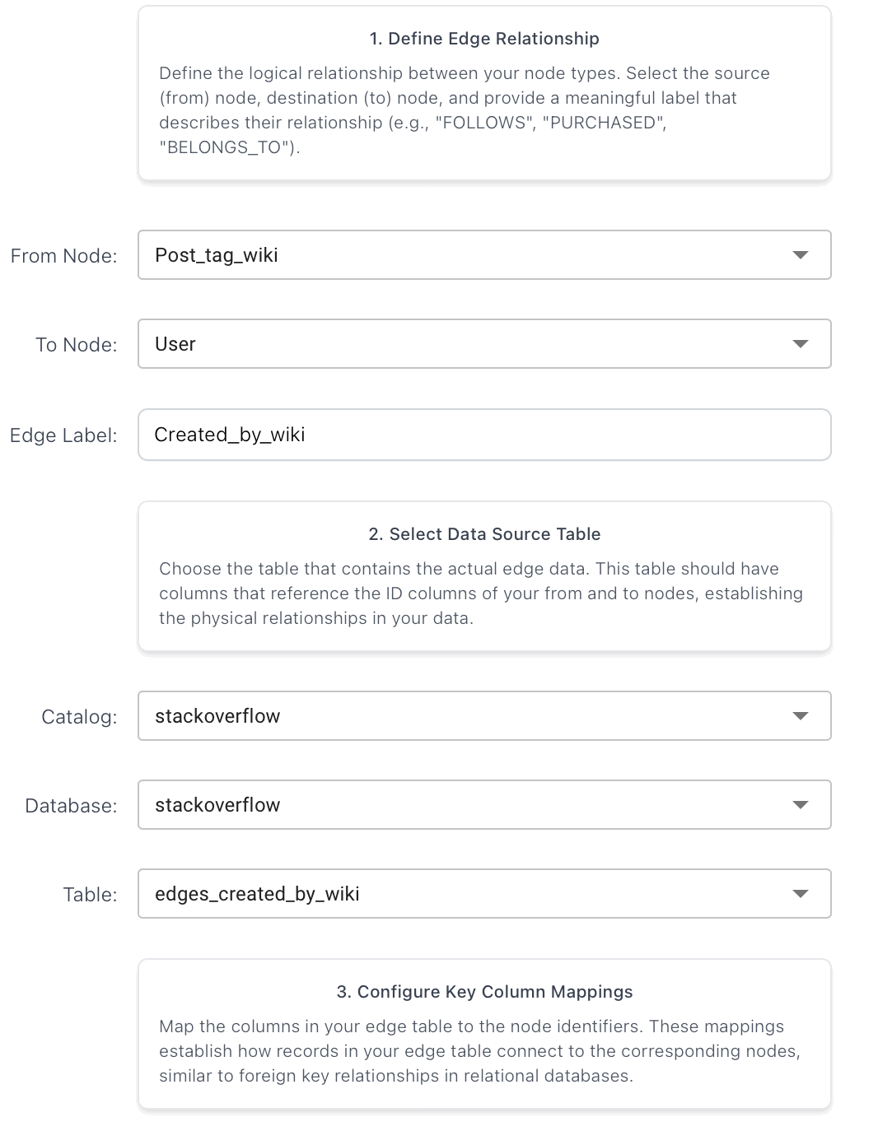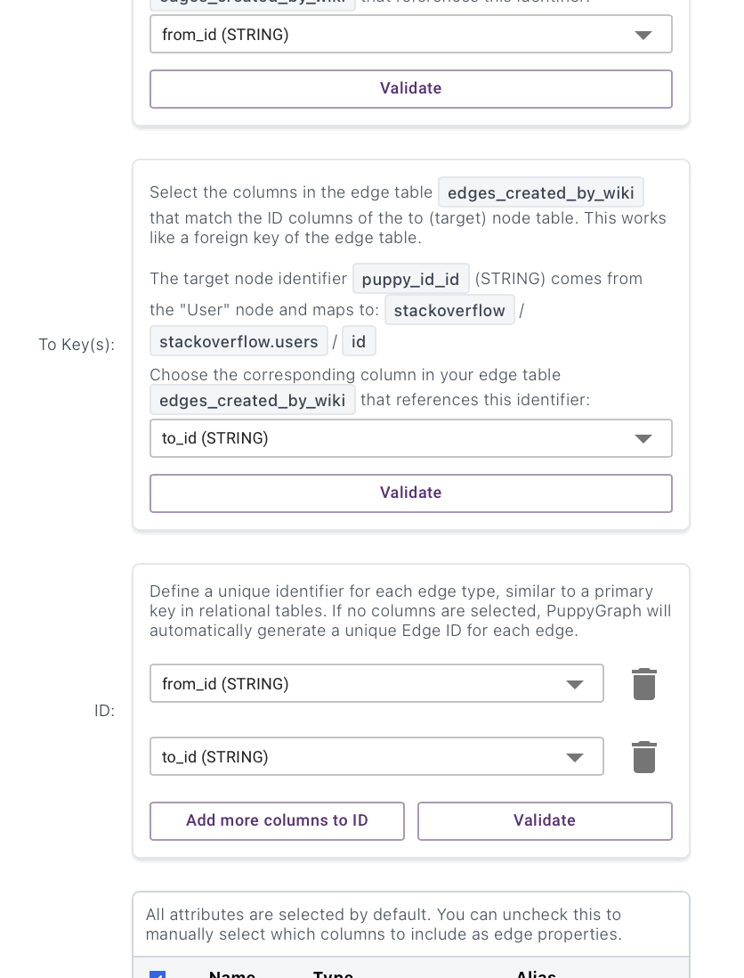
Created_by_excerpt (Post_tag_wiki_excerpt -> User):
Preprocessing:
twe = (spark.table("stackoverflow.posts_tag_wiki_excerpt")
.select(F.trim(F.col("id")).alias("from_id"),
F.trim(F.col("owner_user_id")).alias("to_id")))
edges_created_by_excerpt = (twe
.filter(F.col("to_id").isNotNull())
.filter(F.col("to_id") != "")
.filter(F.col("to_id") != "0")
.join(u, F.col("to_id") == F.col("user_id"), "inner")
.select("from_id", "to_id")
)
print("Created_by_excerpt edges:", edges_created_by_excerpt.count())
edges_created_by_excerpt.write.format("delta").mode("overwrite") \
.saveAsTable("stackoverflow.edges_created_by_excerpt")

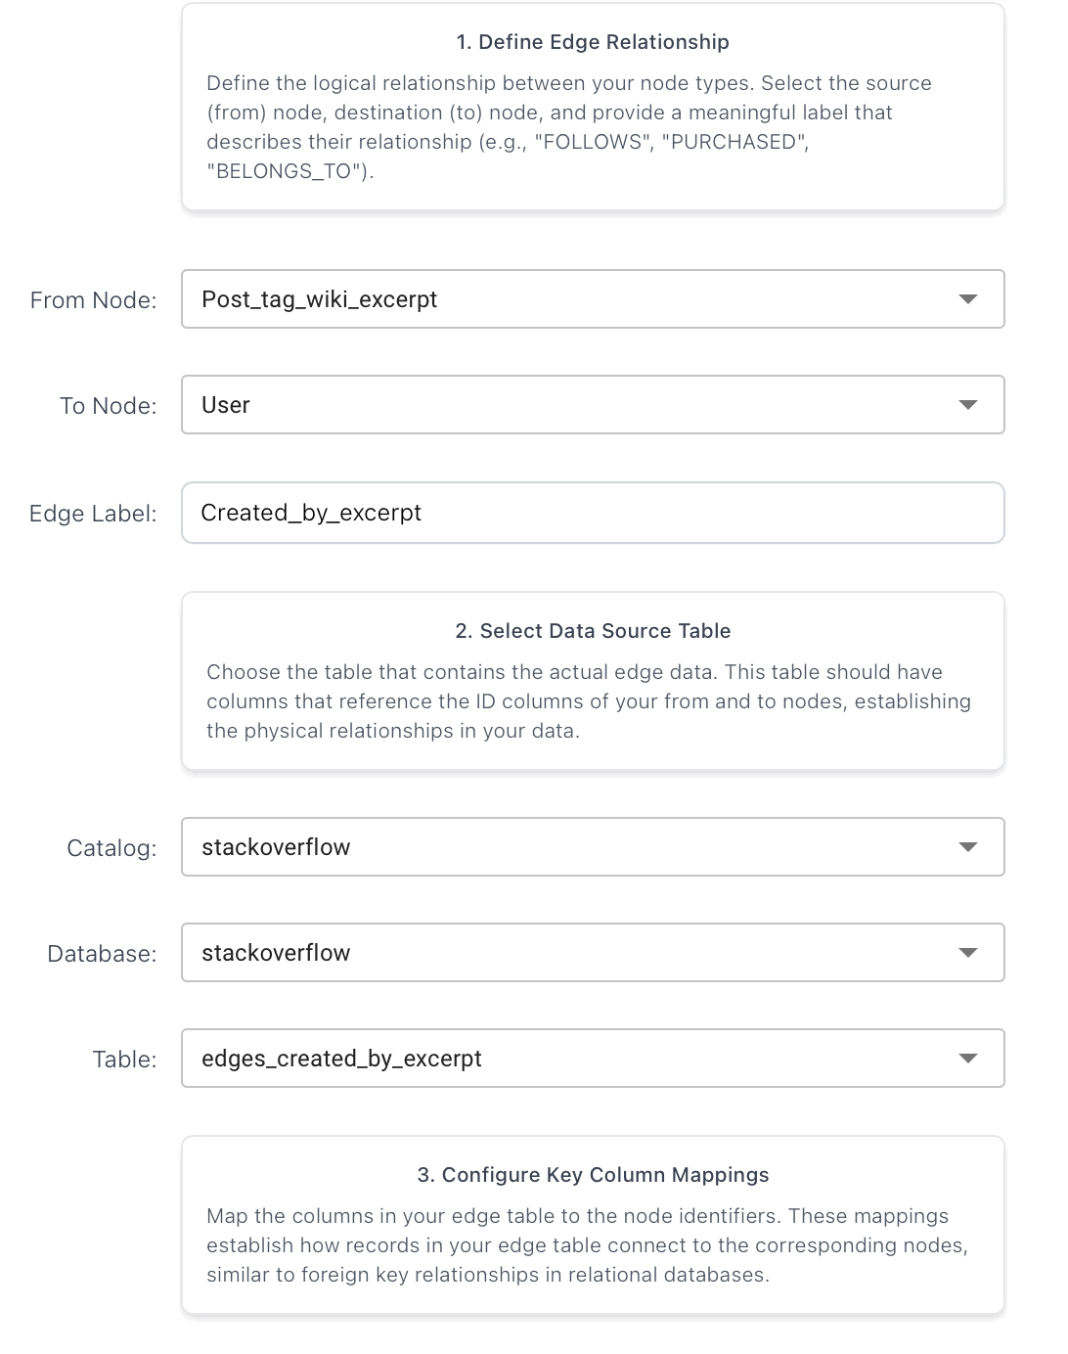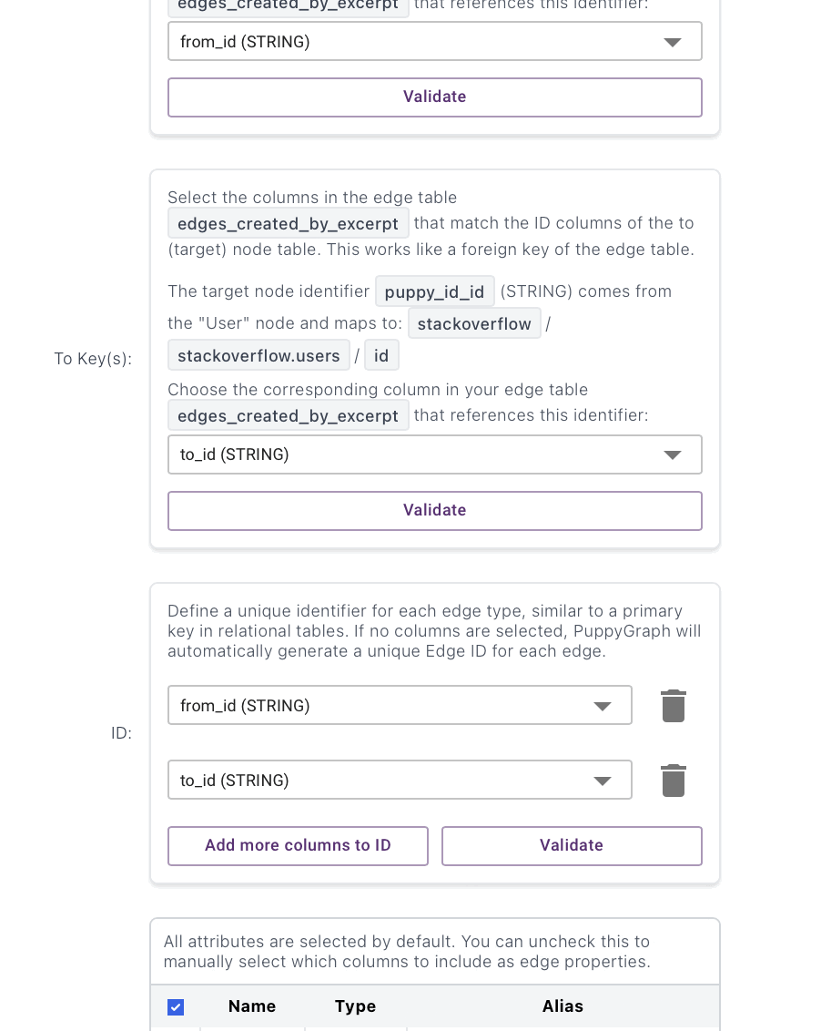
Last_edited_by_question (Post_question -> User):
Preprocessing:
pq_last = (spark.table("stackoverflow.posts_questions")
.select(F.trim(F.col("id")).alias("from_id"),
F.trim(F.col("last_editor_user_id")).alias("to_id")))
edges_last_edited_by_question = (pq_last
.filter(F.col("to_id").isNotNull())
.filter(F.col("to_id") != "")
.filter(F.col("to_id") != "0")
.join(u, F.col("to_id") == F.col("user_id"), "inner")
.select("from_id", "to_id")
)
print("Last_edited_by_question edges:", edges_last_edited_by_question.count())
edges_last_edited_by_question.write.format("delta").mode("overwrite") \
.saveAsTable("stackoverflow.edges_last_edited_by_question")

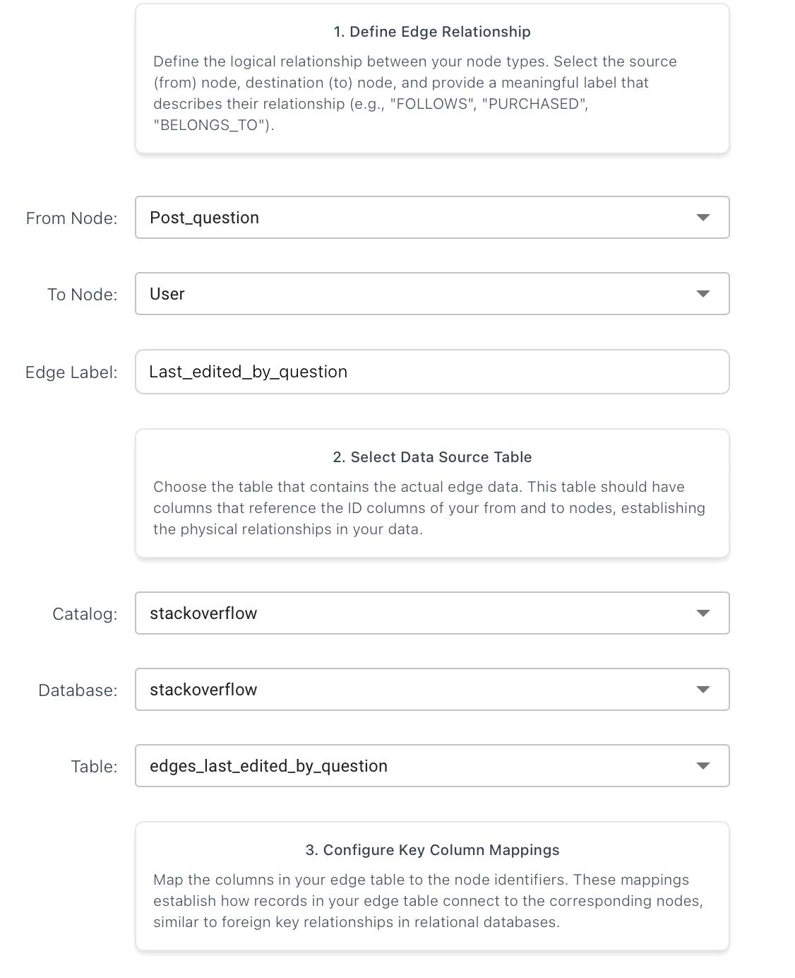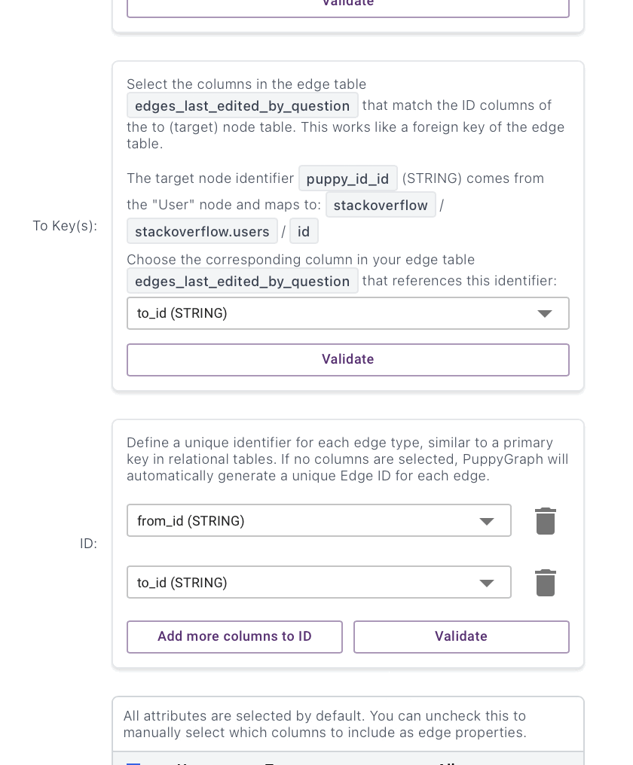
Last_edited_by_answer (Post_answer -> User):
Preprocessing:
pa_last = (spark.table("stackoverflow.posts_answers")
.select(F.trim(F.col("id")).alias("from_id"),
F.trim(F.col("last_editor_user_id")).alias("to_id")))
edges_last_edited_by_answer = (pa_last
.filter(F.col("to_id").isNotNull())
.filter(F.col("to_id") != "")
.filter(F.col("to_id") != "0")
.join(u, F.col("to_id") == F.col("user_id"), "inner")
.select("from_id", "to_id")
)
print("Last_edited_by_answer edges:", edges_last_edited_by_answer.count())
edges_last_edited_by_answer.write.format("delta").mode("overwrite") \
.saveAsTable("stackoverflow.edges_last_edited_by_answer")

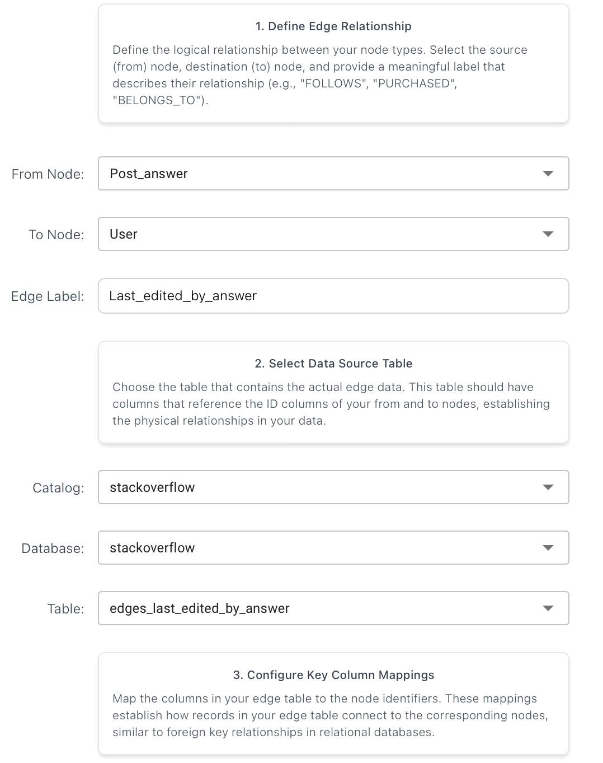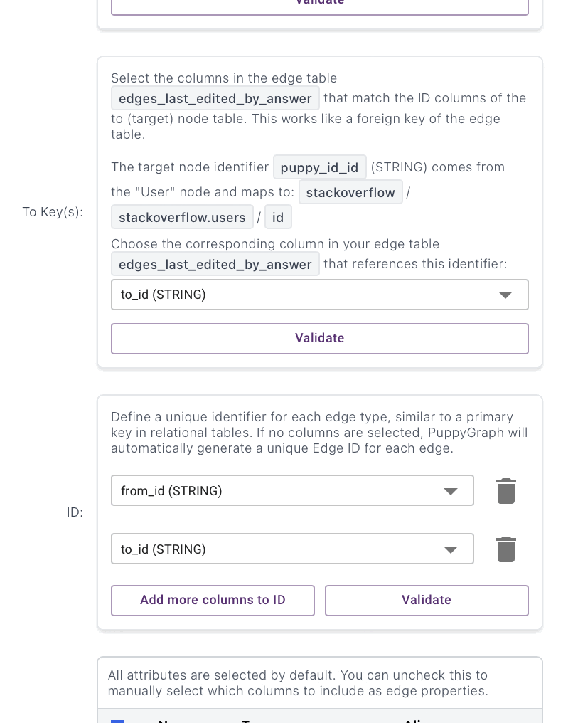
Last_edited_by_wiki (Post_tag_wiki -> User):
Preprocessing:
ptw_last = (spark.table("stackoverflow.posts_tag_wiki")
.select(F.trim(F.col("id")).alias("from_id"),
F.trim(F.col("last_editor_user_id")).alias("to_id")))
edges_last_edited_by_wiki = (ptw_last
.filter(F.col("to_id").isNotNull())
.filter(F.col("to_id") != "")
.filter(F.col("to_id") != "0")
.join(u, F.col("to_id") == F.col("user_id"), "inner")
.select("from_id", "to_id")
)
print("Last_edited_by_wiki edges:", edges_last_edited_by_wiki.count())
edges_last_edited_by_wiki.write.format("delta").mode("overwrite") \
.saveAsTable("stackoverflow.edges_last_edited_by_wiki")
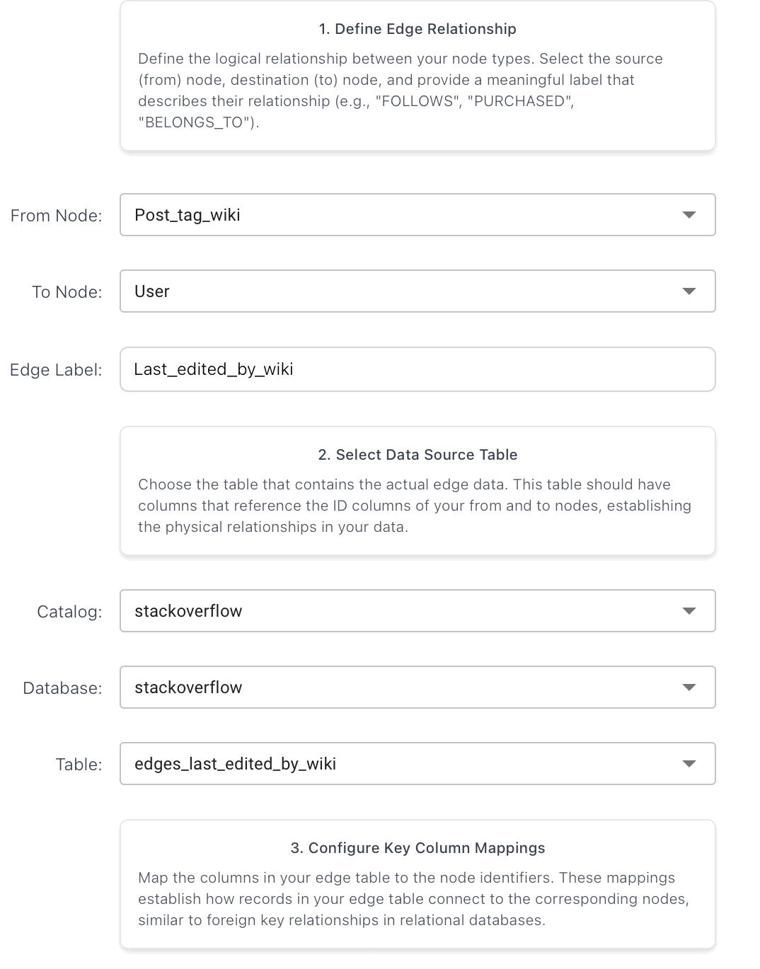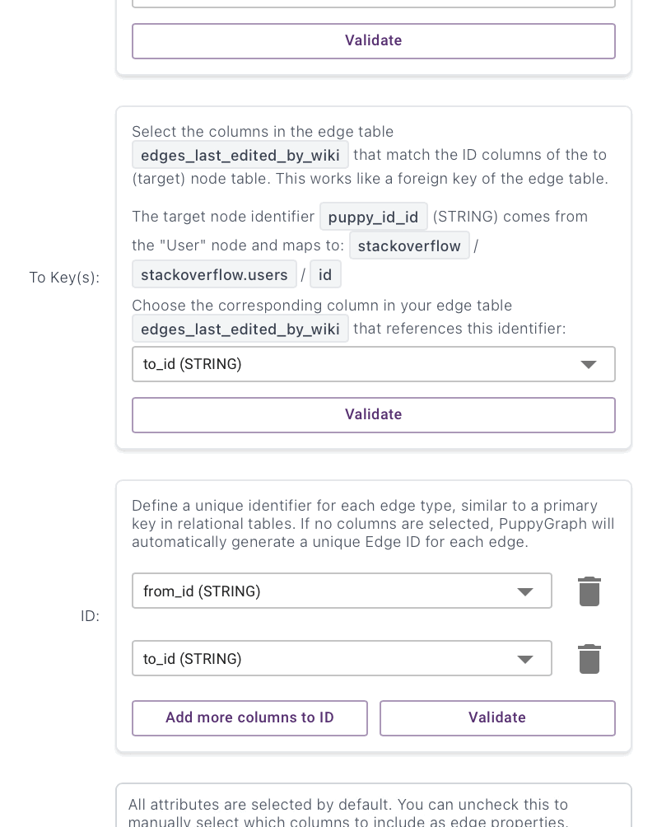
Last_edited_by_excerpt (Post_tag_wiki_excerpt -> User):
Preprocessing:
twe_last = (spark.table("stackoverflow.posts_tag_wiki_excerpt")
.select(F.trim(F.col("id")).alias("from_id"),
F.trim(F.col("last_editor_user_id")).alias("to_id")))
edges_last_edited_by_excerpt = (twe_last
.filter(F.col("to_id").isNotNull())
.filter(F.col("to_id") != "")
.filter(F.col("to_id") != "0")
.join(u, F.col("to_id") == F.col("user_id"), "inner")
.select("from_id", "to_id")
)
print("Last_edited_by_excerpt edges:", edges_last_edited_by_excerpt.count())
edges_last_edited_by_excerpt.write.format("delta").mode("overwrite") \
.saveAsTable("stackoverflow.edges_last_edited_by_excerpt")

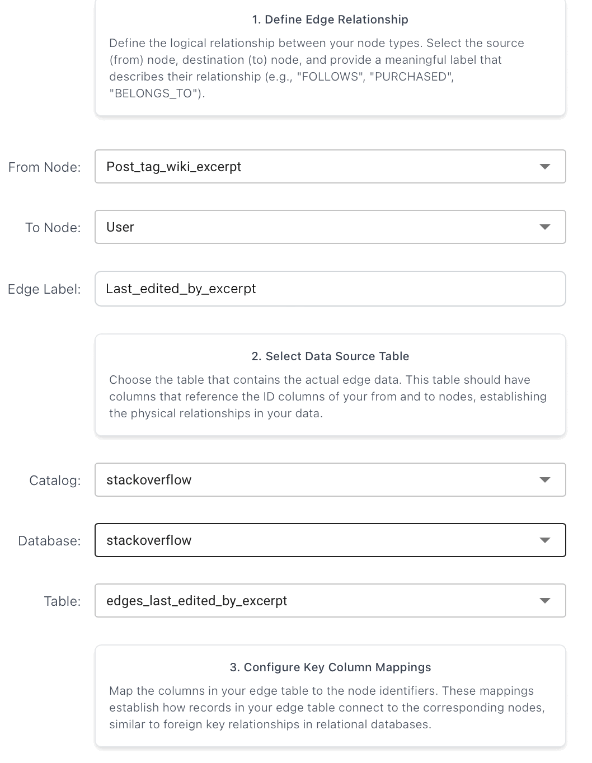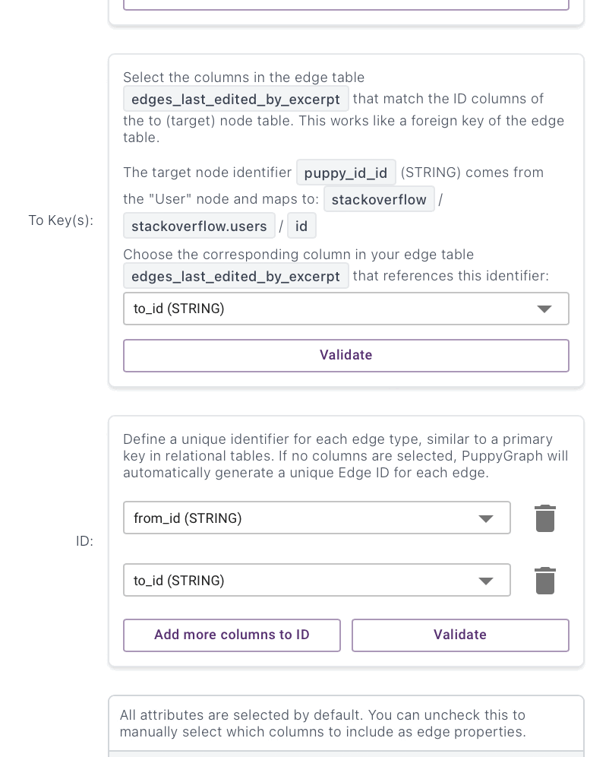
Earns (User -> Badge):
Preprocessing:
u = (spark.table("stackoverflow.users")
.select(F.trim(F.col("id")).alias("user_id"))
.dropna()
.dropDuplicates(["user_id"]))
bdg = (spark.table("stackoverflow.badges")
.select(F.trim(F.col("user_id")).alias("from_id"),
F.trim(F.col("id")).alias("to_id")))
edges_earns = (bdg
.filter(F.col("from_id").isNotNull())
.filter(F.col("from_id") != "")
.filter(F.col("from_id") != "0")
.join(u, F.col("from_id") == F.col("user_id"), "inner") # enforce user exists
.select("from_id", "to_id")
.dropDuplicates(["from_id", "to_id"]) # optional
)
print("Earns edges:", edges_earns.count())
edges_earns.write.format("delta").mode("overwrite").saveAsTable("stackoverflow.edges_earns")

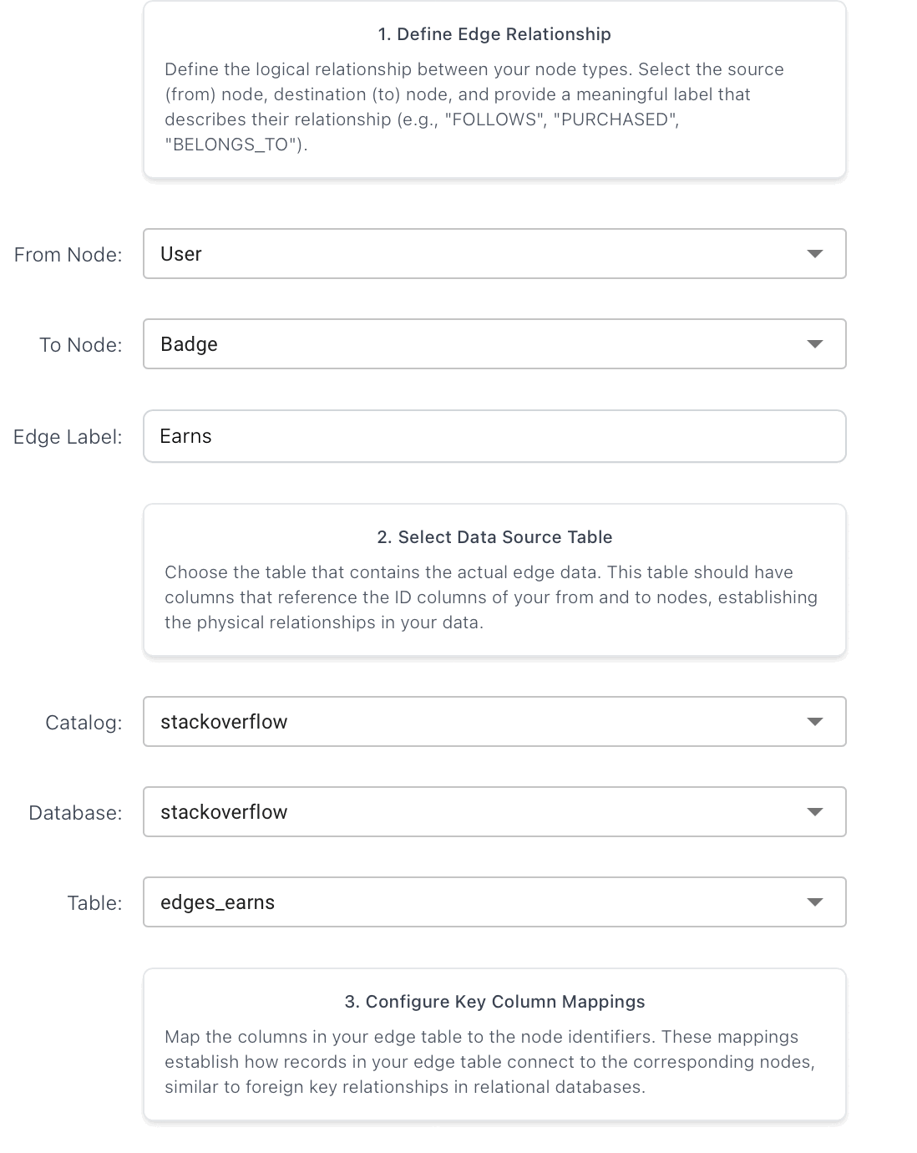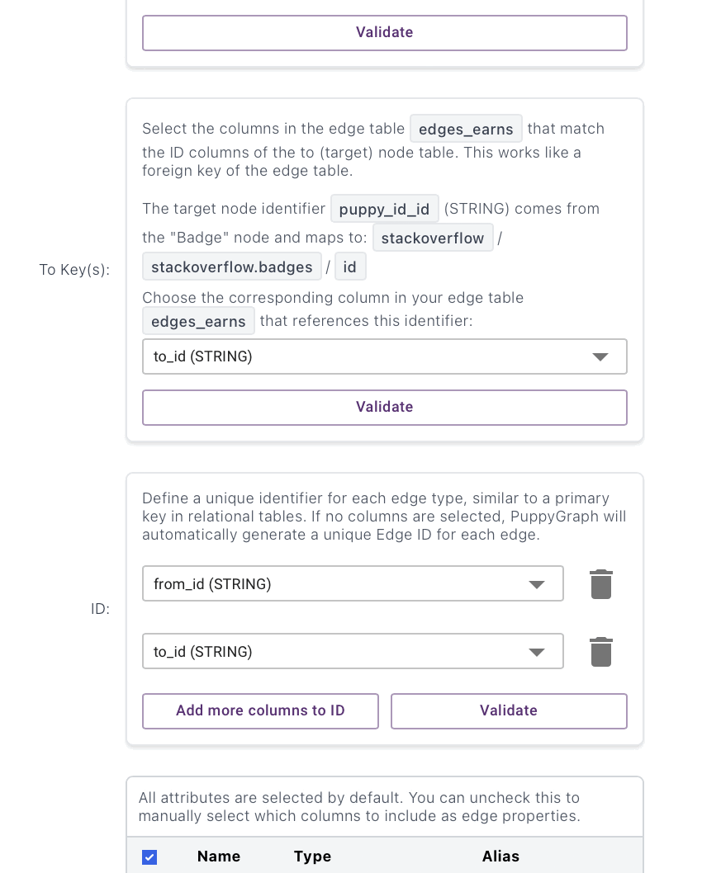

Answers_to (Post_answer -> Post_question):
Preprocessing:
ans_to = (spark.table("stackoverflow.posts_answers")
.select(F.trim(F.col("id")).alias("from_id"),
F.trim(F.col("parent_id")).alias("to_id")))
edges_answers_to = (ans_to
.filter(F.col("to_id").isNotNull())
.filter(F.col("to_id") != "")
.filter(F.col("to_id") != "0")
.select("from_id", "to_id")
)
print("Answers_to edges:", edges_answers_to.count())
edges_answers_to.write.format("delta").mode("overwrite").saveAsTable("stackoverflow.edges_answers_to")

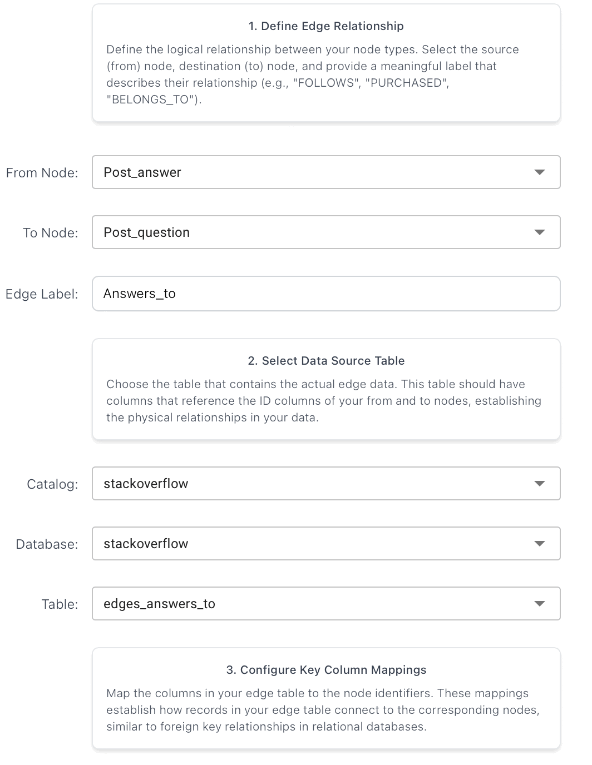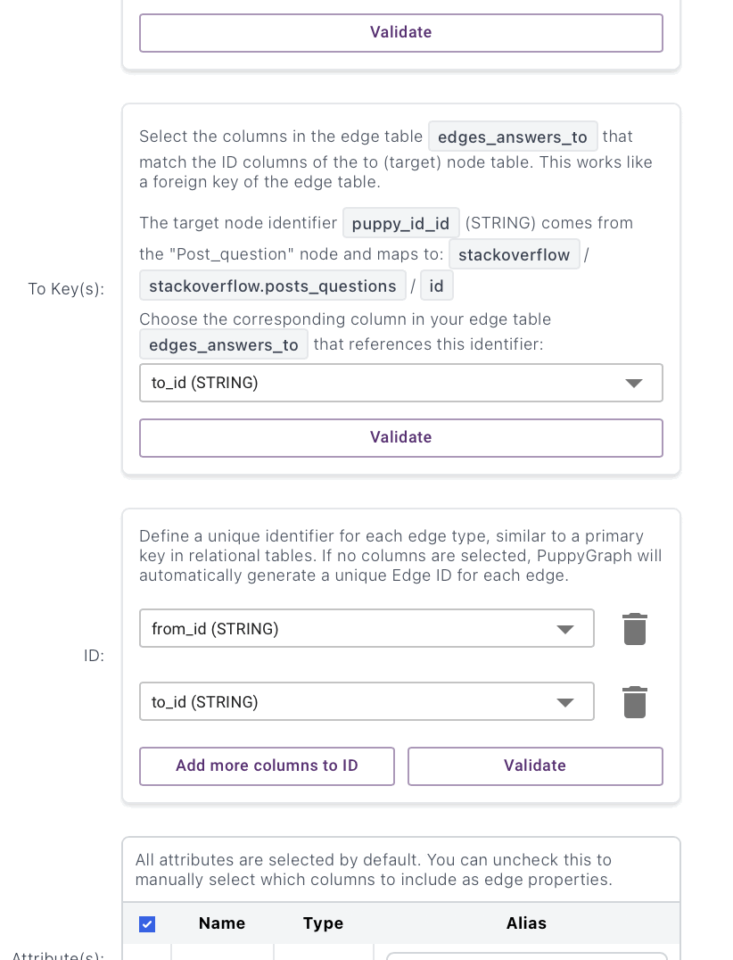

Accepts (Post_question -> Post_answer):
Preprocessing:
acc = (spark.table("stackoverflow.posts_questions")
.select(F.trim(F.col("id")).alias("from_id"),
F.trim(F.col("accepted_answer_id")).alias("to_id")))
edges_accepts = (acc
.filter(F.col("to_id").isNotNull())
.filter(F.col("to_id") != "")
.filter(F.col("to_id") != "0")
.select("from_id", "to_id")
)
print("Accepts edges:", edges_accepts.count())
edges_accepts.write.format("delta").mode("overwrite").saveAsTable("stackoverflow.edges_accepts")
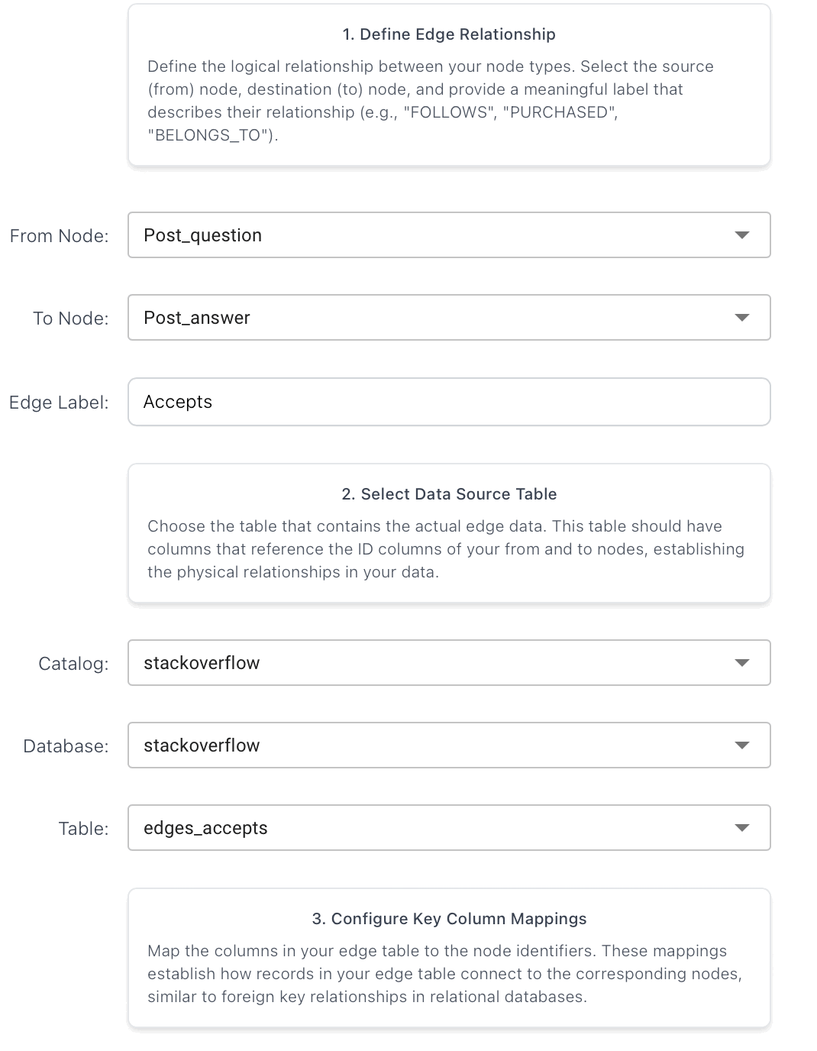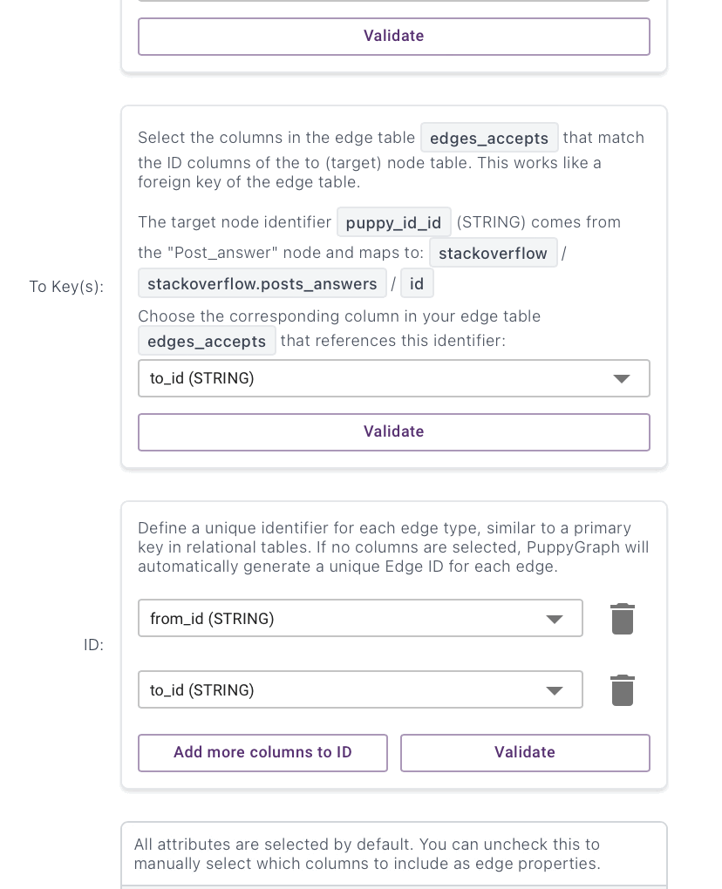

Commented_by (Comment -> User):
Preprocessing:
cm_user = (spark.table("stackoverflow.comments")
.select(F.trim(F.col("id")).alias("from_id"),
F.trim(F.col("user_id")).alias("to_id")))
edges_commented_by = (cm_user
.filter(F.col("to_id").isNotNull())
.filter(F.col("to_id") != "")
.filter(F.col("to_id") != "0")
.join(u, F.col("to_id") == F.col("user_id"), "inner")
.select("from_id", "to_id")
)
print("Commented_by edges:", edges_commented_by.count())
edges_commented_by.write.format("delta").mode("overwrite").saveAsTable("stackoverflow.edges_commented_by")
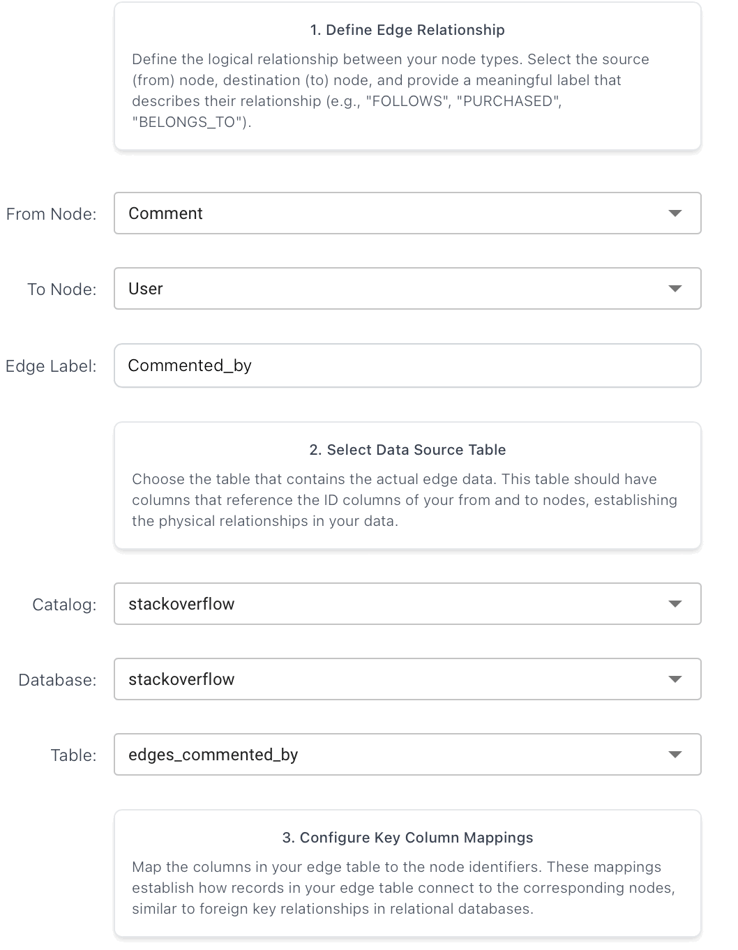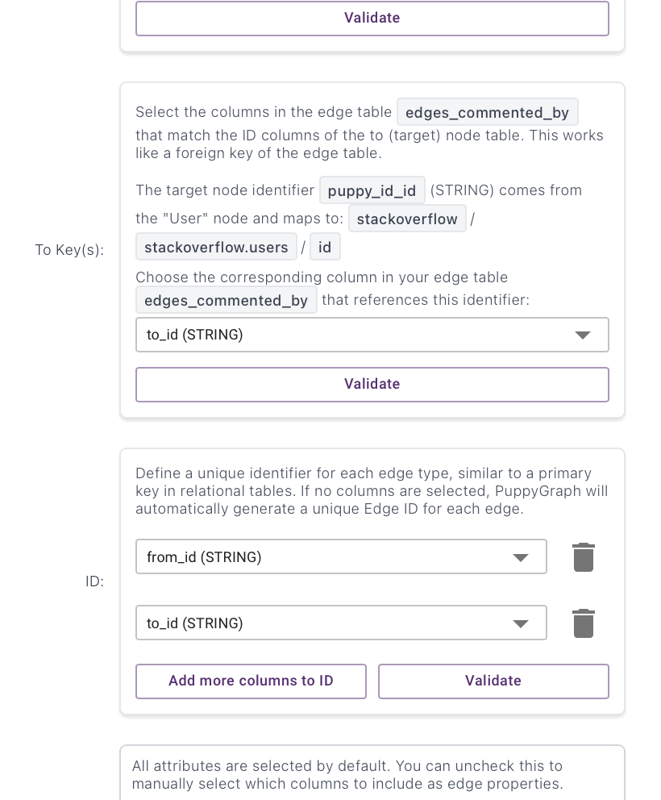

On_question (Comment -> Post_question):
Preprocessing:
u_ids = (spark.table("stackoverflow.users")
.select(F.trim(F.col("id")).alias("user_id"))
.filter(F.col("user_id").isNotNull())
.filter(F.col("user_id") != "")
.filter(F.col("user_id") != "0")
.dropDuplicates(["user_id"]))
q_ids = (spark.table("stackoverflow.posts_questions")
.select(F.trim(F.col("id")).alias("question_id"))
.filter(F.col("question_id").isNotNull())
.filter(F.col("question_id") != "")
.filter(F.col("question_id") != "0")
.dropDuplicates(["question_id"]))
a_ids = (spark.table("stackoverflow.posts_answers")
.select(F.trim(F.col("id")).alias("answer_id"))
.filter(F.col("answer_id").isNotNull())
.filter(F.col("answer_id") != "")
.filter(F.col("answer_id") != "0")
.dropDuplicates(["answer_id"]))
tw_ids = (spark.table("stackoverflow.posts_tag_wiki")
.select(F.trim(F.col("id")).alias("tag_wiki_id"))
.filter(F.col("tag_wiki_id").isNotNull())
.filter(F.col("tag_wiki_id") != "")
.filter(F.col("tag_wiki_id") != "0")
.dropDuplicates(["tag_wiki_id"]))
twe_ids = (spark.table("stackoverflow.posts_tag_wiki_excerpt")
.select(F.trim(F.col("id")).alias("tag_wiki_excerpt_id"))
.filter(F.col("tag_wiki_excerpt_id").isNotNull())
.filter(F.col("tag_wiki_excerpt_id") != "")
.filter(F.col("tag_wiki_excerpt_id") != "0")
.dropDuplicates(["tag_wiki_excerpt_id"]))
b_ids = (spark.table("stackoverflow.badges")
.select(F.trim(F.col("id")).alias("badge_id"))
.filter(F.col("badge_id").isNotNull())
.filter(F.col("badge_id") != "")
.filter(F.col("badge_id") != "0")
.dropDuplicates(["badge_id"]))
c_ids = (spark.table("stackoverflow.comments")
.select(F.trim(F.col("id")).alias("comment_id"))
.filter(F.col("comment_id").isNotNull())
.filter(F.col("comment_id") != "")
.filter(F.col("comment_id") != "0")
.dropDuplicates(["comment_id"]))
v_ids = (spark.table("stackoverflow.votes")
.select(F.trim(F.col("id")).alias("vote_id"))
.filter(F.col("vote_id").isNotNull())
.filter(F.col("vote_id") != "")
.filter(F.col("vote_id") != "0")
.dropDuplicates(["vote_id"]))
def valid(colname: str):
"""helper to filter not null, not '', not '0' on a column name"""
return (F.col(colname).isNotNull()) & (F.col(colname) != "") & (F.col(colname) != "0")

cm_on_src = (spark.table("stackoverflow.comments")
.select(F.trim(F.col("id")).alias("from_id"),
F.trim(F.col("post_id")).alias("to_id"))
.filter(valid("to_id")))
edges_on_question = (cm_on_src
.join(c_ids, F.col("from_id") == F.col("comment_id"), "inner")
.join(q_ids, F.col("to_id") == F.col("question_id"), "inner") # <-- this is the key fix
.select("from_id", "to_id")
)
print("On_question:", edges_on_question.count())
edges_on_question.write.format("delta").mode("overwrite").saveAsTable("stackoverflow.edges_on_question")

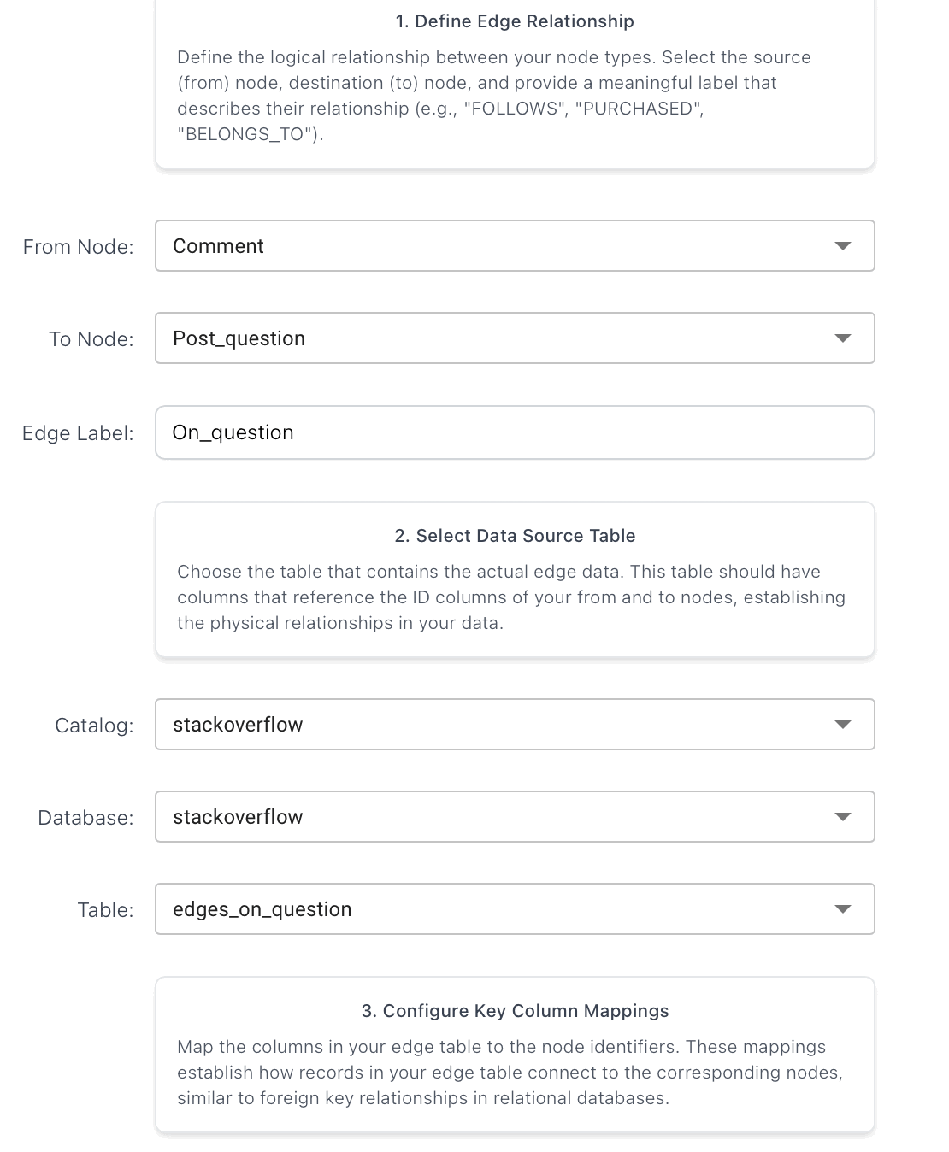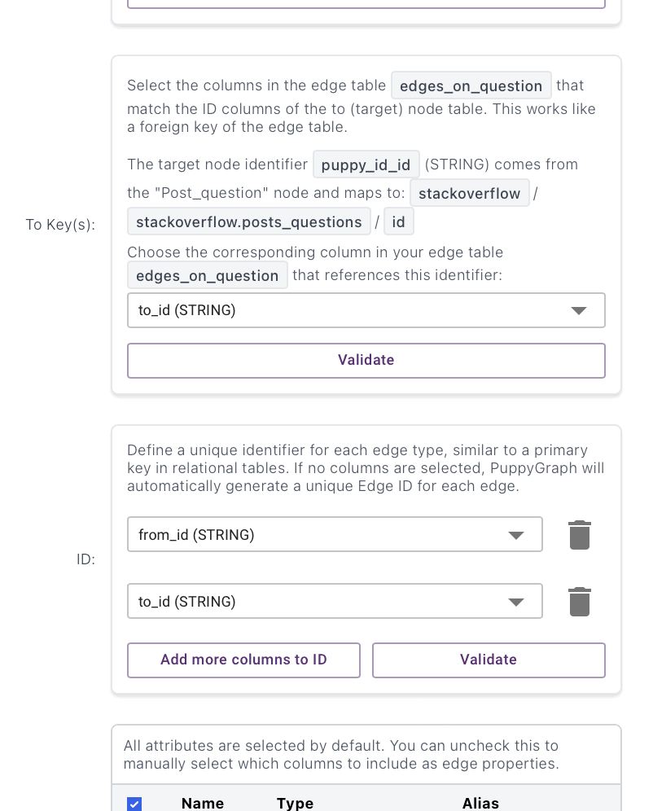

On_answer (Comment -> Post_answer):
Preprocessing:
edges_on_answer = (cm_on_src
.join(c_ids, F.col("from_id") == F.col("comment_id"), "inner")
.join(a_ids, F.col("to_id") == F.col("answer_id"), "inner") # <-- and this
.select("from_id", "to_id")
)
print("On_answer:", edges_on_answer.count())
edges_on_answer.write.format("delta").mode("overwrite").saveAsTable("stackoverflow.edges_on_answer")
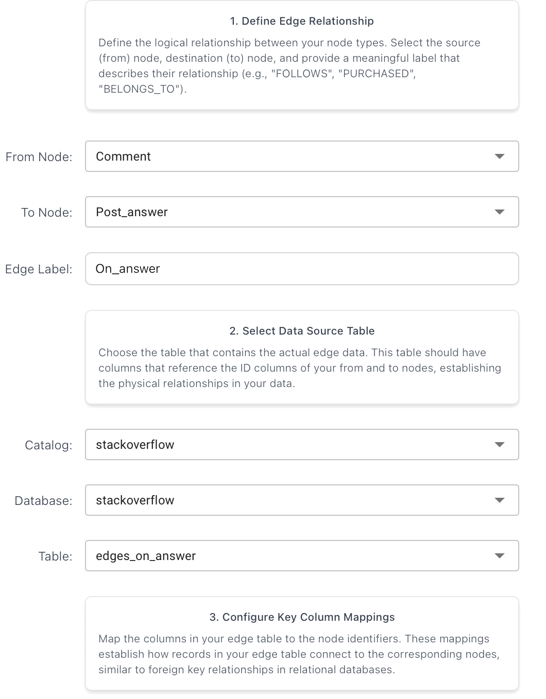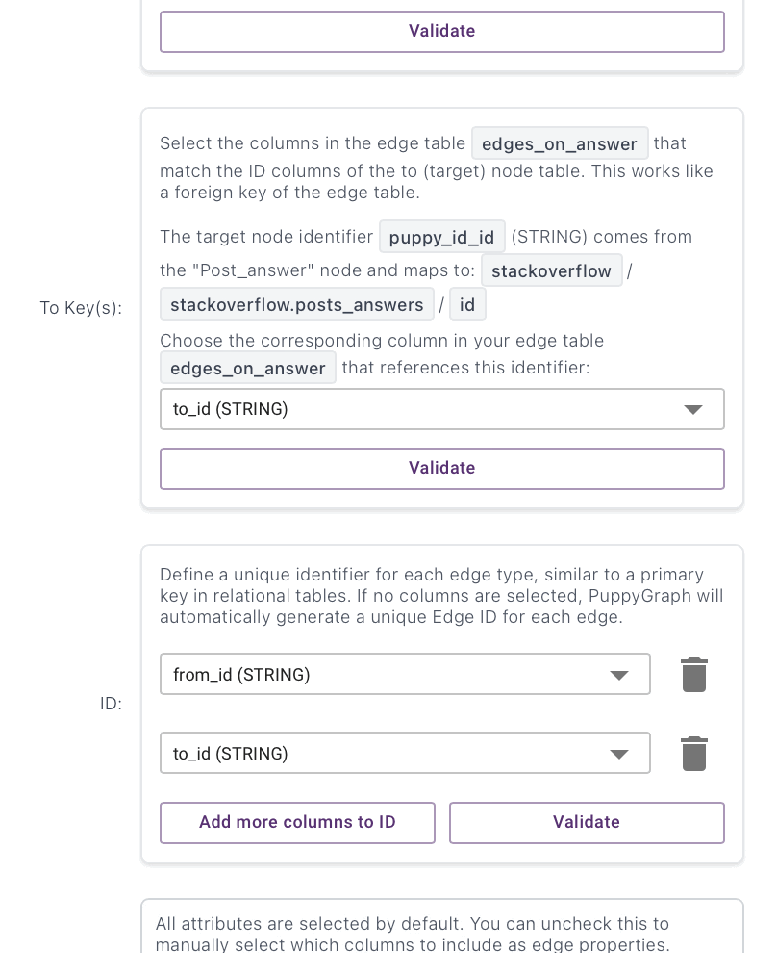

Vote_on_question (Vote -> Post_question):
Preprocessing:
votes_src = (spark.table("stackoverflow.votes")
.select(F.trim(F.col("id")).alias("from_id"),
F.trim(F.col("post_id")).alias("to_id"))
.filter(valid("to_id")))
edges_vote_on_question = (votes_src
.join(v_ids, F.col("from_id") == F.col("vote_id"), "inner")
.join(q_ids, F.col("to_id") == F.col("question_id"), "inner") # <-- key fix
.select("from_id", "to_id")
)
print("Vote_on_question:", edges_vote_on_question.count())
edges_vote_on_question.write.format("delta").mode("overwrite").saveAsTable("stackoverflow.edges_vote_on_question")
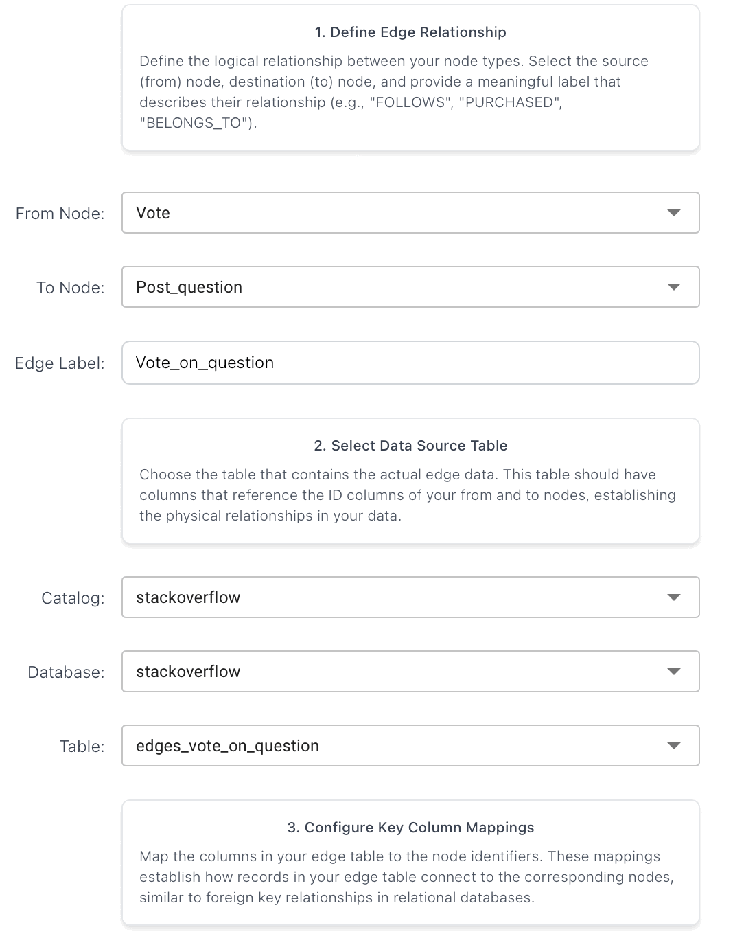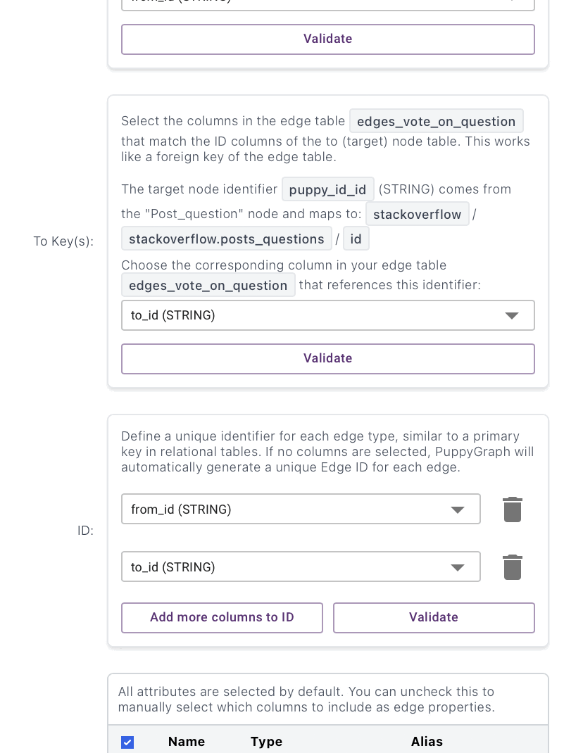
Vote_on_answer (Vote -> Post_answer):
Preprocessing:
edges_vote_on_answer = (votes_src
.join(v_ids, F.col("from_id") == F.col("vote_id"), "inner")
.join(a_ids, F.col("to_id") == F.col("answer_id"), "inner") # <-- key fix
.select("from_id", "to_id")
)
print("Vote_on_answer:", edges_vote_on_answer.count())
edges_vote_on_answer.write.format("delta").mode("overwrite").saveAsTable("stackoverflow.edges_vote_on_answer")
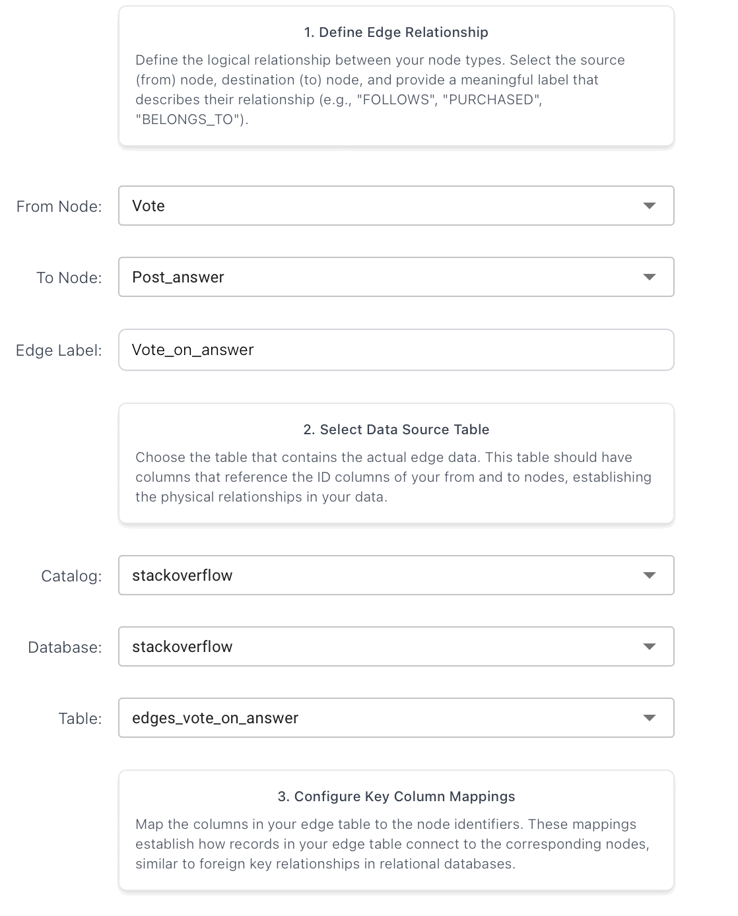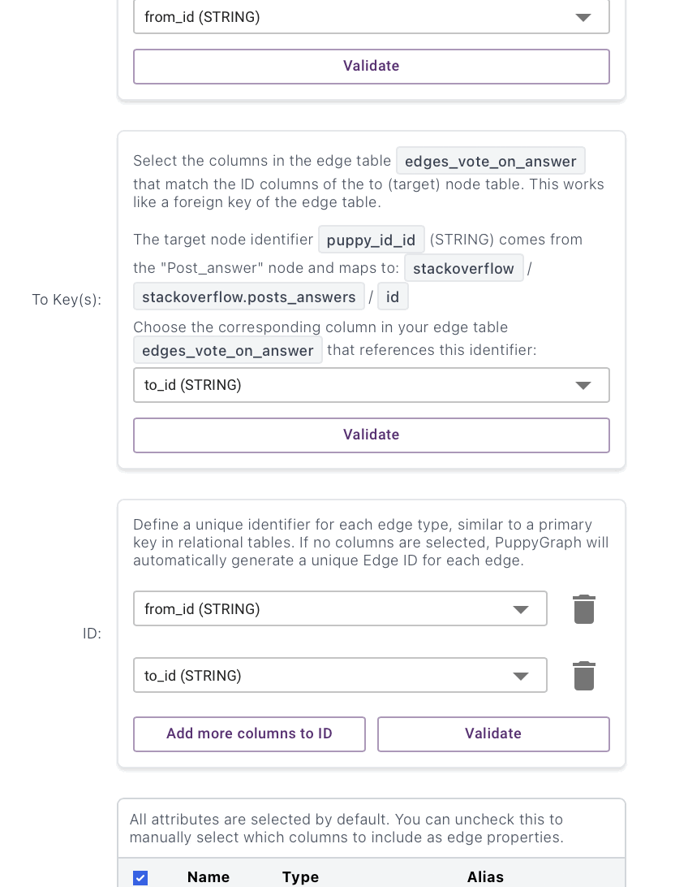
Vote_on_comment (Vote -> Comment):
Preprocessing:
edges_vote_on_comment = (votes_src
.join(v_ids, F.col("from_id") == F.col("vote_id"), "inner")
.join(c_ids, F.col("to_id") == F.col("comment_id"), "inner") # <-- key fix
.select("from_id", "to_id")
)
print("Vote_on_comment:", edges_vote_on_comment.count())
edges_vote_on_comment.write.format("delta").mode("overwrite").saveAsTable("stackoverflow.edges_vote_on_comment")
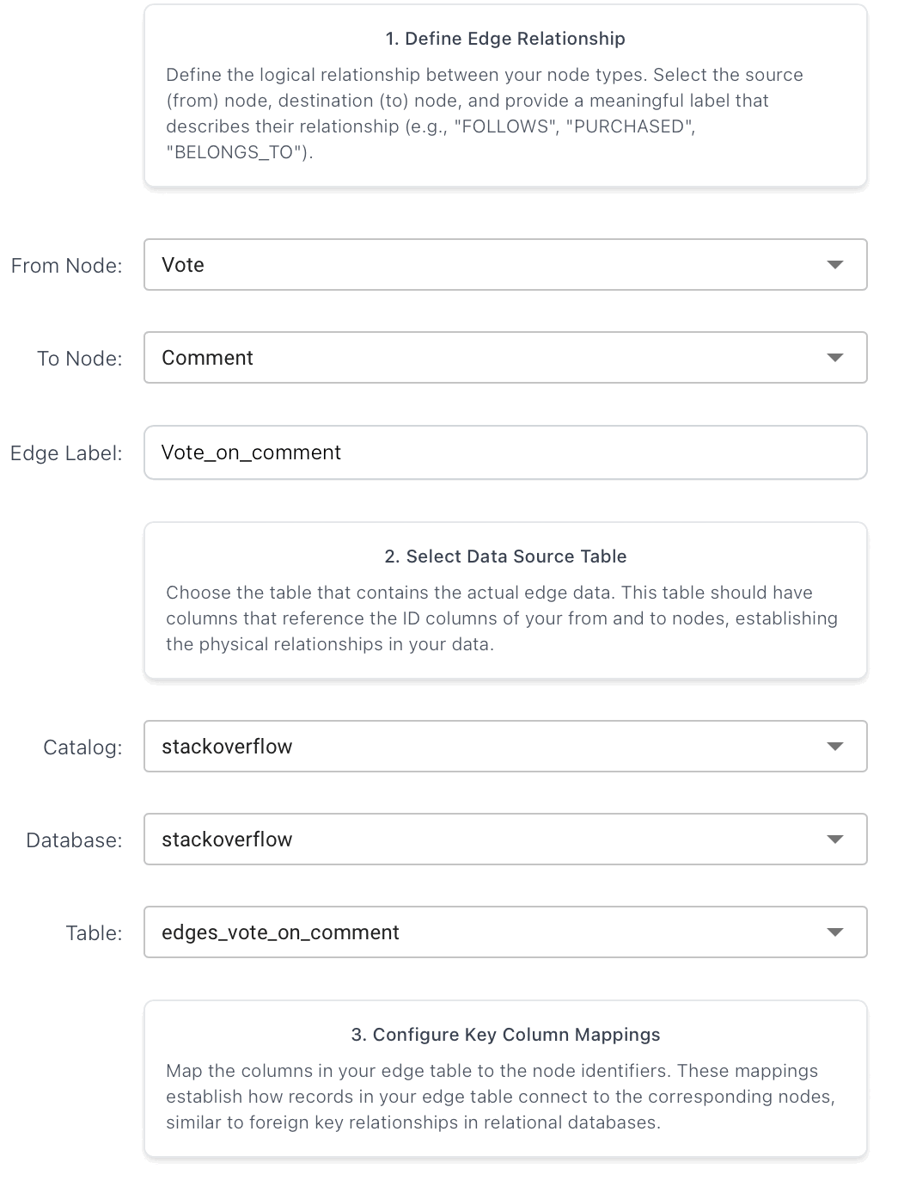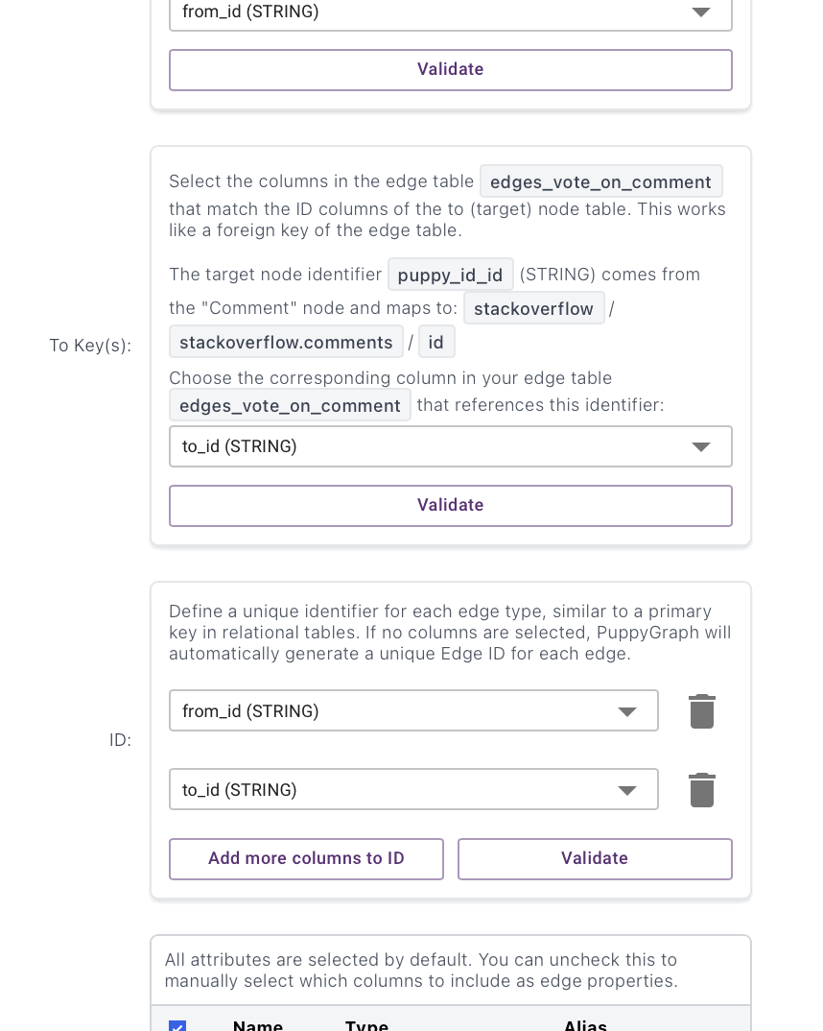
Tag_to (Tag -> Post_question):
Preprocessing:
def valid(colname: str):
return (F.col(colname).isNotNull()) & (F.col(colname) != "") & (F.col(colname) != "0")
tag_ids = (spark.table("stackoverflow.tags")
.select(F.trim(F.col("id")).alias("tag_id"),
F.trim(F.col("tag_name")).alias("tag_name"))
.filter(valid("tag_id"))
.dropDuplicates(["tag_id"]))
# For Tag_to we need tag_name -> tag_id mapping (case-insensitive)
tag_name_map = (spark.table("stackoverflow.tags")
.select(F.lower(F.trim(F.col("tag_name"))).alias("tag_name_lc"),
F.trim(F.col("id")).alias("tag_id"))
.filter(F.col("tag_name_lc").isNotNull())
.filter(F.col("tag_name_lc") != "")
.filter(valid("tag_id"))
.dropDuplicates(["tag_name_lc"]))
question_ids = (spark.table("stackoverflow.posts_questions")
.select(F.trim(F.col("id")).alias("question_id"))
.filter(valid("question_id"))
.dropDuplicates(["question_id"]))
tag_wiki_ids = (spark.table("stackoverflow.posts_tag_wiki")
.select(F.trim(F.col("id")).alias("tag_wiki_id"))
.filter(valid("tag_wiki_id"))
.dropDuplicates(["tag_wiki_id"]))
tag_wiki_excerpt_ids = (spark.table("stackoverflow.posts_tag_wiki_excerpt")
.select(F.trim(F.col("id")).alias("tag_wiki_excerpt_id"))
.filter(valid("tag_wiki_excerpt_id"))
.dropDuplicates(["tag_wiki_excerpt_id"]))

pq_tags = (spark.table("stackoverflow.posts_questions")
.select(F.trim(F.col("id")).alias("question_id"),
F.col("tags").alias("tags_raw"))
.filter(valid("question_id"))
.filter(F.col("tags_raw").isNotNull())
.filter(F.trim(F.col("tags_raw")) != "")
)
# Convert "<a><b><c>" -> "a|b|c" then split+explode
pq_exploded = (pq_tags
.withColumn(
"tags_pipe",
F.regexp_replace(
F.regexp_replace(F.col("tags_raw"), r"><", "|"),
r"[<>]",
""
)
)
.withColumn("tag_name_lc", F.explode(F.split(F.lower(F.col("tags_pipe")), r"\|")))
.withColumn("tag_name_lc", F.trim(F.col("tag_name_lc")))
.filter(F.col("tag_name_lc") != "")
.select("question_id", "tag_name_lc")
)
# Join to get tag_id and enforce both endpoints exist
edges_tag_to = (pq_exploded
.join(tag_name_map, on="tag_name_lc", how="inner") # tag exists
.join(question_ids, on="question_id", how="inner") # question exists
.select(F.col("tag_id").alias("from_id"),
F.col("question_id").alias("to_id"))
.dropDuplicates(["from_id", "to_id"]) # safe: 1 tag per question
)
print("Tag_to edges:", edges_tag_to.count())
edges_tag_to.write.format("delta").mode("overwrite") \
.saveAsTable("stackoverflow.edges_tag_to")

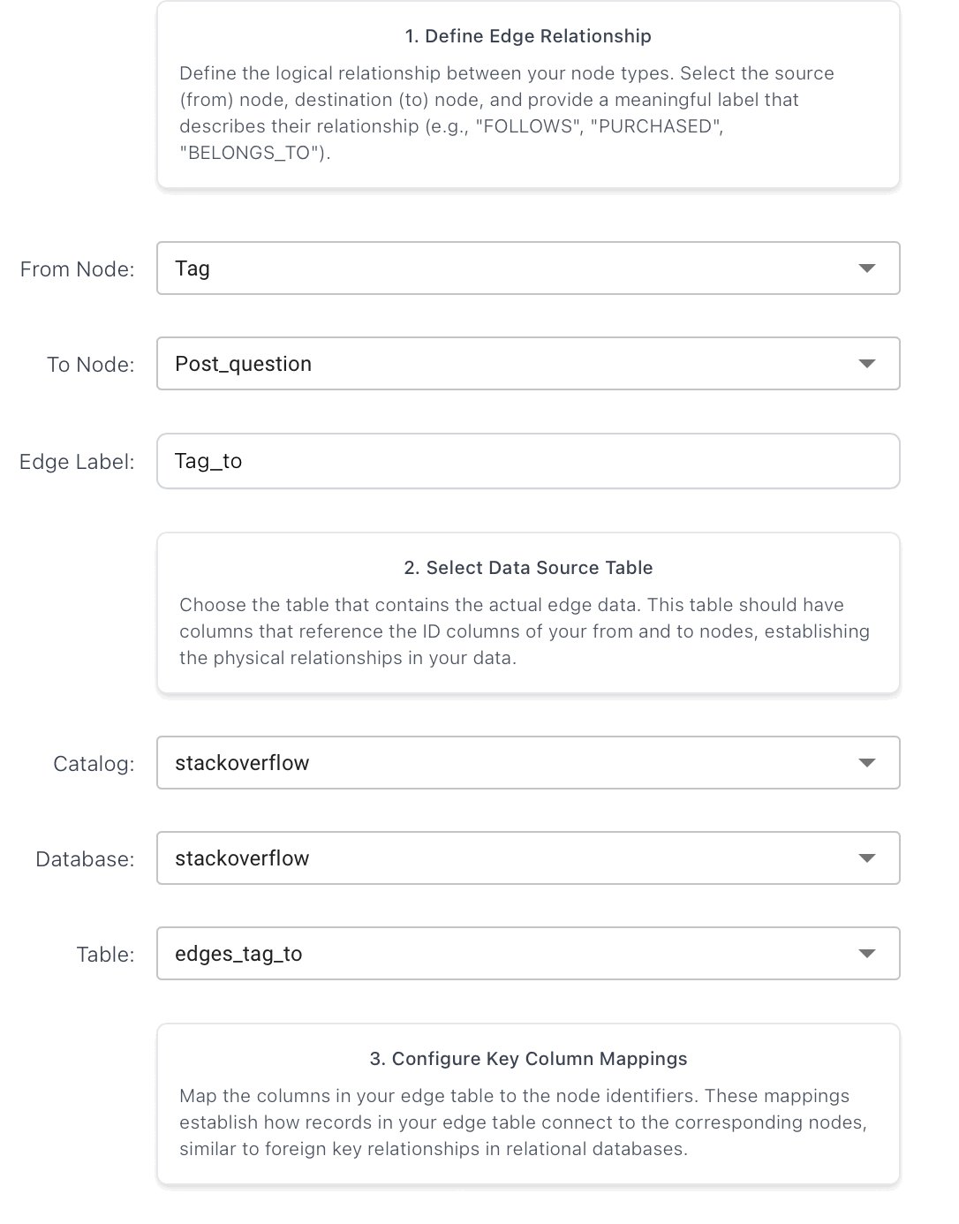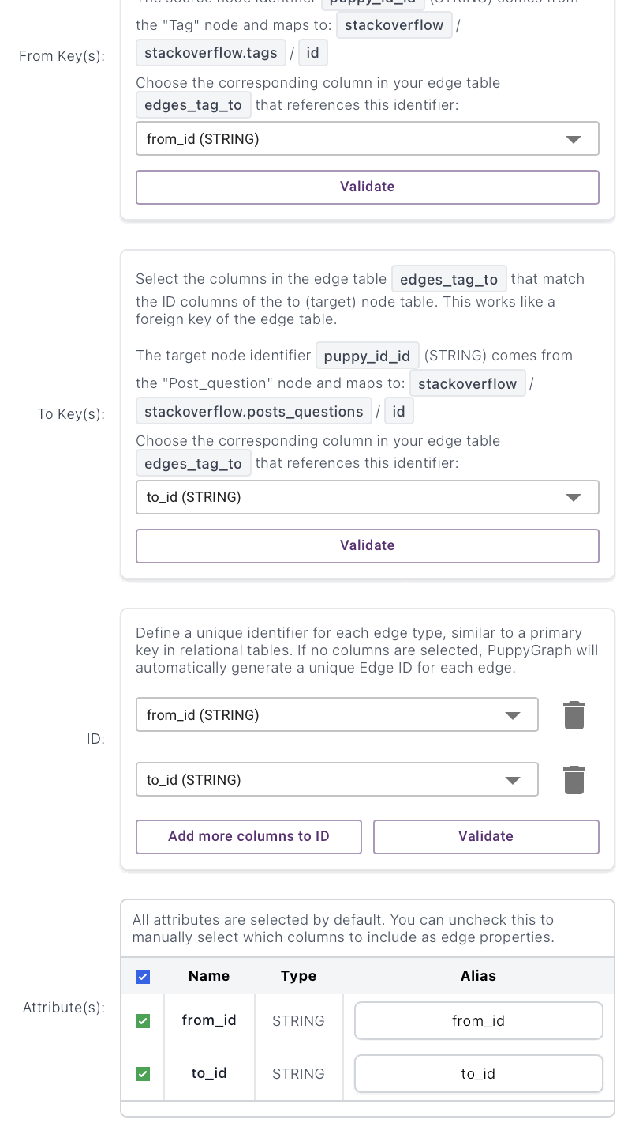
Has_wiki (Tag -> Post_tag_wiki):
Preprocessing:
has_wiki_src = (spark.table("stackoverflow.tags")
.select(F.trim(F.col("id")).alias("from_id"),
F.trim(F.col("wiki_post_id")).alias("to_id"))
.filter(valid("from_id"))
.filter(valid("to_id")))
edges_has_wiki = (has_wiki_src
.join(tag_ids.select("tag_id"), F.col("from_id") == F.col("tag_id"), "inner")
.join(tag_wiki_ids, F.col("to_id") == F.col("tag_wiki_id"), "inner")
.select("from_id", "to_id")
.dropDuplicates(["from_id", "to_id"])
)
print("Has_wiki edges:", edges_has_wiki.count())
edges_has_wiki.write.format("delta").mode("overwrite") \
.saveAsTable("stackoverflow.edges_has_wiki")

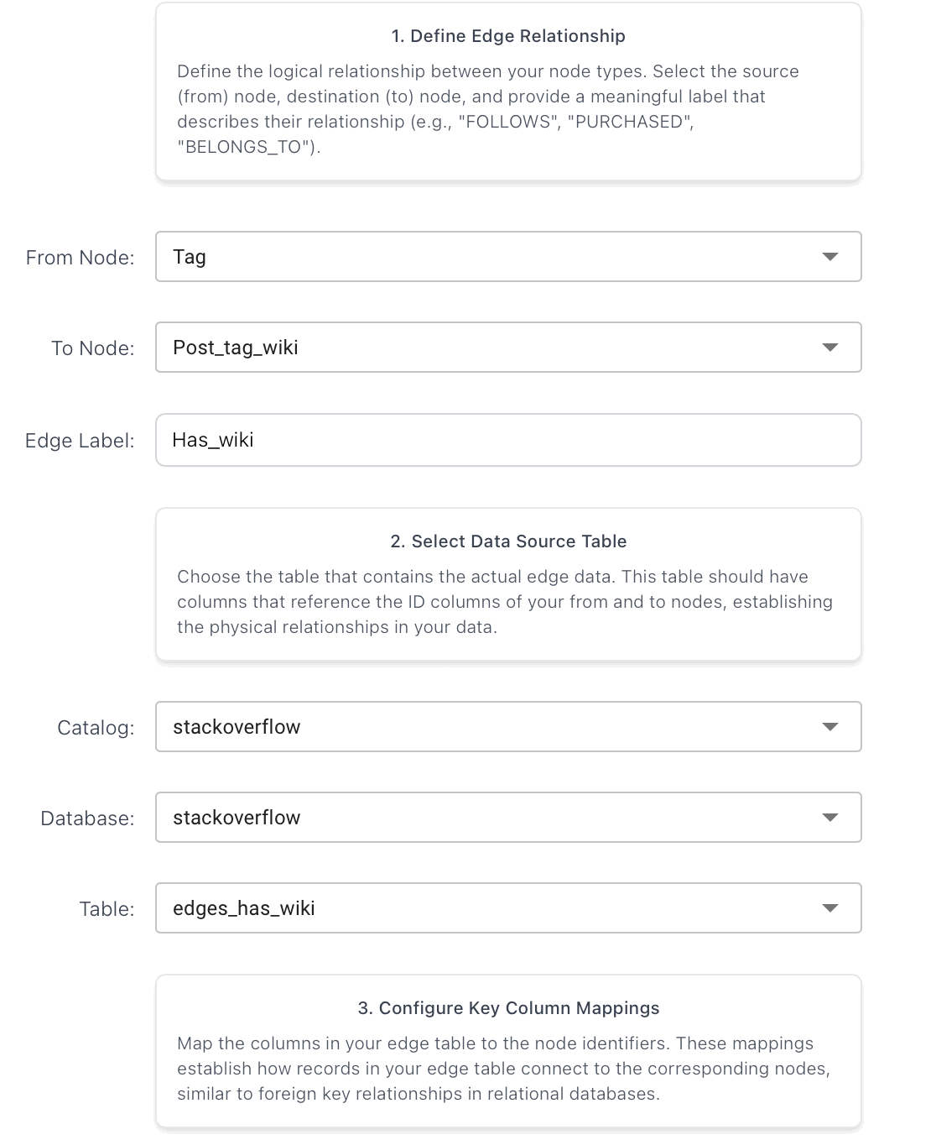

Has_wiki_excerpt (Tag -> Post_tag_wiki_excerpt):
Preprocessing:
has_wiki_excerpt_src = (spark.table("stackoverflow.tags")
.select(F.trim(F.col("id")).alias("from_id"),
F.trim(F.col("excerpt_post_id")).alias("to_id"))
.filter(valid("from_id"))
.filter(valid("to_id")))
edges_has_wiki_excerpt = (has_wiki_excerpt_src
.join(tag_ids.select("tag_id"), F.col("from_id") == F.col("tag_id"), "inner")
.join(tag_wiki_excerpt_ids, F.col("to_id") == F.col("tag_wiki_excerpt_id"), "inner")
.select("from_id", "to_id")
.dropDuplicates(["from_id", "to_id"])
)
print("Has_wiki_excerpt edges:", edges_has_wiki_excerpt.count())
edges_has_wiki_excerpt.write.format("delta").mode("overwrite") \
.saveAsTable("stackoverflow.edges_has_wiki_excerpt")
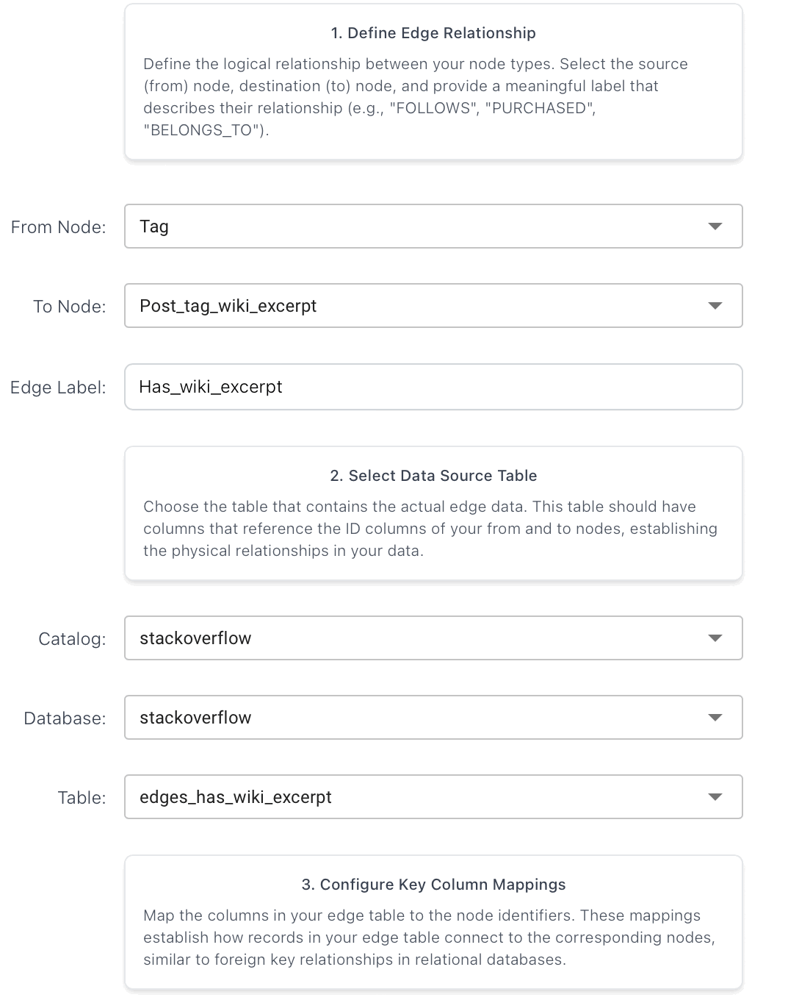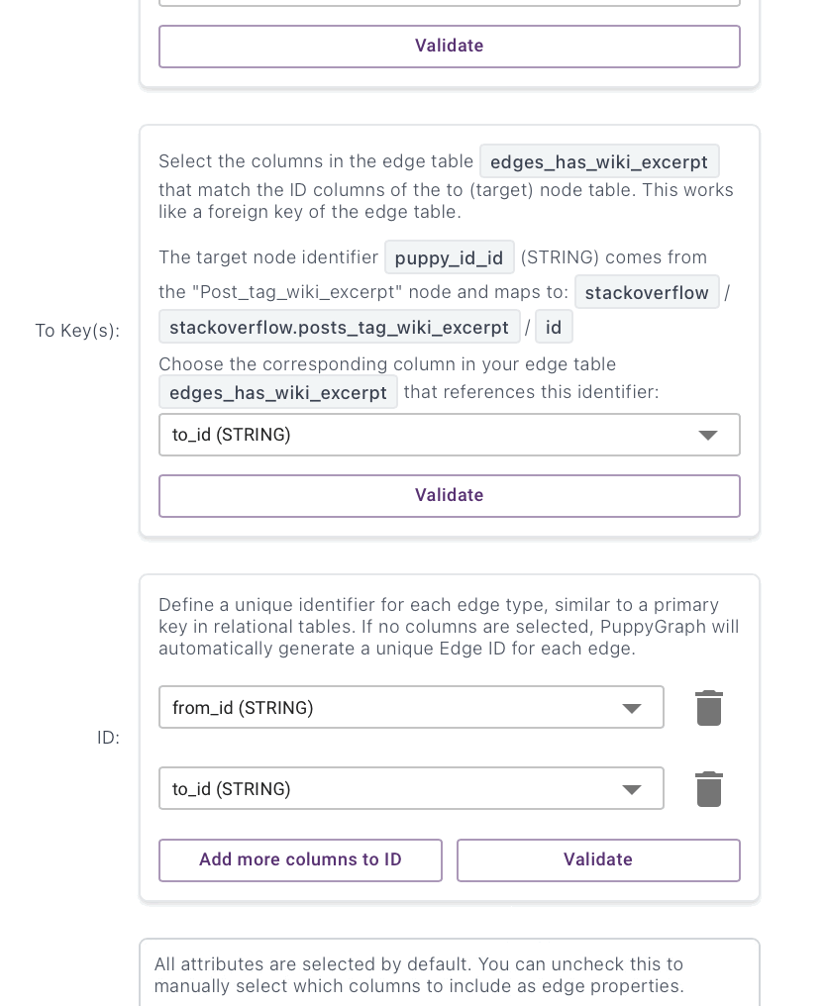

Link_to (Post_question -> Post_question):
Preprocessing:
links_src = (spark.table("stackoverflow.posts_links")
.select(F.trim(F.col("post_id")).alias("from_id"),
F.trim(F.col("related_post_id")).alias("to_id"))
.filter(valid("from_id"))
.filter(valid("to_id")))
edges_link_to = (links_src
.join(question_ids.withColumnRenamed("question_id", "q_from"),
F.col("from_id") == F.col("q_from"), "inner")
.join(question_ids.withColumnRenamed("question_id", "q_to"),
F.col("to_id") == F.col("q_to"), "inner")
.select("from_id", "to_id")
.dropDuplicates(["from_id", "to_id"])
)
print("Link_to edges:", edges_link_to.count())
edges_link_to.write.format("delta").mode("overwrite") \
.saveAsTable("stackoverflow.edges_link_to")

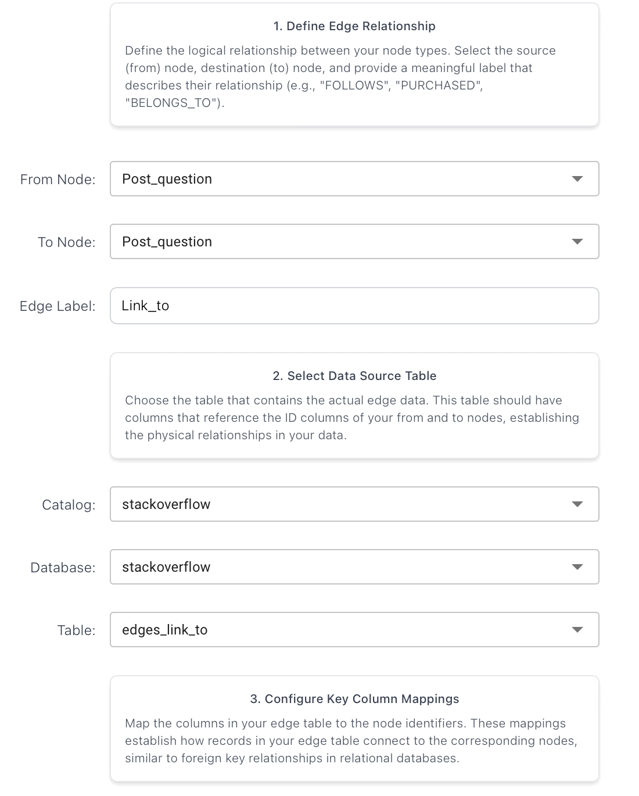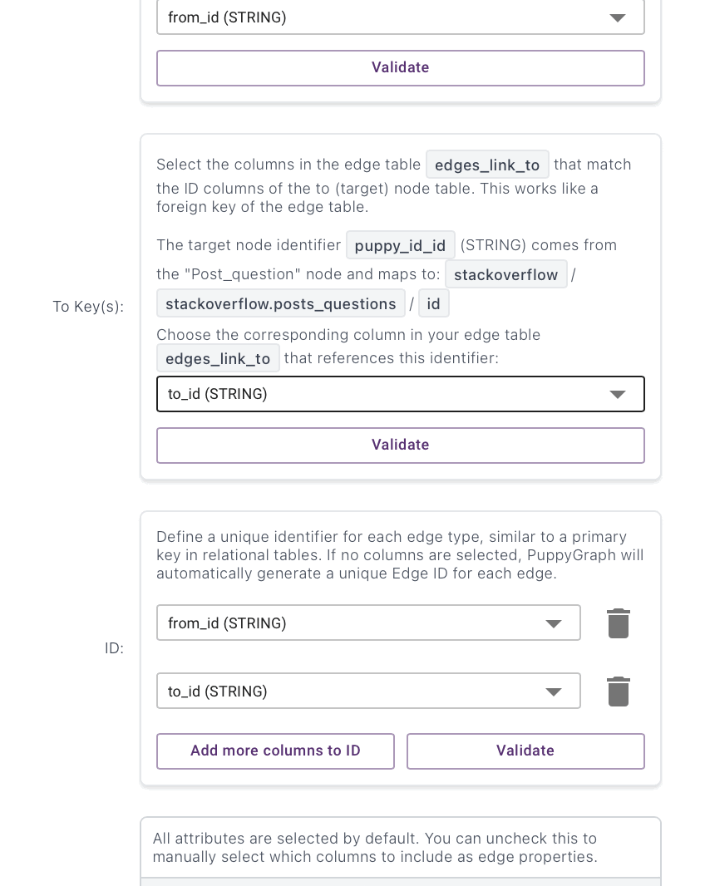

Queries
Query 1: User Pairs with Most Question-Answer Interactions

MATCH (a:Post_answer)-[:Answers_to]->(q:Post_question)
MATCH (a)-[:Answers_by]->(answerer:User)
MATCH (q)-[:Owned_by]->(questioner:User)
WHERE answerer.id <> questioner.id
WITH (answerer.id + ':' + questioner.id) AS pair_key,
COUNT(*) AS interaction_count
WHERE interaction_count >= 5
RETURN pair_key, interaction_count
ORDER BY interaction_count DESC
LIMIT 100;

DURATION: 8.214 s
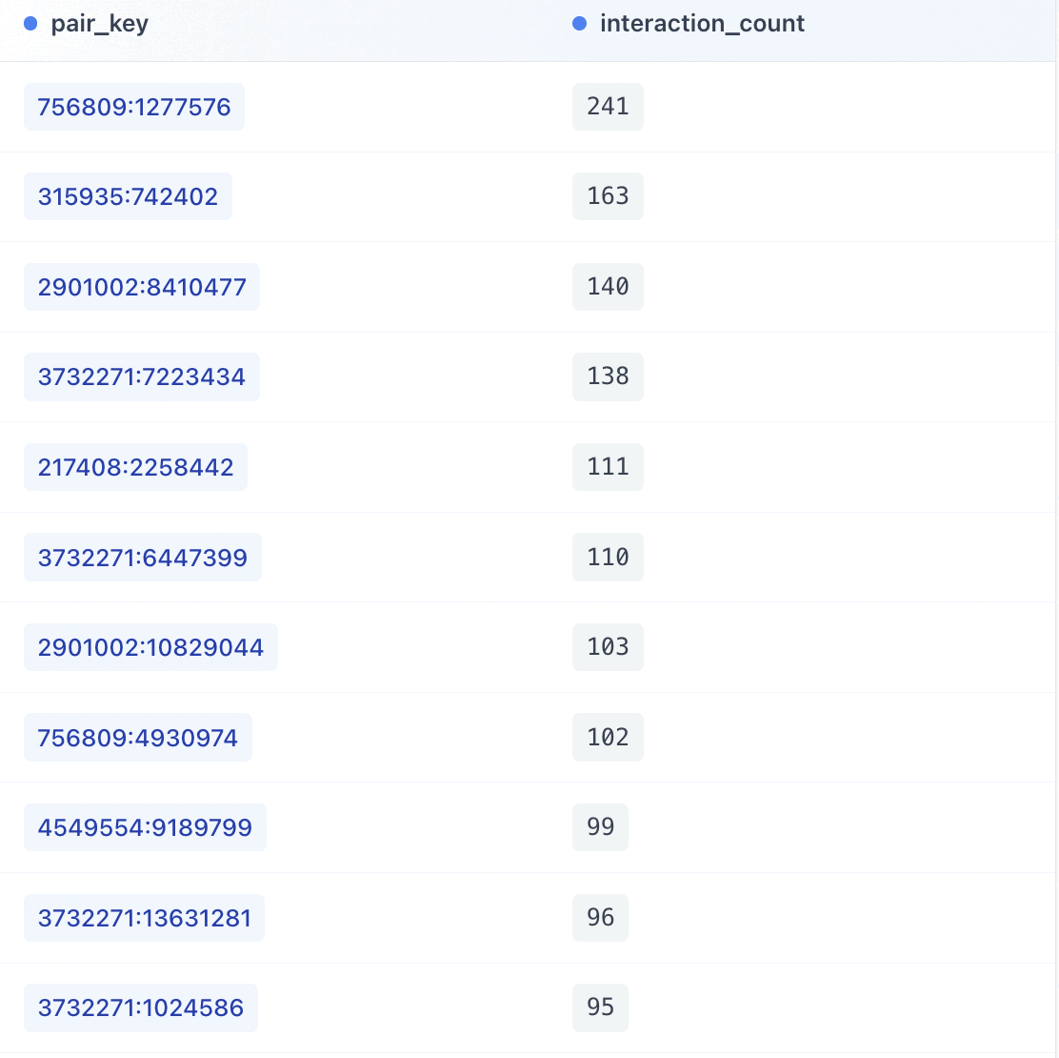

Query 2: Tags with Highest Question-to-Answer Ratio

MATCH (t:Tag)-[:Tag_to]->(q:Post_question)
WITH t, COUNT(q) AS question_count
MATCH (t)-[:Tag_to]->(q2:Post_question)<-[:Answers_to]-(a:Post_answer)
WITH t.tag_name AS tag_name,
question_count,
COUNT(a) AS answer_count
WHERE answer_count > 0
RETURN tag_name,
question_count,
answer_count,
toFloat(question_count) / toFloat(answer_count) AS ratio
ORDER BY ratio DESC
LIMIT 200;

DURATION: 12.044 s

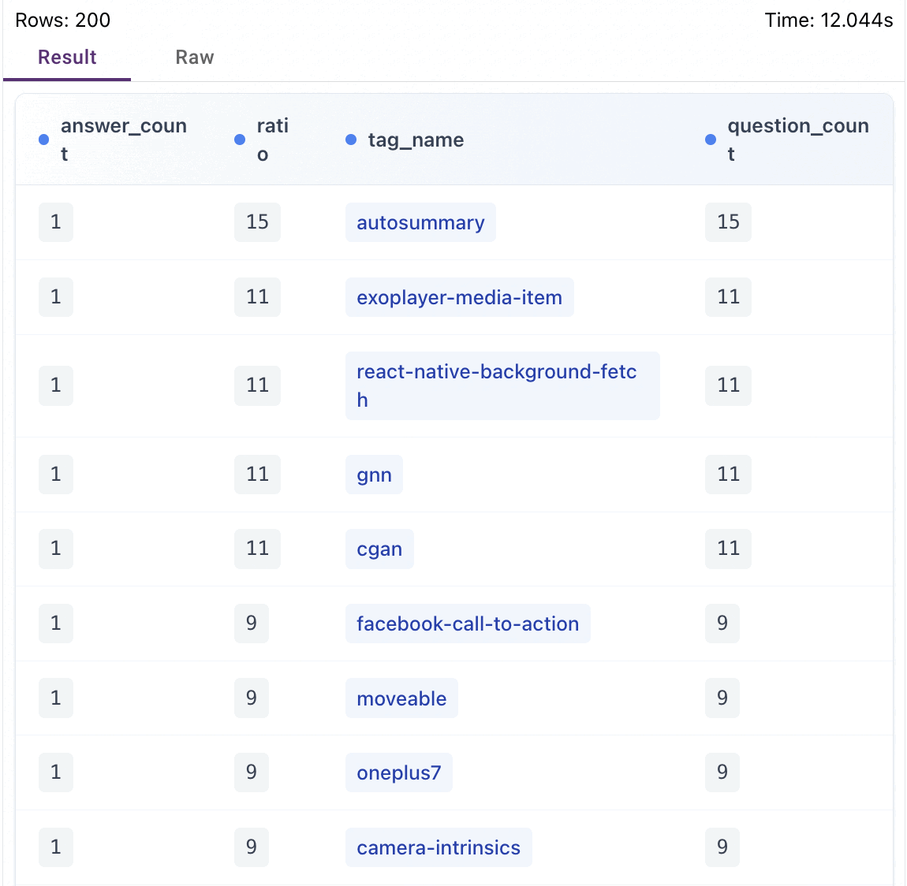

Query 3: Questions with Most Views But No Accepted Answer
MATCH (q:Post_question)
WHERE (q.accepted_answer_id IS NULL
OR q.accepted_answer_id = ''
OR q.accepted_answer_id = '0'
OR q.accepted_answer_id = 'None')
RETURN q.id AS question_id,
toInteger(q.view_count) AS view_count,
toInteger(q.answer_count) AS answer_count
ORDER BY toInteger(q.view_count) DESC
LIMIT 200;

DURATION: 0.502 s

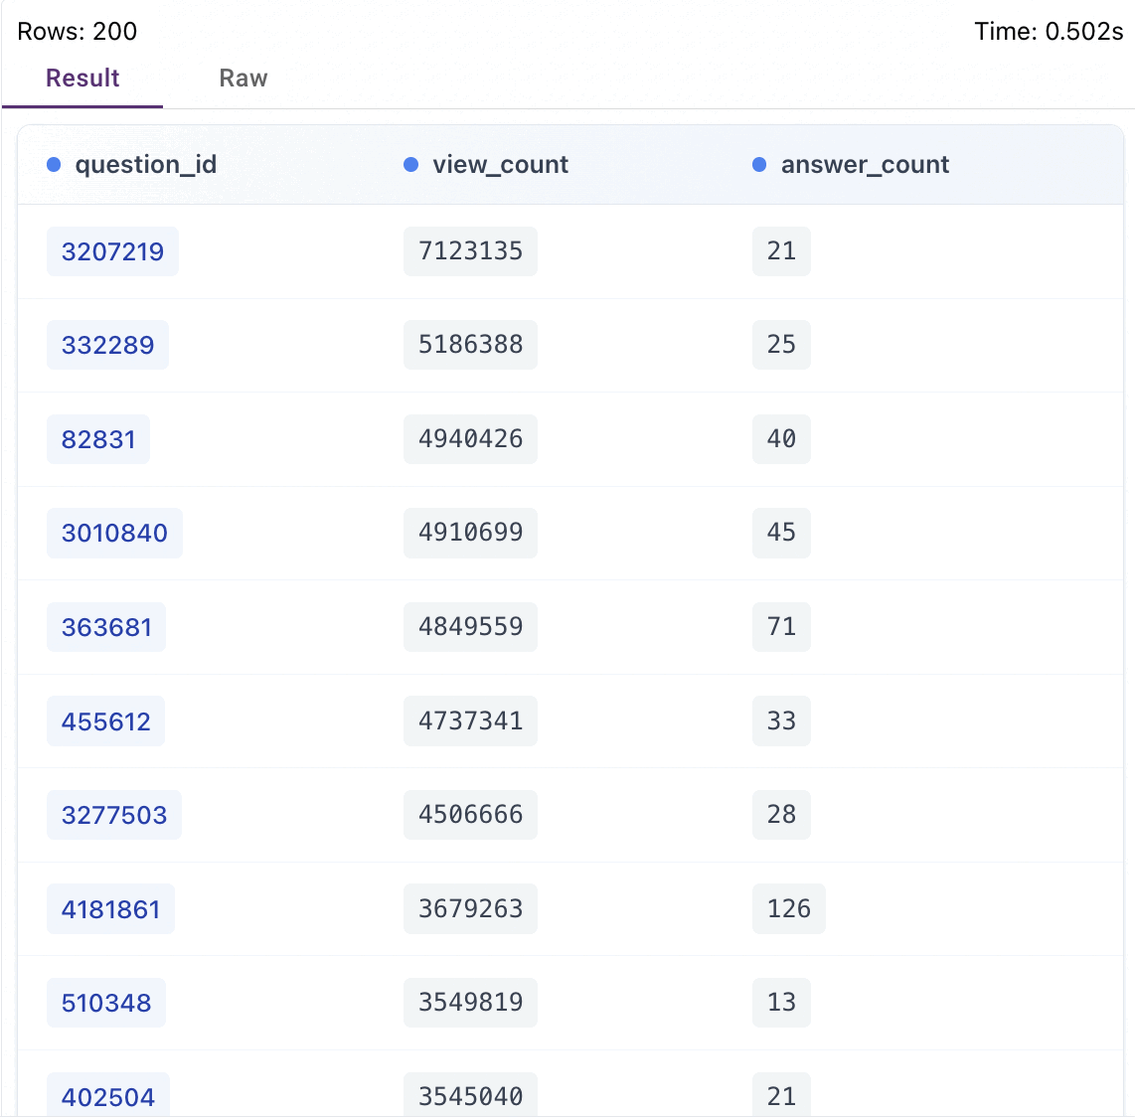

Query 4: Users Who Earn Badges Fastest After Account Creation
MATCH (u:User)-[:Earns]->(b:Badge)
WHERE u.creation_date IS NOT NULL
AND b.date IS NOT NULL
AND u.creation_date <> ''
AND b.date <> ''
WITH u.id AS user_id,
u.display_name AS display_name,
u.creation_date AS creation_date,
MIN(
(toInteger(substring(b.date, 0, 4)) - toInteger(substring(u.creation_date, 0, 4))) * 365 +
(toInteger(substring(b.date, 5, 2)) - toInteger(substring(u.creation_date, 5, 2))) * 30 +
(toInteger(substring(b.date, 8, 2)) - toInteger(substring(u.creation_date, 8, 2)))
) AS min_days
WHERE min_days >= 0
RETURN user_id, display_name, min_days
ORDER BY min_days ASC, user_id ASC
LIMIT 20;

DURATION: 11.275 s

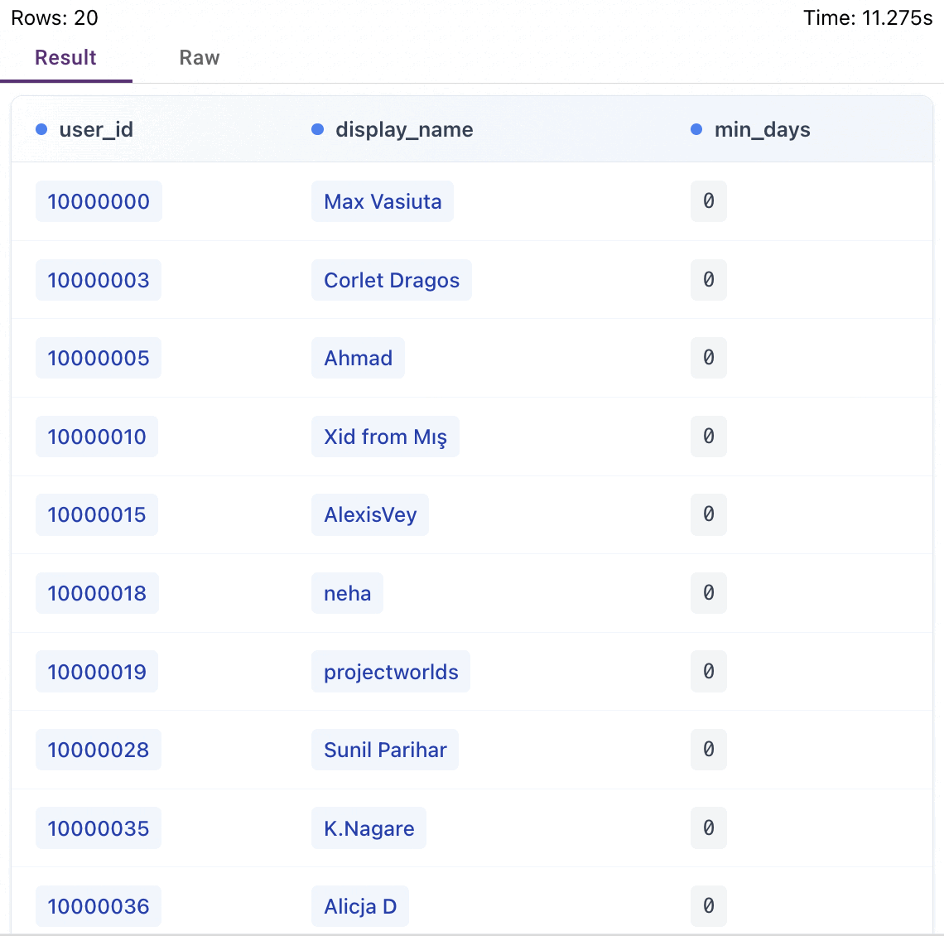
Query 5: Percentage of Questions Answered Over the Years
MATCH (q:Post_question)
WHERE q.creation_date IS NOT NULL
AND q.creation_date <> ''
WITH substring(q.creation_date, 0, 4) AS year_val,
COUNT(q) AS total_questions,
SUM(CASE
WHEN toInteger(q.answer_count) > 0 THEN 1
ELSE 0
END) AS answered_questions
RETURN year_val,
total_questions,
answered_questions,
round(
toFloat(answered_questions) * 100.0 / toFloat(total_questions),
5
) AS answer_rate
ORDER BY year_val ASC;

DURATION: 0.797 s
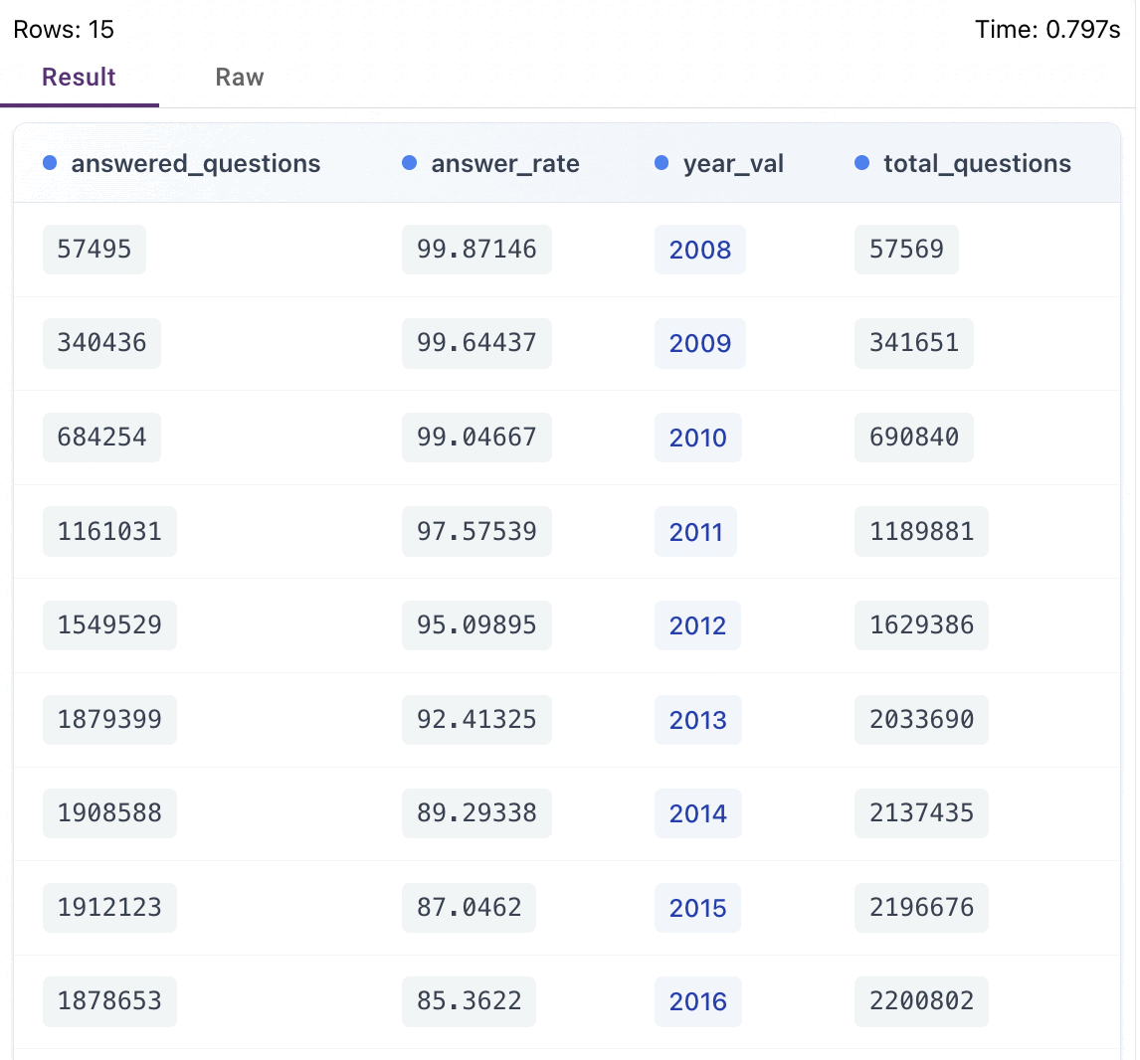
Query 6: Top 10 Easiest Gold Badges to Earn
MATCH (u:User)-[:Earns]->(b:Badge)
WHERE b.class = '1'
AND u.creation_date IS NOT NULL
AND b.date IS NOT NULL
AND u.creation_date <> ''
AND b.date <> ''
WITH b.name AS badge_name,
COUNT(DISTINCT u.id) AS total_earners,
MIN(
(toInteger(substring(b.date, 0, 4)) - toInteger(substring(u.creation_date, 0, 4))) * 365 +
(toInteger(substring(b.date, 5, 2)) - toInteger(substring(u.creation_date, 5, 2))) * 30 +
(toInteger(substring(b.date, 8, 2)) - toInteger(substring(u.creation_date, 8, 2)))
) AS min_days
WHERE min_days >= 0
RETURN badge_name, total_earners, min_days
ORDER BY total_earners DESC
LIMIT 10;

DURATION: 1.477 s
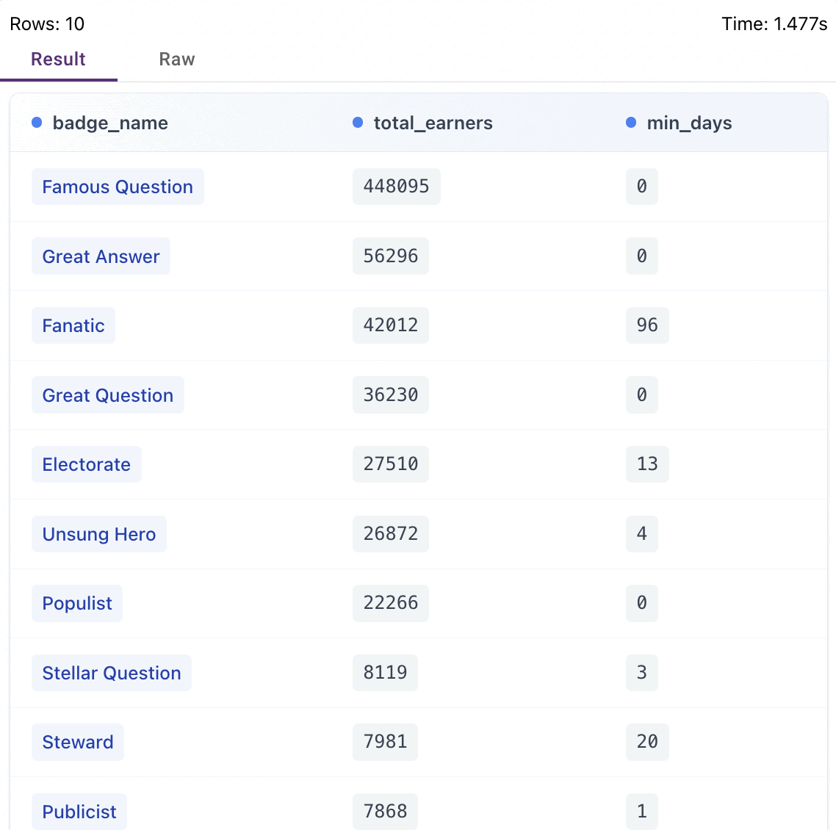

Query 7: Vote Distribution
MATCH (u:User)
OPTIONAL MATCH (q:Post_question)-[:Owned_by]->(u)
OPTIONAL MATCH (vq:Vote)-[:Vote_on_question]->(q)
WITH u, COUNT(vq) AS q_votes
OPTIONAL MATCH (a:Post_answer)-[:Answers_by]->(u)
OPTIONAL MATCH (va:Vote)-[:Vote_on_answer]->(a)
WITH u.id AS user_id,
u.display_name AS display_name,
q_votes + COUNT(va) AS total_votes
WHERE total_votes > 0
RETURN user_id, display_name, total_votes
ORDER BY total_votes DESC
LIMIT 20;

DURATION: 78.500 s
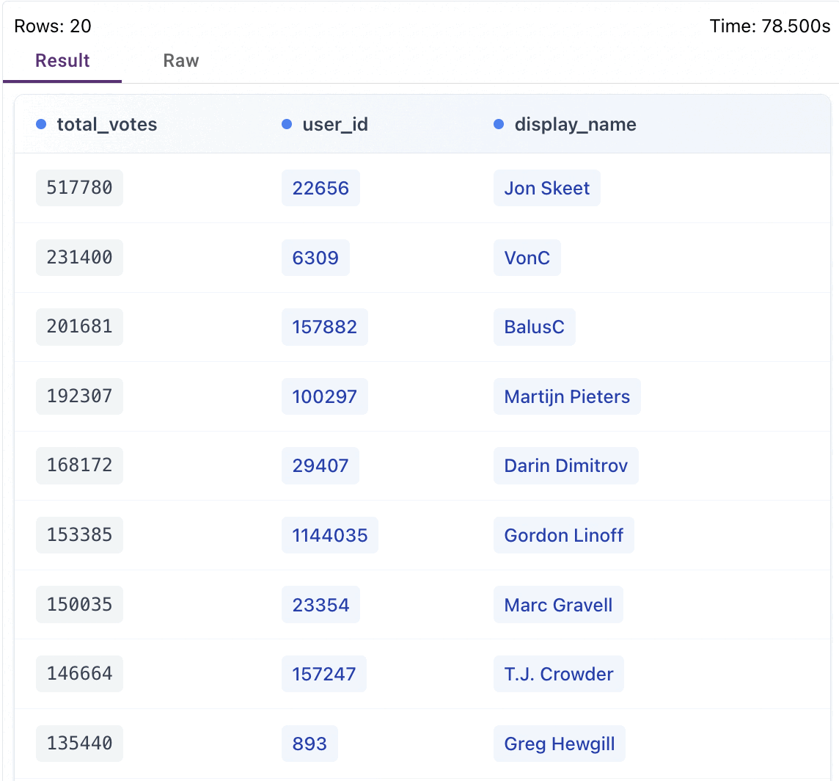

Query 8: Most Linked Questions
MATCH (src:Post_question)-[:Link_to]->(target:Post_question)
WITH target.id AS question_id,
COUNT(src) AS link_count
WHERE link_count > 0
RETURN question_id, link_count
ORDER BY link_count DESC
LIMIT 20;

DURATION: 0.303 s
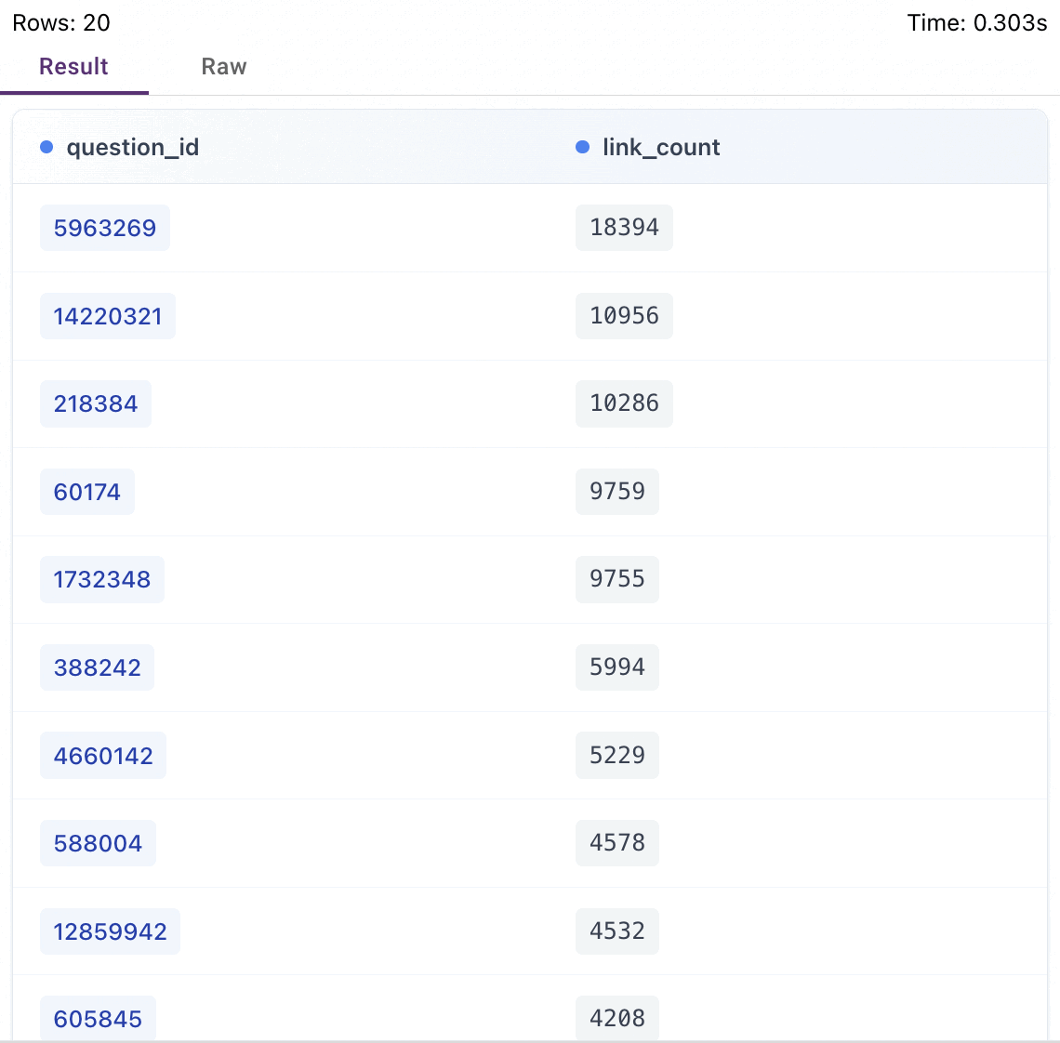

Query 9: Users Who Comment Most
MATCH (c:Comment)-[:Commented_by]->(u:User)
WITH u.id AS user_id,
u.display_name AS display_name,
COUNT(c) AS total_comments
WHERE total_comments > 0
RETURN user_id, display_name, total_comments
ORDER BY total_comments DESC
LIMIT 20;

DURATION: 3.959 s
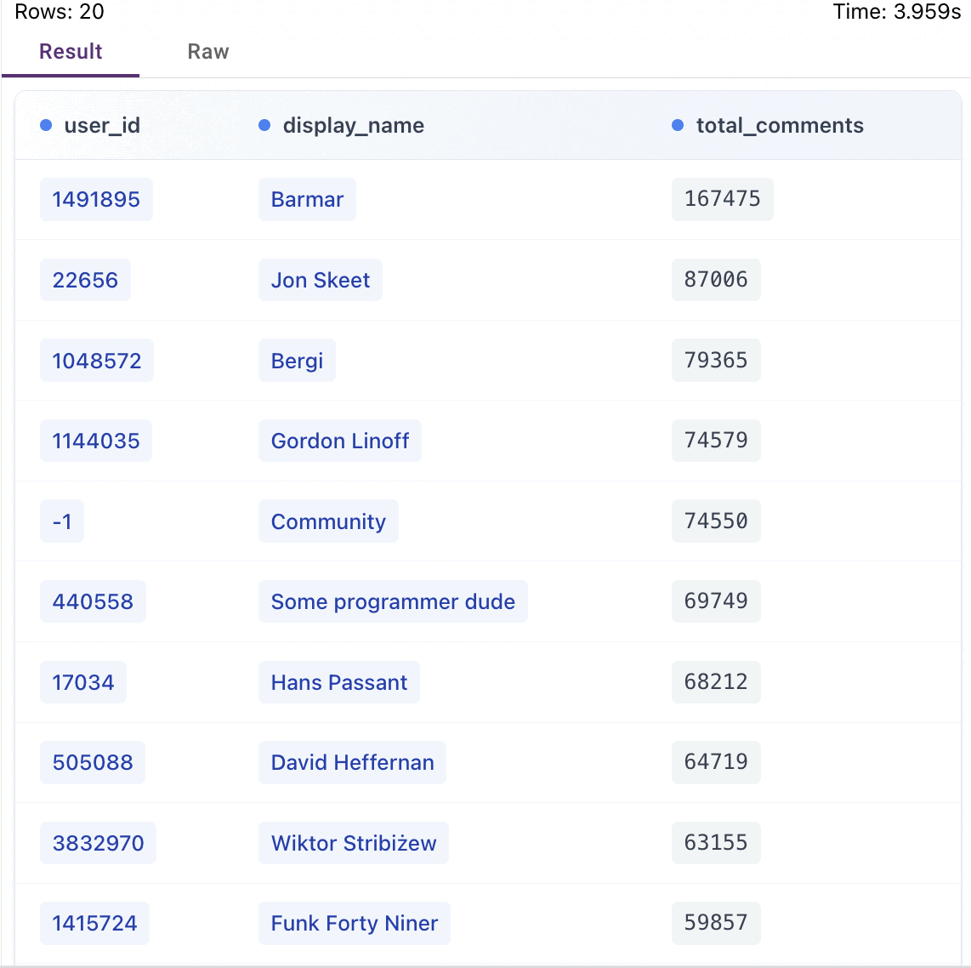
Query 10: Most Accepted Answers
MATCH (q:Post_question)-[:Accepts]->(a:Post_answer)-[:Answers_by]->(u:User)
WITH u.id AS user_id,
u.display_name AS display_name,
COUNT(a) AS accepted_count
WHERE accepted_count > 0
RETURN user_id, display_name, accepted_count
ORDER BY accepted_count DESC
LIMIT 20;

DURATION: 2.574 s
