Puppygraph movielens genome

PySpark Initialization, Database Creation, and Table Loading
To preprocess the MovieLens genome dataset and prepare it for ingestion into PuppyGraph, we first initialized a PySpark session configured with Delta Lake, Hive Metastore, and HDFS support. The following configuration launches Spark in cluster mode (Spark Standalone) and enables full Delta compatibility with Spark 3.4:
from pyspark.sql import SparkSession
spark = (
SparkSession.builder
.appName("yelp_puppy")
.master("spark://master:7077")

# executors
.config("spark.executor.instances", "2")
.config("spark.executor.cores", "2")
.config("spark.executor.memory", "20g")
.config("spark.driver.memory", "4g")

.config("spark.jars.packages", "io.delta:delta-core_2.12:2.3.0")
.config("spark.sql.extensions", "io.delta.sql.DeltaSparkSessionExtension")
.config("spark.sql.catalog.spark_catalog", "org.apache.spark.sql.delta.catalog.DeltaCatalog")

# --- HDFS ---
.config("spark.hadoop.fs.defaultFS", "hdfs://master:9000")
.config("spark.sql.warehouse.dir", "hdfs://master:9000/spark-warehouse")

# --- HIVE METASTORE ---
.config("spark.sql.catalogImplementation", "hive")
.config("hive.metastore.uris", "thrift://master:9083")

.getOrCreate()
)
This initializes a fully integrated Spark environment where:
- Delta Lake provides ACID-compliant storage
- Hive Metastore stores table metadata and allows catalog access
- HDFS acts as the distributed storage layer
Since PuppyGraph reads all metadata and table definitions directly from the Hive Metastore, it is essential that the MovieLens tables are created inside a Hive-managed database.
The database was created using the underlying JVM SparkSession:
spark._jsparkSession.sql("CREATE DATABASE IF NOT EXISTS movielens_genome")
By creating the database in Hive, all Delta tables we generate, such as movies, ratings, genres, tags, and edge mappings, become automatically visible and accessible inside PuppyGraph during data import. This guarantees smooth interoperability between PySpark preprocessing and PuppyGraph graph construction.

Loading MovieLens CSV Files from HDFS
All raw CSV files were uploaded to HDFS under /movielens.
These were loaded into PySpark exactly as they exist in HDFS:
metadata_df = spark.read.json("hdfs://master:9000/movielens_genome/metadata.json")
ratings_df = spark.read.json("hdfs://master:9000/movielens_genome/ratings.json")
tags_df = spark.read.json("hdfs://master:9000/movielens_genome/tags.json")
tag_count_df = spark.read.json("hdfs://master:9000/movielens_genome/tag_count.json")
review_df = spark.read.json("hdfs://master:9000/movielens_genome/review_with_id.json")
survey_df = spark.read.json("hdfs://master:9000/movielens_genome/surveys_id.json")
actor_movie_df = spark.read.json("hdfs://master:9000/movielens_genome/actor_movie_edge.json")
actor_vertices_df = spark.read.json("hdfs://master:9000/movielens_genome/actor_vertices.json")
director_vertices_df = spark.read.json("hdfs://master:9000/movielens_genome/director_vertices.json")
director_movie_df = spark.read.json("hdfs://master:9000/movielens_genome/director_movie_edges.json")
Each DataFrame now holds the corresponding MovieLens dataset.

Writing Delta Tables into the MovieLens Database
To prepare the data for PuppyGraph, each DataFrame was written as a Delta table inside the movielens_genome Hive database. This makes the dataset persistent, ACID-compliant, and fully accessible through the Hive Metastore.
metadata_df.write.format("delta").mode("overwrite").saveAsTable("movielens_genome.metadata")
ratings_df.write.format("delta").mode("overwrite").saveAsTable("movielens_genome.ratings")
tags_df.write.format("delta").mode("overwrite").saveAsTable("movielens_genome.tags")
tag_count_df.write.format("delta").mode("overwrite").saveAsTable("movielens_genome.tag_count")
review_df.write.format("delta").mode("overwrite").saveAsTable("movielens_genome.review_with_id")
survey_df.write.format("delta").mode("overwrite").saveAsTable("movielens_genome.surveys_id")
actor_movie_df.write.format("delta").mode("overwrite").saveAsTable("movielens_genome.actor_movie_edges")
actor_vertices_df.write.format("delta").mode("overwrite").saveAsTable("movielens_genome.actor_vertices")
director_vertices_df.write.format("delta").mode("overwrite").saveAsTable("movielens_genome.director_vertices")
director_movie_df.write.format("delta").mode("overwrite").saveAsTable("movielens_genome.director_movie_edges")
Nodes and edges creation on puppygraph
Once PuppyGraph is connected to the Hive Metastore (thrift://master:9083), all Delta tables created earlier, including metadata, survey, ratings, tags, reviews, and ratings appear under the movielens_genome database in the PuppyGraph Data Import UI.

- Movie node

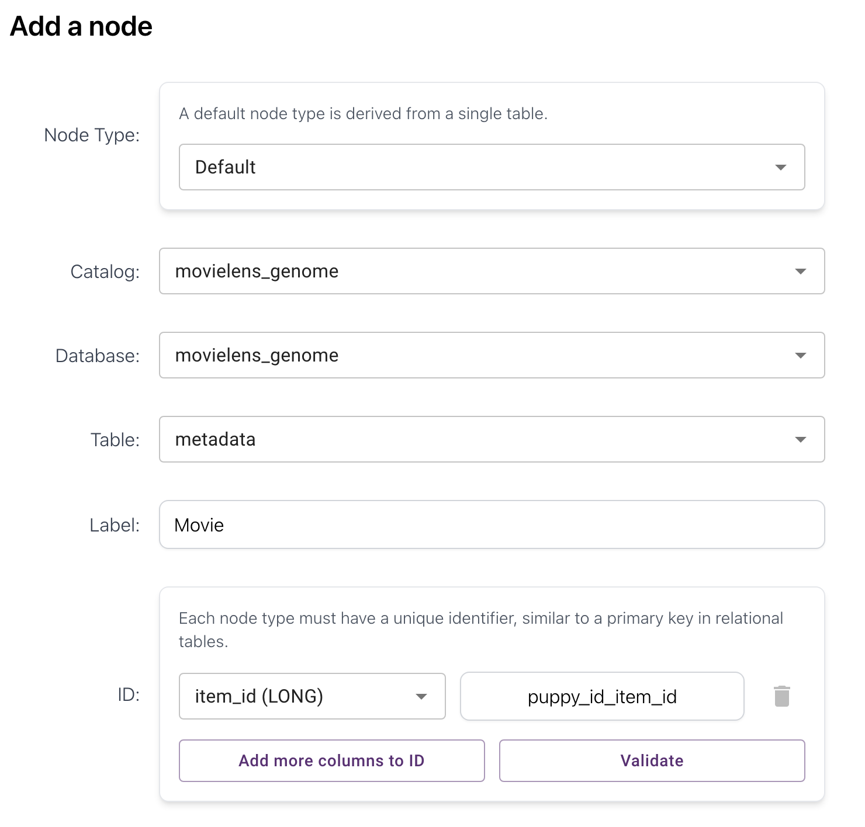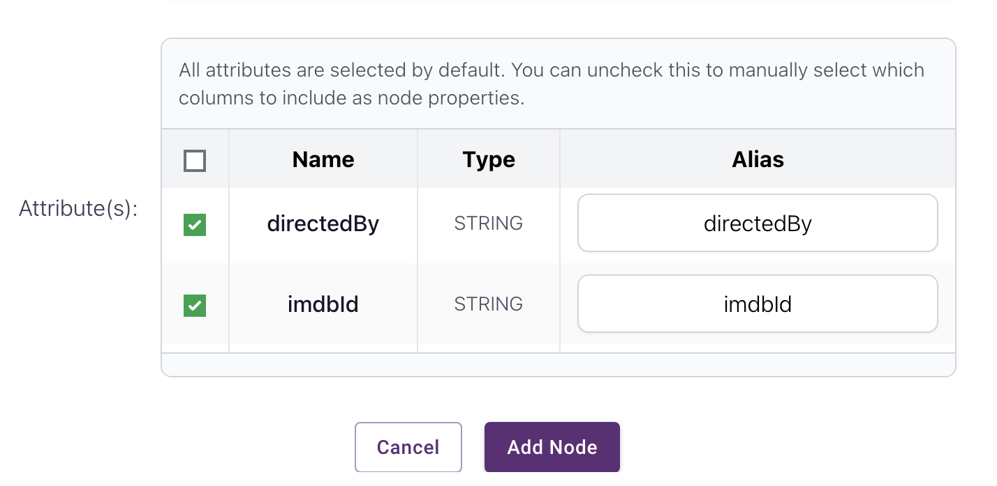
The attributes are item_id, title, avgRating, imdbId , directedBy, starring

- User node

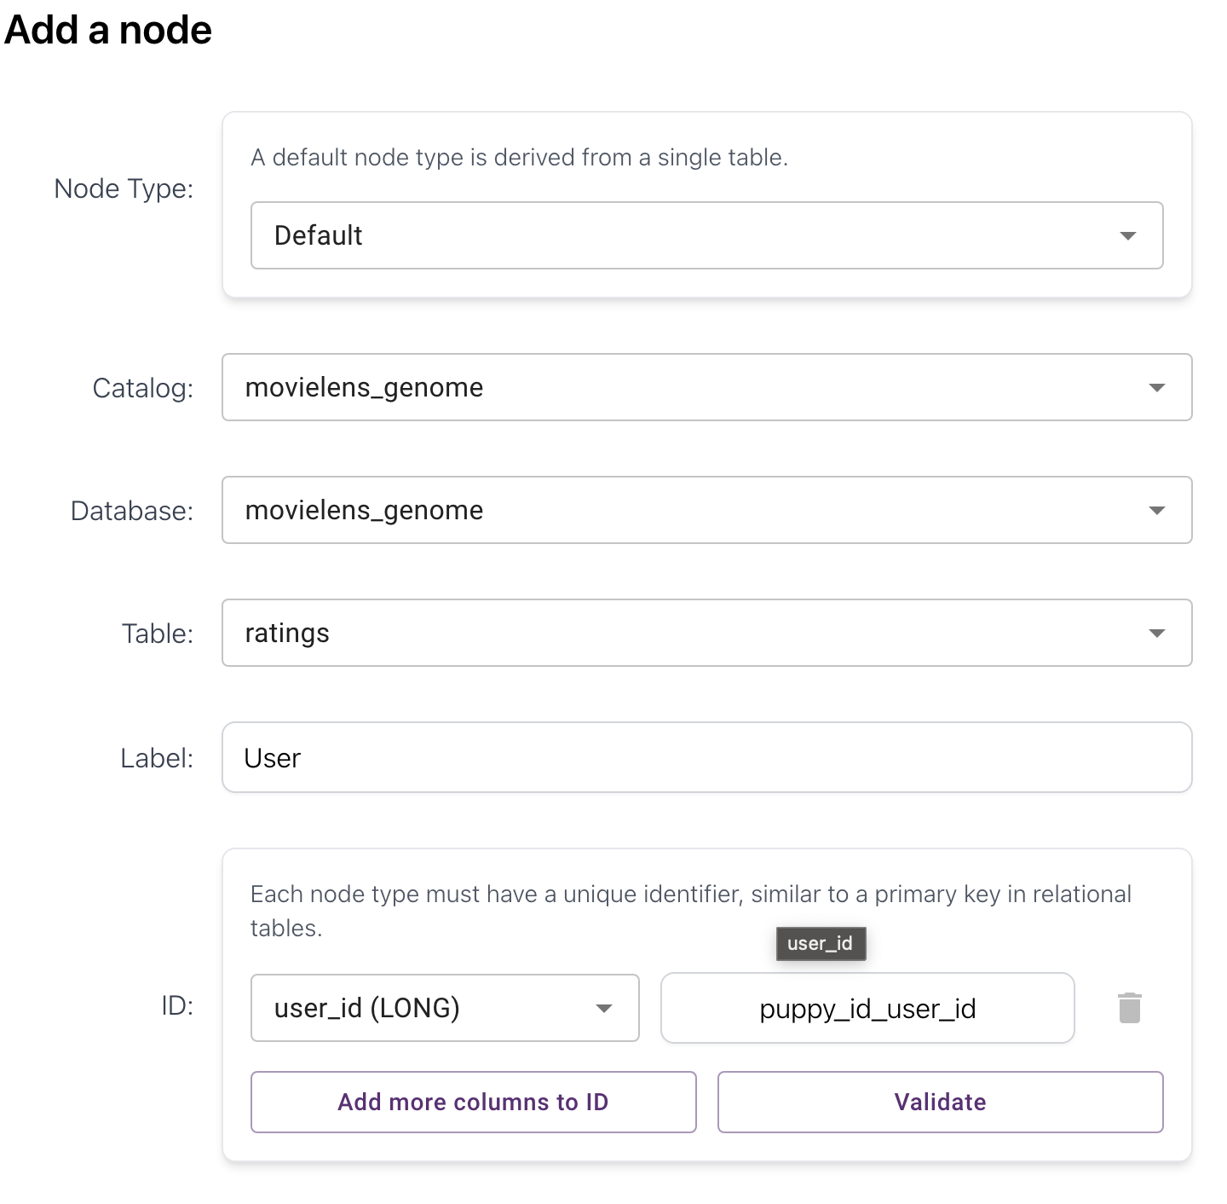
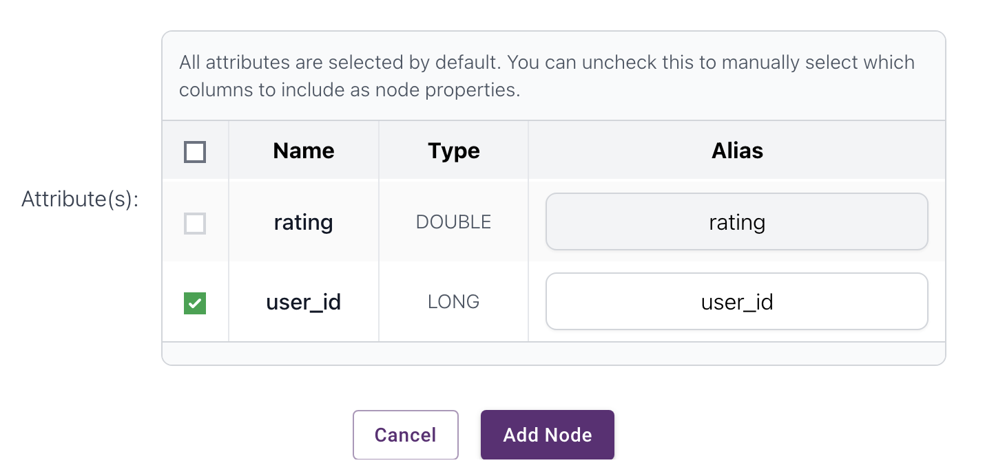

- RATED edge (User Movie)

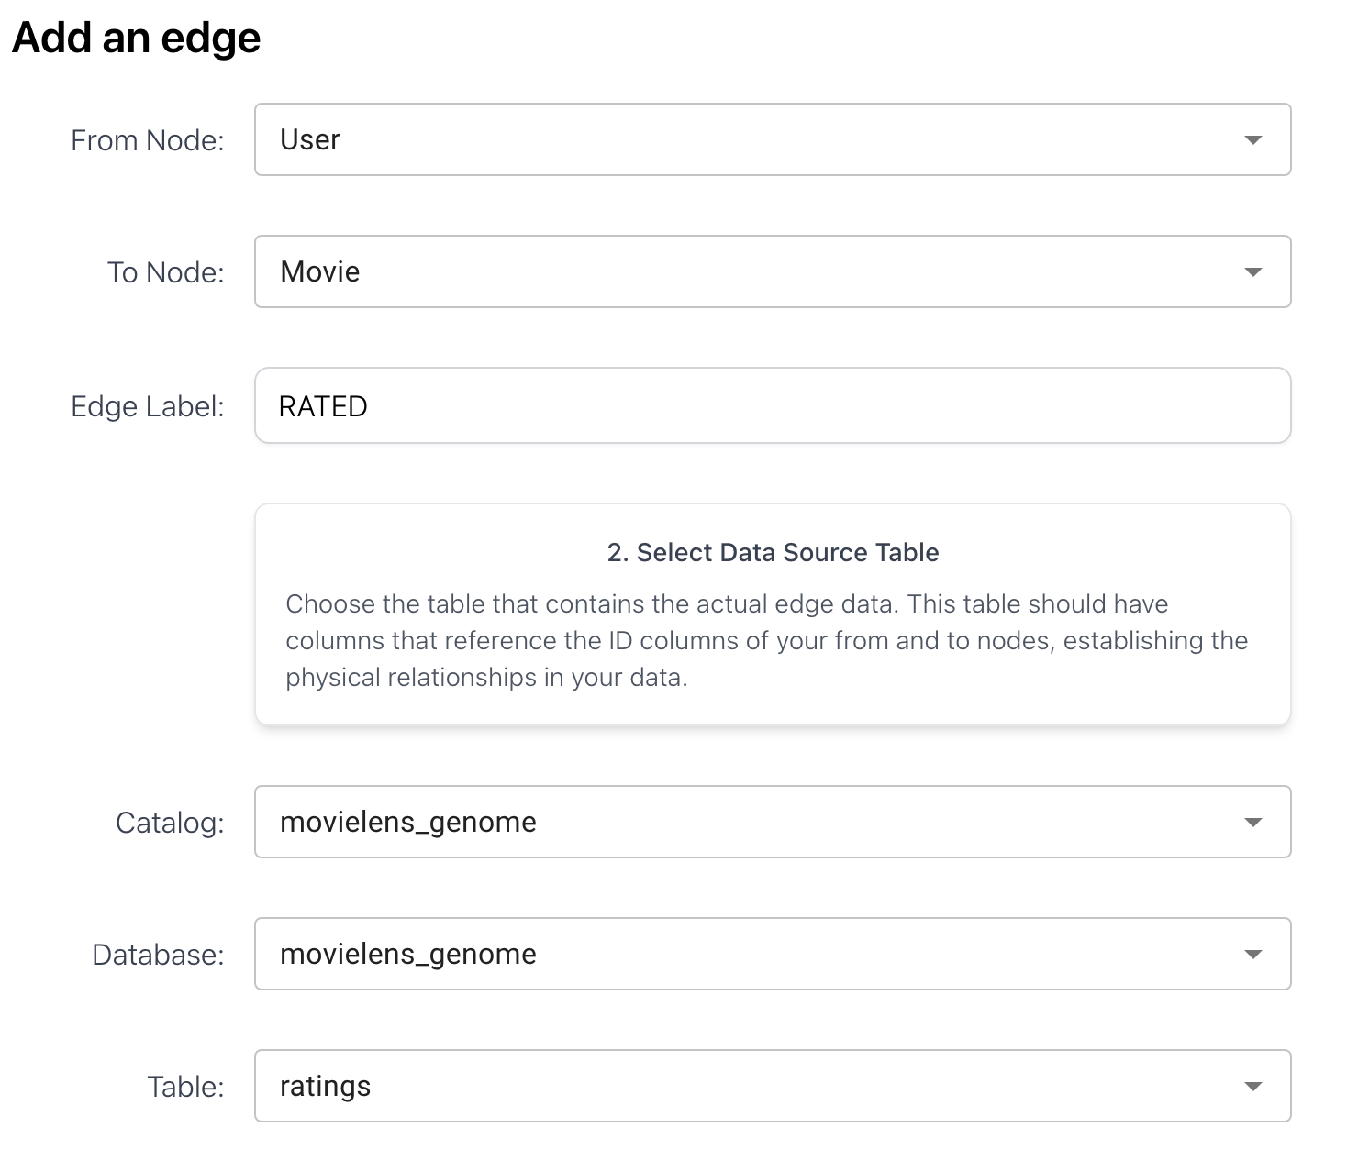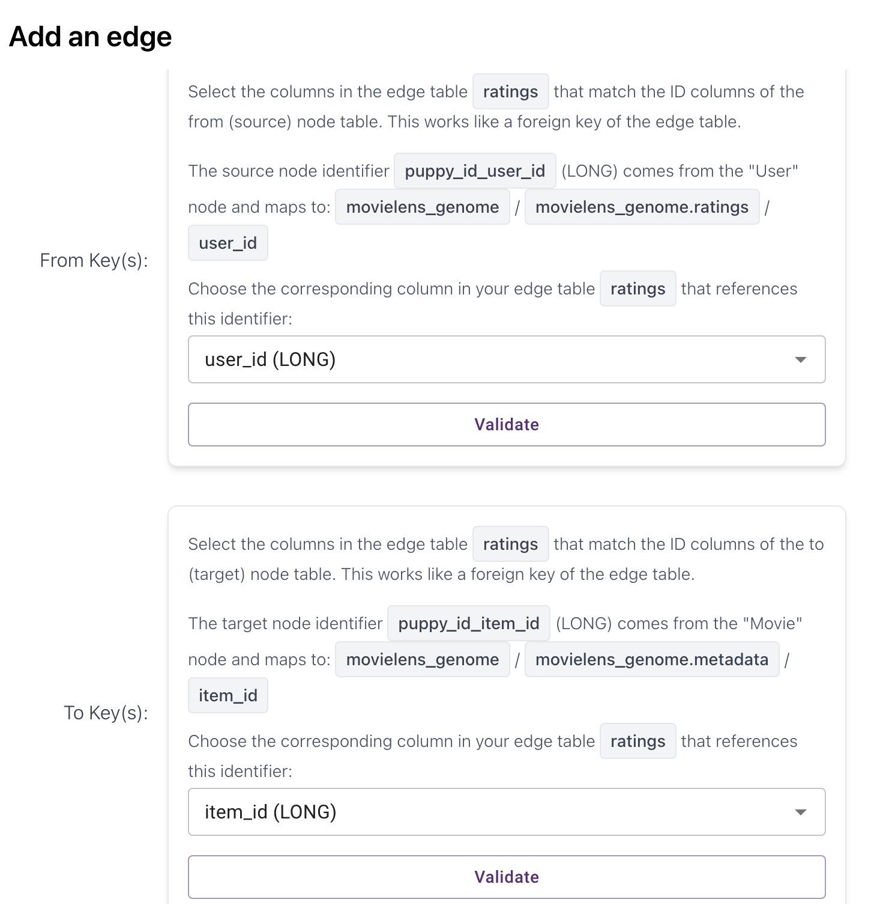

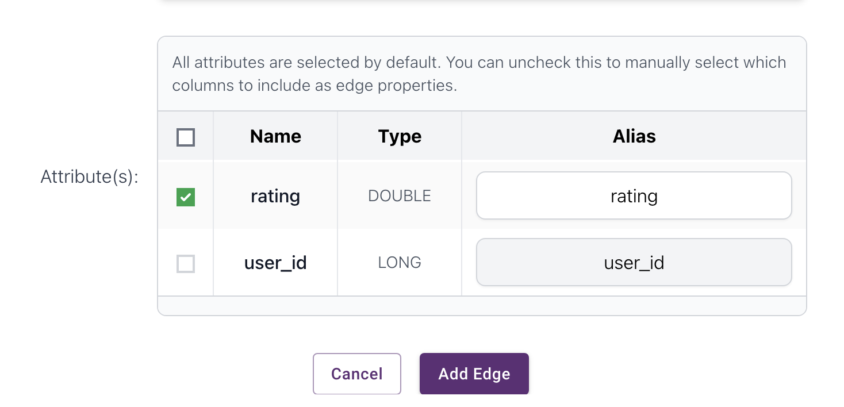

- Tag node

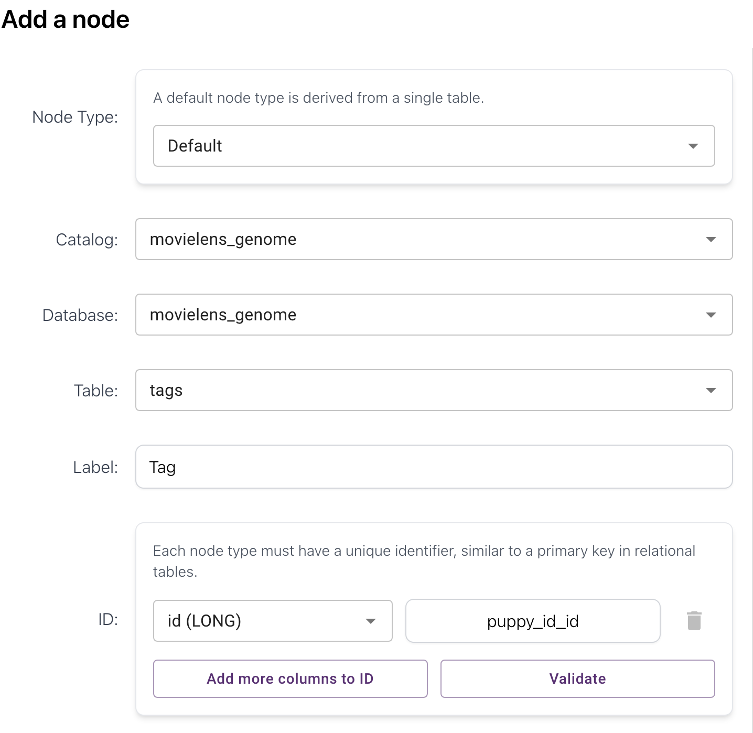
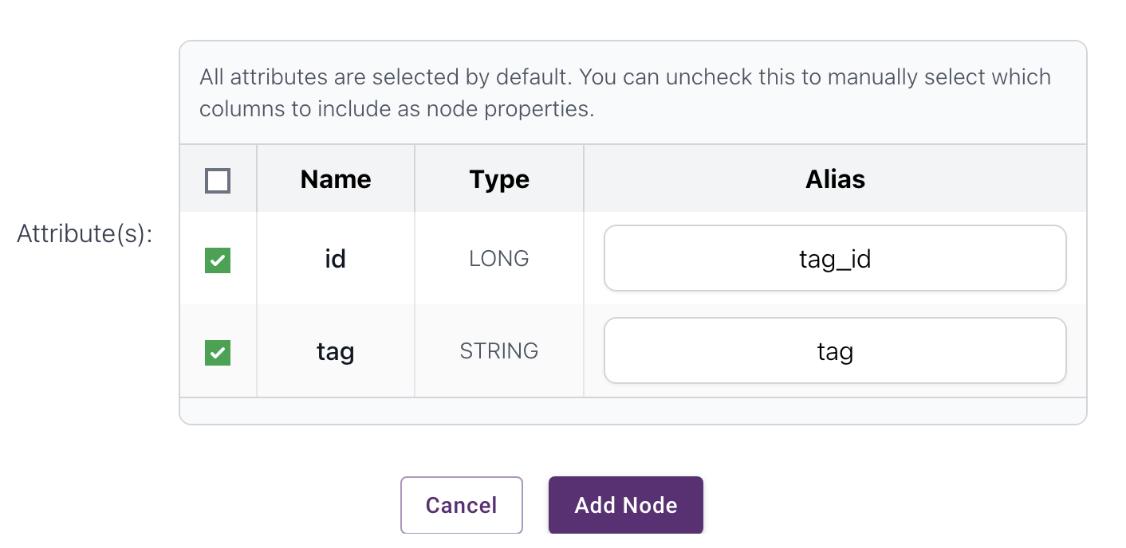

- HAS_TAG edge (Movie User)

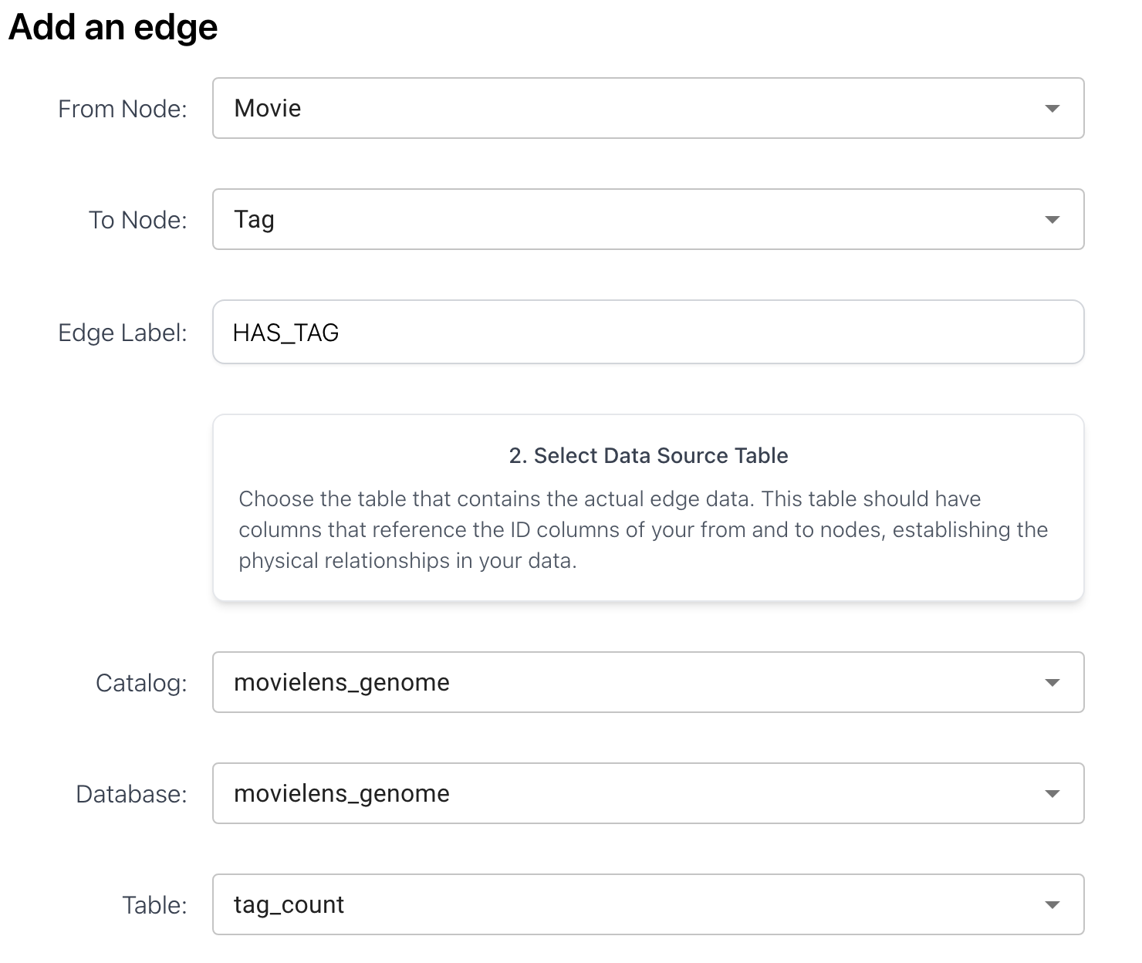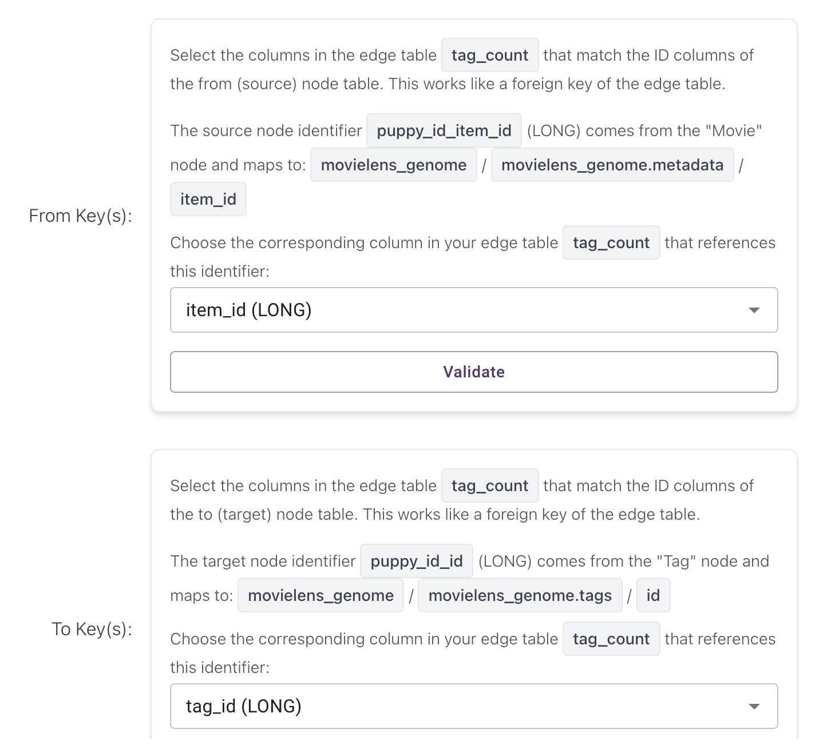

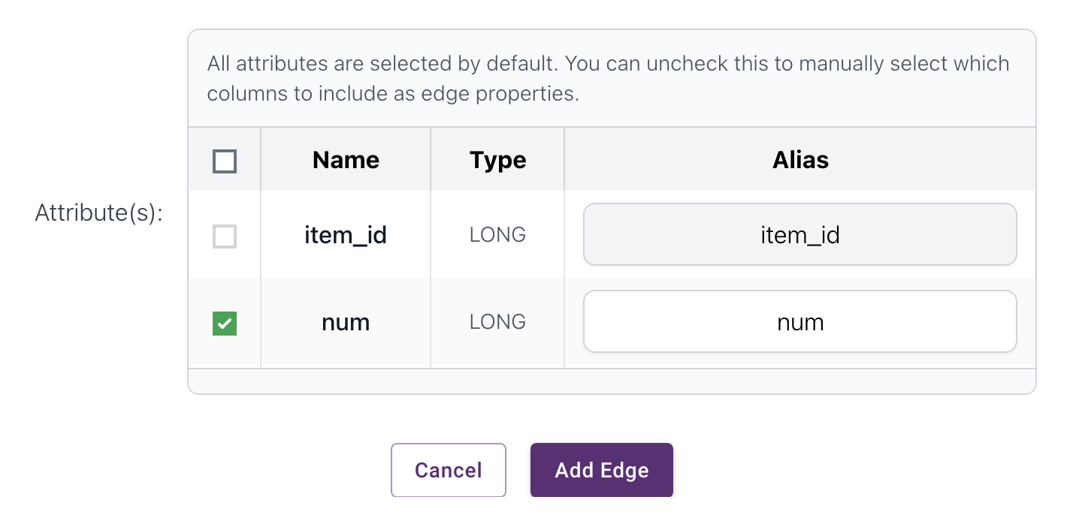

- Review node

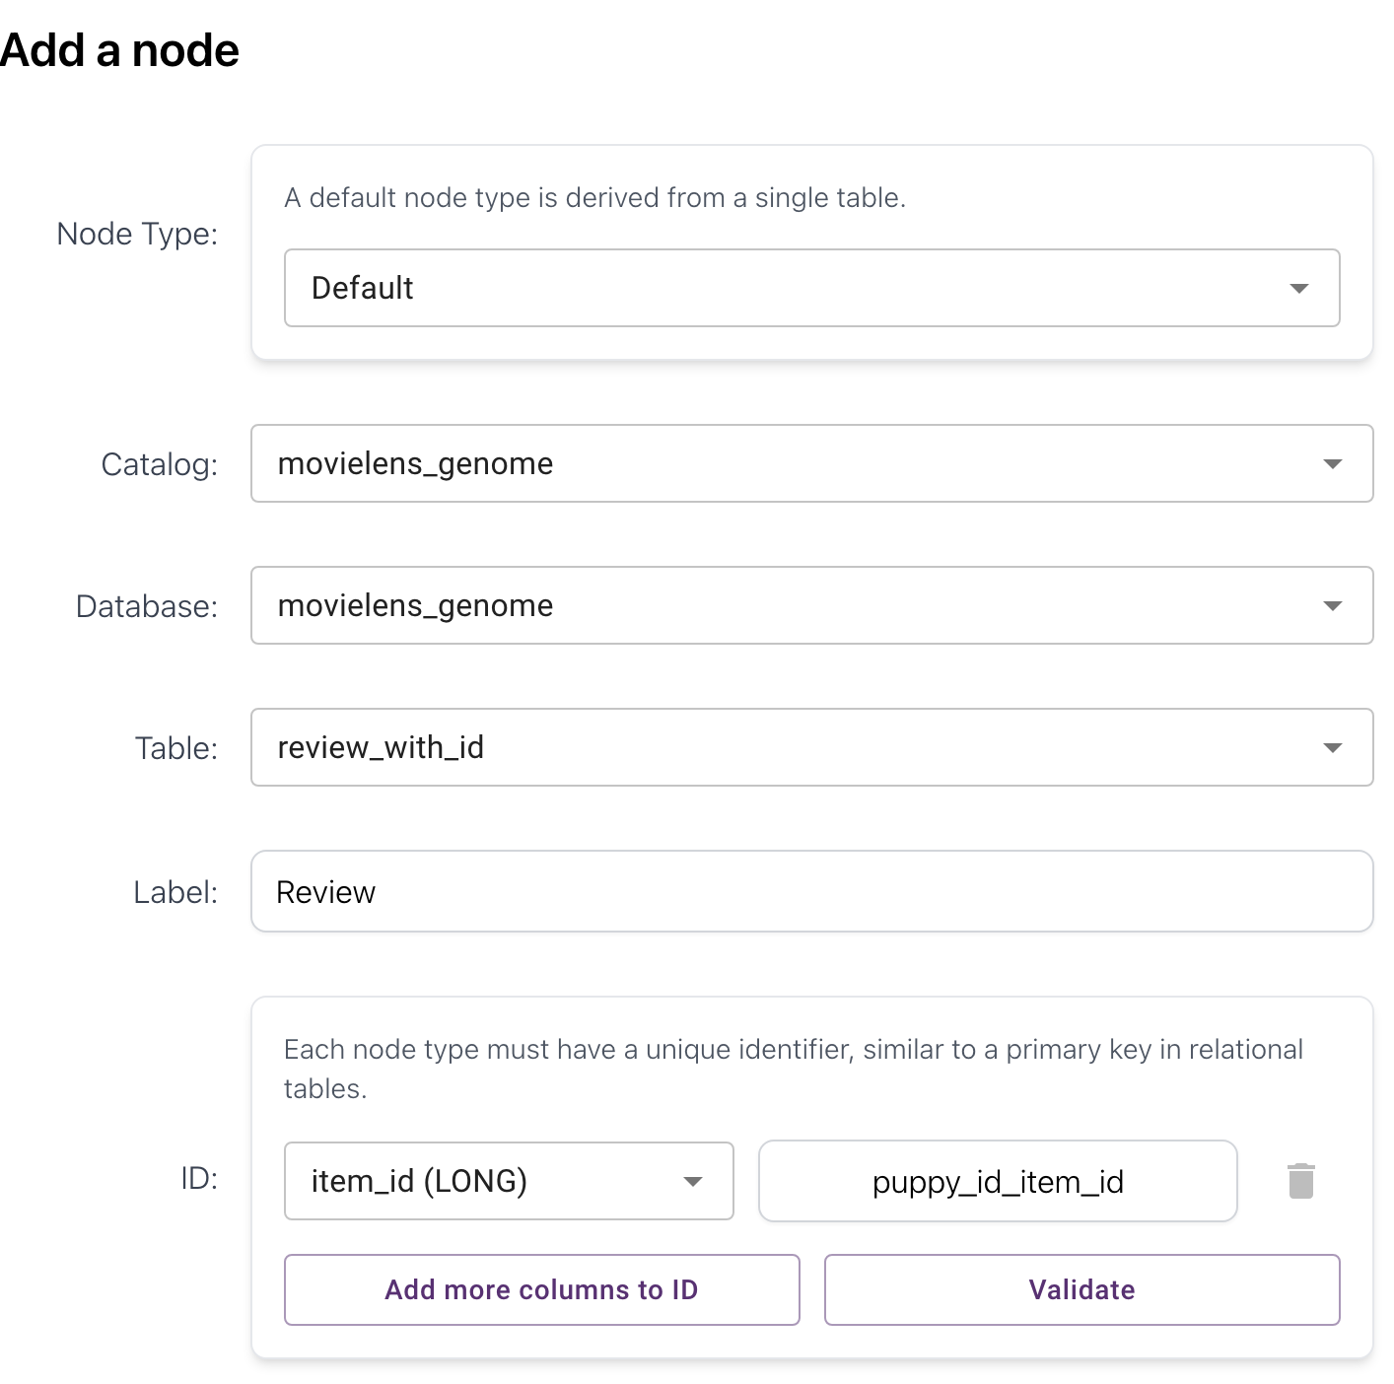
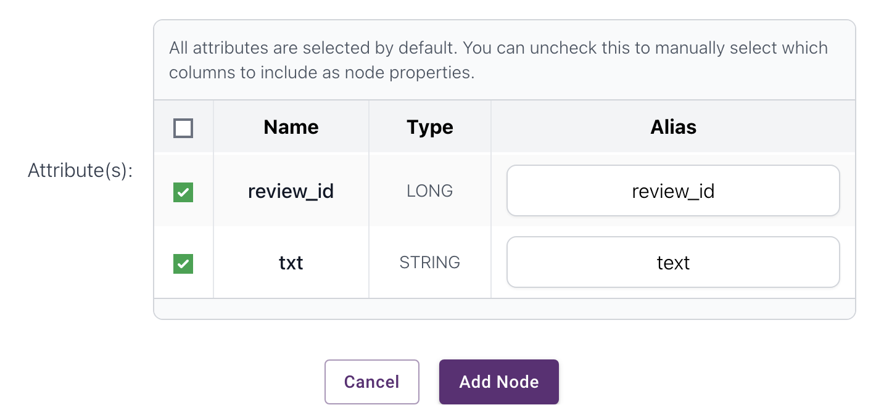

- HAS_REVIEW edge (Movie Review)
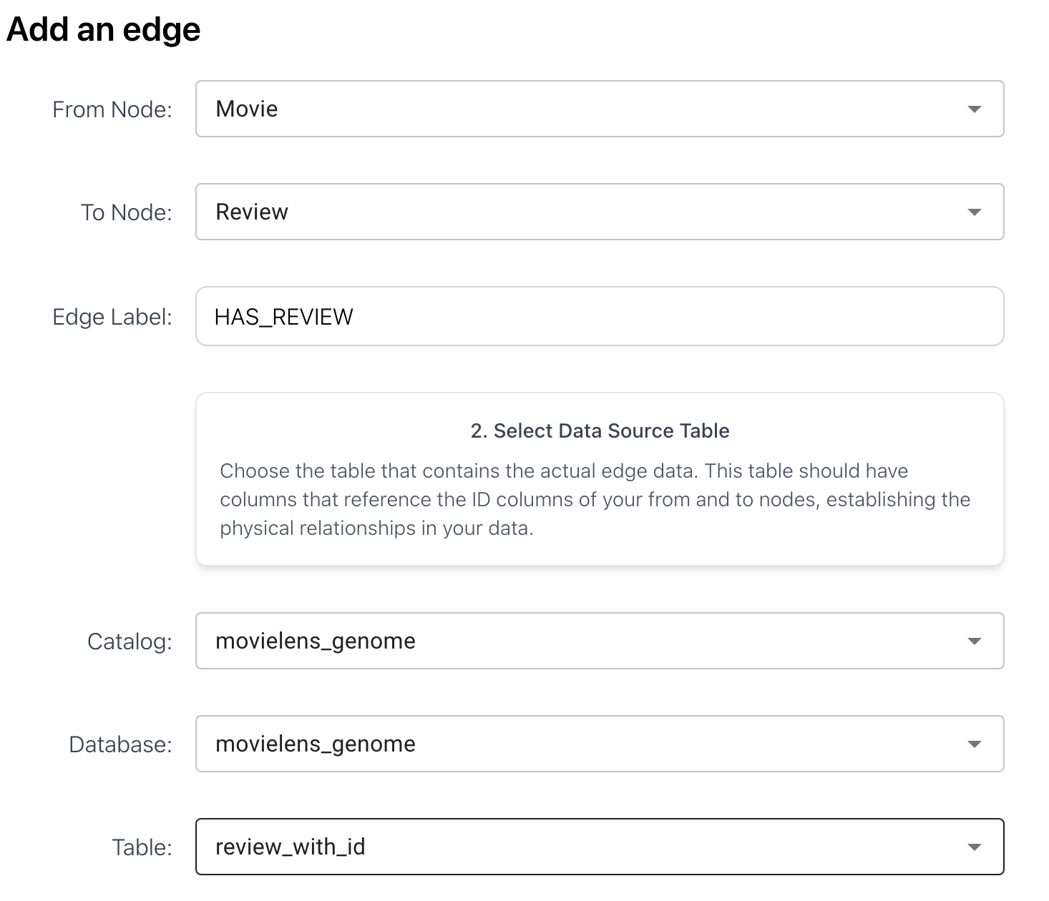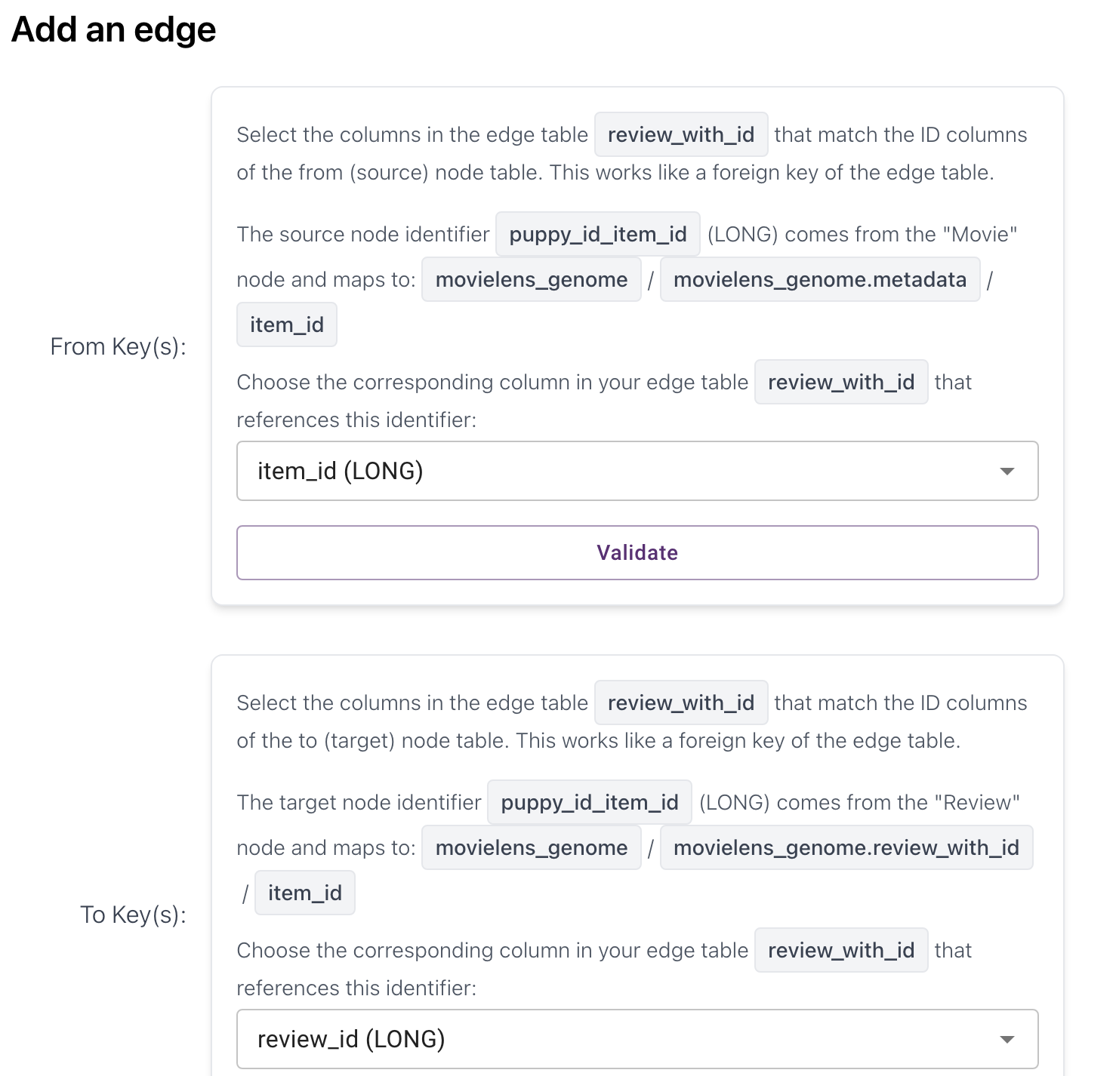

- Survey node

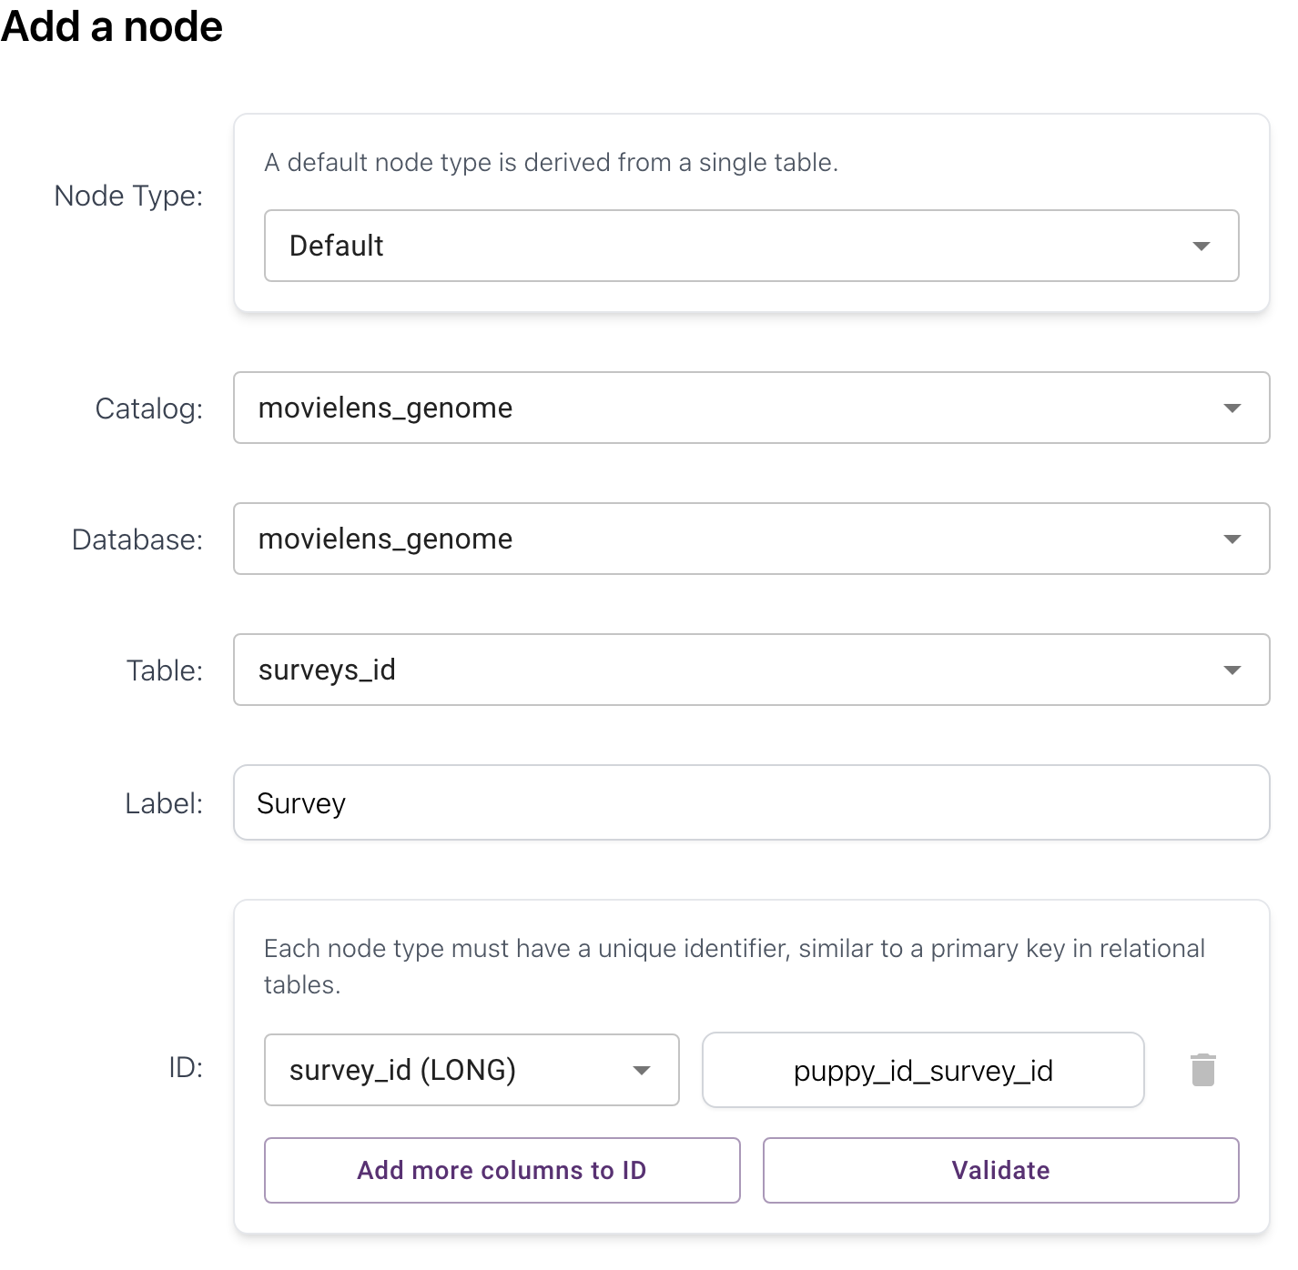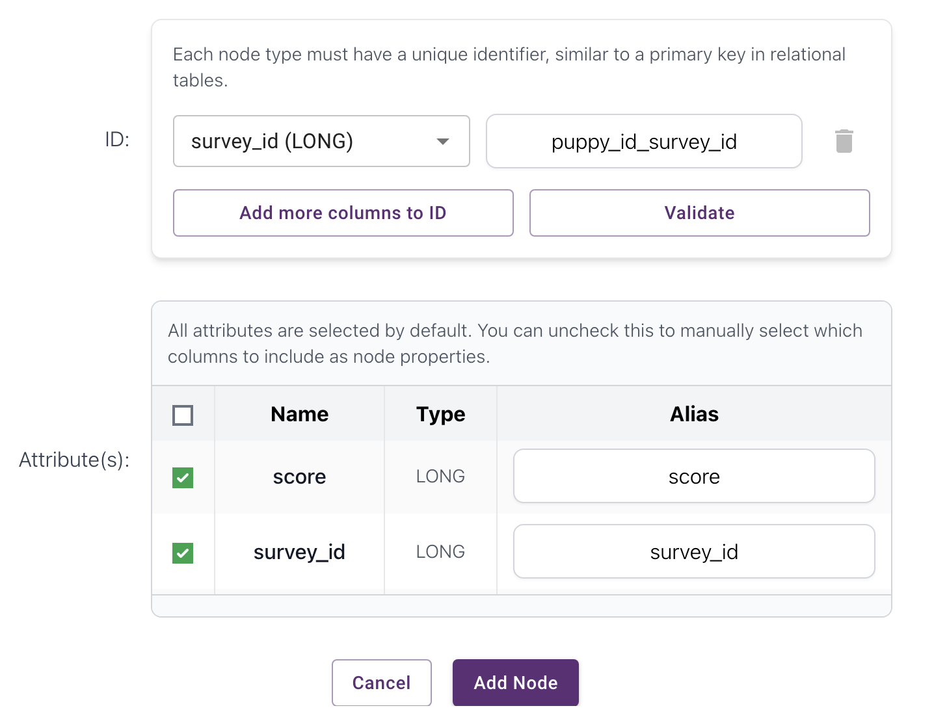

- ANSWERED edge (User Survey)

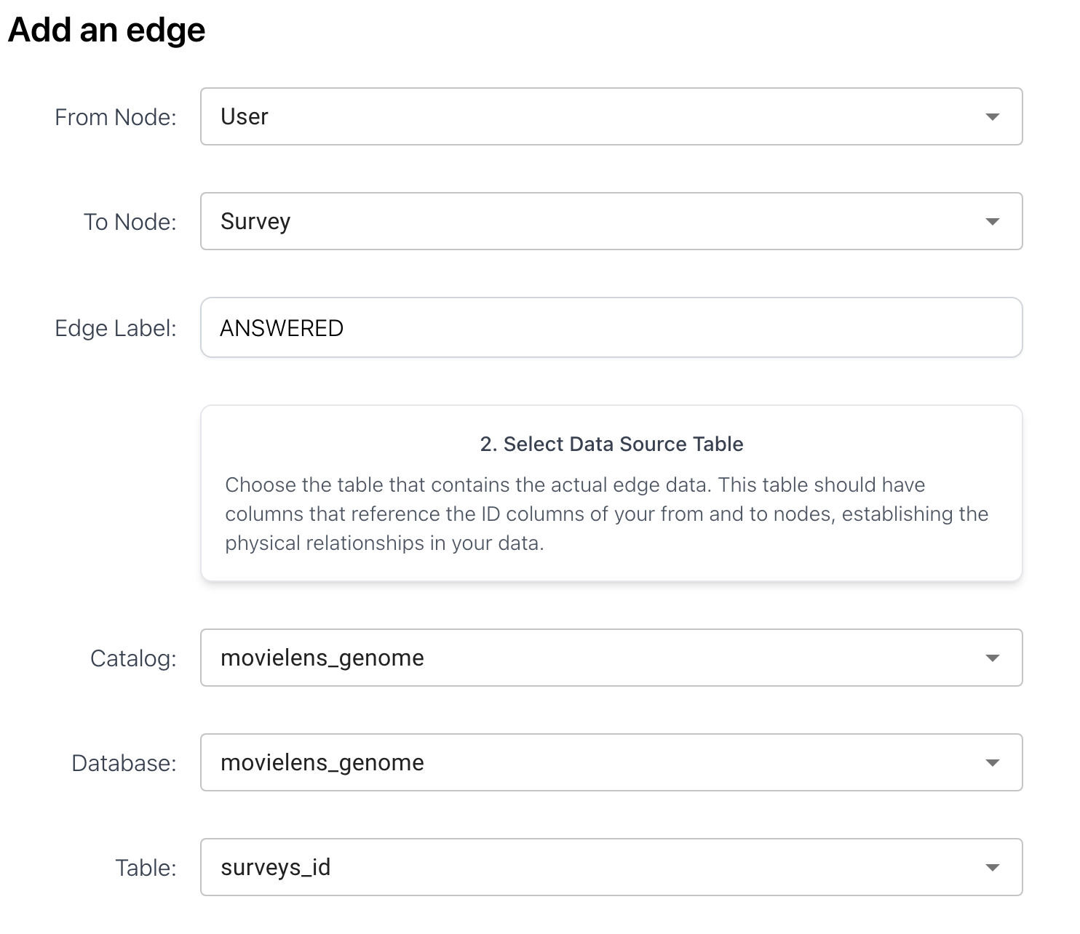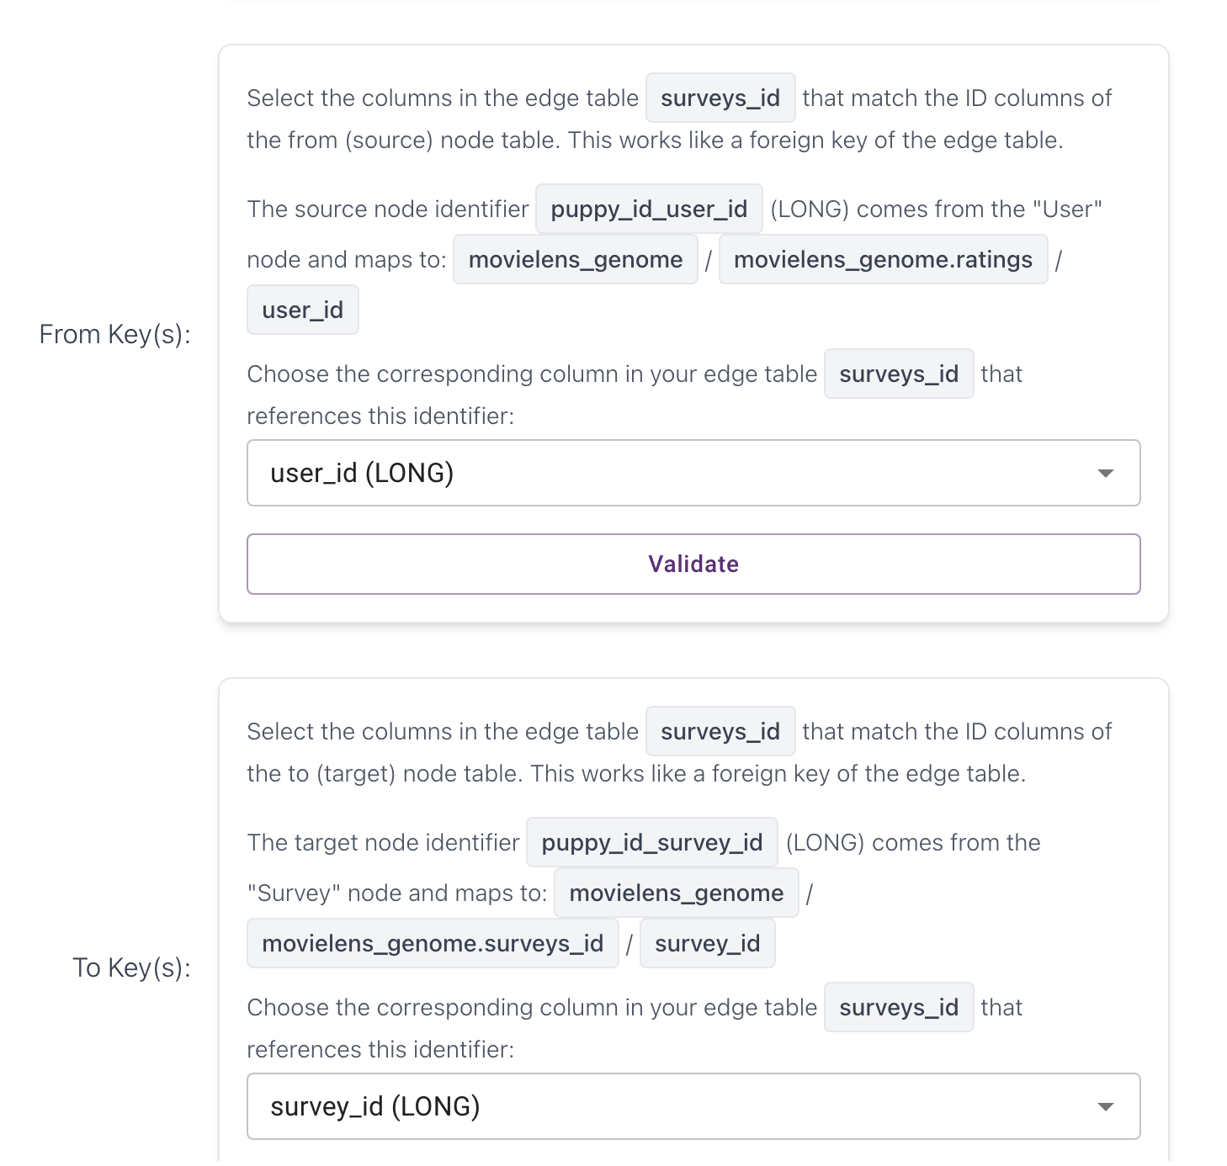

- ABOUT_MOVIE edge (Survey Movie)
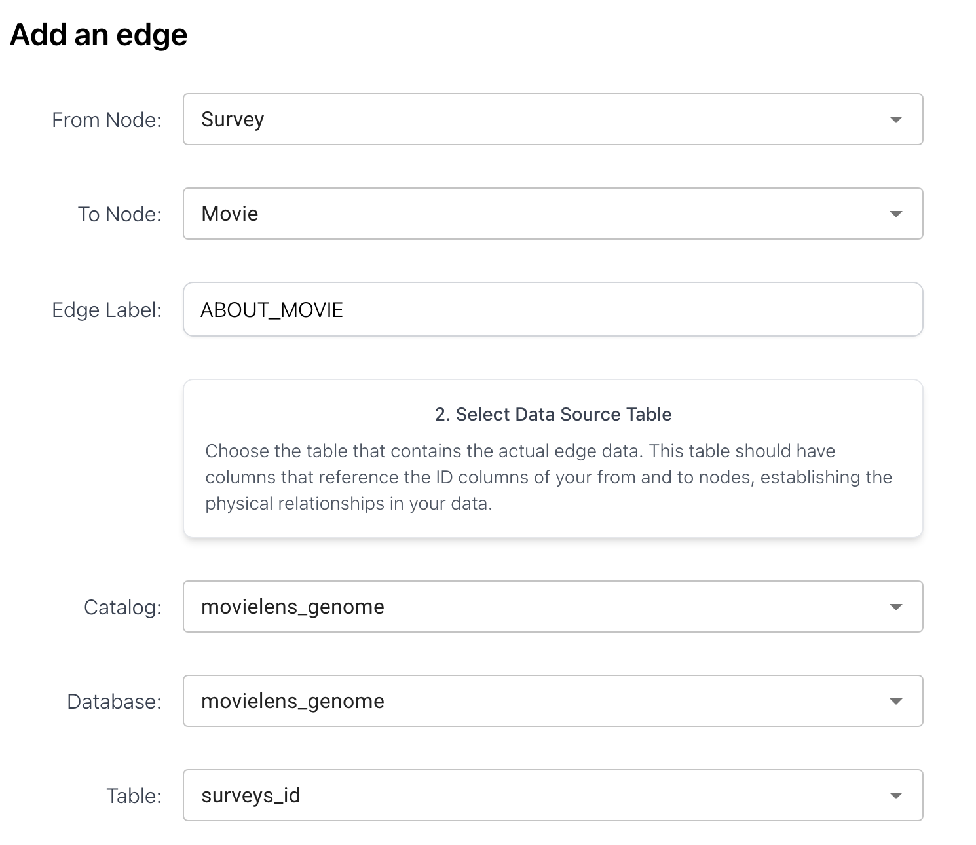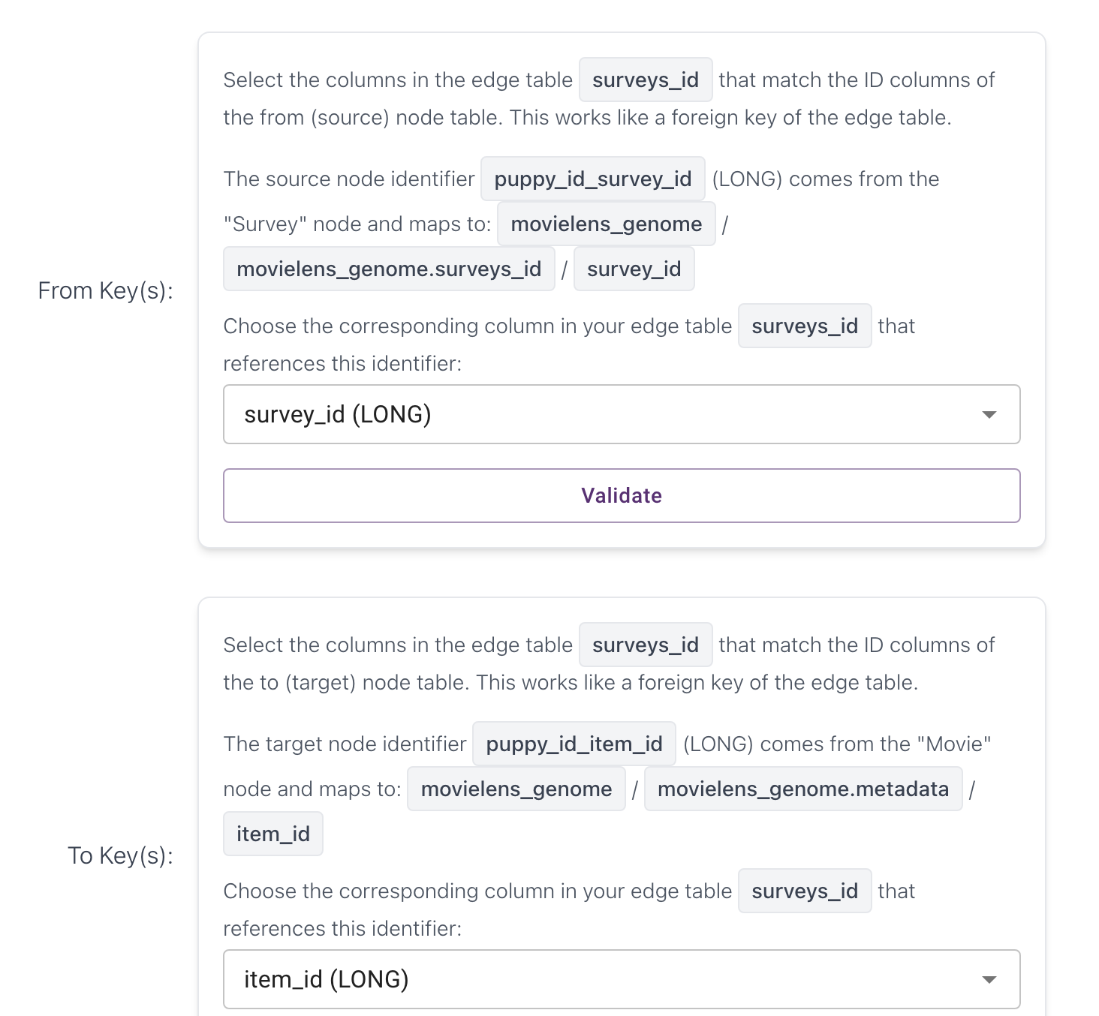

- ABOUT_TAG (Survey Tag)

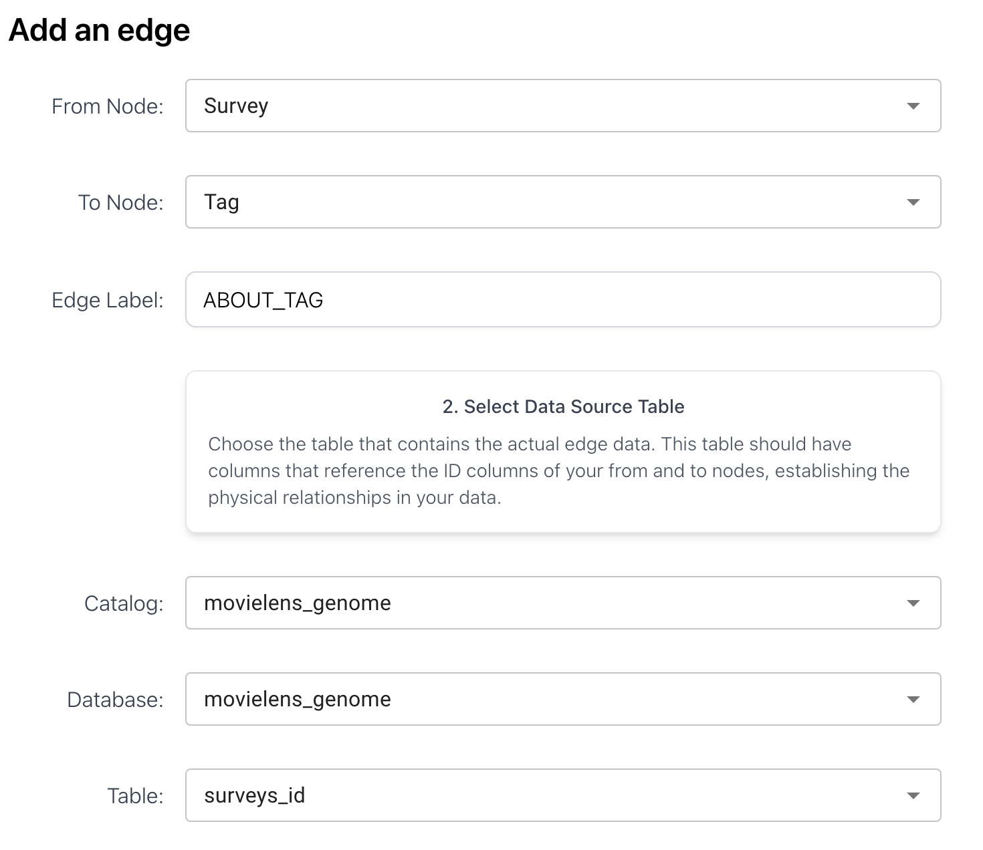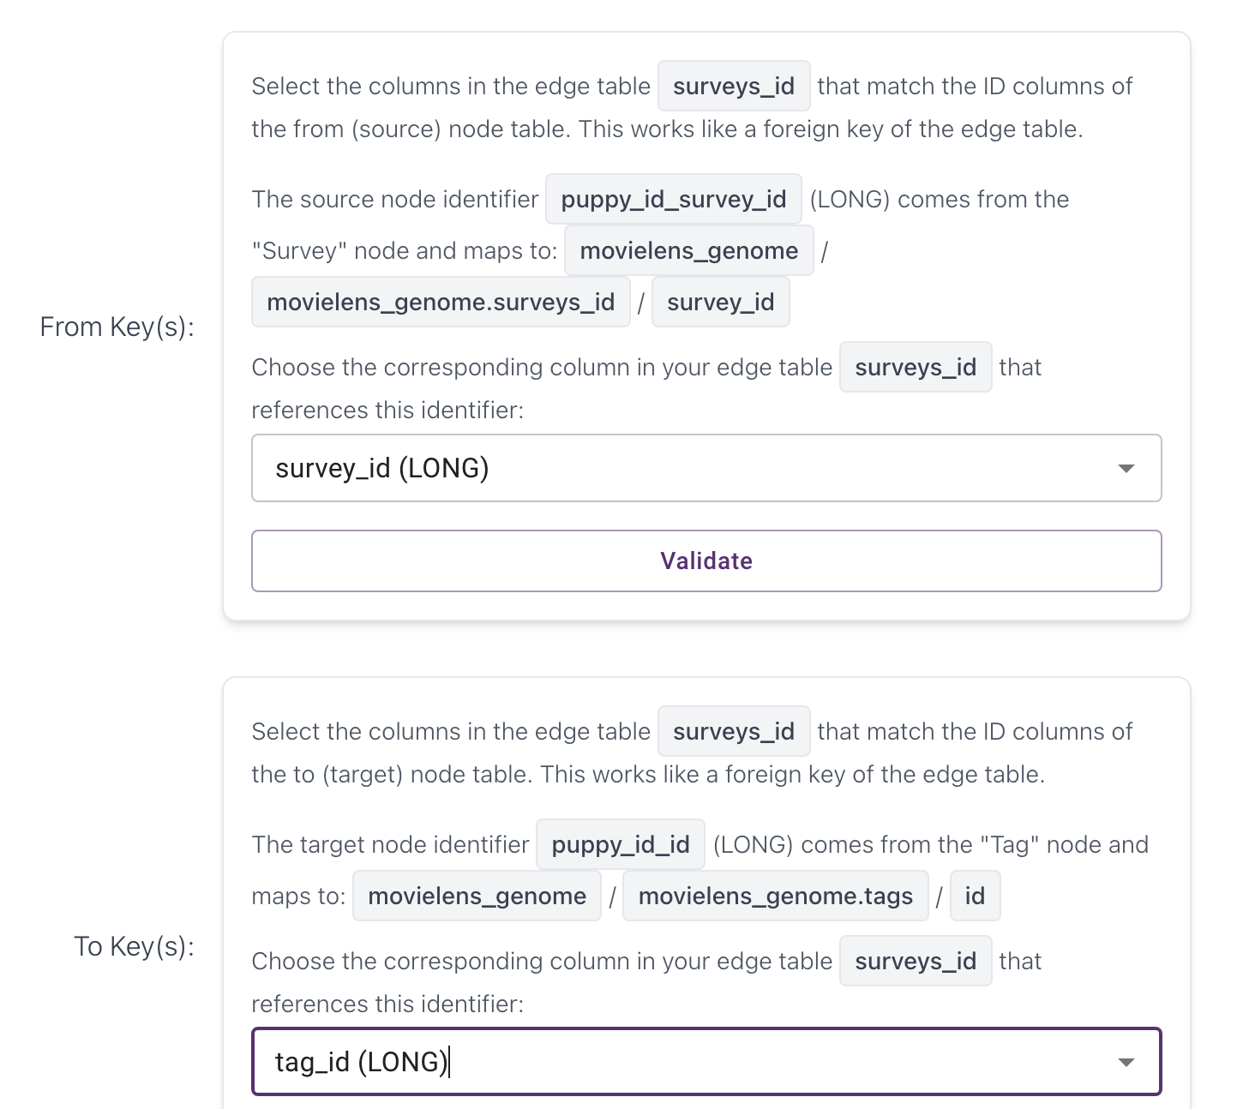

- Director node

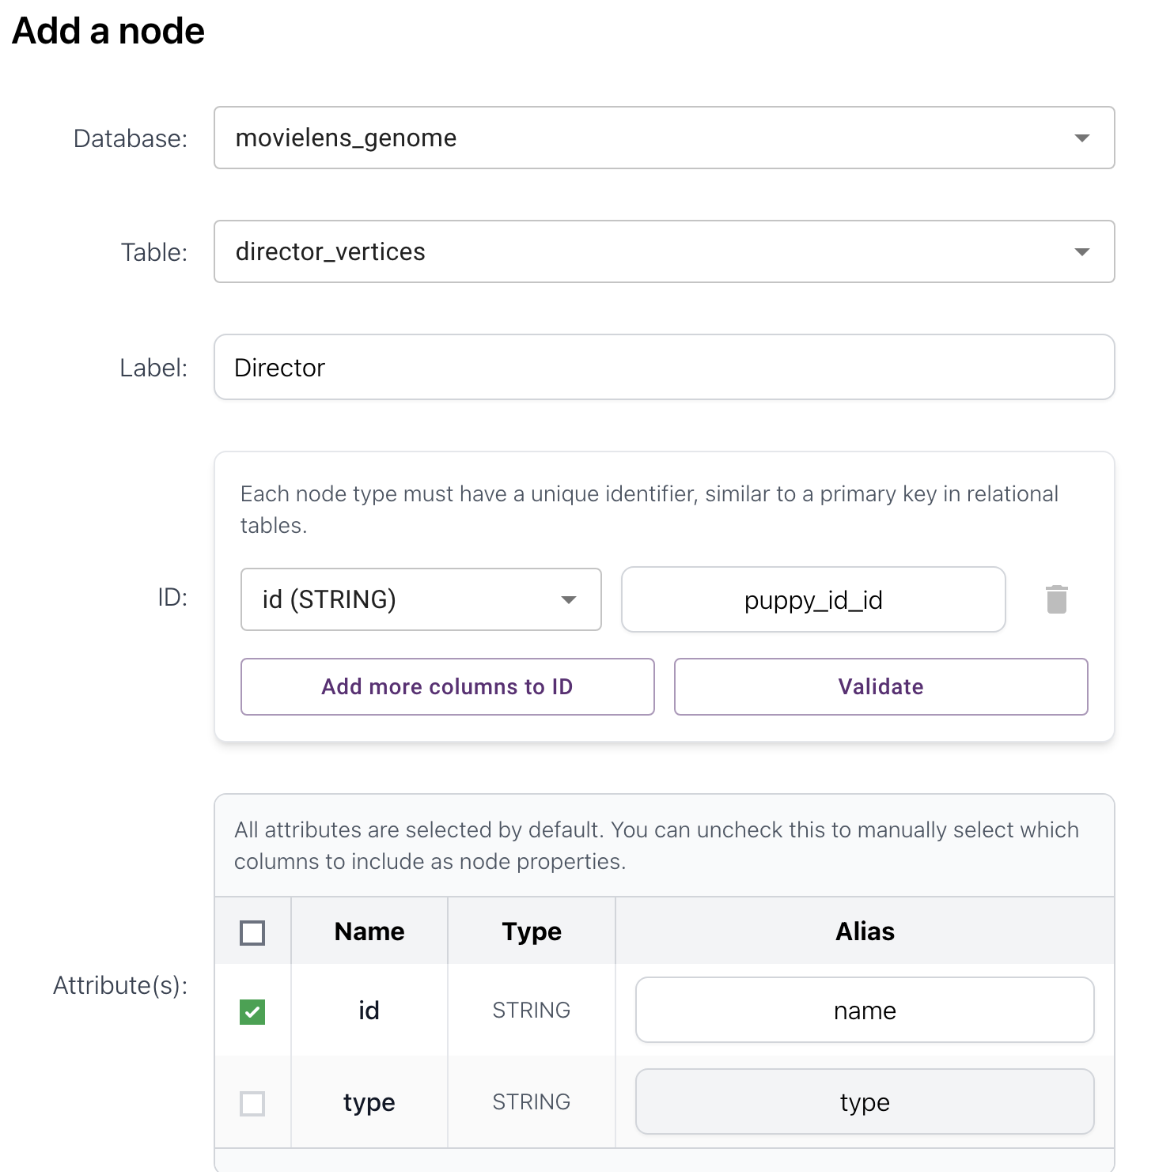
- DIRECTED edge (Director Movie)

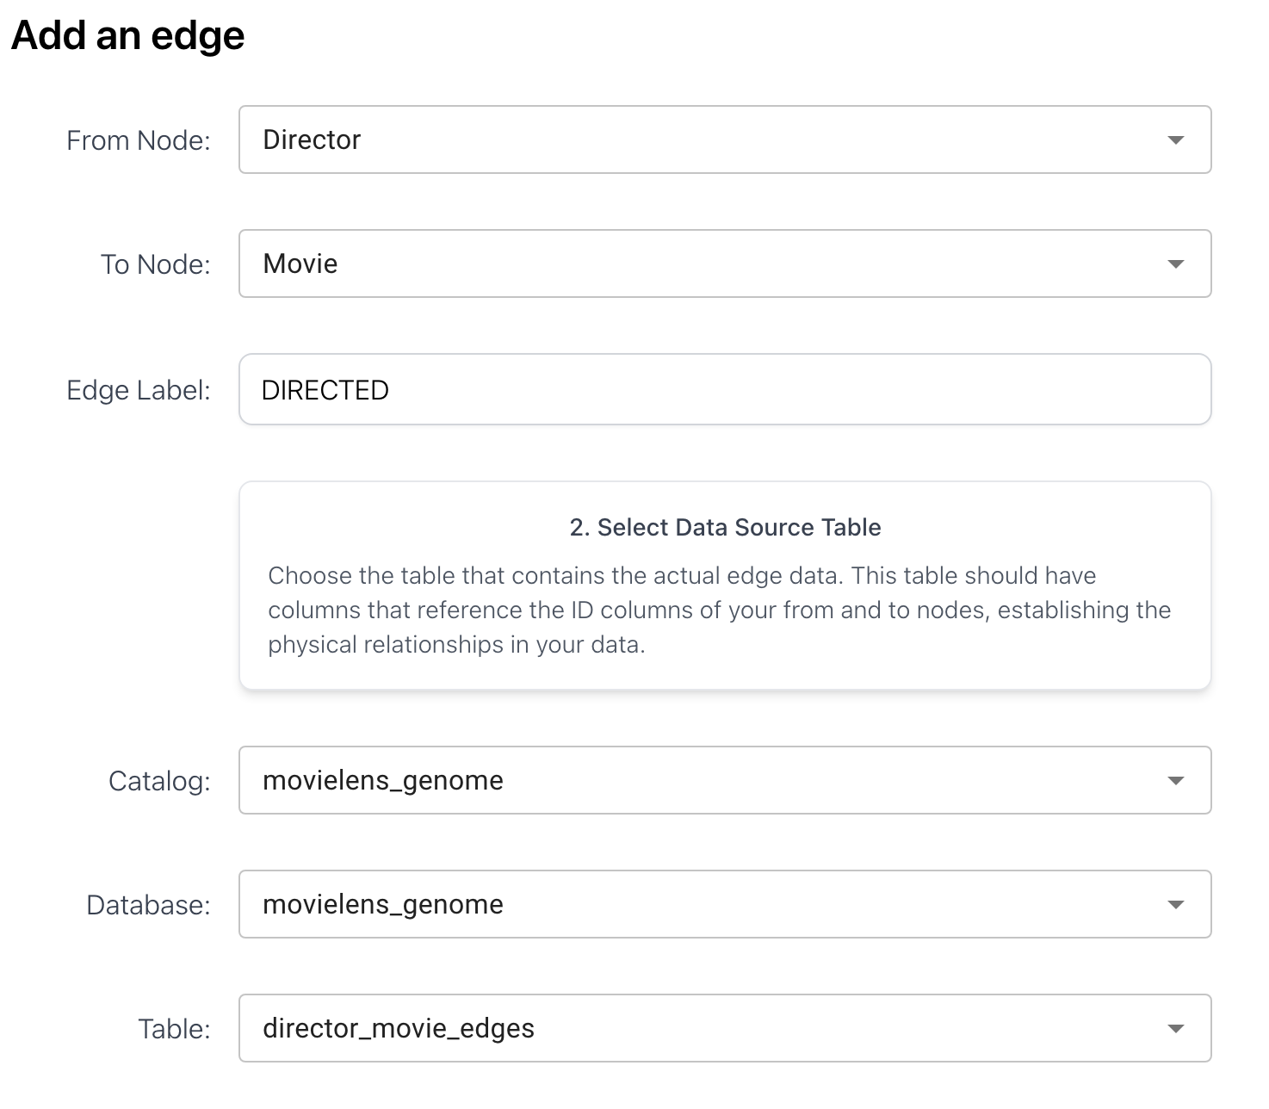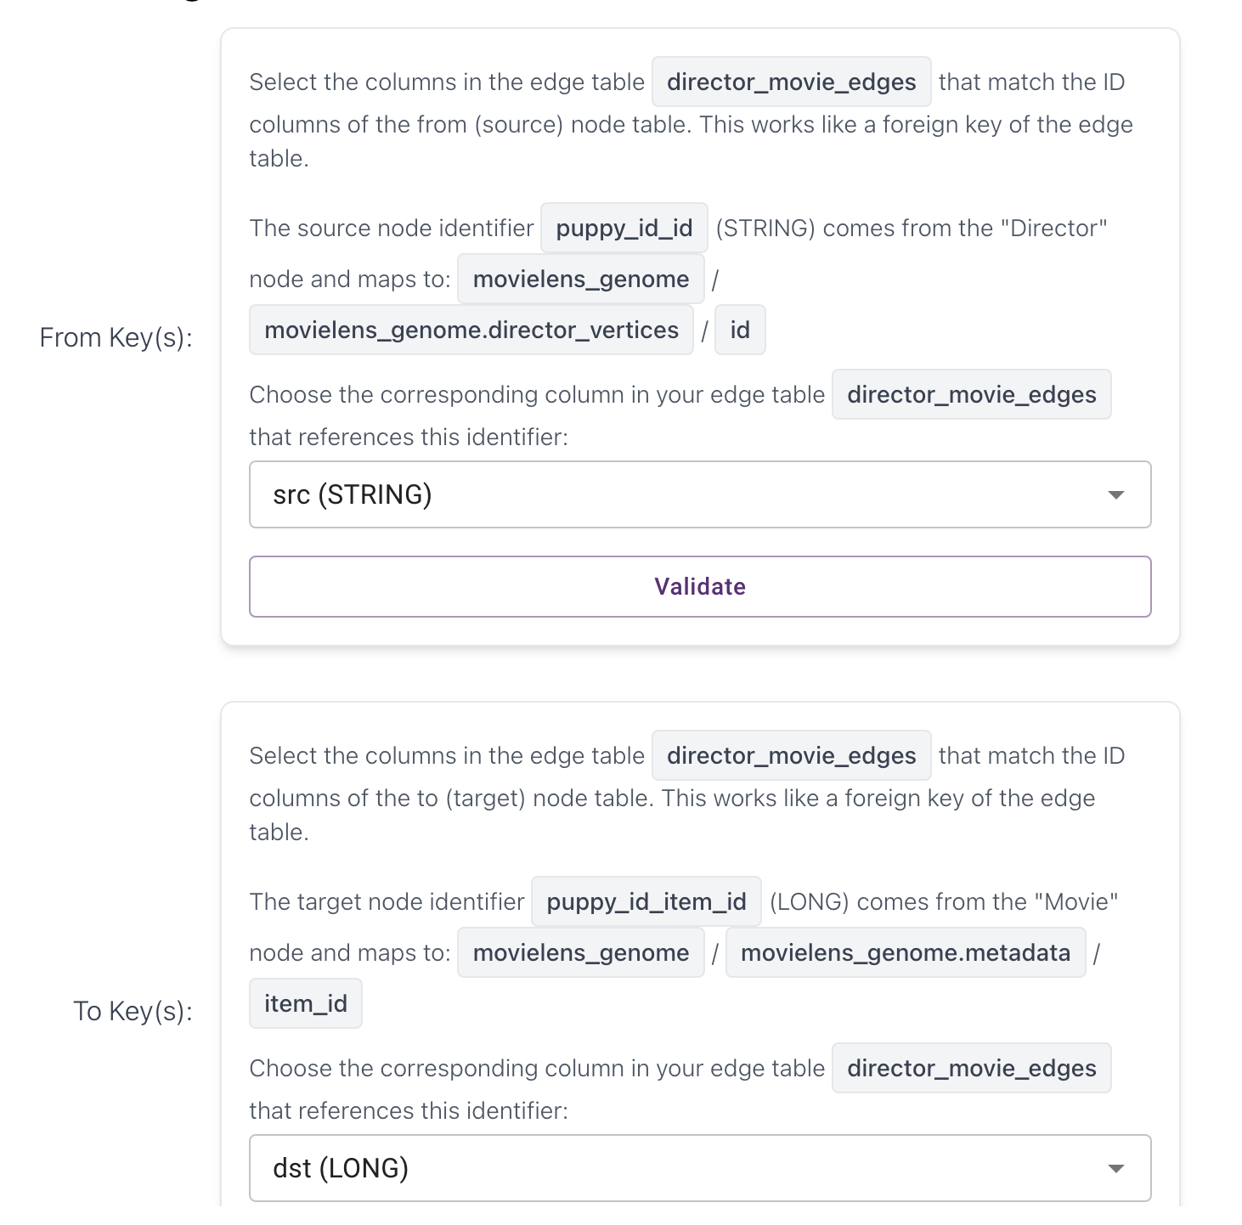

- Actor node

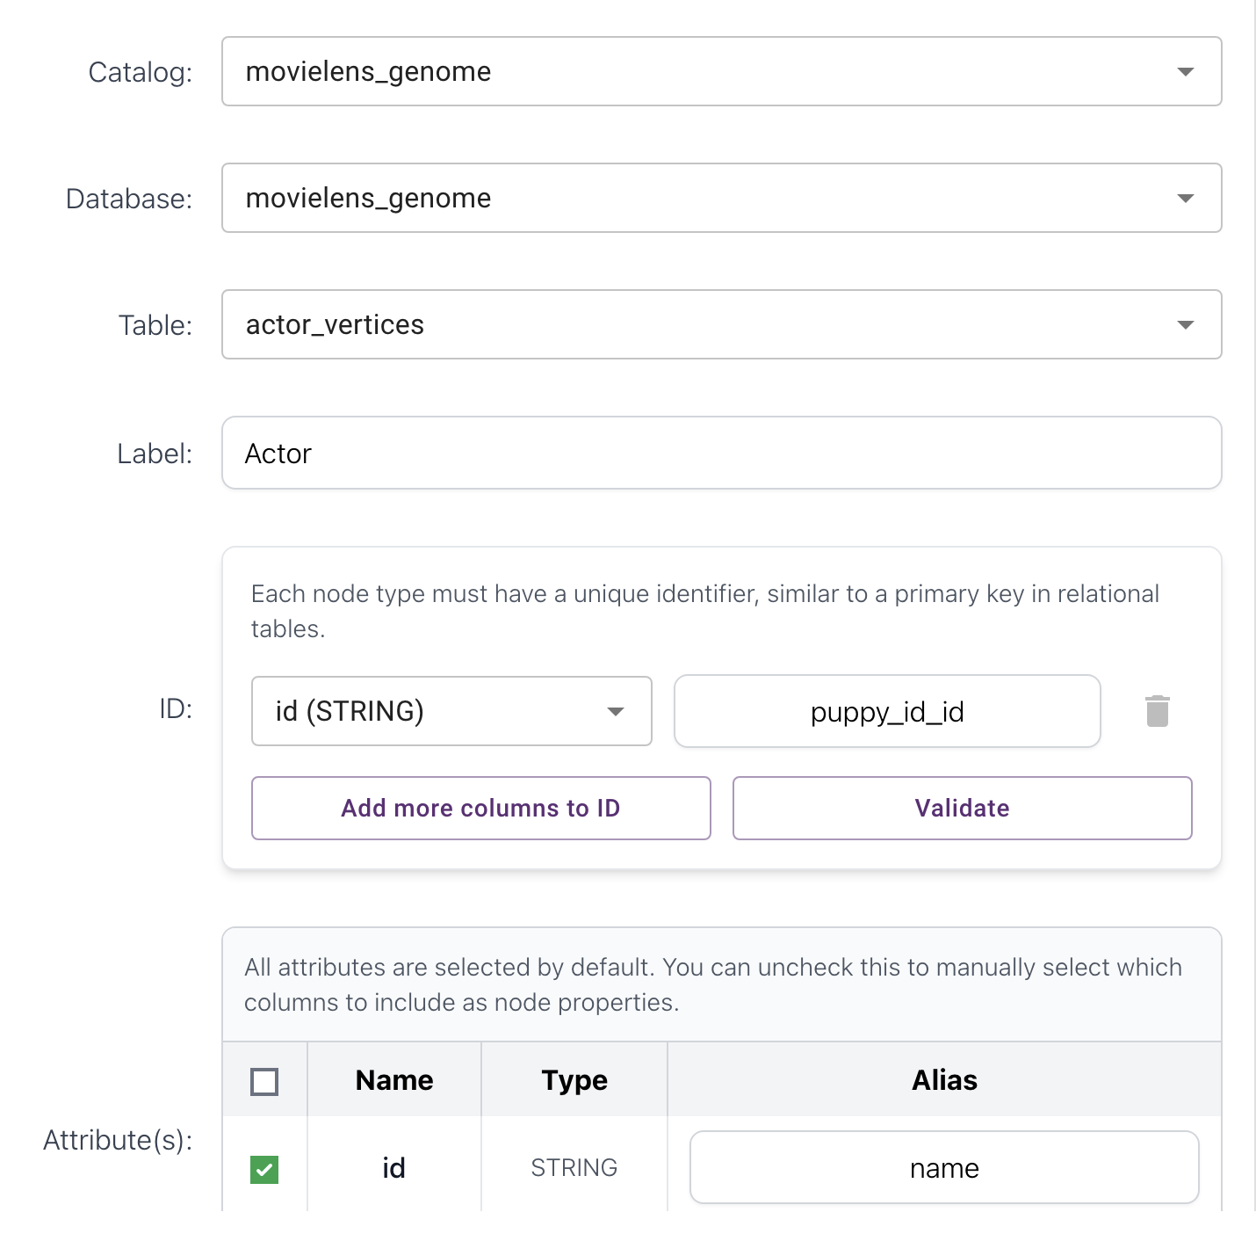
- ACTED_IN edge (Actor Movie)

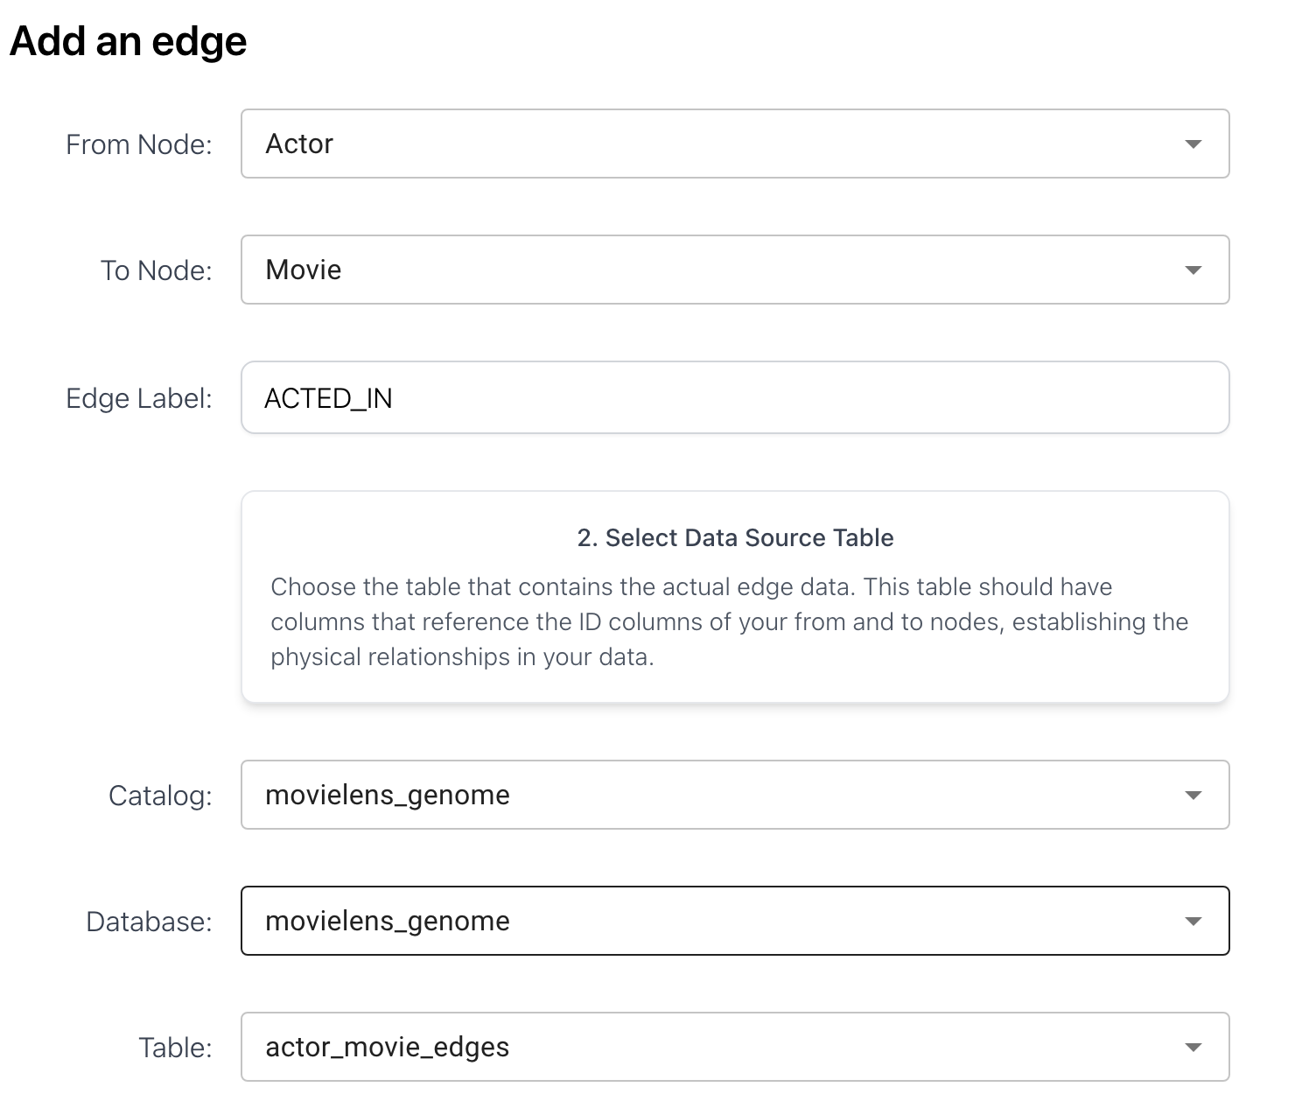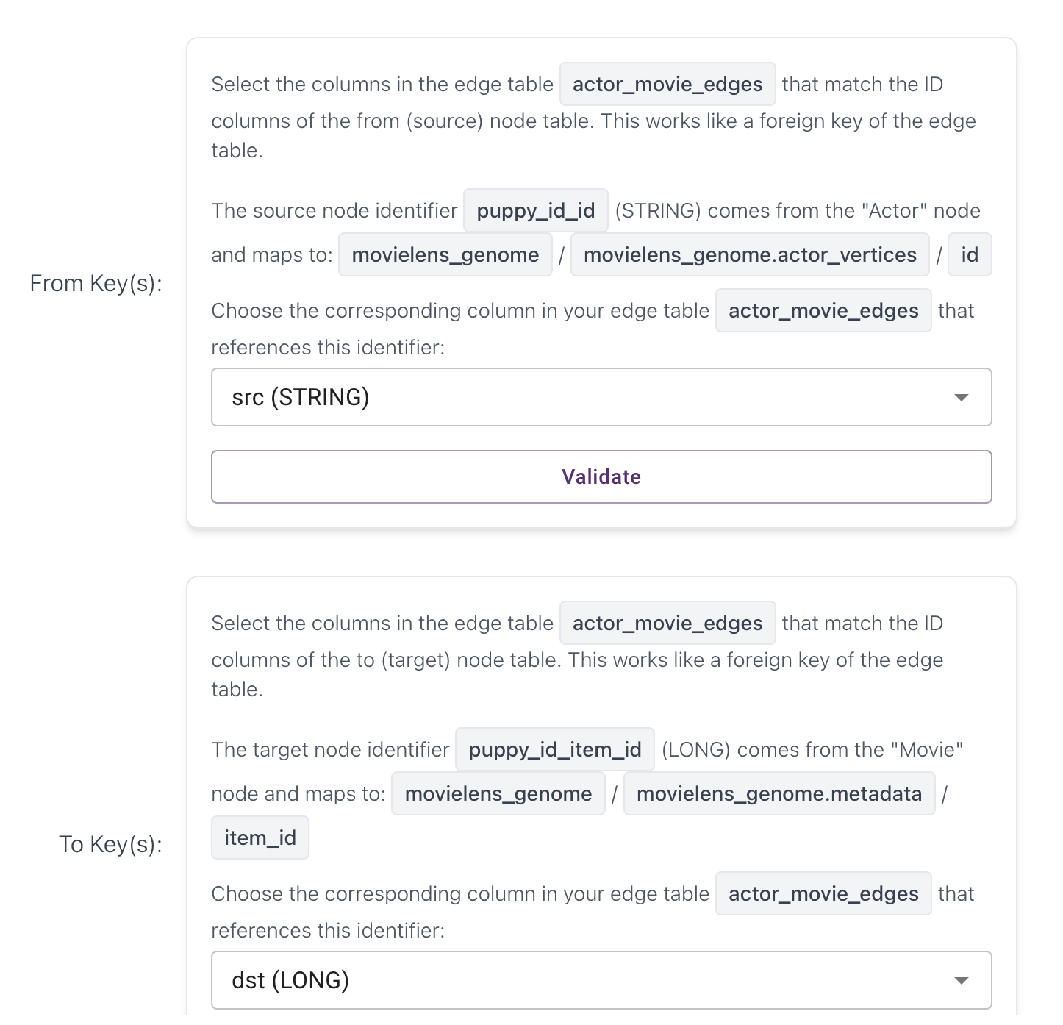

=== Queries ===

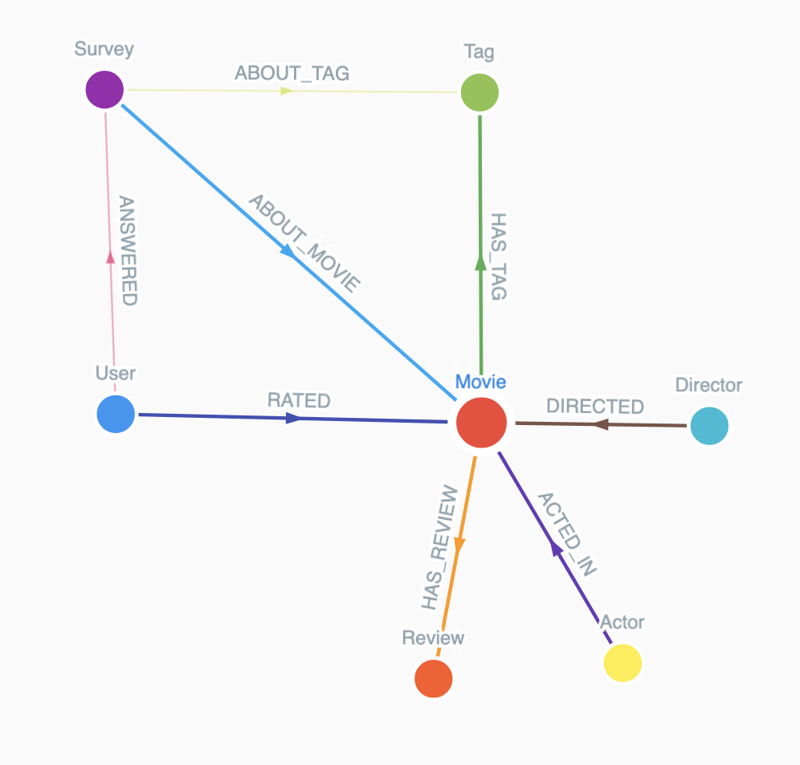

Top 10 Directors by Average Movie Rating (Filtering to avoid bias from 1-hit wonders, so considering movies >= 3):

MATCH (d:Director)-[:DIRECTED]->(m:Movie)
WHERE m.avgRating IS NOT NULL
WITH d.name AS Director, round(avg(m.avgRating), 2) AS AvgRating, count(m) AS Movies
WHERE Movies >= 3
RETURN Director, AvgRating, Movies
ORDER BY AvgRating DESC
LIMIT 10

Directors with the Most Movies Above 4.0 Rating (Not just average, how many great movies have they made? Considered minimum of 2 movies)
MATCH (d:Director)-[:DIRECTED]->(m:Movie)
WHERE m.avgRating >= 4.0
WITH d.name AS Director, count(m) AS HighRatedMovies
WHERE HighRatedMovies >= 2
RETURN Director, HighRatedMovies
ORDER BY HighRatedMovies DESC
LIMIT 10

Top 10 Actors by Number of Movies Acted In
MATCH (a:Actor)-[:ACTED_IN]->(m:Movie)
RETURN a.name AS Actor, count(m) AS TotalMovies
ORDER BY TotalMovies DESC
LIMIT 10

Top Actor-Director Pairs by Number of Collaborations
MATCH (d:Director)-[:DIRECTED]->(m:Movie)<-[:ACTED_IN]-(a:Actor)
RETURN d.name AS Director, a.name AS Actor, count(m) AS Collaborations
ORDER BY Collaborations DESC
LIMIT 10

Actor-Director Collaboration Quality (Which pairs consistently produce great movies?)
MATCH (d:Director)-[:DIRECTED]->(m:Movie)<-[:ACTED_IN]-(a:Actor)
WHERE m.avgRating IS NOT NULL
WITH d.name AS Director, a.name AS Actor, count(m) AS Collabs, round(avg(m.avgRating), 2) AS AvgRating
WHERE Collabs >= 3
RETURN Director, Actor, Collabs, AvgRating
ORDER BY AvgRating DESC
LIMIT 10

Top Actor Groups That Consistently Produce High-Rated Movies
MATCH (a1:Actor)-[:ACTED_IN]->(m:Movie)<-[:ACTED_IN]-(a2:Actor),
(a3:Actor)-[:ACTED_IN]->(m)
WHERE a1.name < a2.name AND a2.name < a3.name AND a1 <> a3 AND m.avgRating IS NOT NULL
WITH a1.name AS Actor1, a2.name AS Actor2, a3.name AS Actor3, collect(m.title) AS Movies,
count(DISTINCT m) AS MovieCount, round(avg(m.avgRating), 2) AS AvgRating
WHERE MovieCount >= 3
RETURN Actor1, Actor2, Actor3, MovieCount, AvgRating, Movies
ORDER BY AvgRating DESC
LIMIT 10
Returned result in 2s while it took 14s on neo4j

Actors Frequently Appearing in High-Rated Movies with Different Directors (Highlights high-performing, collaborative actors trusted by many top directors.)
MATCH (a:Actor)-[:ACTED_IN]->(m:Movie)<-[:DIRECTED]-(d:Director)
WHERE m.avgRating >= 4.0
WITH a.name AS Actor, count(DISTINCT d.name) AS UniqueTopDirectors, count(DISTINCT m) AS TopRatedMovies
WHERE TopRatedMovies >= 3
RETURN Actor, UniqueTopDirectors, TopRatedMovies
ORDER BY UniqueTopDirectors DESC, TopRatedMovies DESC
LIMIT 10

===USER + RATING====

Top 10 Most Active Users by Rating Count
MATCH (u:User)-[:RATED]->(m:Movie)
RETURN u.user_id AS UserID, count(*) AS RatedMovies
ORDER BY RatedMovies DESC
LIMIT 10
Returned result in ms while it took 30s on neo4j

Users Who Rate Harshly (Lowest Average Rating)
MATCH (u:User)-[r:RATED]->(m:Movie)
WHERE r.rating IS NOT NULL
WITH u.user_id AS UserID, count(r) AS TotalRatings, round(avg(r.rating), 2) AS AvgRating
WHERE TotalRatings >= 5
RETURN UserID, AvgRating, TotalRatings
ORDER BY AvgRating ASC
LIMIT 10
Returned result in ms while it took 55s on neo4j

Most Similar Users Based on Ratings for the Same Movies (Find pairs of users with overlapping movie preferences. (Collaborative filtering foundation))

MATCH (u1:User)-[r1:RATED]->(m:Movie)<-[r2:RATED]-(u2:User)
WHERE u1 <> u2 AND abs(r1.rating - r2.rating) <= 1
WITH u1.user_id AS User1, u2.user_id AS User2, count(m) AS SharedMovies
WHERE SharedMovies >= 5
RETURN User1, User2, SharedMovies
ORDER BY SharedMovies DESC
LIMIT 10
Cypher query error: [PEPS-06] Failed to build iterators

Users Whose Ratings Most Closely Match Movie Averages
MATCH (u:User)-[r:RATED]->(m:Movie)
WHERE m.avgRating IS NOT NULL AND r.rating IS NOT NULL
WITH u.user_id AS UserID,
count(r) AS RatingCount,
round(avg(abs(r.rating - m.avgRating)), 3) AS AvgDeviation
WHERE RatingCount >= 5
RETURN UserID, RatingCount, AvgDeviation
ORDER BY AvgDeviation ASC
LIMIT 10
Returned result in ms while it took 51s on neo4j

===REVIEW===

Movies with the Most Reviews
MATCH (m:Movie)-[:HAS_REVIEW]->(r:Review)
RETURN m.title AS Movie, count(r) AS ReviewCount
ORDER BY ReviewCount DESC
LIMIT 10

High-Rated Movies That Also Have Many Reviews
MATCH (m:Movie)-[:HAS_REVIEW]->(r:Review)
WHERE m.avgRating IS NOT NULL
WITH m.title AS Movie, m.avgRating AS Rating, count(r) AS ReviewCount
WHERE ReviewCount >= 10 AND Rating >= 4.0
RETURN Movie, Rating, ReviewCount
ORDER BY ReviewCount DESC
LIMIT 10

Directors Whose Movies Collect the Most Reviews
MATCH (d:Director)-[:DIRECTED]->(m:Movie)-[:HAS_REVIEW]->(r:Review)
RETURN d.name AS Director, count(r) AS TotalReviews
ORDER BY TotalReviews DESC
LIMIT 10

Most frequently used words in reviews:
MATCH (r:Review)
WHERE r.text IS NOT NULL
UNWIND apoc.text.split(toLower(r.text), "\\W+") AS word
WITH word
WHERE size(word) > 3 AND NOT word IN ["this", "that", "with", "from", "have", "your", "just", "what", "when", "they", "were", "then", "there", "would", "which", "could", "really"]
RETURN word, count(*) AS freq
ORDER BY freq DESC
LIMIT 20
Cypher query error: [FET-99] Unsupported Function: split

Average Review Length per Movie (Which movies received the most detailed (or terse) reviews?)
MATCH (m:Movie)-[:HAS_REVIEW]->(r:Review)
WITH m.title AS Movie, avg(size(r.text)) AS AvgLength, count(r) AS ReviewCount
WHERE ReviewCount >= 5
RETURN Movie, round(AvgLength, 2) AS AvgReviewLength, ReviewCount
ORDER BY AvgReviewLength DESC
LIMIT 10

Movies Most Frequently Called "Boring", "Disgusting", etc.
MATCH (m:Movie)-[:HAS_REVIEW]->(r:Review)
WHERE toLower(r.text) CONTAINS 'boring'
OR toLower(r.text) CONTAINS 'disgusting'
OR toLower(r.text) CONTAINS 'waste'
OR toLower(r.text) CONTAINS 'terrible'
OR toLower(r.text) CONTAINS 'bad'
WITH m.title AS Movie, count(*) AS NegativeMentions
RETURN Movie, NegativeMentions
ORDER BY NegativeMentions DESC
LIMIT 10
Returned result in ms while it took 37s on neo4j

===SURVEY + TAG===

Top Tags by Frequency in Surveys (Which tags are evaluated most often by users?)
MATCH (:Survey)-[:ABOUT_TAG]->(t:Tag)
RETURN t.tag AS Tag, count(*) AS SurveyCount
ORDER BY SurveyCount DESC
LIMIT 10

Tags Most Frequently Scored Highly in Surveys (Which tags do users consistently agree are applicable to movies (score ≥ 4)?)
MATCH (s:Survey)-[:ABOUT_TAG]->(t:Tag)
WHERE s.score >= 4
RETURN t.tag AS Tag, count(*) AS HighScoreCount
ORDER BY HighScoreCount DESC
LIMIT 10
Cypher query error: [PEPS-06] Failed to build iterators

Movies With Most Tagged Survey Feedback (Which movies have been analyzed most often in surveys?)
MATCH (s:Survey)-[:ABOUT_MOVIE]->(m:Movie)
RETURN m.title AS Movie, count(*) AS SurveyMentions
ORDER BY SurveyMentions DESC
LIMIT 10

Best Tags per Movie by Survey and Tag_Count
MATCH (m:Movie)-[ht:HAS_TAG]->(t:Tag)
MATCH (s:Survey)-[:ABOUT_MOVIE]->(m)
MATCH (s)-[:ABOUT_TAG]->(t)
WITH m.title AS Movie, t.tag AS Tag,
sum(ht.num) AS TagApplications,
avg(s.score) AS AvgSurveyScore,
count(s) AS SurveyMentions
WHERE TagApplications > 5 AND SurveyMentions >= 5
RETURN Movie, Tag, TagApplications, round(AvgSurveyScore, 2) AS AvgSurveyScore, SurveyMentions
ORDER BY AvgSurveyScore DESC, SurveyMentions DESC
LIMIT 20

Users Who Participated in the Most Surveys
MATCH (u:User)-[:ANSWERED]->(s:Survey)
RETURN u.user_id AS User, count(s) AS TotalSurveys
ORDER BY TotalSurveys DESC
LIMIT 10

Tag-Movie Associations with High Confidence (Which movie-tag pairs were most confidently agreed upon by users?)
MATCH (s:Survey)-[:ABOUT_MOVIE]->(m:Movie), (s)-[:ABOUT_TAG]->(t:Tag)
WHERE s.score >= 4
RETURN m.title AS Movie, t.tag AS Tag, count(*) AS HighScoreCount
ORDER BY HighScoreCount DESC
LIMIT 10
Cypher query error: [PEPS-06] Failed to build iterators

Users Who Did NOT Participate in Any Survey
MATCH (u:User)
WHERE NOT (u)-[:ANSWERED]->(:Survey)
RETURN u.user_id AS UserID
LIMIT 20

Users With Highest Survey Agreement Accuracy (Measures users whose survey scores closely align with consensus (like those who gave 5 when others did too)).
MATCH (u:User)-[:ANSWERED]->(s:Survey)-[:ABOUT_TAG]->(t:Tag)
WITH u.user_id AS User, t.tag AS Tag, s.score AS UserScore
MATCH (s2:Survey)-[:ABOUT_TAG]->(t)
WHERE s2.score IS NOT NULL
WITH User, Tag, UserScore, avg(s2.score) AS Consensus
WITH User, avg(abs(UserScore - Consensus)) AS AvgDeviation, count(*) AS Count
WHERE Count >= 10
RETURN User, round(AvgDeviation, 2) AS AvgTagDisagreement, Count
ORDER BY AvgTagDisagreement ASC
LIMIT 10
Cypher query error: [PEPS-06] Failed to build iterators

