Puppygraph movielens ml-32

PySpark Initialization, Database Creation, and Table Loading
To preprocess the MovieLens ML-32M dataset and prepare it for ingestion into PuppyGraph, we first initialized a PySpark session configured with Delta Lake, Hive Metastore, and HDFS support. The following configuration launches Spark in cluster mode (Spark Standalone) and enables full Delta compatibility with Spark 3.4:
from pyspark.sql import SparkSession

spark = (
SparkSession.builder
.appName("yelp_puppy")
.master("spark://master:7077")

# executors
.config("spark.executor.instances", "2")
.config("spark.executor.cores", "2")
.config("spark.executor.memory", "20g")
.config("spark.driver.memory", "4g")

.config("spark.jars.packages", "io.delta:delta-core_2.12:2.3.0")
.config("spark.sql.extensions", "io.delta.sql.DeltaSparkSessionExtension")
.config("spark.sql.catalog.spark_catalog", "org.apache.spark.sql.delta.catalog.DeltaCatalog")

# --- HDFS ---
.config("spark.hadoop.fs.defaultFS", "hdfs://master:9000")
.config("spark.sql.warehouse.dir", "hdfs://master:9000/spark-warehouse")

# --- HIVE METASTORE ---
.config("spark.sql.catalogImplementation", "hive")
.config("hive.metastore.uris", "thrift://master:9083")

.getOrCreate()
)
This initializes a fully integrated Spark environment where:
- Delta Lake provides ACID-compliant storage
- Hive Metastore stores table metadata and allows catalog access
- HDFS acts as the distributed storage layer
Since PuppyGraph reads all metadata and table definitions directly from the Hive Metastore, it is essential that the MovieLens tables are created inside a Hive-managed database.
The database was created using the underlying JVM SparkSession:
spark._jsparkSession.sql("CREATE DATABASE IF NOT EXISTS movielens_ml32")
By creating the database in Hive, all Delta tables we generate, such as movies, ratings, genres, tags, and edge mappings, become automatically visible and accessible inside PuppyGraph during data import. This guarantees smooth interoperability between PySpark preprocessing and PuppyGraph graph construction.

Loading MovieLens CSV Files from HDFS
All raw CSV files were uploaded to HDFS under /movielens.
These were loaded into PySpark exactly as they exist in HDFS:
movies_df = spark.read.option("header", True).csv("hdfs://master:9000/movielens/movies.csv")
ratings_df = spark.read.option("header", True).csv("hdfs://master:9000/movielens/ratings.csv")
clean_ratings_df = spark.read.option("header", True).csv("hdfs://master:9000/movielens/clean_ratings.csv")
genres_df = spark.read.option("header", True).csv("hdfs://master:9000/movielens/genres.csv")
has_genre_df = spark.read.option("header", True).csv("hdfs://master:9000/movielens/has_genre_edge.csv")
tags_df = spark.read.option("header", True).csv("hdfs://master:9000/movielens/tags.csv")
tags_with_id_df = spark.read.option("header", True).csv("hdfs://master:9000/movielens/tags_with_id.csv")
links_df = spark.read.option("header", True).csv("hdfs://master:9000/movielens/links.csv")

Each DataFrame now holds the corresponding MovieLens dataset.

Writing Delta Tables into the MovieLens Database
To prepare the data for PuppyGraph, each DataFrame was written as a Delta table inside the movielens_ml32 Hive database.
This makes the dataset persistent, ACID-compliant, and fully accessible through the Hive Metastore.
movies_df.write.format("delta").mode("overwrite").saveAsTable("movielens_ml32.movies")
ratings_df.write.format("delta").mode("overwrite").saveAsTable("movielens_ml32.ratings")
clean_ratings_df.write.format("delta").mode("overwrite").saveAsTable("movielens_ml32.clean_ratings")
genres_df.write.format("delta").mode("overwrite").saveAsTable("movielens_ml32.genres")
has_genre_df.write.format("delta").mode("overwrite").saveAsTable("movielens_ml32.has_genre")
tags_df.write.format("delta").mode("overwrite").saveAsTable("movielens_ml32.tags_raw")
tags_with_id_df.write.format("delta").mode("overwrite").saveAsTable("movielens_ml32.tags_with_id")
links_df.write.format("delta").mode("overwrite").saveAsTable("movielens_ml32.links")

Nodes and edges creation on puppygraph
Once PuppyGraph is connected to the Hive Metastore (thrift://master:9083), all Delta tables created earlier, including movies, genres, ratings, clean_ratings, has_genre, and tags appear under the movielens_ml32 database in the PuppyGraph Data Import UI.

- Movie node
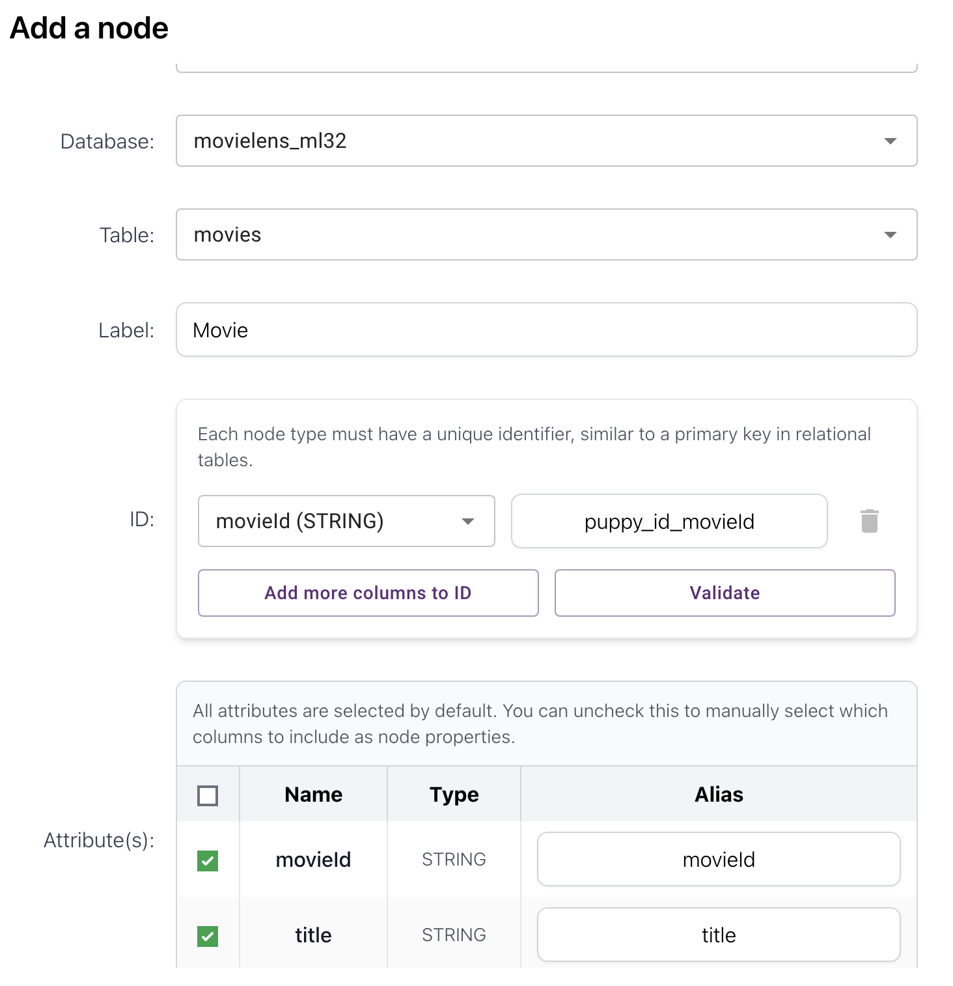
- Genre node
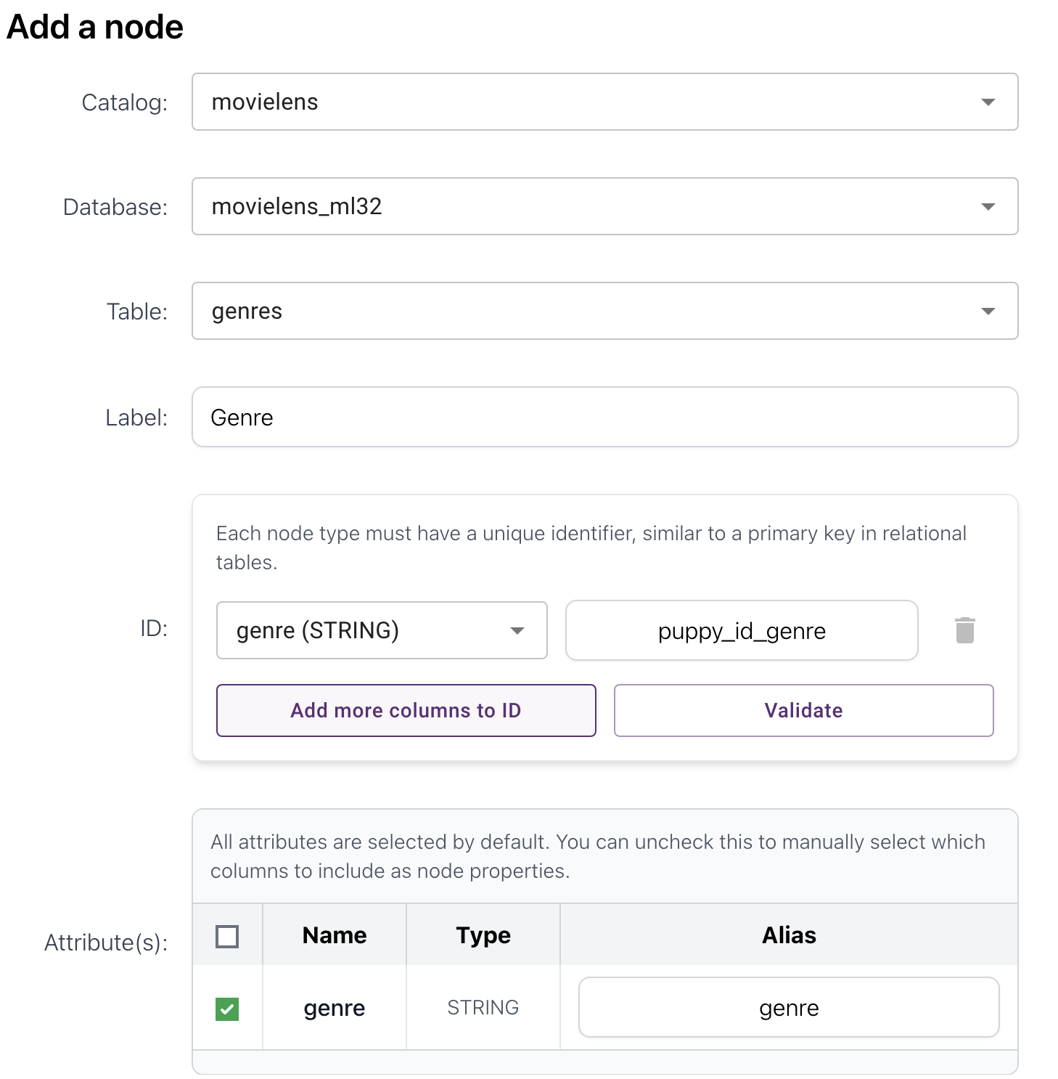
- HAS_GENRE edge (Movie Genre)
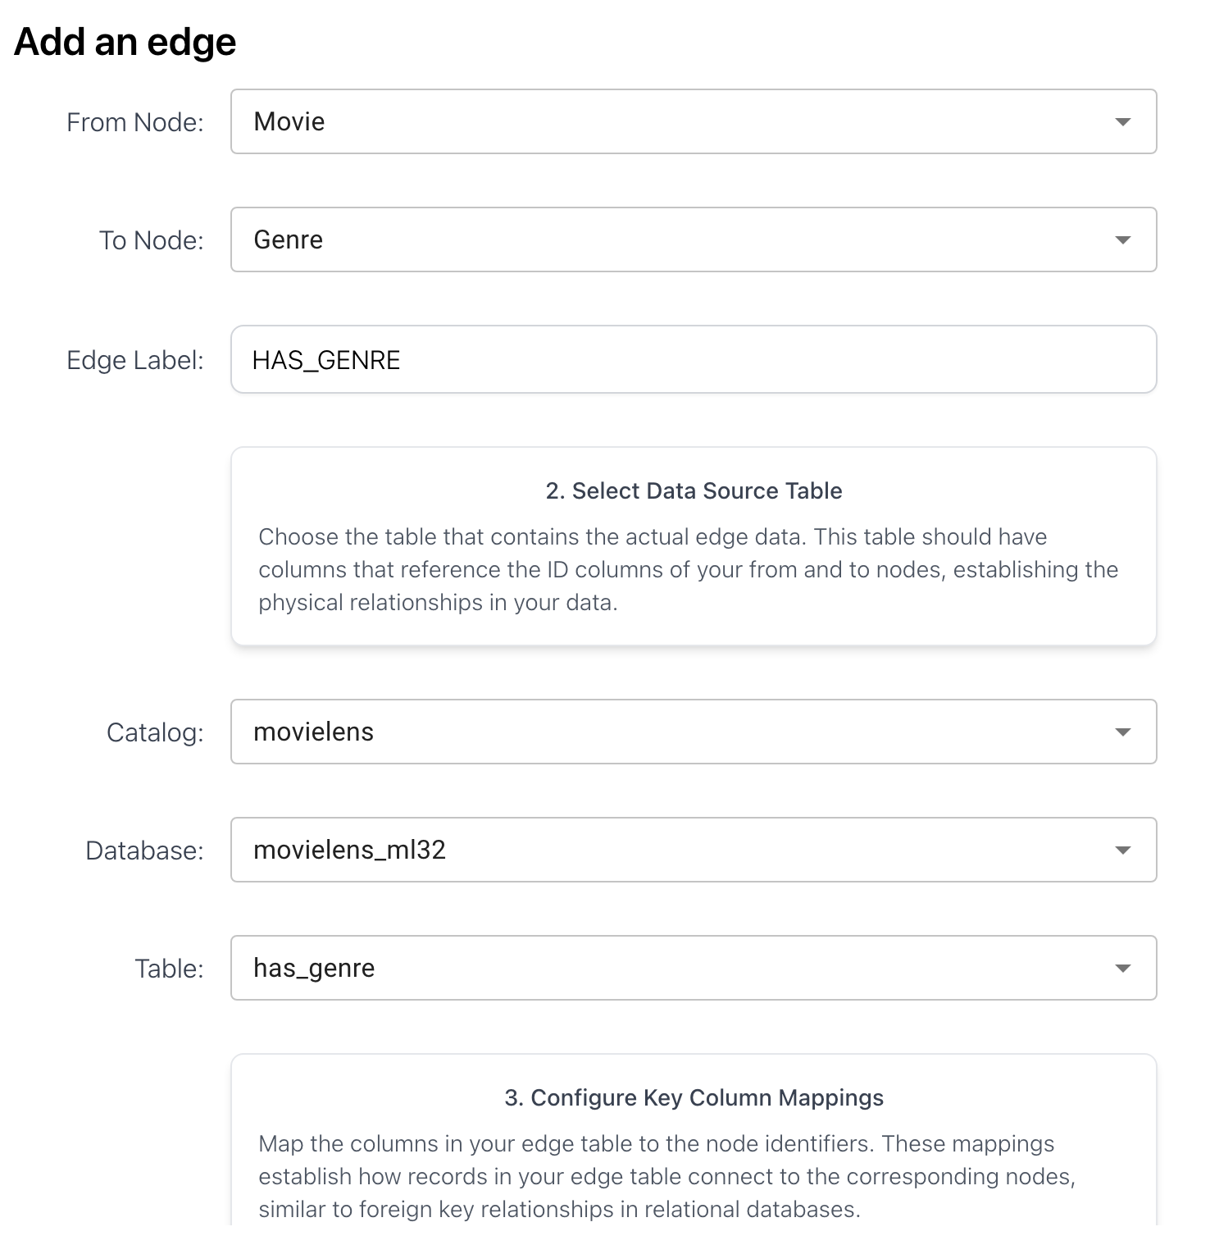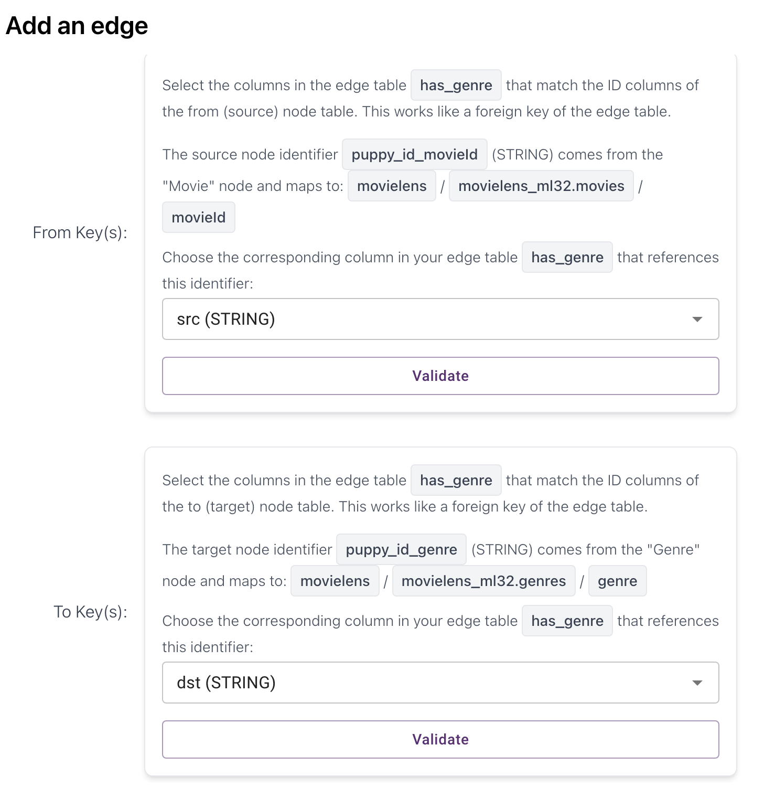

- User node
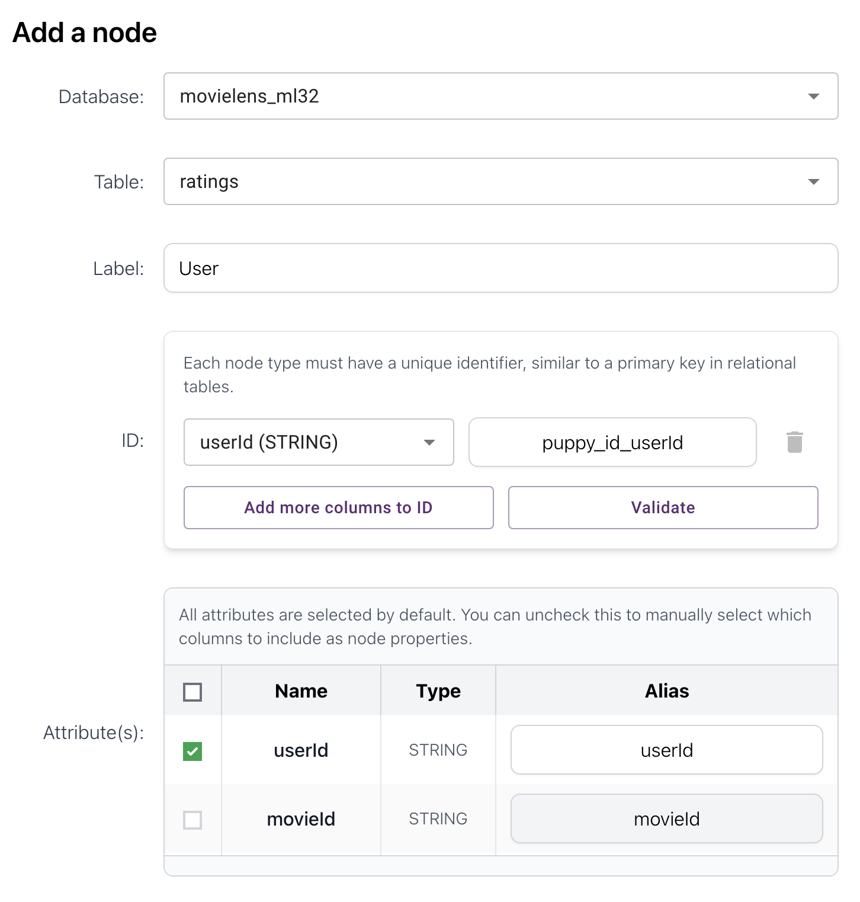

- RATED edge (User Movie)

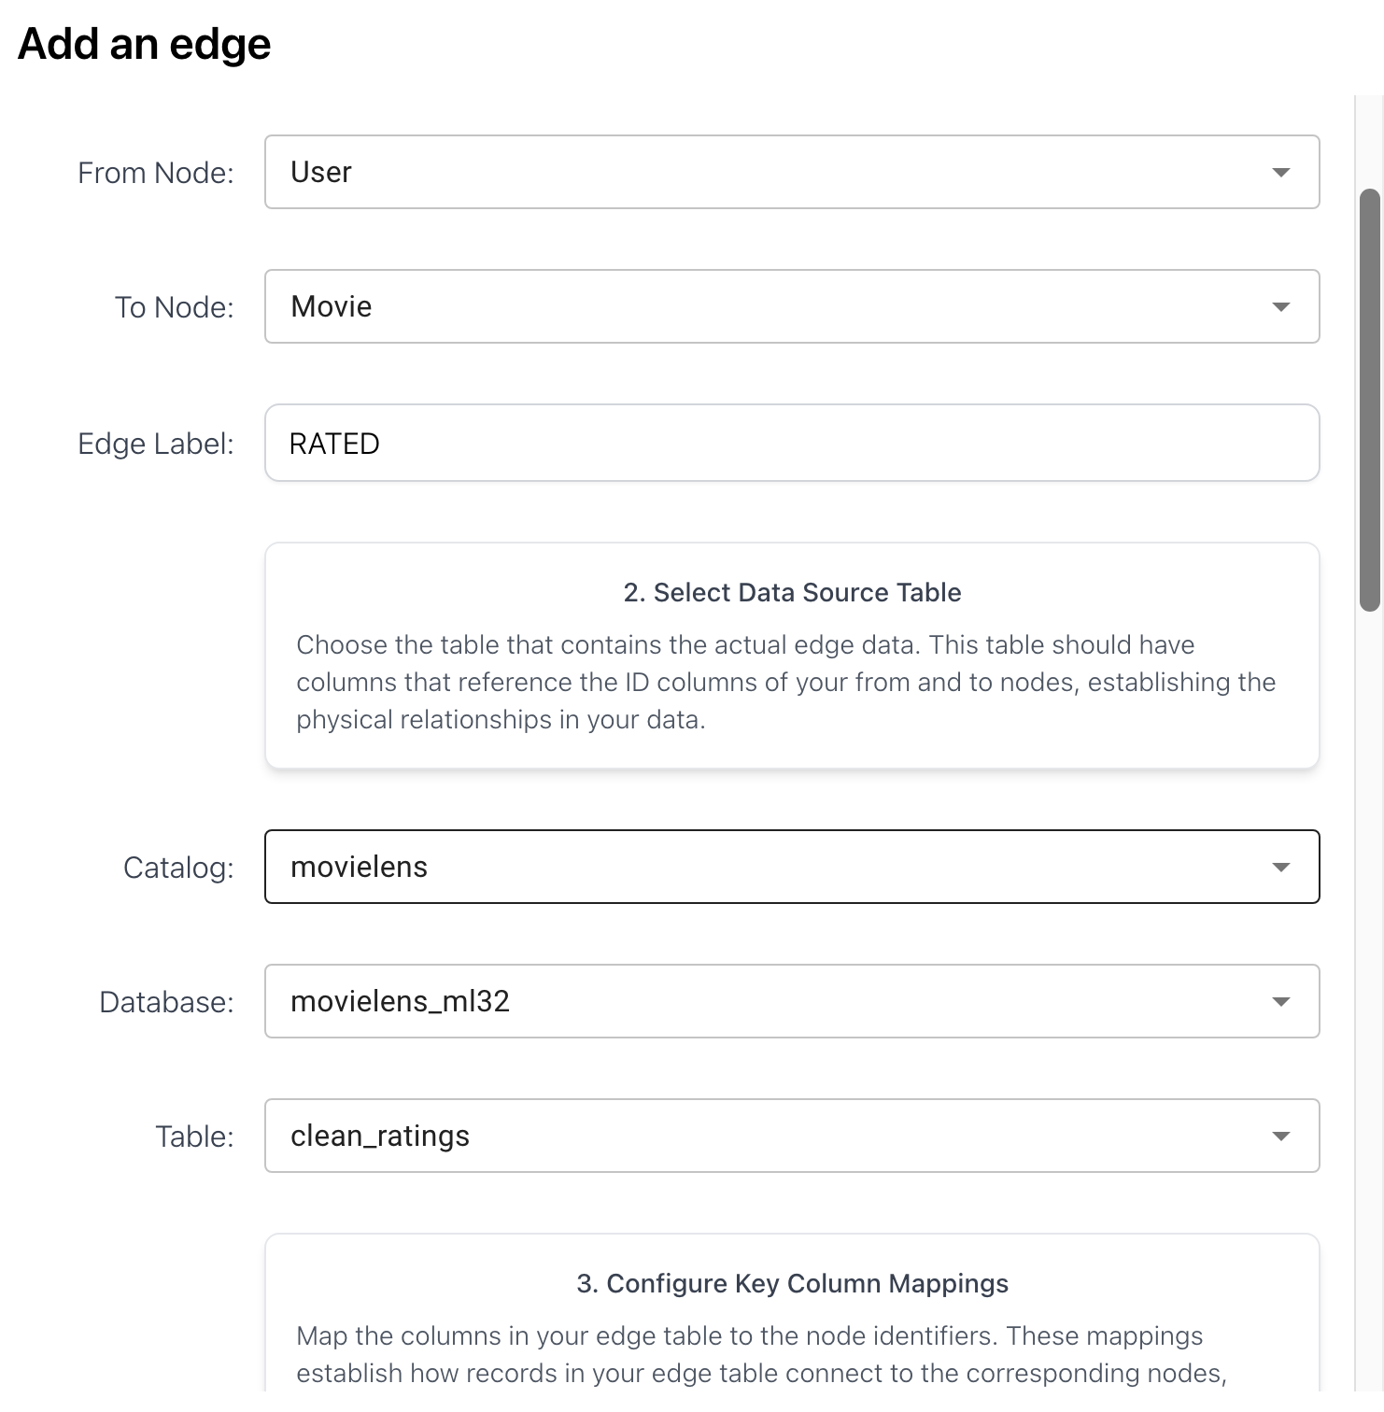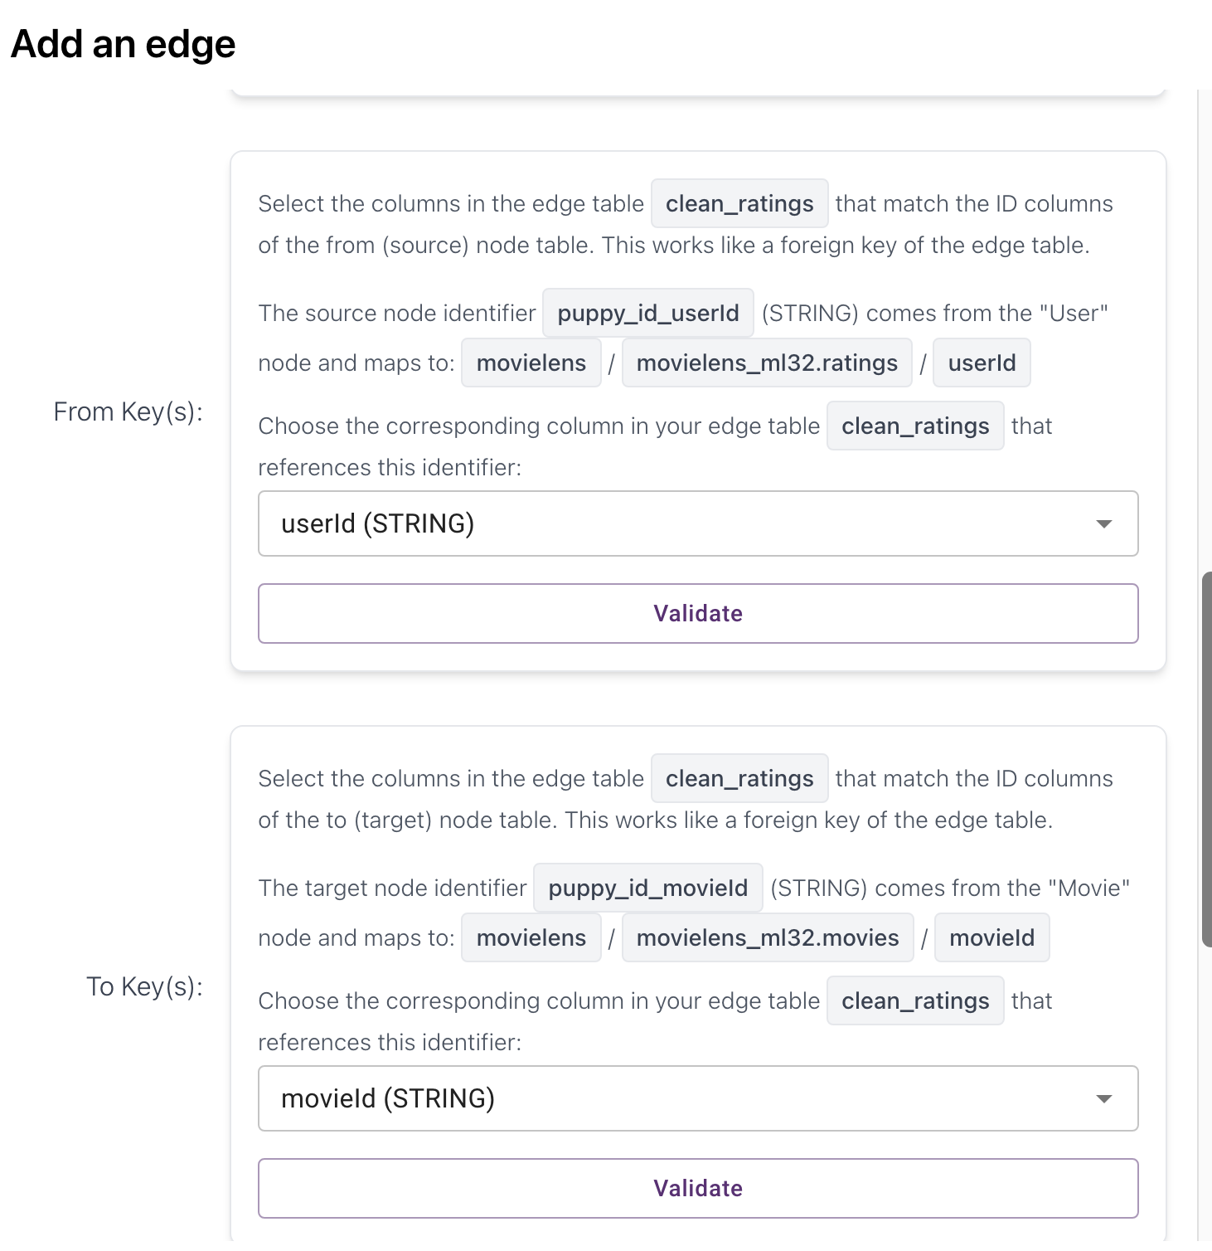

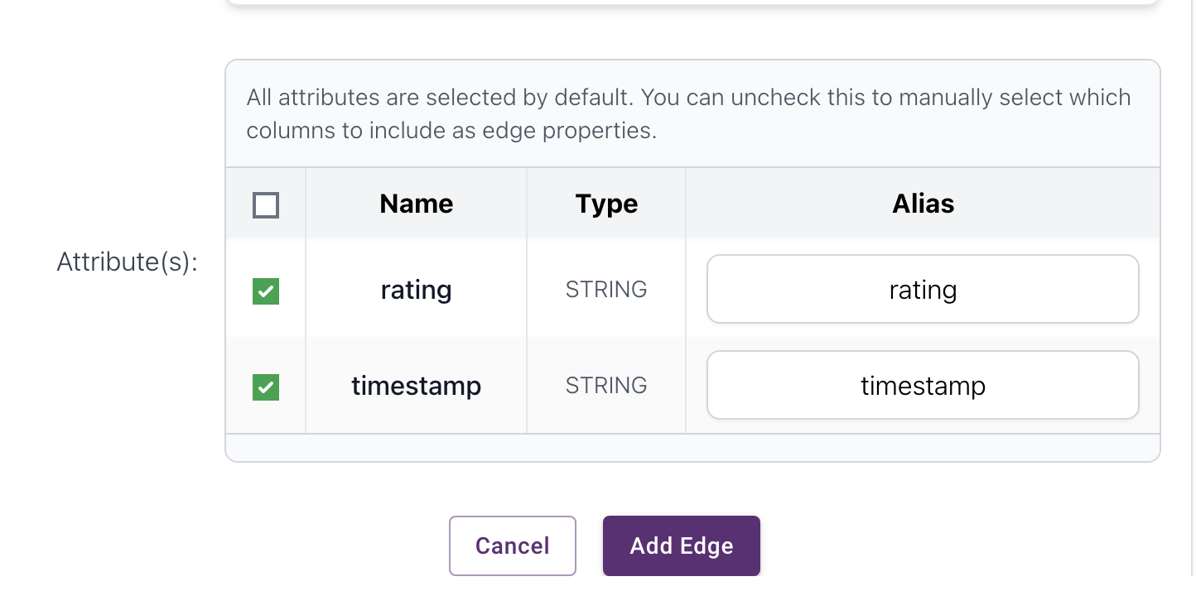

- TAGGED edge (User Movie)

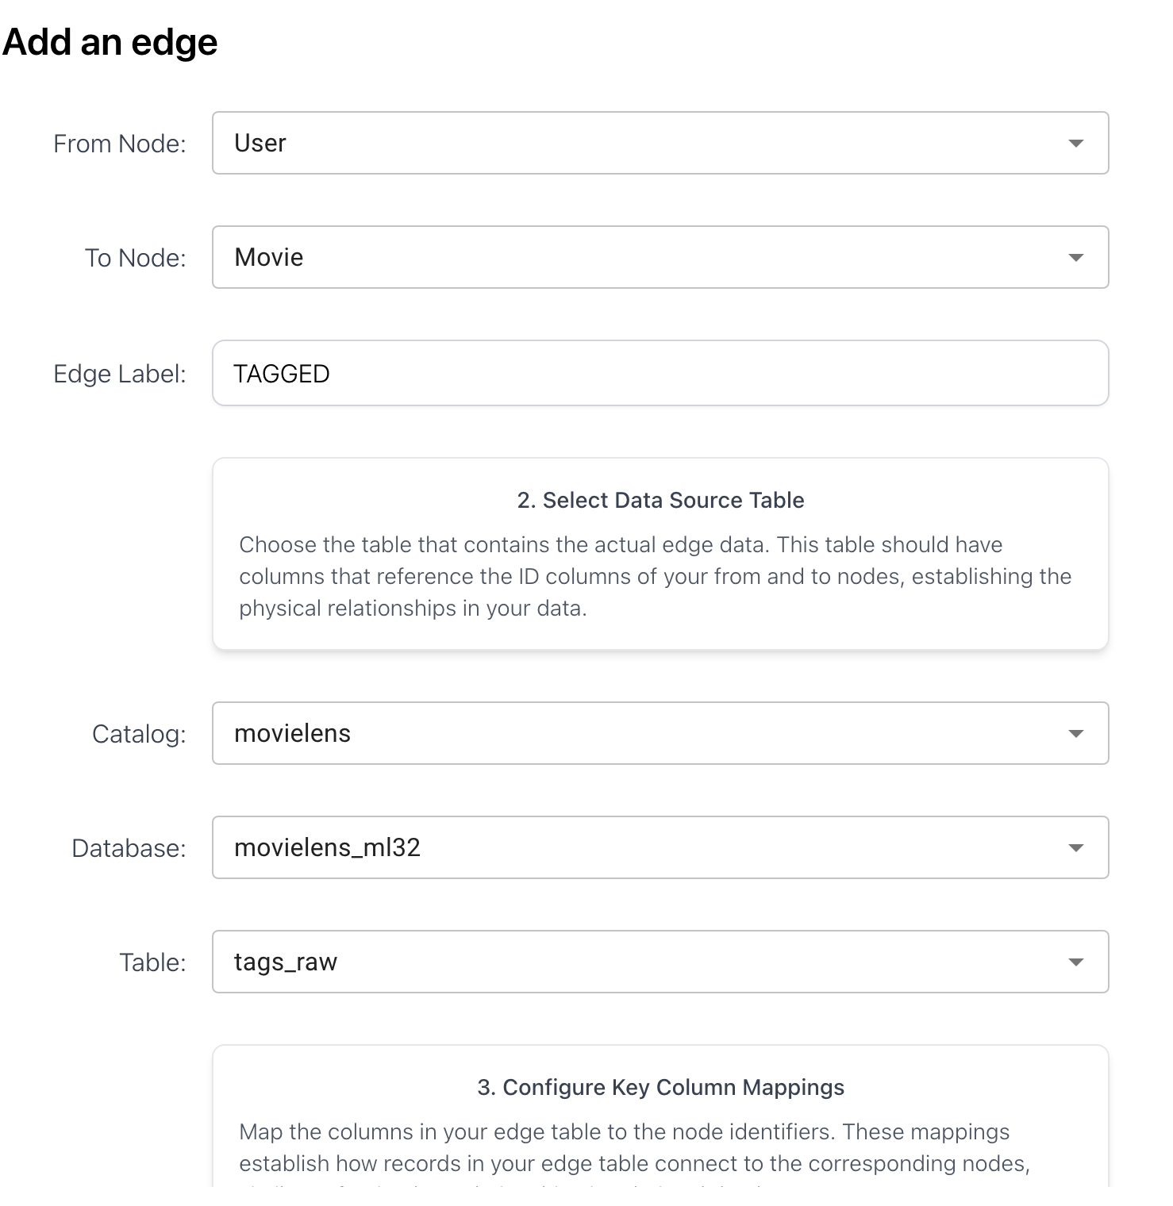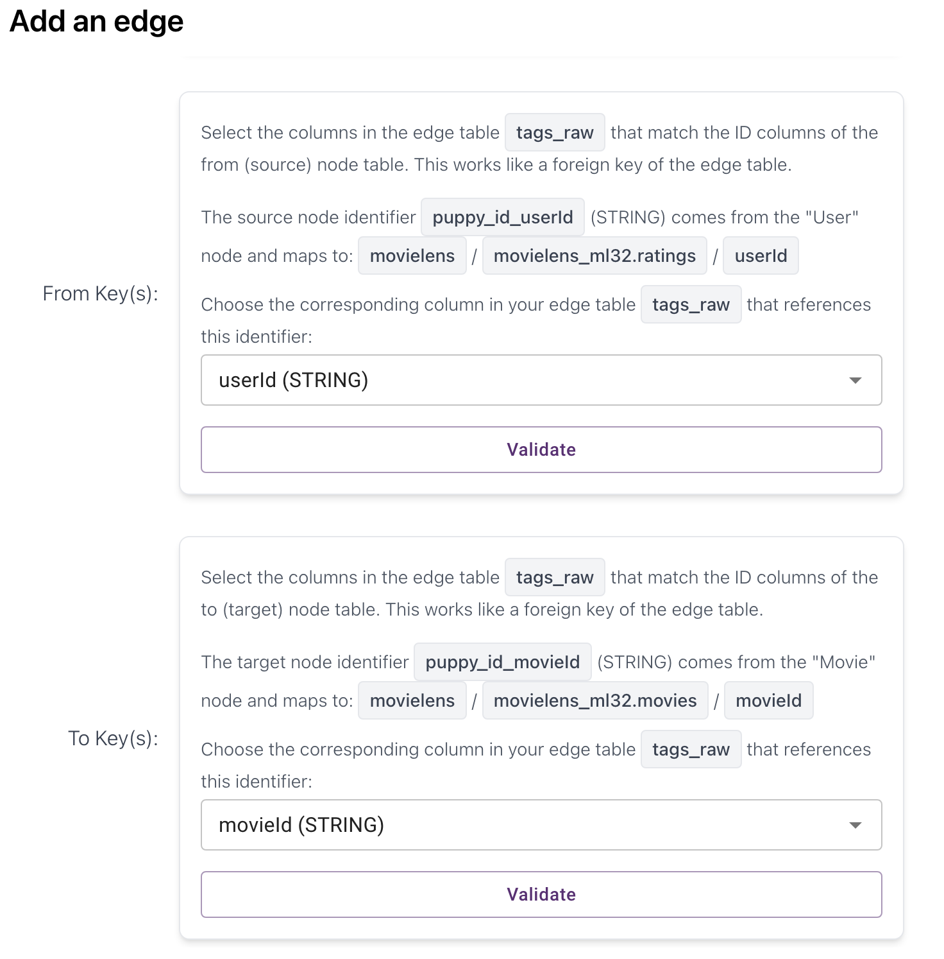

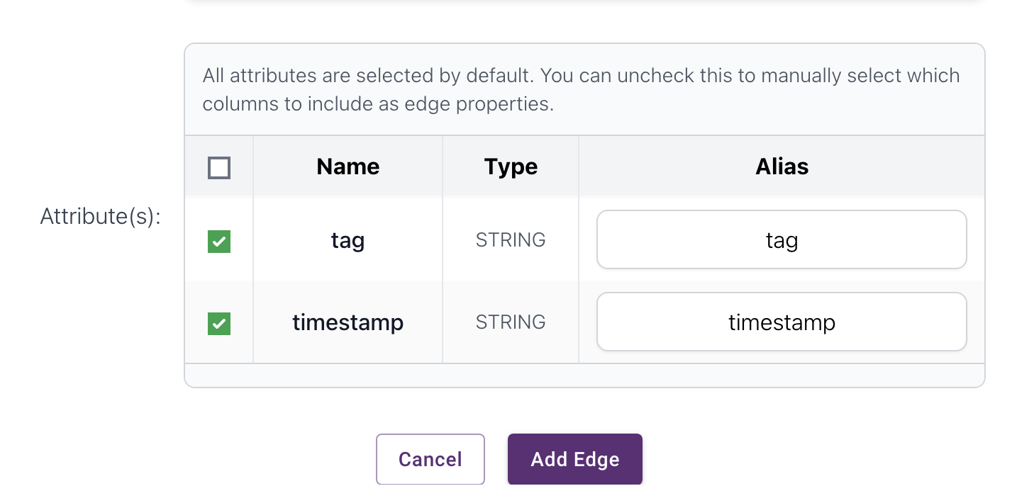

=== Queries ===
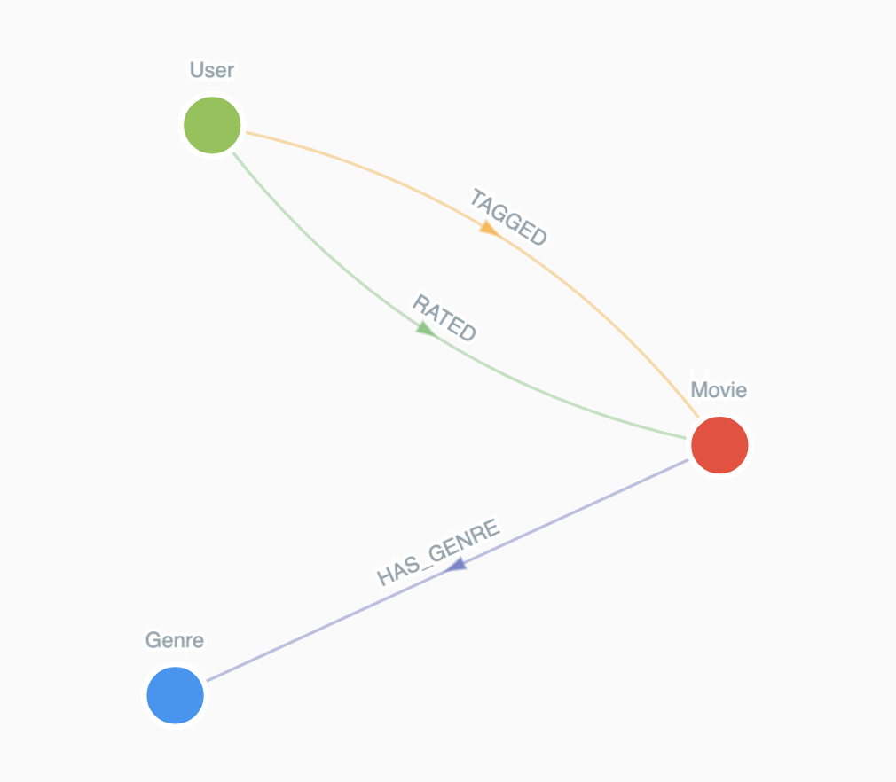
Check different rating values and their occurrence frequencies
MATCH (:User)-[r:RATED]->(:Movie)
RETURN r.rating AS rating, COUNT(*) AS frequency
ORDER BY rating
Returned result in ms while it took 30 seconds on neo4j

List users and the movies they rated that belong to the specific genre "Comedy", find top-20 results in descending order of ratings:
MATCH (u:User)-[r:RATED]->(m:Movie)-[:HAS_GENRE]->(g:Genre {name: "Comedy"})
RETURN u.userId AS userId, m.title AS movieTitle, g.name AS genre, r.rating AS rating
ORDER BY r.rating DESC
LIMIT 20;
Returned result in ms while it took 11 seconds on neo4j

Find the title of the movies that belong to multiple genres, e.g., "Comedy" and "Romance":
MATCH (m:Movie)-[:HAS_GENRE]->(g1:Genre {name: "Comedy"})
MATCH (m)-[:HAS_GENRE]->(g2:Genre {name: "Romance"})
RETURN m.title AS movieTitle
LIMIT 10;

Find users who have rated movies in both "Action" and "Romance" genres, list 10 userIds:
MATCH (u:User)-[:RATED]->(m1:Movie)-[:HAS_GENRE]->(g1:Genre {name: "Action"})
MATCH (u)-[:RATED]->(m2:Movie)-[:HAS_GENRE]->(g2:Genre {name: "Romance"})
RETURN DISTINCT u.userId AS userId
LIMIT 10;

Find users who have rated movies from at least 3 distinct genres, list the top-10 in descending order of the genre count.
MATCH (u:User)-[:RATED]->(m:Movie)-[:HAS_GENRE]->(g:Genre)
WITH u, COUNT(DISTINCT g.name) AS genreCount
WHERE genreCount >= 3
RETURN u.userId AS userId, genreCount
ORDER BY genreCount DESC
LIMIT 10;
Returned result in ms while it took 1 min 5 sec on neo4j

Find users who have rated movies from at least 3 distinct genres, list 10 such users along with the corresponding list of genres in descending order of genre count.
MATCH (u:User)-[:RATED]->(m:Movie)-[:HAS_GENRE]->(g:Genre)
WITH u, collect(DISTINCT g.name) AS genres
WHERE size(genres) >= 3
RETURN u.userId AS userId, genres
ORDER BY size(genres) DESC
LIMIT 10;
Returned result in ms while it took 1 min 8 sec on neo4j

Find movies that span at least 3 genres and have at least 50 user ratings, return top-10 movies in descending order of their rating count, along with the list of genres and the rating count.
MATCH (m:Movie)-[:HAS_GENRE]->(g:Genre)
MATCH (u:User)-[r:RATED]->(m)
WITH m, collect(DISTINCT g.name) AS genres, count(r) AS ratingCount
WHERE size(genres) >= 3 AND ratingCount >= 50
RETURN m.title AS movie, genres, ratingCount
ORDER BY ratingCount DESC
LIMIT 10;
Returned result in 3 sec while it took 40 sec on neo4j

Find (user, movie) pairs where the movie is first rated by the user, and then tagged by the user, return 10 such user-movie pairs with the latest timestamps, along with the rating and the list of tags (tagged after the rating).
MATCH (u:User)-[r:RATED]->(m:Movie)<-[t:TAGGED]-(u)
WHERE r.timestamp < t.timestamp
WITH u.userId AS userId, m.title AS movieTitle, r.rating AS rating, r.timestamp AS ratingTime,
COLLECT(DISTINCT t.tag) AS tags
RETURN userId, movieTitle, rating, tags
ORDER BY ratingTime DESC
LIMIT 10
Returned result in 5 sec while it took 1min 40 sec on neo4j

Find the top-50 most frequent tags, return the tags along with their frequencies.
MATCH (:User)-[t:TAGGED]->(:Movie)
WHERE t.tag IS NOT NULL
RETURN t.tag AS tag, COUNT(*) AS frequency
ORDER BY frequency DESC
LIMIT 50

Find top-20 movies with the highest number of genres + tags, return this number, list of their genres, and list of their tags
MATCH (m:Movie)
OPTIONAL MATCH (m)-[:HAS_GENRE]->(g:Genre)
OPTIONAL MATCH (:User)-[t:TAGGED]->(m)
WITH m,
COLLECT(DISTINCT g.name) AS genres,
COLLECT(DISTINCT t.tag) AS tags,
SIZE(COLLECT(DISTINCT g.name)) + SIZE(COLLECT(DISTINCT t.tag)) AS total
ORDER BY total DESC
LIMIT 20
RETURN m.title AS movieTitle, total, genres, tags
While executing a multi-aggregation query involving genres and tags like the above query, PuppyGraph returned the following error:
Cypher query error: [APT-18] To use collect distinct, it must be the only aggregation in your query. Please use a separate query for each aggregation.
This error occurs because PuppyGraph enforces a stricter rule than Neo4j:
each COLLECT(DISTINCT …) must appear alone inside its own WITH clause.
Neo4j allows multiple collections and mixed aggregations in a single pipeline, but PuppyGraph does not. As a result, the original query failed because it attempted to compute multiple distinct collections and their sizes in a single aggregation stage.
So, changed the query to the below version, which is to split the aggregation into multiple stages, ensuring that each distinct collection occurs in its own WITHclause and it returns the same result as neo4j.
MATCH (m:Movie)
OPTIONAL MATCH (m)-[:HAS_GENRE]->(g:Genre)
WITH m, COLLECT(DISTINCT g.name) AS genres
OPTIONAL MATCH (:User)-[t:TAGGED]->(m)
WITH m, genres, COLLECT(DISTINCT t.tag) AS tags
WITH m, genres, tags,
SIZE(genres) + SIZE(tags) AS total
RETURN m.title AS movieTitle, total, genres, tags
ORDER BY total DESC
LIMIT 20;

Find top-20 movies with the highest number of 5-ratings, return the movies and this rating number.
MATCH (:User)-[r:RATED]->(m:Movie)
WHERE r.rating = 5.0
RETURN m.title AS movieTitle, COUNT(*) AS fiveStarCount
ORDER BY fiveStarCount DESC
LIMIT 20
Returned result in ms while it took 30 seconds on neo4j

