Puppygraph Amazon

PySpark Initialization, Database Creation, and Table Loading
To preprocess the amazon dataset and prepare it for ingestion into PuppyGraph, we first initialized a PySpark session configured with Delta Lake, Hive Metastore, and HDFS support. The following configuration launches Spark in cluster mode (Spark Standalone) and enables full Delta compatibility with Spark 3.4:
from pyspark.sql import SparkSession

spark = (
SparkSession.builder
.appName("yelp_puppy")
.master("spark://master:7077")

# executors
.config("spark.executor.instances", "2")
.config("spark.executor.cores", "2")
.config("spark.executor.memory", "20g")
.config("spark.driver.memory", "4g")

.config("spark.jars.packages", "io.delta:delta-core_2.12:2.4.0")
.config("spark.sql.extensions", "io.delta.sql.DeltaSparkSessionExtension")
.config("spark.sql.catalog.spark_catalog", "org.apache.spark.sql.delta.catalog.DeltaCatalog")

# --- HDFS ---
.config("spark.hadoop.fs.defaultFS", "hdfs://master:9000")
.config("spark.sql.warehouse.dir", "hdfs://master:9000/spark-warehouse")

# --- HIVE METASTORE ---
.config("spark.sql.catalogImplementation", "hive")
.config("hive.metastore.uris", "thrift://master:9083")

.getOrCreate()
)
This initializes a fully integrated Spark environment where:
- Delta Lake provides ACID-compliant storage
- Hive Metastore stores table metadata and allows catalog access
- HDFS acts as the distributed storage layer
Since PuppyGraph reads all metadata and table definitions directly from the Hive Metastore, it is essential that the amazon tables are created inside a Hive-managed database.
The database was created using the underlying JVM SparkSession:
spark._jsparkSession.sql("CREATE DATABASE IF NOT EXISTS amazon")
By creating the database in Hive, all Delta tables we generate, such as movies, ratings, genres, tags, and edge mappings, become automatically visible and accessible inside PuppyGraph during data import. This guarantees smooth interoperability between PySpark preprocessing and PuppyGraph graph construction.

Loading Amazon JSON Files from HDFS
All raw CSV files were uploaded to HDFS under /movielens.
These were loaded into PySpark exactly as they exist in HDFS:

# Edge files (relationships)
also_buy_edge_df = spark.read.json("hdfs://master:9000/tg/amazon/also_buy_edge")
also_view_edge_df = spark.read.json("hdfs://master:9000/tg/amazon/also_view_edge")
has_product_image_edge_df = spark.read.json("hdfs://master:9000/tg/amazon/has_product_image_edge")
has_review_image_edge_df = spark.read.json("hdfs://master:9000/tg/amazon/has_review_image_edge")
in_category_edge_df = spark.read.json("hdfs://master:9000/tg/amazon/in_category_edge")
reviews_edge_df = spark.read.json("hdfs://master:9000/tg/amazon/reviews_edge")
wrote_edge_df = spark.read.json("hdfs://master:9000/tg/amazon/wrote_edge")

# Entity files (nodes)
category_df = spark.read.json("hdfs://master:9000/tg/amazon/category_json")
image_df = spark.read.json("hdfs://master:9000/tg/amazon/image_json")
product_df = spark.read.json("hdfs://master:9000/tg/amazon/product_json")
review_df = spark.read.json("hdfs://master:9000/tg/amazon/review_json")
reviewer_df = spark.read.json("hdfs://master:9000/tg/amazon/reviewer_json")
reviewimage_df = spark.read.json("hdfs://master:9000/tg/amazon/reviewimage_json")

Writing Delta Tables into the amazon Database
To prepare the data for PuppyGraph, each DataFrame was written as a Delta table inside the amazon Hive database.
# Writing Amazon Dataset to Delta Tables

# Edge tables (relationships)
also_buy_edge_df.write.format("delta").mode("overwrite").saveAsTable("amazon.also_buy_edge")
also_view_edge_df.write.format("delta").mode("overwrite").saveAsTable("amazon.also_view_edge")
has_product_image_edge_df.write.format("delta").mode("overwrite").saveAsTable("amazon.has_product_image_edge")
has_review_image_edge_df.write.format("delta").mode("overwrite").saveAsTable("amazon.has_review_image_edge")
in_category_edge_df.write.format("delta").mode("overwrite").saveAsTable("amazon.in_category_edge")
reviews_edge_df.write.format("delta").mode("overwrite").saveAsTable("amazon.reviews_edge")
wrote_edge_df.write.format("delta").mode("overwrite").saveAsTable("amazon.wrote_edge")

# Entity tables (nodes)
category_df.write.format("delta").mode("overwrite").saveAsTable("amazon.category")
image_df.write.format("delta").mode("overwrite").saveAsTable("amazon.image")
product_df.write.format("delta").mode("overwrite").saveAsTable("amazon.product")
review_df.write.format("delta").mode("overwrite").saveAsTable("amazon.review")
reviewer_df.write.format("delta").mode("overwrite").saveAsTable("amazon.reviewer")
reviewimage_df.write.format("delta").mode("overwrite").saveAsTable("amazon.reviewimage")

Nodes and edges creation on puppygraph
Once PuppyGraph is connected to the Hive Metastore (thrift://master:9083), all Delta tables created earlier, including product, user, ratings appear under the amazon database in the PuppyGraph Data Import UI.

- Product Node
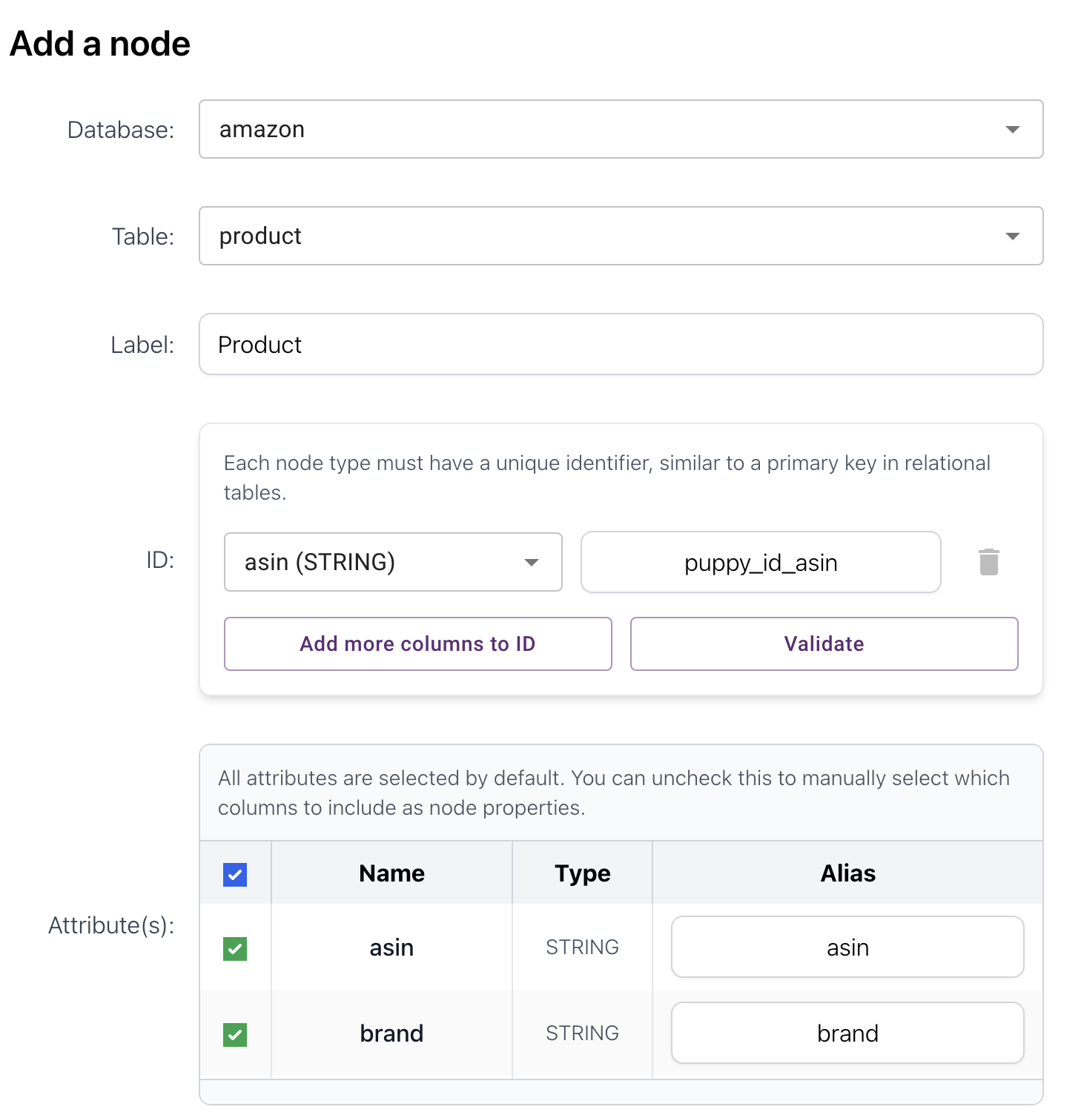
- Image Node
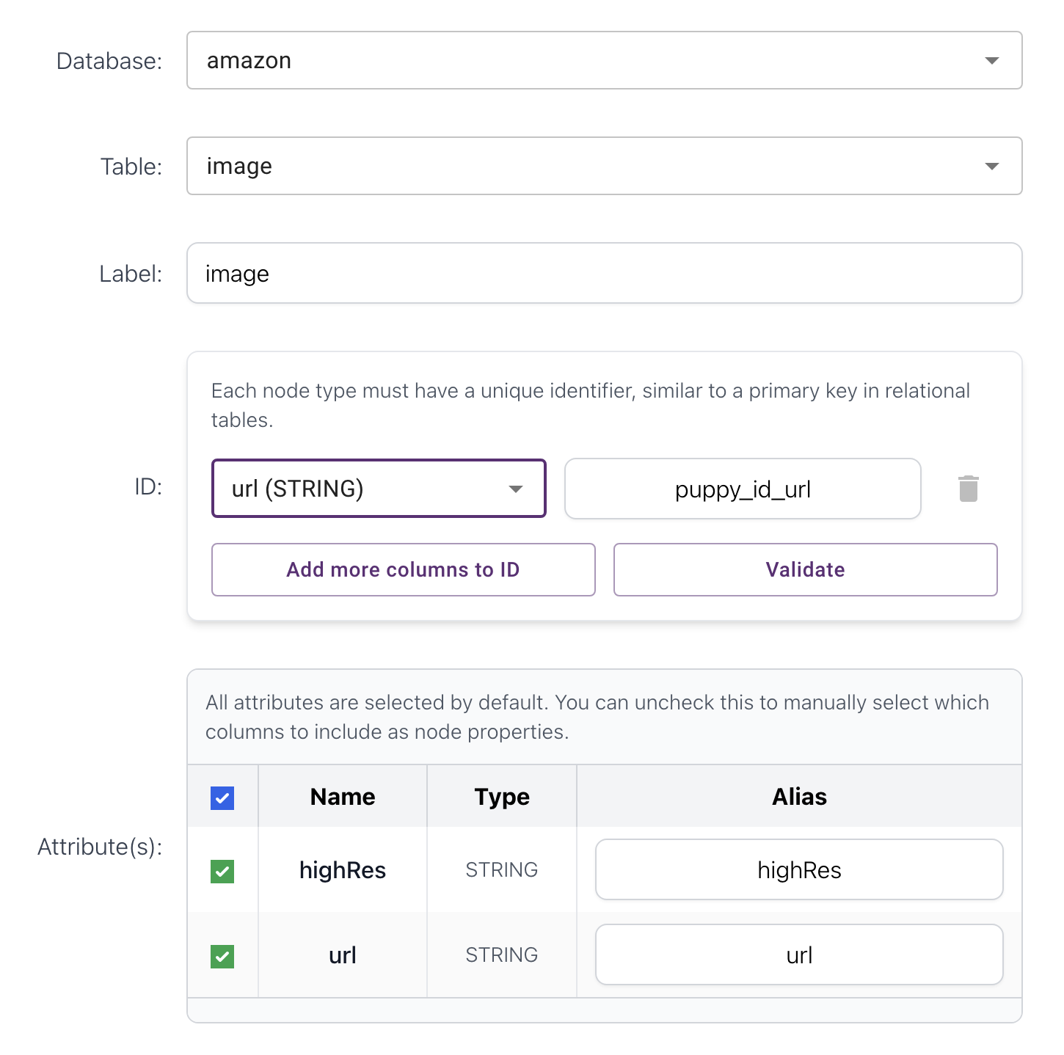

- ReviewImage Node
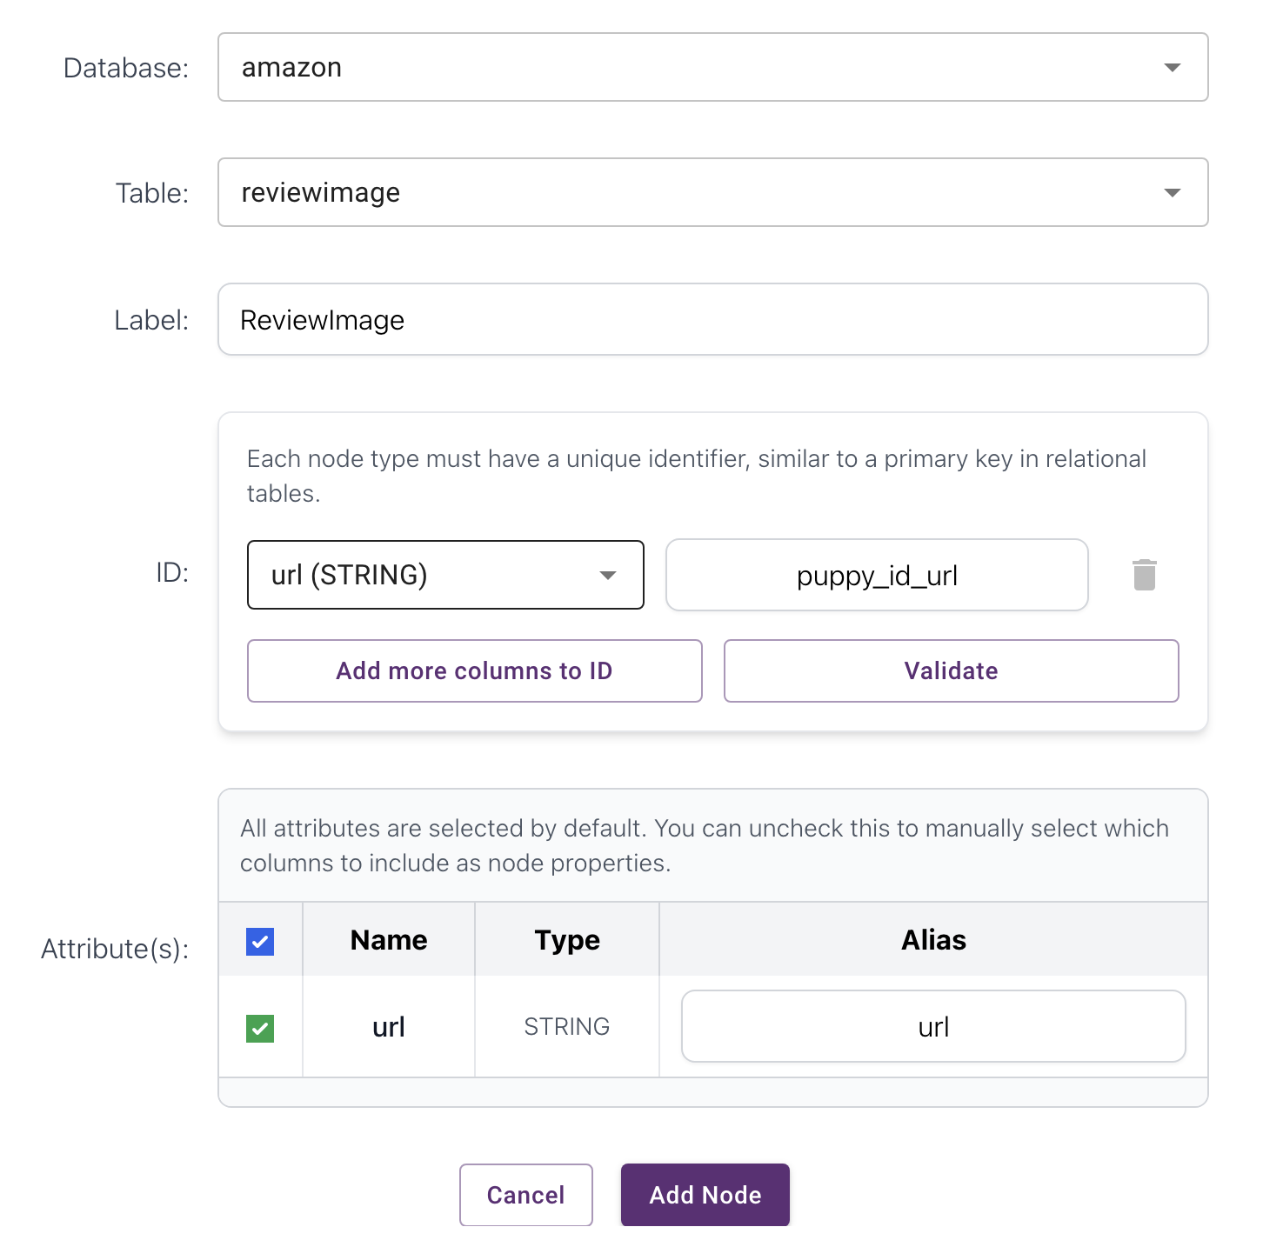
- Category Node
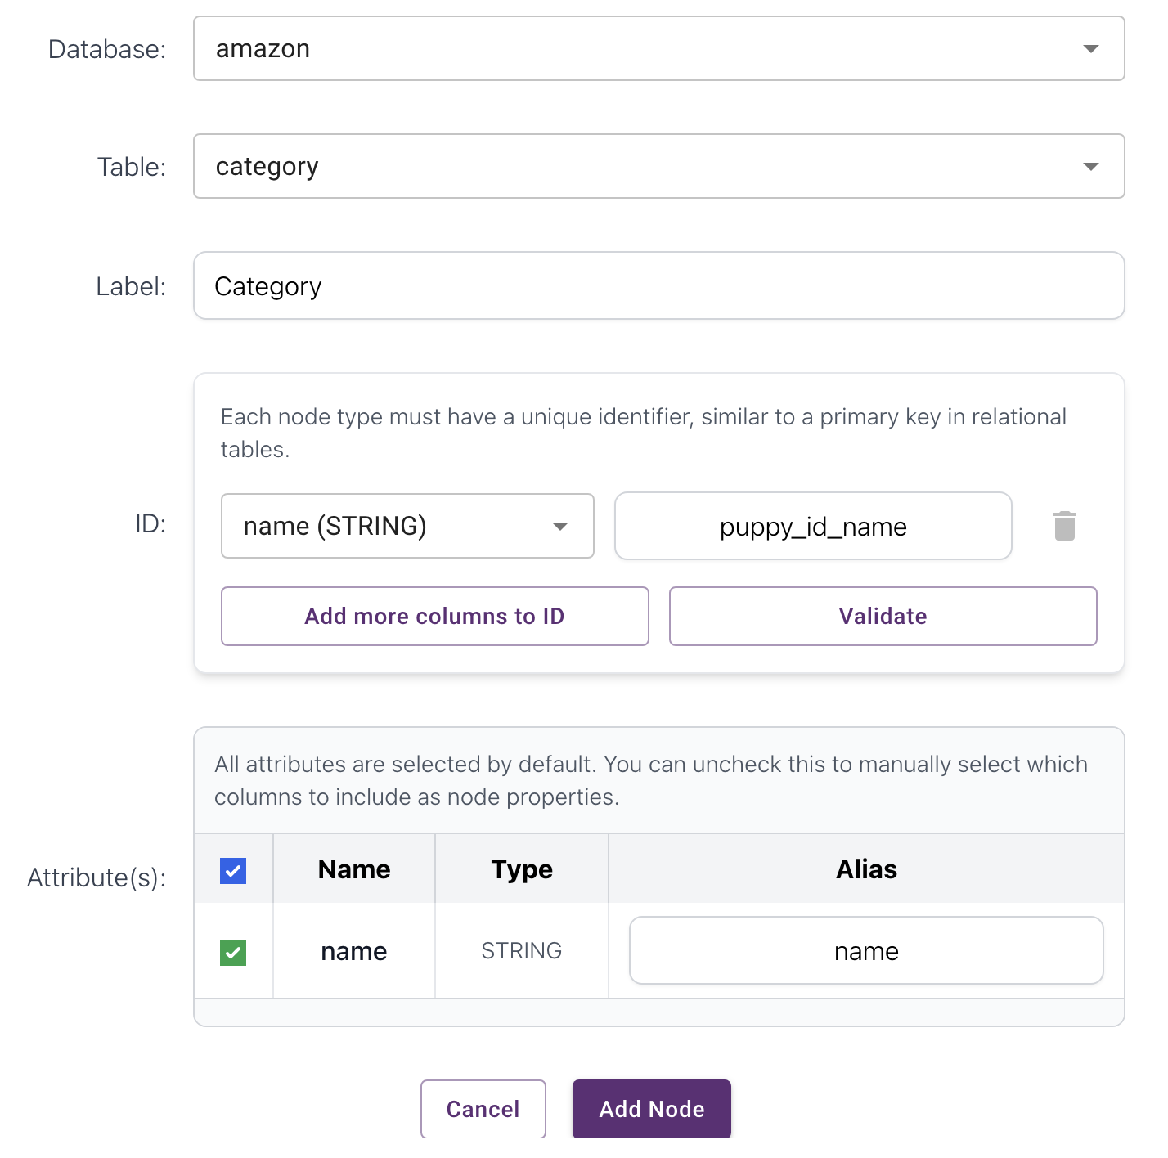

- Reviewer Node
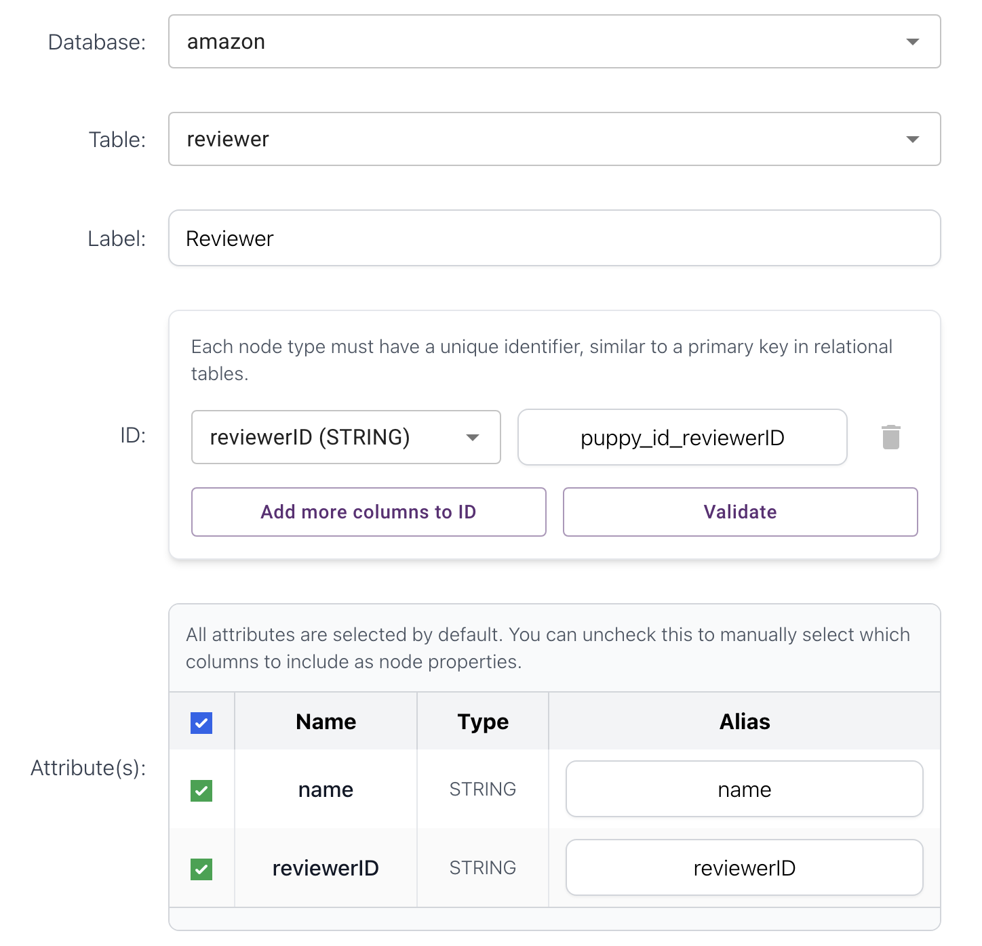
- Review Node
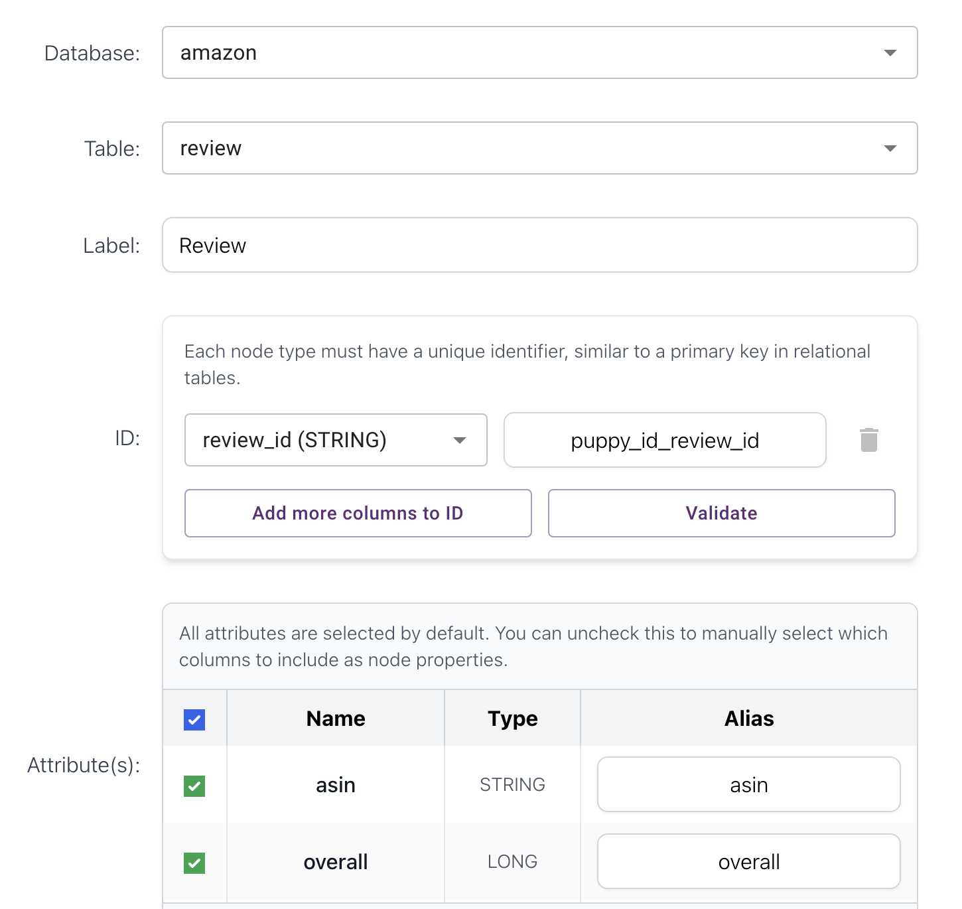
- HAS_PRODUCT_IMAGE Edge (Product Image)
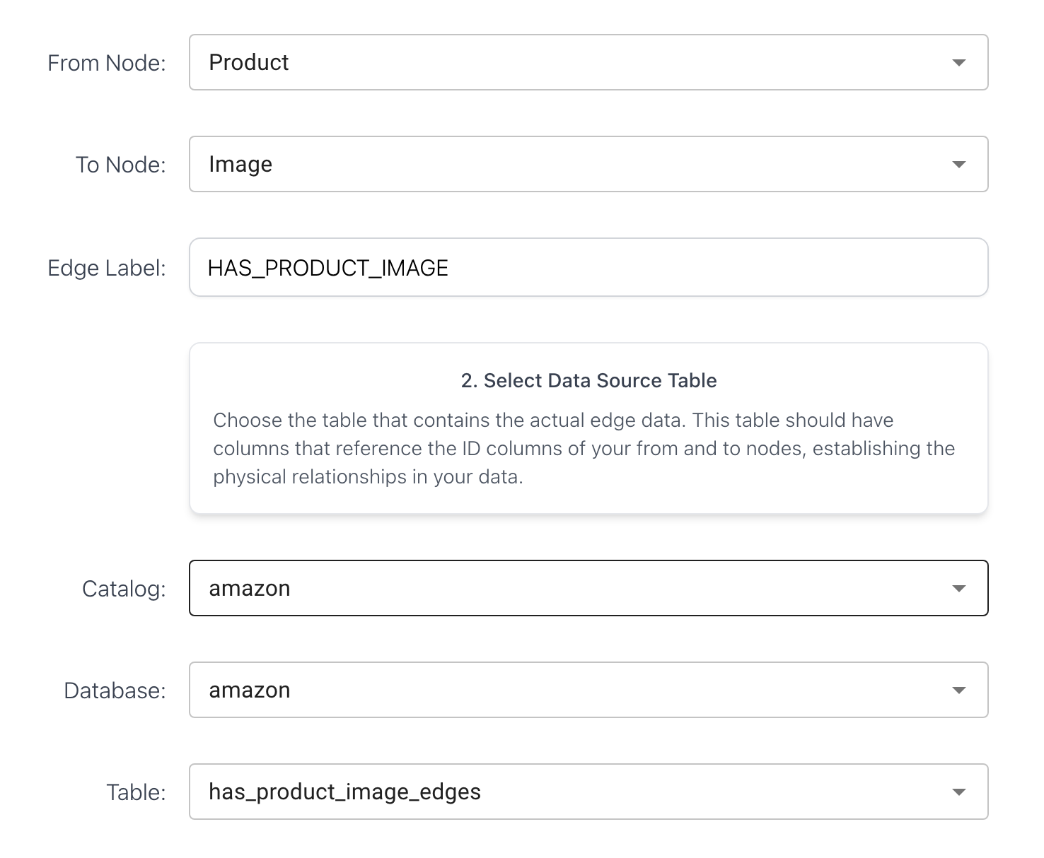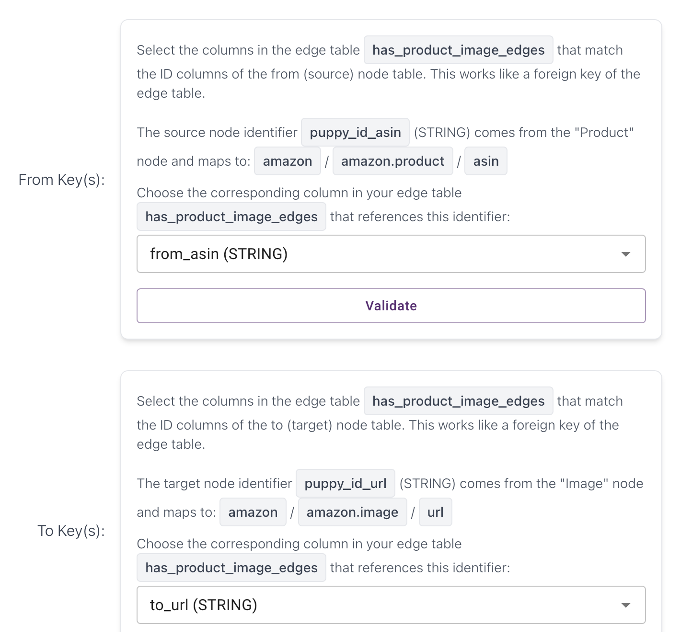

- HAS_REVIEW_IMAGE (Review ReviewImage)
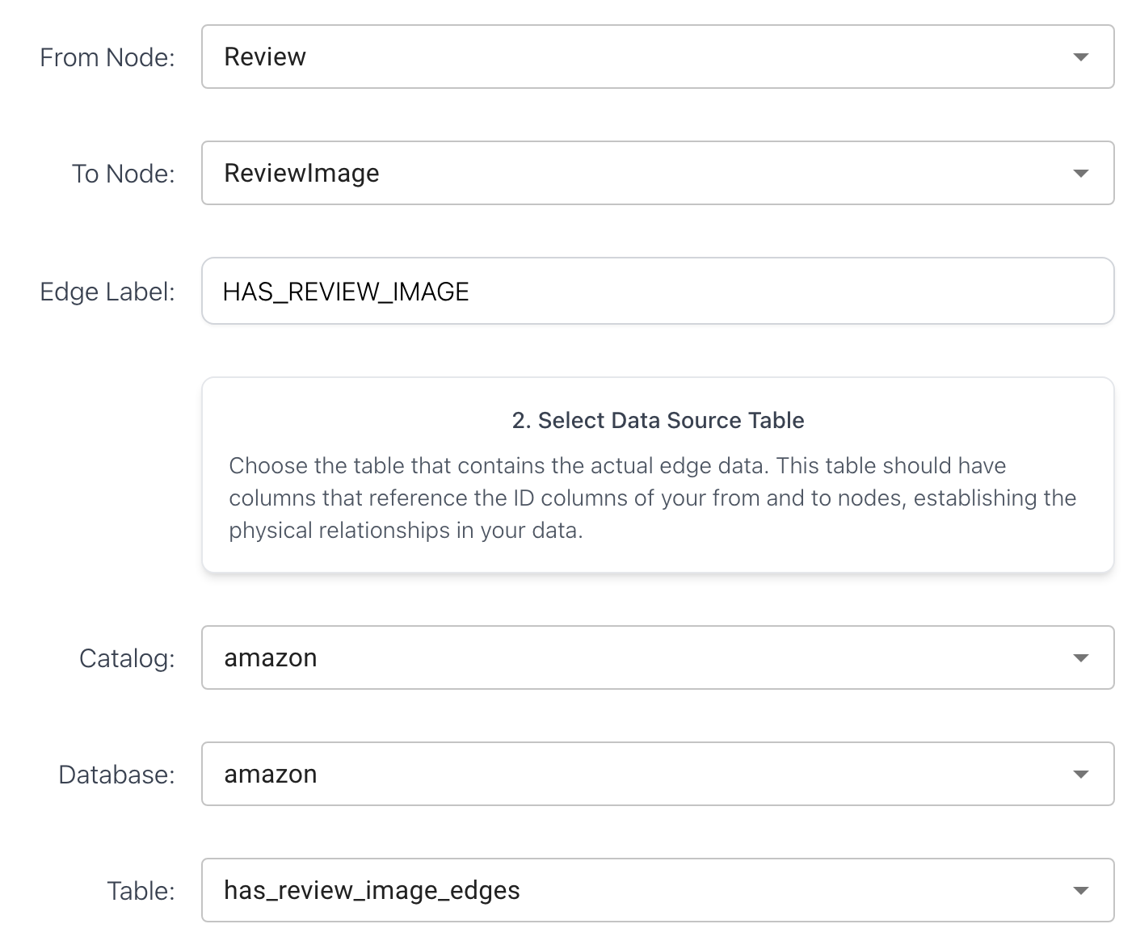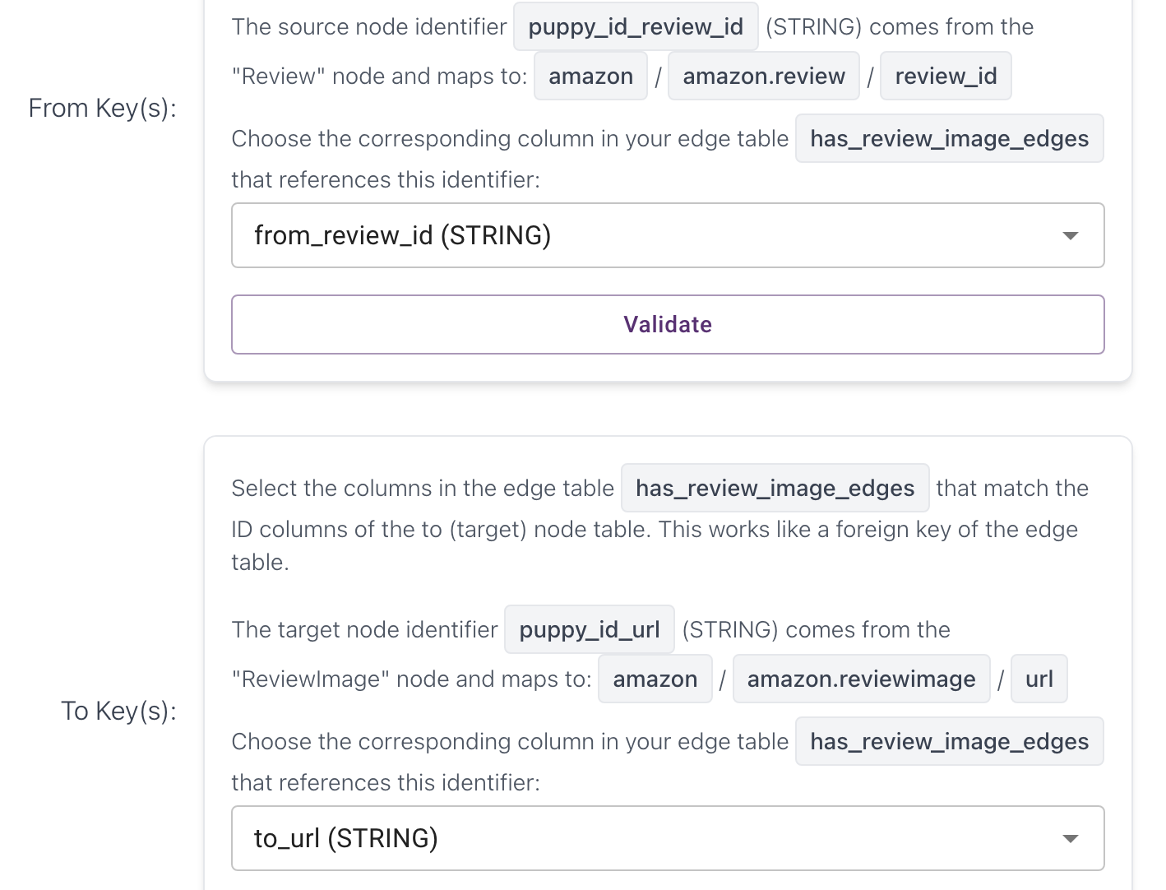

- ALSO_BUY Edge (Product Product)
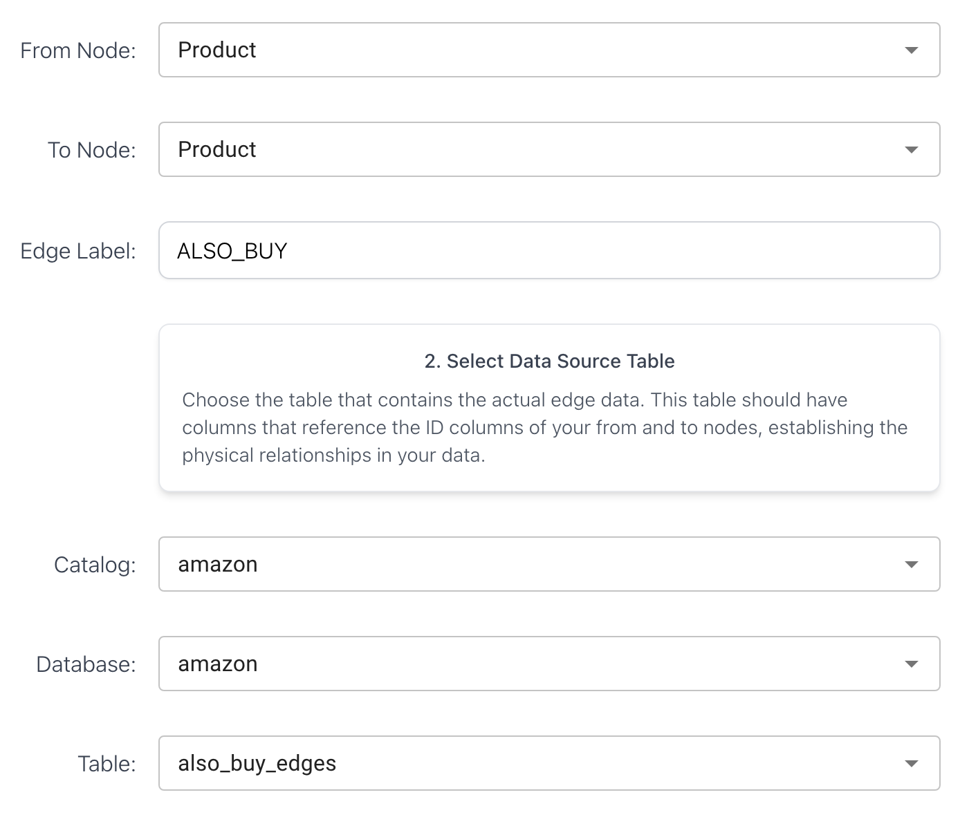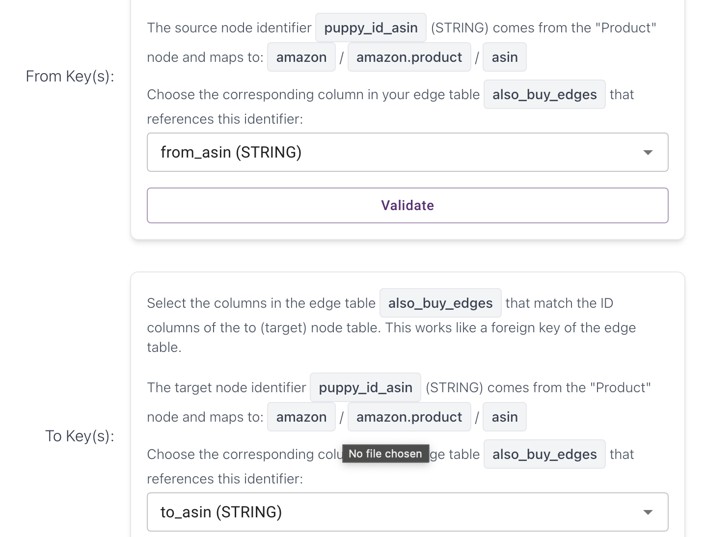

- ALSO_VIEW Edge (Product Product)
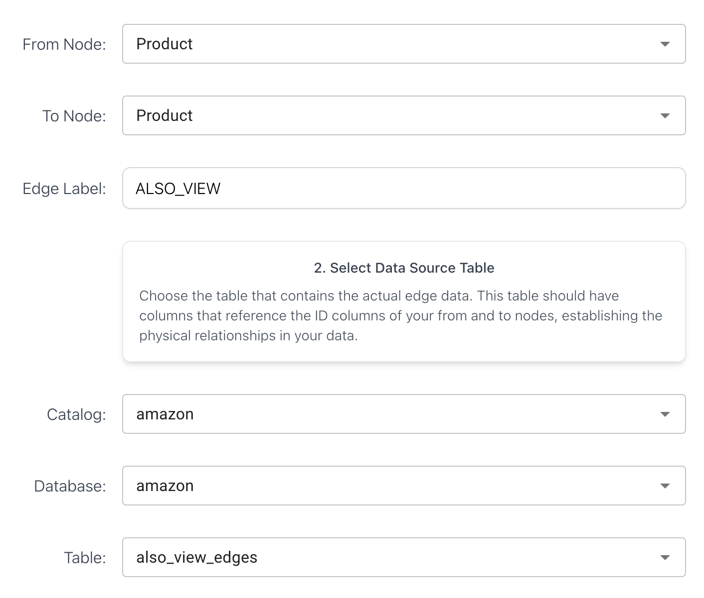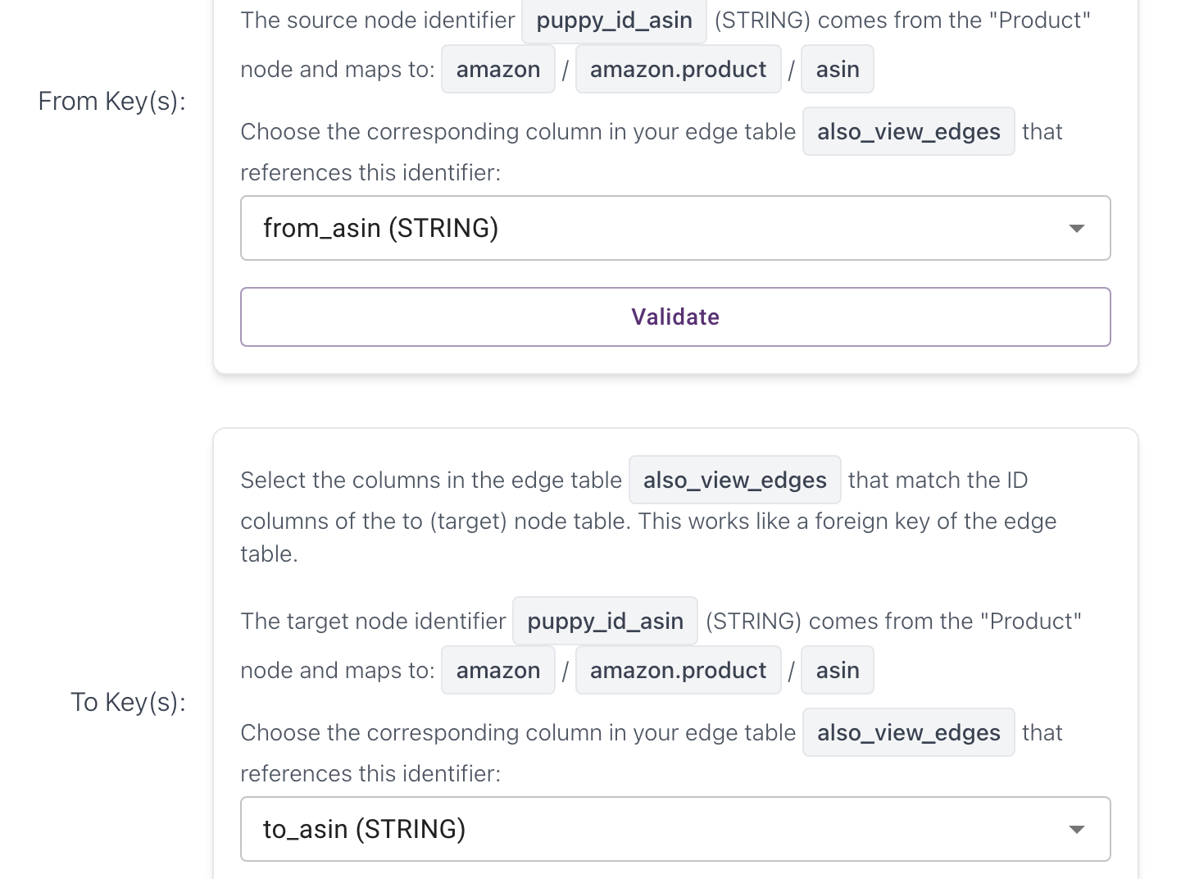

- IN_CATEGORY Edge (Product Category)
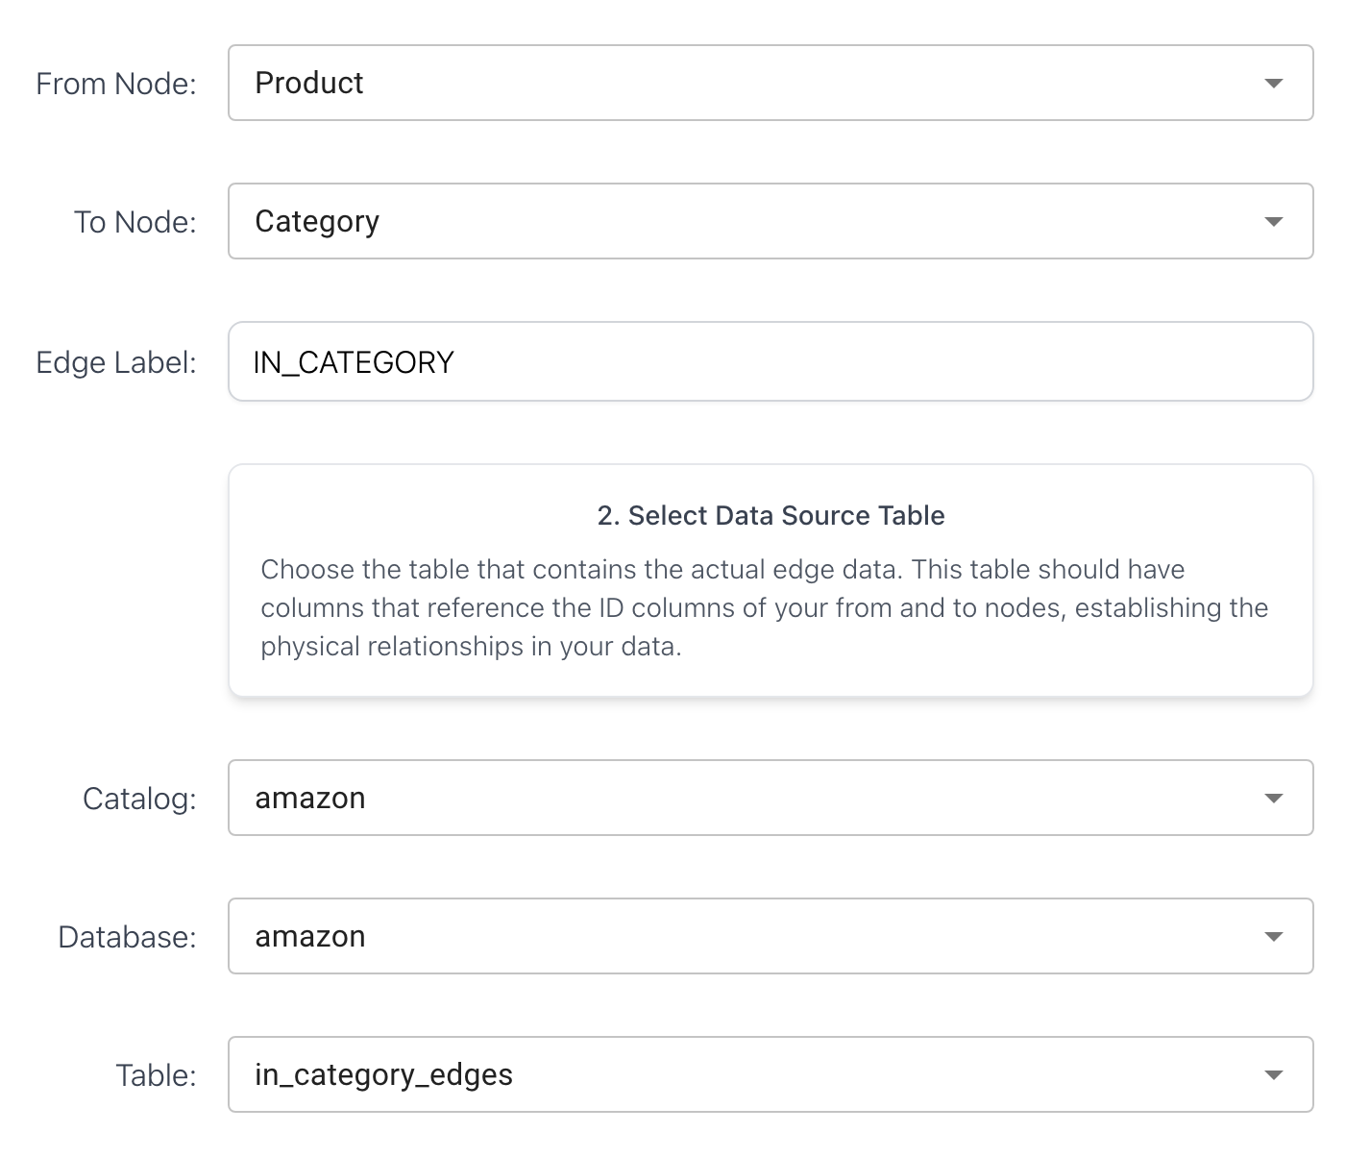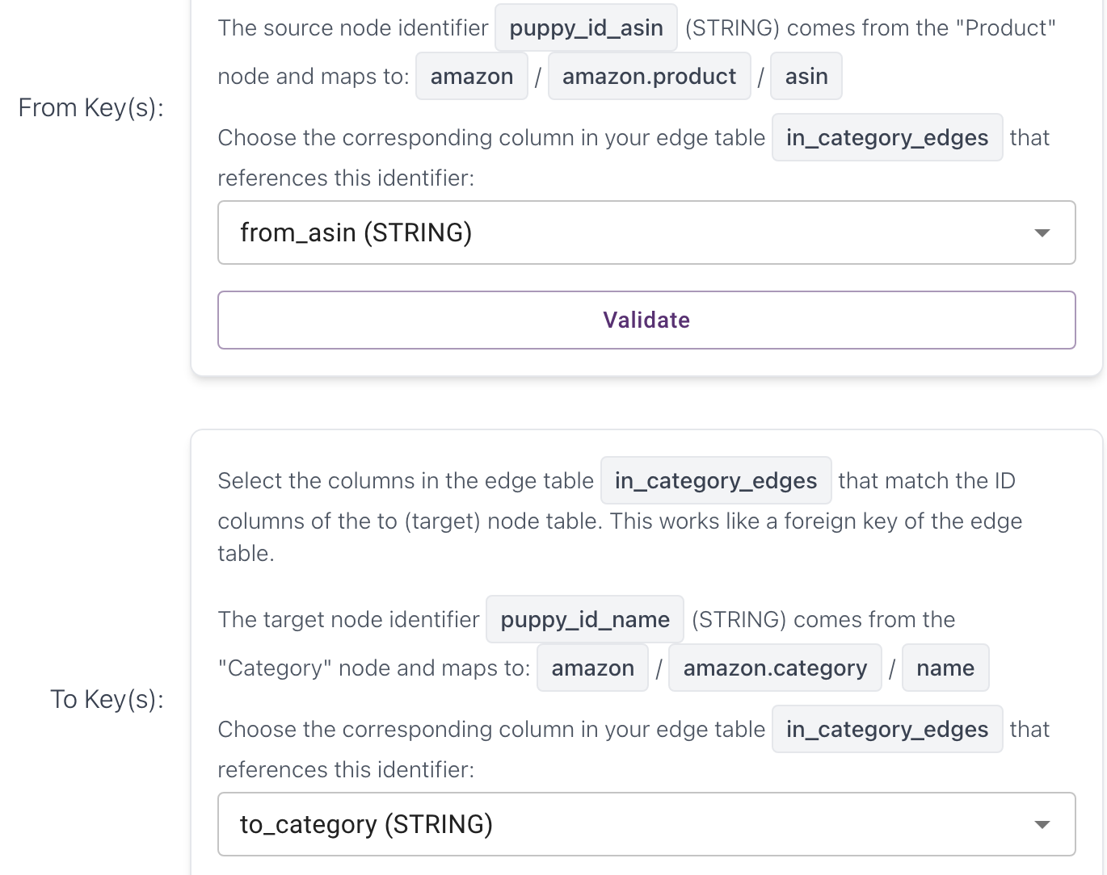
- REVIEWS Edge (Review Product)
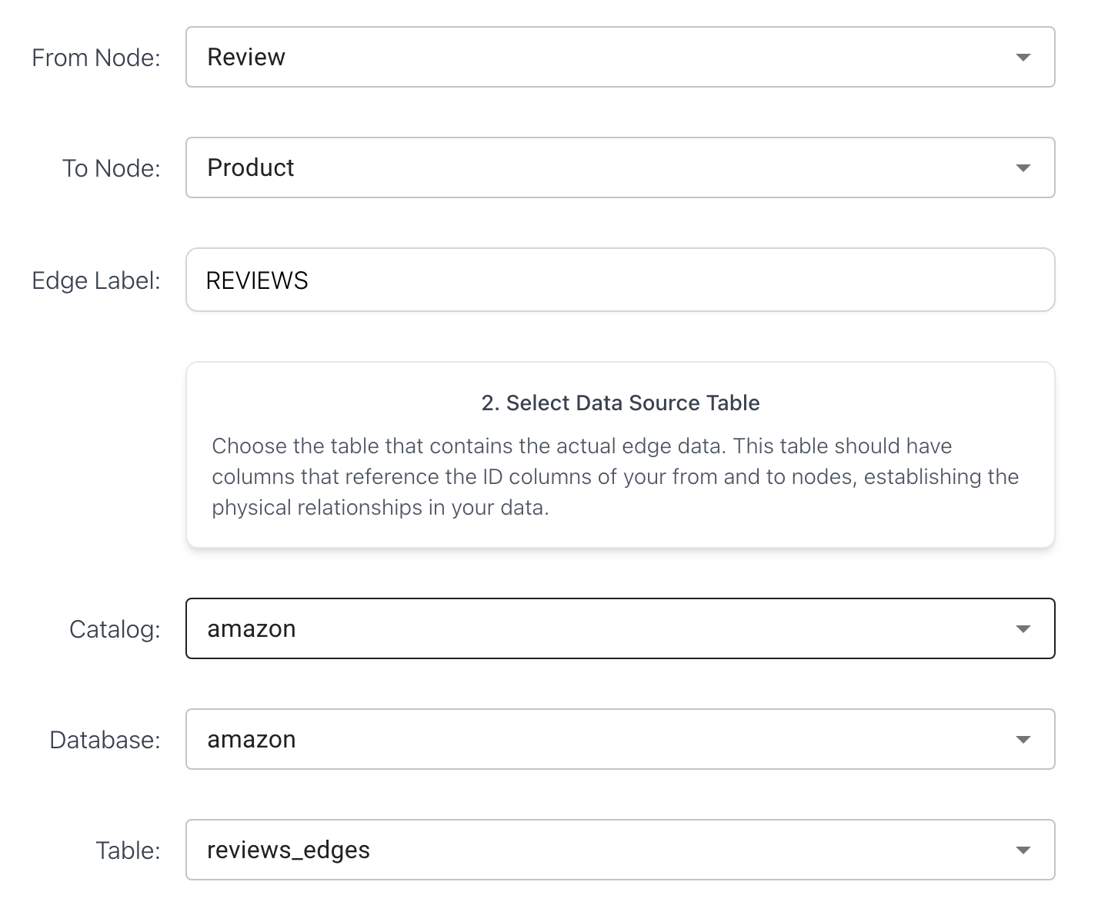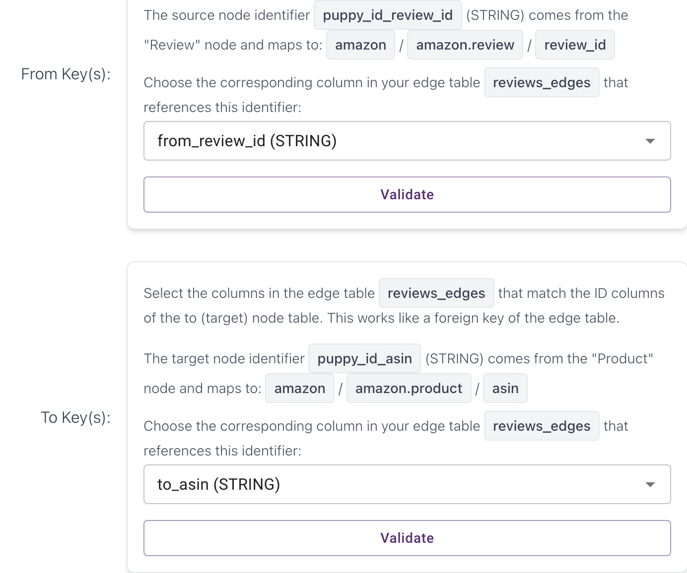
- WROTE Edge (Reviewer Review)
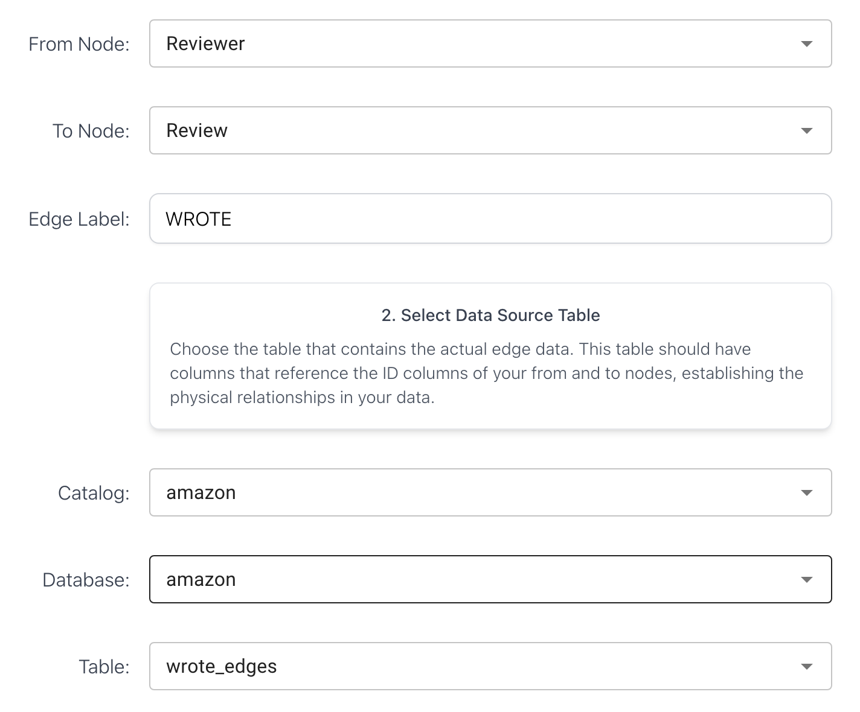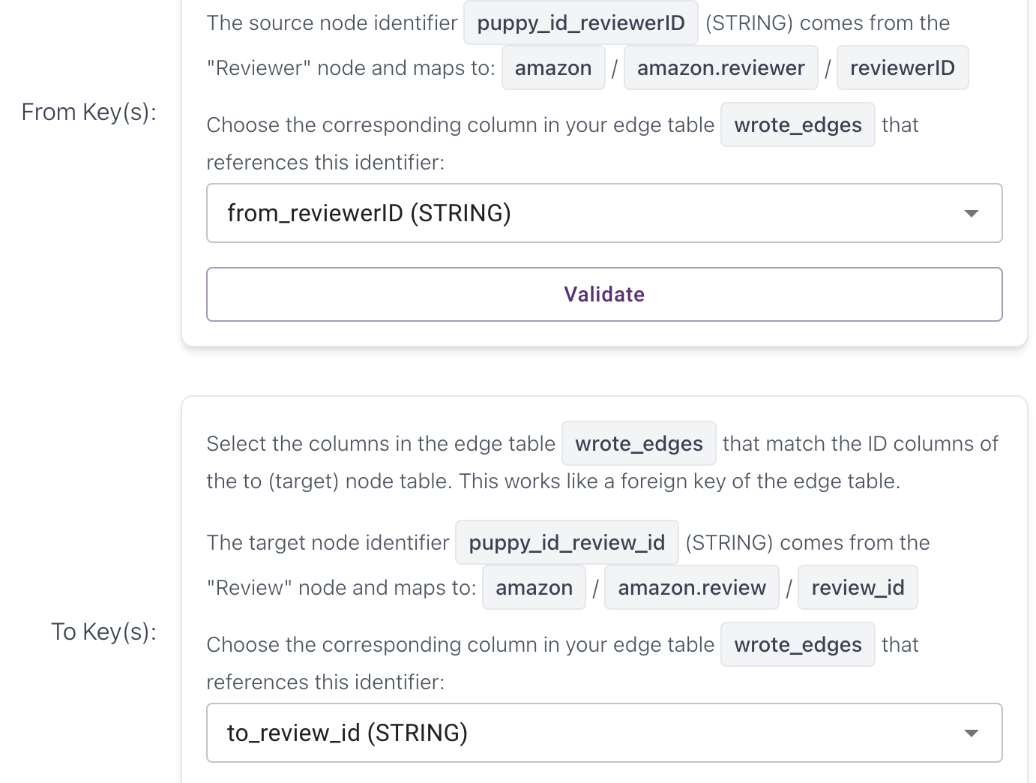

Queries

===Review===

Products with the Most Reviews
Identify the top 200 products with the most reviews (customer engagement).

MATCH (p:Product)<-[:REVIEWS]-(r:Review)
WITH p, count(r) AS ReviewCount
ORDER BY ReviewCount DESC
LIMIT 200
RETURN p.asin AS ASIN, coalesce(p.title, p.asin) AS Product, ReviewCount;

Cypher query error: [PEPS-06] Failed to build iterators

Highly Rated Products with Many Reviews
Find reliable “quality” products with ≥ 50 reviews and avg rating ≥ 4.0.

MATCH (p:Product)<-[:REVIEWS]-(r:Review)
WHERE r.overall IS NOT NULL
WITH p, avg(r.overall) AS AvgRating, count(r) AS ReviewCount
WHERE ReviewCount >= 50 AND AvgRating >= 4.0
RETURN p.asin AS ASIN,
coalesce(p.title, p.asin) AS Product,
round(AvgRating, 2) AS AvgRating,
ReviewCount
ORDER BY ReviewCount DESC, AvgRating DESC
LIMIT 200;

Cypher query error: [PEPS-06] Failed to build iterators

===Reviewer===

Most Active Reviewers
Top 200 users by review count (power users, potential spam or influencers).

MATCH (u:Reviewer)-[:WROTE]->(r:Review)
WITH u, count(r) AS ReviewCount
ORDER BY ReviewCount DESC
LIMIT 200
RETURN u.reviewerID AS ReviewerID,
coalesce(u.name, u.reviewerID) AS ReviewerName,
ReviewCount
ORDER BY ReviewCount DESC;

Time: 189.443s

Reviewers Who Write the Longest Reviews
Order the 200 reviewers from the previous query by their average review length in descending order, returning each reviewer’s ID, name, total number of reviews, and their average review length.

MATCH (u:Reviewer)-[:WROTE]->(r:Review)
WHERE r.reviewText IS NOT NULL
WITH u,
count(r) AS ReviewCount,
avg(size(r.reviewText)) AS AvgReviewLength
ORDER BY ReviewCount DESC
LIMIT 200
RETURN u.reviewerID AS ReviewerID,
coalesce(u.name, u.reviewerID) AS ReviewerName,
ReviewCount,
AvgReviewLength
ORDER BY AvgReviewLength DESC;

Cypher query error: [PEPS-06] Failed to build iterators

===Product Associations===

People Who Bought This Also Bought (Seed Expansion)

MATCH (p:Product)<-[:REVIEWS]-(r:Review)
WITH p, count(r) AS ReviewCount
ORDER BY ReviewCount DESC
LIMIT 200
WITH collect(p.asin) AS seedAsins
MATCH (seed:Product)-[:ALSO_BUY]->(other:Product)
WHERE seed.asin IN seedAsins AND NOT other.asin IN seedAsins
RETURN other.asin AS ASIN,
coalesce(other.title, other.asin) AS CoBuyProduct,
count(DISTINCT seed) AS LinkedSeeds
ORDER BY LinkedSeeds DESC
LIMIT 200;

Cypher query error: [PEPS-06] Failed to build iterators

Second-Hop Co-Buy Influence (Ripple Effect)
Start from the #1 most reviewed product (the single seed). Look at its co-buy neighbors. Then check their own co-buys. Rank the second-hop products by how many first-hop neighbors they share with the seed.

// Step 1: Pick the single most reviewed product
MATCH (seed:Product)<-[:REVIEWS]-(r:Review)
WITH seed, count(r) AS ReviewCount
ORDER BY ReviewCount DESC
LIMIT 1

// Step 2: First-hop co-buy neighbors
MATCH (seed)-[:ALSO_BUY]->(firstHop:Product)
WHERE firstHop <> seed

// Step 3: Second-hop neighbors (co-buys of firstHop)
MATCH (firstHop)-[:ALSO_BUY]->(secondHop:Product)
WHERE secondHop <> seed
RETURN secondHop.asin AS ASIN,
coalesce(secondHop.title, secondHop.asin) AS SecondHopProduct,
count(DISTINCT firstHop) AS SharedNeighbors
ORDER BY SharedNeighbors DESC
LIMIT 200;

Cypher query error: [PEPS-06] Failed to build iterators

===Category/ Brand===

Most Popular Categories by Reviews
Rank categories by review volume.

MATCH (c:Category)<-[:IN_CATEGORY]-(p:Product)<-[:REVIEWS]-(r:Review)
RETURN c.name AS Category,
count(r) AS TotalReviews
ORDER BY TotalReviews DESC
LIMIT 200;

Time: 248.644s

Top Brands by Average Rating
Brands with ≥100 reviews across their catalog and high avg ratings.

MATCH (p:Product)<-[:REVIEWS]-(r:Review)
WHERE p.brand IS NOT NULL
WITH p.brand AS Brand, avg(r.overall) AS AvgRating, count(r) AS ReviewCount
WHERE ReviewCount >= 100
RETURN Brand,
round(AvgRating,2) AS AvgRating,
ReviewCount
ORDER BY AvgRating DESC
LIMIT 200;

Cypher query error: [PEPS-06] Failed to build iterators

===Images / Multimedia===

Products with the Most Images
Find products with the most marketing assets (images).

MATCH (p:Product)-[:HAS_PRODUCT_IMAGE]->(i:Image)
WITH p.asin AS ASIN, coalesce(p.title, p.asin) AS Product, count(i) AS ImageCount
RETURN ASIN, Product, ImageCount
ORDER BY ImageCount DESC
LIMIT 200;

Cypher query error: [PEPS-06] Failed to build iterators

Images reused by multiple products (Image-Centric View)
For each Image, count how many distinct products are using it (i.e., shared images across products).

MATCH (p:Product)-[:HAS_IMAGE]->(i:Image)
RETURN i.url AS ImageURL,
count(DISTINCT p) AS ProductCount
ORDER BY ProductCount DESC
LIMIT 200;

Cypher query error: [PEPS-06] Failed to build iterators

Find the top 200 reviews with the highest helpful votes, returning each review’s reviewer, rating, number of helpful votes, and number of images attached.
This helps us check whether reviews containing more images tend to be marked as more helpful.

MATCH (r:Review)
WHERE r.vote IS NOT NULL
OPTIONAL MATCH (r)-[:HAS_IMAGE]->(ri:ReviewImage)
WITH r.reviewerID AS ReviewerID,
coalesce(r.reviewerID, "Unknown") AS ReviewerName,
r.overall AS Rating,
r.vote AS HelpfulVotes,
count(ri) AS ImageCount
RETURN ReviewerID, ReviewerName, Rating, HelpfulVotes, ImageCount
ORDER BY HelpfulVotes DESC
LIMIT 200;

Cypher query error: [PEPS-06] Failed to build iterators

