OnTime Dataset Full Report
By Zhijun Zachary Zhao

Abstract
This document contains the performance reports of four graph database (GraphDB) systems on the OnTime flight records dataset. These four GraphDB system include neo4j, TigerGraph, GraphFrame, and PuppyGraph.

Dataset Description
This dataset contains data from Bureau of Transportation Statistics, documenting all the flights (in the United States) from 1987 to 2022. Each row in the original csv represents a flight record, with its specific date, origin, destination, aircraft id (tail number,) airline company, reported departure time, reported arrival time, etc. Here is the link to the dataset website: https://clickhouse.com/docs/getting-started/example-datasets/ontime#import-from-raw-data

Graph Model
The following graph model was used for all four graphdb systems. Airports were modeled as nodes (with airport ID, city, state, and a unique airport abbreviation code as its attributes.) Flights were modeled as edges, carrying other flight-related information, such as date, departure and arrival time.

Data Preparation
Upon downloading the data, we will get one csv file for each month. For example, for January of 2021, we would get a file with the suffix “2021_01.” In total, we would have 36 csv files for all the data in three years. The original csv copies are stored at /shared/datasets/ontime20-22
When importing the data to Neo4j, we first scan all the data (2020 to 2022) to find all distinct airports and create a node for each airport. Then we scan the data again and create an edge for each flight, pointing from the origin airport to the destination airport, with supplemental information as edge attributes (date, arrival time, etc.) Below is the schema of the data.
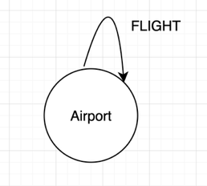
We used only the flight records from 2020 to 2022. This gave us 379 airport nodes, and 17,412,876 edges on all neo4j, TigerGraph, and GraphFrame (PuppyGraph to be tested.) These numbers are different from the ones in the report from our PuppyGraph partners, in which they claimed to also have used data from 2020 to 2022. However, they collected 435 nodes and 12,282,219 edges. They mentioned that they used the copy provided by ClickHouse and the snapshot was created on 2022-05-29, so their data might only cover flights up to April of 2022, while ours cover flights from January 2020 to December 2022, which explains the discrepancy in edge counts. However, the reason for the difference in node counts is unclear. My guess would be that they scan the full dataset from 1987 to 2022 to collect nodes while only using data from 2020 to 2022 to build edges.

Neo4j
Data were deployed on a ubuntu machine with 16 CPU cores, 60 GB RAM, and 60 GB root disk storage space using neo4j community 5.26.0.

Data Upload
This contains two stages, uploading data for nodes and uploading data for edges.

Node Import
The cypher query for node creation is stored in /shared/datasets/ontime20-22/import_nodes.cypher
Below is the actual query:
CALL apoc.periodic.iterate(
"
UNWIND [
'file:///ontime20-22/2020_1.csv',
'file:///ontime20-22/2020_2.csv',
'file:///ontime20-22/2020_3.csv',
'file:///ontime20-22/2020_4.csv',
'file:///ontime20-22/2020_5.csv',
'file:///ontime20-22/2020_6.csv',
'file:///ontime20-22/2020_7.csv',
'file:///ontime20-22/2020_8.csv',
'file:///ontime20-22/2020_9.csv',
'file:///ontime20-22/2020_10.csv',
'file:///ontime20-22/2020_11.csv',
'file:///ontime20-22/2020_12.csv',
'file:///ontime20-22/2021_1.csv',
'file:///ontime20-22/2021_2.csv',
'file:///ontime20-22/2021_3.csv',
'file:///ontime20-22/2021_4.csv',
'file:///ontime20-22/2021_5.csv',
'file:///ontime20-22/2021_6.csv',
'file:///ontime20-22/2021_7.csv',
'file:///ontime20-22/2021_8.csv',
'file:///ontime20-22/2021_9.csv',
'file:///ontime20-22/2021_10.csv',
'file:///ontime20-22/2021_11.csv',
'file:///ontime20-22/2021_12.csv',
'file:///ontime20-22/2022_1.csv',
'file:///ontime20-22/2022_2.csv',
'file:///ontime20-22/2022_3.csv',
'file:///ontime20-22/2022_4.csv',
'file:///ontime20-22/2022_5.csv',
'file:///ontime20-22/2022_6.csv',
'file:///ontime20-22/2022_7.csv',
'file:///ontime20-22/2022_8.csv',
'file:///ontime20-22/2022_9.csv',
'file:///ontime20-22/2022_10.csv',
'file:///ontime20-22/2022_11.csv',
'file:///ontime20-22/2022_12.csv'
] AS file
LOAD CSV WITH HEADERS FROM file AS row
WITH [
{
id: toInteger(row.OriginAirportID),
code: row.Origin,
city: row.OriginCityName,
state: row.OriginState,
stateName: row.OriginStateName
},
{
id: toInteger(row.DestAirportID),
code: row.Dest,
city: row.DestCityName,
state: row.DestState,
stateName: row.DestStateName
}
] AS airports
UNWIND airports AS a
WITH DISTINCT a.id AS airport_id, a.code AS code, a.city AS city, a.state AS state, a.stateName AS stateName
RETURN airport_id, code, city, state, stateName
",
"
MERGE (ap:Airport {airport_id: airport_id})
SET ap.code = code,
ap.city = city,
ap.state = state,
ap.stateName = stateName
",
{batchSize:1000, parallel:false}
);

Edge Import
The cypher query for edge creation is enclosed in a bash script file so that each file is read and uploaded in a sequential order. The script is stored in /shared/datasets/ontime20-22/import_edges.sh
Below is the query itself:
#!/bin/bash

YEARS=(2020 2021 2022)
MONTHS=(1 2 3 4 5 6 7 8 9 10 11 12)

echo "========================================"
echo "Starting Flight Import Process"
echo "Started at: $(date)"
echo "========================================"

for year in "${YEARS[@]}"; do
for month in "${MONTHS[@]}"; do
FILE="${year}_${month}.csv"
echo ""
echo "----------------------------------------"
echo "Processing: ${FILE}"
echo "Time: $(date)"
echo "----------------------------------------"

cypher-shell -u neo4j << CYPHER
CALL apoc.periodic.iterate(
"
LOAD CSV WITH HEADERS FROM 'file:///ontime20-22/${FILE}' AS row
RETURN row
",
"
MATCH (origin:Airport {airport_id: toInteger(row.OriginAirportID)})
MATCH (dest:Airport {airport_id: toInteger(row.DestAirportID)})
MERGE (origin)-[f:FLIGHT {
flightDate: date(row.FlightDate),
airline: row.IATA_CODE_Reporting_Airline,
flightNumber: row.Flight_Number_Reporting_Airline
}]->(dest)
SET f.Year = toInteger(row.Year),
f.Quarter = toInteger(row.Quarter),
f.Month = toInteger(row.Month),
f.DayofMonth = toInteger(row.DayofMonth),
f.DayOfWeek = toInteger(row.DayOfWeek),
f.FlightDate = date(row.FlightDate),
f.Reporting_Airline = row.Reporting_Airline,
f.DOT_ID_Reporting_Airline = toInteger(row.DOT_ID_Reporting_Airline),
f.IATA_CODE_Reporting_Airline = row.IATA_CODE_Reporting_Airline,
f.Tail_Number = row.Tail_Number,
f.Flight_Number_Reporting_Airline = row.Flight_Number_Reporting_Airline,
f.OriginAirportID = toInteger(row.OriginAirportID),
f.OriginAirportSeqID = toInteger(row.OriginAirportSeqID),
f.OriginCityMarketID = toInteger(row.OriginCityMarketID),
f.Origin = row.Origin,
f.OriginCityName = row.OriginCityName,
f.OriginState = row.OriginState,
f.OriginStateFips = row.OriginStateFips,
f.OriginStateName = row.OriginStateName,
f.OriginWac = toInteger(row.OriginWac),
f.DestAirportID = toInteger(row.DestAirportID),
f.DestAirportSeqID = toInteger(row.DestAirportSeqID),
f.DestCityMarketID = toInteger(row.DestCityMarketID),
f.Dest = row.Dest,
f.DestCityName = row.DestCityName,
f.DestState = row.DestState,
f.DestStateFips = row.DestStateFips,
f.DestStateName = row.DestStateName,
f.DestWac = toInteger(row.DestWac),
f.CRSDepTime = toInteger(row.CRSDepTime),
f.DepTime = toInteger(row.DepTime),
f.DepDelay = toInteger(row.DepDelay),
f.DepDelayMinutes = toInteger(row.DepDelayMinutes),
f.DepDel15 = toInteger(row.DepDel15),
f.DepartureDelayGroups = row.DepartureDelayGroups,
f.DepTimeBlk = row.DepTimeBlk,
f.TaxiOut = toInteger(row.TaxiOut),
f.WheelsOff = row.WheelsOff,
f.WheelsOn = row.WheelsOn,
f.TaxiIn = toInteger(row.TaxiIn),
f.CRSArrTime = toInteger(row.CRSArrTime),
f.ArrTime = toInteger(row.ArrTime),
f.ArrDelay = toInteger(row.ArrDelay),
f.ArrDelayMinutes = toInteger(row.ArrDelayMinutes),
f.ArrDel15 = toInteger(row.ArrDel15),
f.ArrivalDelayGroups = row.ArrivalDelayGroups,
f.ArrTimeBlk = row.ArrTimeBlk,
f.Cancelled = toInteger(row.Cancelled),
f.CancellationCode = row.CancellationCode,
f.Diverted = toInteger(row.Diverted),
f.CRSElapsedTime = toInteger(row.CRSElapsedTime),
f.ActualElapsedTime = toInteger(row.ActualElapsedTime),
f.AirTime = toInteger(row.AirTime),
f.Flights = toInteger(row.Flights),
f.Distance = toInteger(row.Distance),
f.DistanceGroup = toInteger(row.DistanceGroup),
f.CarrierDelay = toInteger(row.CarrierDelay),
f.WeatherDelay = toInteger(row.WeatherDelay),
f.NASDelay = toInteger(row.NASDelay),
f.SecurityDelay = toInteger(row.SecurityDelay),
f.LateAircraftDelay = toInteger(row.LateAircraftDelay),
f.FirstDepTime = toInteger(row.FirstDepTime),
f.TotalAddGTime = toInteger(row.TotalAddGTime),
f.LongestAddGTime = toInteger(row.LongestAddGTime)
",
{batchSize:1000, parallel:false}
) YIELD batches, total, timeTaken, committedOperations, failedOperations
RETURN batches, total, timeTaken/1000.0 AS seconds, committedOperations, failedOperations;
CYPHER

echo "Completed: ${FILE}"

done
done

echo ""
echo "========================================"
echo "All files processed!"
echo "Completed at: $(date)"
echo "========================================"

Queries

Q1: Same-day Flight Connections
Description: Finds all possible same-day flight connections between LAX (airport ID 12892) and LGA (airport ID 12953) with at least a 1-hour layover. It returns the monthly count of such connections for a given year.
MATCH p = (a)-[r1]->(b)-[r2]->(c)
WHERE (r1.FlightDate = r2.FlightDate)
AND (r1.CRSArrTime + 60 <= r2.CRSDepTime)
AND (a.airport_id = 12892)
AND (c.airport_id = 12953)
AND (r1.Year = $year)
WITH r1.Month as month, count(p) as path_count
RETURN month, path_count
ORDER BY month

Q1 Cumulative
Description: Finds all possible same-day flight connections between LAX (airport ID 12892) and LGA (airport ID 12953) with at least a 1-hour layover. It returns the monthly count of such connections starting at a given year.
MATCH p = (a)-[r1]->(b)-[r2]->(c)
WHERE (r1.FlightDate = r2.FlightDate)
AND (r1.CRSArrTime + 60 <= r2.CRSDepTime)
AND (a.airport_id = 12892)
AND (c.airport_id = 12953)
AND (r1.Year >= $year)
WITH r1.Month as month, count(p) as path_count
RETURN month, path_count
ORDER BY month

Q2: Missed Connecting Flights
Description: Identifies instances where passengers would have missed connecting flights between LAX and LGA due to the first flight arriving at or after the second flight's departure time, despite a planned 1-hour layover. It returns the monthly count of such missed connections in a given year.
MATCH p = (a)-[r1]->(b)-[r2]->(c)
WHERE (r1.FlightDate = r2.FlightDate)
AND (r1.CRSArrTime + 60 <= r2.CRSDepTime)
AND (r1.ArrTime >= r2.DepTime)
AND (a.airport_id = 12892)
AND (c.airport_id = 12953)
AND (r1.Year = $year)
WITH r1.Month as month, count(p) as path_count
RETURN month, path_count
ORDER BY month

Q2 Cumulative
Description: Identifies instances where passengers would have missed connecting flights between LAX and LGA due to the first flight arriving at or after the second flight's departure time, despite a planned 1-hour layover. It returns the monthly count of such missed connections starting a given year.
MATCH p = (a)-[r1]->(b)-[r2]->(c)
WHERE (r1.FlightDate = r2.FlightDate)
AND (r1.CRSArrTime + 60 <= r2.CRSDepTime)
AND (r1.ArrTime >= r2.DepTime)
AND (a.airport_id = 12892)
AND (c.airport_id = 12953)
AND (r1.Year >= $year)
WITH r1.Month as month, count(p) as path_count
RETURN month, path_count
ORDER BY month

Q3: Top 10 Aircraft Turnarounds
Description: Finds the top 10 airports with the most aircraft turnarounds on a specific date, counting distinct aircraft with scheduled connections (same tail number arriving and departing from the same airport on the same day.) 20 dates were randomly chosen.
MATCH ()-[r1]->(n)-[r2]->()
WHERE (r1.FlightDate = date($date))
AND (r1.FlightDate = r2.FlightDate)
AND (r1.Tail_Number = r2.Tail_Number)
AND (r1.Tail_Number IS NOT NULL)
AND (r1.Tail_Number <> "")
AND (r1.CRSArrTime < r2.CRSDepTime)
WITH n, count(DISTINCT r1.Tail_Number) AS cnt
RETURN n, cnt
ORDER BY cnt DESC
LIMIT 10;

Q4: Three-Leg Flight Sequences
Description: Counts the number of distinct aircraft that completed a 3-leg flight sequence on a specific date. 20 dates were randomly chosen (same as those used for Q3.)
MATCH ()-[r1]->()-[r2]->()-[r3]->()
WHERE (r1.FlightDate = date($date))
AND (r1.FlightDate = r2.FlightDate)
AND (r1.FlightDate = r3.FlightDate)
AND (r1.Tail_Number = r2.Tail_Number)
AND (r1.Tail_Number = r3.Tail_Number)
AND (r1.Tail_Number IS NOT NULL)
AND (r1.Tail_Number <> "")
AND (r1.CRSArrTime < r2.CRSDepTime)
AND (r2.CRSArrTime < r3.CRSDepTime)
RETURN count(DISTINCT r1.Tail_Number) AS cnt;

Performance Charts

Q1
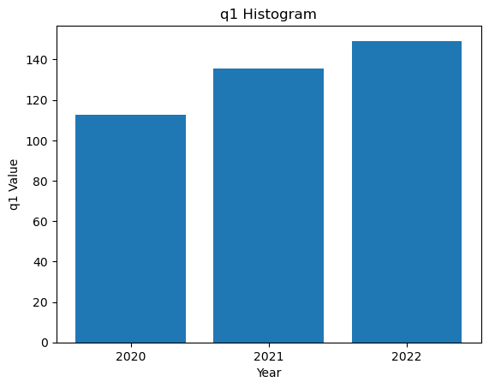
2020: 112556 2021: 135685 2022: 149218

Q1 Cumulative
363621 from 2020

Q2
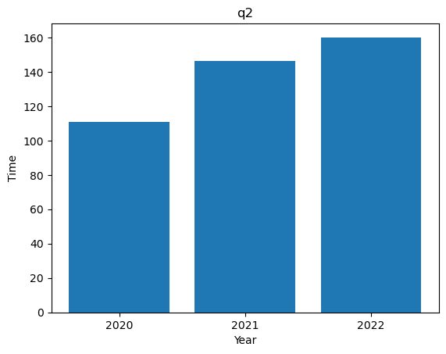
2020: 110966 2021: 146455 2022: 160073

Q2 Cumulative
384711 from 2020

Q3
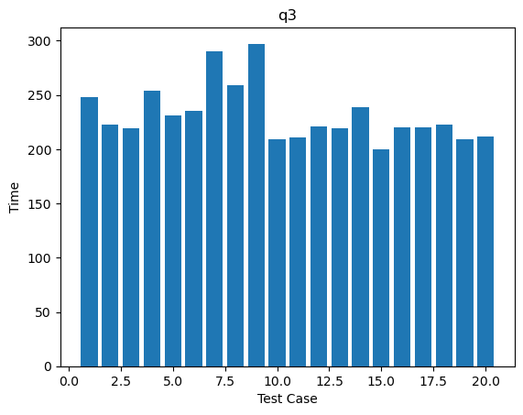
'2020-11-03’: 247811 '2021-01-28’: 223034 '2020-01-25’: 219076 '2021-01-15’: 254257
'2022-09-22’: 230790 '2022-11-16’: 235408 '2021-12-09’: 290187 '2022-01-31’: 258994
'2021-07-06’: 297220 '2020-06-19’: 208847 '2021-08-31’: 210565 '2022-01-25’: 220721
'2022-06-03’: 219528 '2021-08-23’: 238648 '2021-05-05’: 200110 '2020-07-16’: 219752
'2021-07-30’: 220282 '2021-09-20’: 222850 '2020-12-09’: 209526 '2022-01-05’: 211645

Q4
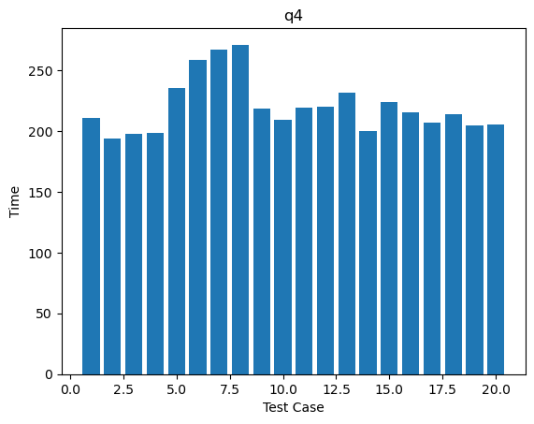
'2020-11-03’: 210401 '2021-01-28’: 194020 '2020-01-25’: 197468 '2021-01-15’: 198475
'2022-09-22’: 235025 '2022-11-16’: 258113 '2021-12-09’: 266988 '2022-01-31’: 270917
'2021-07-06’: 218440 '2020-06-19’: 208896 '2021-08-31’: 218788 '2022-01-25’: 219561
'2022-06-03’: 231570 '2021-08-23’: 200263 '2021-05-05’: 223876 '2020-07-16’: 215283
'2021-07-30’: 206637 '2021-09-20’: 214016 '2020-12-09’: 204351 '2022-01-05’: 205514

TigerGraph
Data were deployed on a ubuntu machine with 8 CPU cores, 30 GB RAM, and 60 GB root disk storage space using TigerGraph community 4.2.0.

Data Upload
Graph creation, node import and edge import can be done by running the following gsql code:
CREATE VERTEX Airport (
PRIMARY_ID id INT,
city STRING,
code STRING,
state STRING
) WITH primary_id_as_attribute="true"

CREATE DIRECTED EDGE Flight (
FROM Airport,
TO Airport,

DISCRIMINATOR(FlightDate DATETIME, Reporting_Airline STRING, Flight_Number_Reporting_Airline STRING),

Year INT,
Quarter INT,
Month INT,
DayofMonth INT,
IATA_CODE_Reporting_Airline STRING,
DOT_ID_Reporting_Airline INT,
Tail_Number STRING,
OriginAirportSeqID INT,
DestAirportSeqID INT,
CRSDepTime INT,
DepTime INT,
DepDelay DOUBLE,
DepDelayMinutes DOUBLE,
DepDel15 DOUBLE,
DepartureDelayGroups STRING,
DepTimeBlk STRING,
TaxiOut DOUBLE,
WheelsOff INT,
CRSArrTime INT,
ArrTime INT,
ArrDelay DOUBLE,
ArrDelayMinutes DOUBLE,
ArrDel15 DOUBLE,
ArrivalDelayGroups STRING,
ArrTimeBlk STRING,
TaxiIn DOUBLE,
WheelsOn INT,
Cancelled DOUBLE,
CancellationCode STRING,
Diverted DOUBLE,
CRSElapsedTime DOUBLE,
ActualElapsedTime DOUBLE,
AirTime DOUBLE,
Flights DOUBLE,
Distance DOUBLE,
DistanceGroup INT,
CarrierDelay DOUBLE,
WeatherDelay DOUBLE,
NASDelay DOUBLE,
SecurityDelay DOUBLE,
LateAircraftDelay DOUBLE
)

CREATE GRAPH OnTimeGraph (Airport, Flight)

Queries
The query descriptions can be found under the Neo4j section.

Q1
CREATE OR REPLACE QUERY Q1(INT target_year) {

TYPEDEF TUPLE <DATETIME flight_date, INT arr_time, INT month> FlightInfo;

DATETIME t0;
t0 = now();
ListAccum<FlightInfo> @r1_list;
MapAccum<INT, INT> @@monthly_counts;
Start = {Airport.*};
Source = SELECT s FROM Start:s WHERE s.id == 12892;
Intermediate = SELECT t FROM Source:s -(Flight:e)-> Airport:t
WHERE e.Year == target_year
ACCUM t.@r1_list += FlightInfo(e.FlightDate, e.CRSArrTime, e.Month);
Dest = SELECT t FROM Intermediate:s -(Flight:e)-> Airport:t
WHERE t.id == 12953
ACCUM
FOREACH r1 IN s.@r1_list DO
IF r1.flight_date == e.FlightDate AND
(r1.arr_time + 100 <= e.CRSDepTime) THEN
@@monthly_counts += (r1.month -> 1)
END
END;
PRINT @@monthly_counts AS Monthly_Stats;
PRINT datetime_diff(now(), t0) AS Execution_Time_Seconds;
}

Q1 Cumulative
CREATE OR REPLACE QUERY Q1(INT target_year) {

TYPEDEF TUPLE <DATETIME flight_date, INT arr_time, INT month> FlightInfo;

DATETIME t0;
t0 = now();
ListAccum<FlightInfo> @r1_list;
MapAccum<INT, INT> @@monthly_counts;
Start = {Airport.*};
Source = SELECT s FROM Start:s WHERE s.id == 12892;
Intermediate = SELECT t FROM Source:s -(Flight:e)-> Airport:t
WHERE e.Year >= target_year
ACCUM t.@r1_list += FlightInfo(e.FlightDate, e.CRSArrTime, e.Month);
Dest = SELECT t FROM Intermediate:s -(Flight:e)-> Airport:t
WHERE t.id == 12953
ACCUM
FOREACH r1 IN s.@r1_list DO
IF r1.flight_date == e.FlightDate AND
(r1.arr_time + 100 <= e.CRSDepTime) THEN
@@monthly_counts += (r1.month -> 1)
END
END;
PRINT @@monthly_counts AS Monthly_Stats;
PRINT datetime_diff(now(), t0) AS Execution_Time_Seconds;
}

Q2
CREATE OR REPLACE QUERY Q2(INT target_year) {

TYPEDEF TUPLE <DATETIME flight_date, INT sched_arr_time, INT actual_arr_time, INT month> FlightInfo;

DATETIME t0;
t0 = now();
ListAccum<FlightInfo> @r1_list;
MapAccum<INT, INT> @@monthly_counts;
Start = {Airport.*};
Source = SELECT s FROM Start:s WHERE s.id == 12892;
Intermediate = SELECT t FROM Source:s -(Flight:e)-> Airport:t
WHERE e.Year == target_year
ACCUM t.@r1_list += FlightInfo(e.FlightDate, e.CRSArrTime, e.ArrTime, e.Month);
Dest = SELECT t FROM Intermediate:s -(Flight:e)-> Airport:t
WHERE t.id == 12953
ACCUM
FOREACH r1 IN s.@r1_list DO
IF r1.flight_date == e.FlightDate AND
(r1.sched_arr_time + 100 <= e.CRSDepTime) AND
(r1.actual_arr_time >= e.DepTime) THEN
@@monthly_counts += (r1.month -> 1)
END
END;
PRINT @@monthly_counts AS Monthly_Stats;
PRINT datetime_diff(now(), t0) AS Execution_Time_Seconds;
}

Q2 Cumulative
CREATE OR REPLACE QUERY Q2(INT target_year) {

TYPEDEF TUPLE <DATETIME flight_date, INT sched_arr_time, INT actual_arr_time, INT month> FlightInfo;

DATETIME t0;
t0 = now();
ListAccum<FlightInfo> @r1_list;
MapAccum<INT, INT> @@monthly_counts;
Start = {Airport.*};
Source = SELECT s FROM Start:s WHERE s.id == 12892;
Intermediate = SELECT t FROM Source:s -(Flight:e)-> Airport:t
WHERE e.Year >= target_year
ACCUM t.@r1_list += FlightInfo(e.FlightDate, e.CRSArrTime, e.ArrTime, e.Month);
Dest = SELECT t FROM Intermediate:s -(Flight:e)-> Airport:t
WHERE t.id == 12953
ACCUM
FOREACH r1 IN s.@r1_list DO
IF r1.flight_date == e.FlightDate AND
(r1.sched_arr_time + 100 <= e.CRSDepTime) AND
(r1.actual_arr_time >= e.DepTime) THEN
@@monthly_counts += (r1.month -> 1)
END
END;
PRINT @@monthly_counts AS Monthly_Stats;
PRINT datetime_diff(now(), t0) AS Execution_Time_Seconds;
}

Q3
CREATE OR REPLACE QUERY Q3(DATETIME target_date) {
TYPEDEF TUPLE <STRING tail_num, INT arr_time> IncomingPlane;

DATETIME t0;
t0 = now();
ListAccum<IncomingPlane> @incoming_list;
SetAccum<STRING> @transit_planes;
Start = {Airport.*};
Intermediate = SELECT t FROM Start:s -(Flight:e)-> Airport:t
WHERE e.FlightDate == target_date
AND e.Tail_Number != ""
ACCUM
t.@incoming_list += IncomingPlane(e.Tail_Number, e.CRSArrTime);
Results = SELECT s FROM Intermediate:s -(Flight:e)-> Airport:t
WHERE e.FlightDate == target_date
AND e.Tail_Number != ""
ACCUM
FOREACH r1 IN s.@incoming_list DO
IF r1.tail_num == e.Tail_Number AND r1.arr_time < e.CRSDepTime THEN
s.@transit_planes += r1.tail_num
END
END
ORDER BY s.@transit_planes.size() DESC
LIMIT 10;
PRINT Results[Results.city, Results.code, Results.@transit_planes.size() AS cnt];
PRINT datetime_diff(now(), t0) AS Execution_Time_Seconds;
}

Q4
CREATE OR REPLACE QUERY Q4(DATETIME target_date) {
TYPEDEF TUPLE <STRING tail_num, INT arr_time> IncomingPlane;
DATETIME t0;
t0 = now();
ListAccum<IncomingPlane> @hop1_list;
ListAccum<IncomingPlane> @hop2_list;
SetAccum<STRING> @@valid_tails;
Start = {Airport.*};
Hop1_Target = SELECT t FROM Start:s -(Flight:e)-> Airport:t
WHERE e.FlightDate == target_date AND e.Tail_Number != ""
ACCUM t.@hop1_list += IncomingPlane(e.Tail_Number, e.CRSArrTime);
Hop2_Target = SELECT t FROM Hop1_Target:s -(Flight:e)-> Airport:t
WHERE e.FlightDate == target_date AND e.Tail_Number != ""
ACCUM
FOREACH prev IN s.@hop1_list DO
IF prev.tail_num == e.Tail_Number AND prev.arr_time < e.CRSDepTime THEN
t.@hop2_list += IncomingPlane(e.Tail_Number, e.CRSArrTime)
END
END;
Hop3_Target = SELECT t FROM Hop2_Target:s -(Flight:e)-> Airport:t
WHERE e.FlightDate == target_date AND e.Tail_Number != ""
ACCUM
FOREACH prev IN s.@hop2_list DO
IF prev.tail_num == e.Tail_Number AND prev.arr_time < e.CRSDepTime THEN
@@valid_tails += e.Tail_Number
END
END;
PRINT @@valid_tails.size() AS cnt;
PRINT datetime_diff(now(), t0) AS Execution_Time_Seconds;
}

Performance Charts
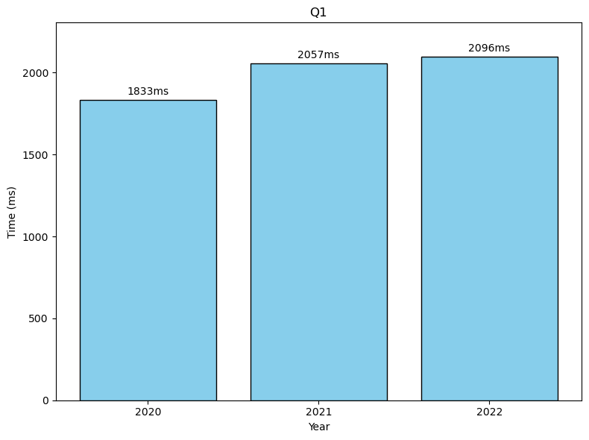
Q1v: 2020: 3778ms 2021: 3121ms
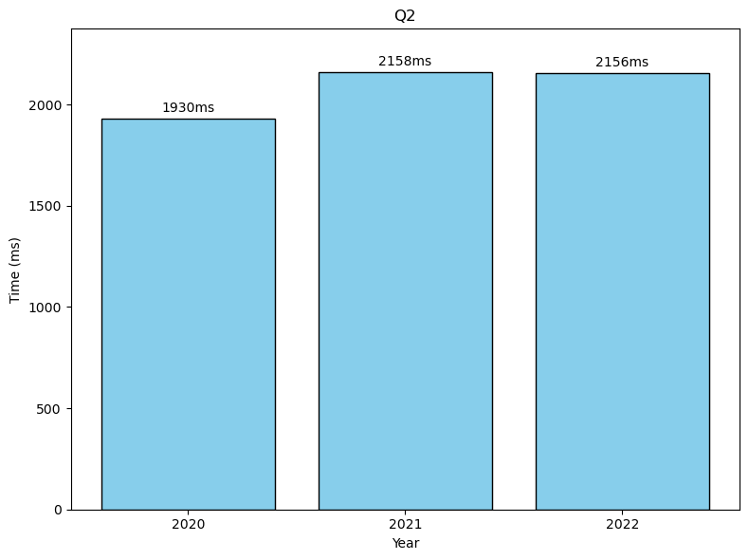
Q2v: 2020: 3686ms 2021: 2919ms
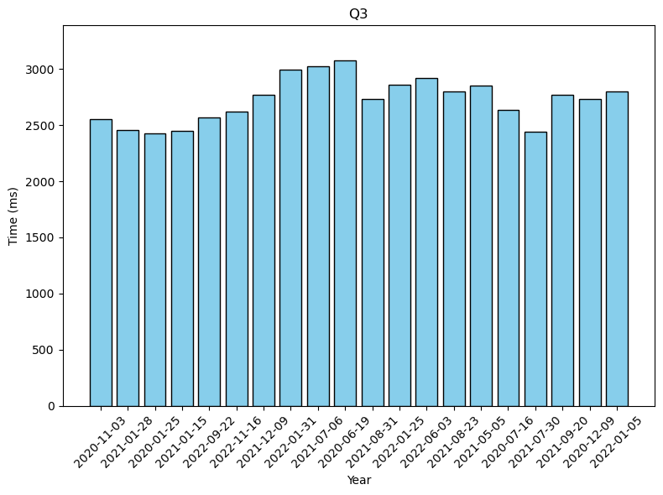
2020-11-03: 2555 2021-01-28: 2459 2020-01-25: 2426 2021-01-15: 2446 2022-09-22: 2570 2022-11-16: 2624 2021-12-09: 2769 2022-01-31: 2991 2021-07-06: 3026 2020-06-19: 3080 2021-08-31: 2736 2022-01-25: 2859 2022-06-03: 2917 2021-08-23: 2798 2021-05-05: 2851 2020-07-16: 2633 2021-07-30: 2438 2021-09-20: 2769 2020-12-09: 2732 2022-01-05: 2802
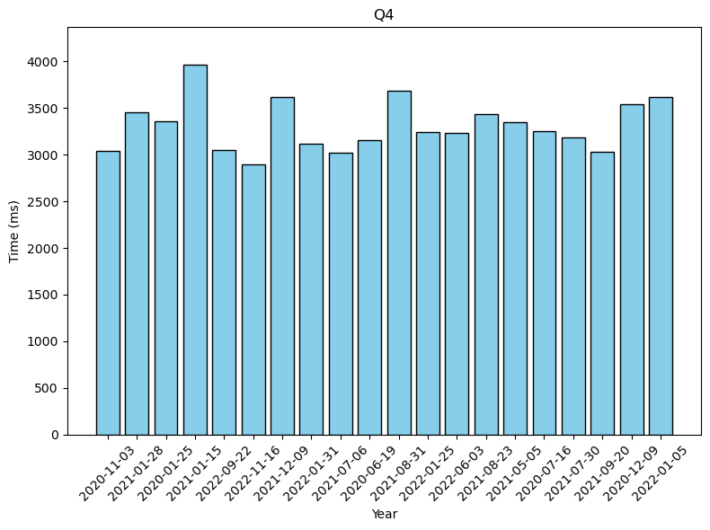
2020-11-03: 3045 2021-01-28: 3455 2020-01-25: 3359 2021-01-15: 3970 2022-09-22: 3053 2022-11-16: 2896 2021-12-09: 3620 2022-01-31: 3117 2021-07-06: 3026 2020-06-19: 3157 2021-08-31: 3691 2022-01-25: 3242 2022-06-03: 3232 2021-08-23: 3439 2021-05-05: 3346 2020-07-16: 3253 2021-07-30: 3189 2021-09-20: 3032 2020-12-09: 3545 2022-01-05: 3617

GraphFrame
Data were deployed on the spark cluster on master machine with 7 worker nodes. The notebook file is under /shared/ontime_graph.ipynb

Data Upload
First we load all csv files into dataframes:
import time
dfs = {} # store dataframes by using key (year,month)
for year in range(2020, 2023):
timeacc = 0
for month in range(1, 13):
path = f"hdfs:///ontime20-22/{year}_{month}.csv"
start_time = time.time()
df = (
spark.read
.option("header", "true")
.option("inferSchema", "true")
.csv(path)
)
time_cost = time.time() - start_time
print(f"Loaded file for {year}_{month} in {time_cost:.2f} seconds")
dfs[(year, month)] = df
timeacc += time_cost
print(f"Average loading time for year {year} is {timeacc / 12:.2f} seconds")

Then we create airport nodes:
from pyspark.sql.functions import expr
from functools import reduce
from pyspark.sql import DataFrame
start_time = time.time()
all_monthly_dfs = list(dfs.values())
full_flight_history = reduce(DataFrame.unionByName, all_monthly_dfs)
airport_vertices = (
full_flight_history.selectExpr(
"""
stack(2,
OriginAirportID, OriginCityName, Origin, OriginStateName,
DestAirportID, DestCityName, Dest, DestStateName
) as (id, city, code, state)
"""
)
.dropna(subset=["id"])
.dropDuplicates(["id"])
)
airport_vertices.printSchema()
airport_vertices.show(10, truncate=False)
print(f"Total Unique Airports: {airport_vertices.count()}")
time_cost = time.time() - start_time
print(f"Building all airport vertices require {time_cost:.2f} seconds")

Then we load flight edges:
from pyspark.sql.functions import col
columns_to_select = [
col("OriginAirportID").alias("src"),
col("DestAirportID").alias("dst"),
"FlightDate",
"Reporting_Airline",
"Flight_Number_Reporting_Airline",
"Year", "Quarter", "Month", "DayofMonth",
"IATA_CODE_Reporting_Airline", "DOT_ID_Reporting_Airline",
"Tail_Number",
"OriginAirportSeqID", "DestAirportSeqID",
"CRSDepTime", "DepTime", "DepDelay", "DepDelayMinutes", "DepDel15",
"DepartureDelayGroups", "DepTimeBlk", "TaxiOut", "WheelsOff",
"CRSArrTime", "ArrTime", "ArrDelay", "ArrDelayMinutes", "ArrDel15",
"ArrivalDelayGroups", "ArrTimeBlk", "TaxiIn", "WheelsOn",
"Cancelled", "CancellationCode", "Diverted",
"CRSElapsedTime", "ActualElapsedTime", "AirTime", "Flights",
"Distance", "DistanceGroup",
"CarrierDelay", "WeatherDelay", "NASDelay", "SecurityDelay", "LateAircraftDelay"
]
flight_edges = full_flight_history.select(columns_to_select)
flight_edges.printSchema()

Finally we can create graph schema:
from graphframes import GraphFrame
g = GraphFrame(airport_vertices, flight_edges)
print(f"Total Flights (Edges): {g.edges.count()}")

Queries
For descriptions of each query, check Neo4j section.

Q1
def run_q1(g, target_year):
start_time = time.time()
paths = g.find("(a)-[r1]->(b); (b)-[r2]->(c)")
paths = paths.repartition(72)
valid_paths = paths.filter(
(col("a.id") == 12892) &
(col("c.id") == 12953) &
(col("r1.Year") == target_year) &
(col("r1.FlightDate") == col("r2.FlightDate")) &
((col("r1.CRSArrTime") + 100) <= col("r2.CRSDepTime"))
)

monthly_stats = (
valid_paths
.groupBy(col("r1.Month").alias("Month"))
.count()
.orderBy("Month")
)
monthly_stats.cache()
row_count = monthly_stats.count()
time_cost = time.time() - start_time
print(f"Q1 Execution Time: {time_cost:.4f} seconds")
return monthly_stats

Q1 Cumulative
def run_q1(g, target_year):
start_time = time.time()
paths = g.find("(a)-[r1]->(b); (b)-[r2]->(c)")
paths = paths.repartition(72)
valid_paths = paths.filter(
(col("a.id") == 12892) &
(col("c.id") == 12953) &
(col("r1.Year") >= target_year) &
(col("r1.FlightDate") == col("r2.FlightDate")) &
((col("r1.CRSArrTime") + 100) <= col("r2.CRSDepTime"))
)

monthly_stats = (
valid_paths
.groupBy(col("r1.Month").alias("Month"))
.count()
.orderBy("Month")
)
monthly_stats.cache()
row_count = monthly_stats.count()
time_cost = time.time() - start_time
print(f"Q1 Execution Time: {time_cost:.4f} seconds")
return monthly_stats

Q2
def run_q2(g, target_year):
start_time = time.time()
paths = g.find("(a)-[r1]->(b); (b)-[r2]->(c)")
paths = paths.repartition(72)
valid_paths = paths.filter(
(col("a.id") == 12892) &
(col("c.id") == 12953) &
(col("r1.Year") == target_year) &
(col("r1.FlightDate") == col("r2.FlightDate")) &
((col("r1.CRSArrTime") + 100) <= col("r2.CRSDepTime")) &
(col("r1.ArrTime") >= col("r2.DepTime"))
)
monthly_stats = (
valid_paths
.groupBy(col("r1.Month").alias("Month"))
.count()
.orderBy("Month")
)
monthly_stats.cache()
row_count = monthly_stats.count()
time_cost = time.time() - start_time
print(f"Q2 Execution Time: {time_cost:.4f} seconds")
return monthly_stats

Q2 Cumulative
def run_q2(g, target_year):
start_time = time.time()
paths = g.find("(a)-[r1]->(b); (b)-[r2]->(c)")
paths = paths.repartition(72)
valid_paths = paths.filter(
(col("a.id") == 12892) &
(col("c.id") == 12953) &
(col("r1.Year") >= target_year) &
(col("r1.FlightDate") == col("r2.FlightDate")) &
((col("r1.CRSArrTime") + 100) <= col("r2.CRSDepTime")) &
(col("r1.ArrTime") >= col("r2.DepTime"))
)
monthly_stats = (
valid_paths
.groupBy(col("r1.Month").alias("Month"))
.count()
.orderBy("Month")
)
monthly_stats.cache()
row_count = monthly_stats.count()
time_cost = time.time() - start_time
print(f"Q2 Execution Time: {time_cost:.4f} seconds")
return monthly_stats

Q3
def run_q3(g, target_date):
start_time = time.time()
paths = g.find("(a)-[r1]->(b); (b)-[r2]->(c)")
paths = paths.repartition(72)
valid_transits = paths.filter(
(col("r1.FlightDate") == target_date) &
(col("r2.FlightDate") == target_date) &
(col("r1.Tail_Number") != "") &
(col("r2.Tail_Number") != "") &
(col("r1.Tail_Number") == col("r2.Tail_Number")) &
(col("r1.CRSArrTime") < col("r2.CRSDepTime"))
)
transit_hubs = (
valid_transits
.groupBy(col("b.city"), col("b.code")) # Group by the Intermediate Hub (b)
.agg(countDistinct("r1.Tail_Number").alias("cnt"))
.orderBy(desc("cnt"))
.limit(10)
)
transit_hubs.cache()
transit_hubs.show()
time_cost = time.time() - start_time
print(f"Q3 Execution Time: {time_cost:.2f} seconds")
return transit_hubs

Q4
def run_q4(g, target_date):
start_time = time.time()
paths = g.find("(a)-[r1]->(b); (b)-[r2]->(c); (c)-[r3]->(d)")
paths = paths.repartition(100)
valid_chains = paths.filter(
(col("r1.FlightDate") == target_date) &
(col("r2.FlightDate") == target_date) &
(col("r3.FlightDate") == target_date) &
(col("r1.Tail_Number") != "") &
(col("r2.Tail_Number") != "") &
(col("r3.Tail_Number") != "") &
(col("r1.Tail_Number") == col("r2.Tail_Number")) &
(col("r2.Tail_Number") == col("r3.Tail_Number")) &
(col("r1.CRSArrTime") < col("r2.CRSDepTime")) &
(col("r2.CRSArrTime") < col("r3.CRSDepTime"))
)
result = valid_chains.agg(countDistinct("r1.Tail_Number").alias("cnt"))
final_count = result.collect()[0]["cnt"]
time_cost = time.time() - start_time
print(f"Q4 Execution Time: {time_cost:.2f} seconds")
print(f"Total Planes with 3-hop journeys: {final_count}")
return final_count

Performance Charts
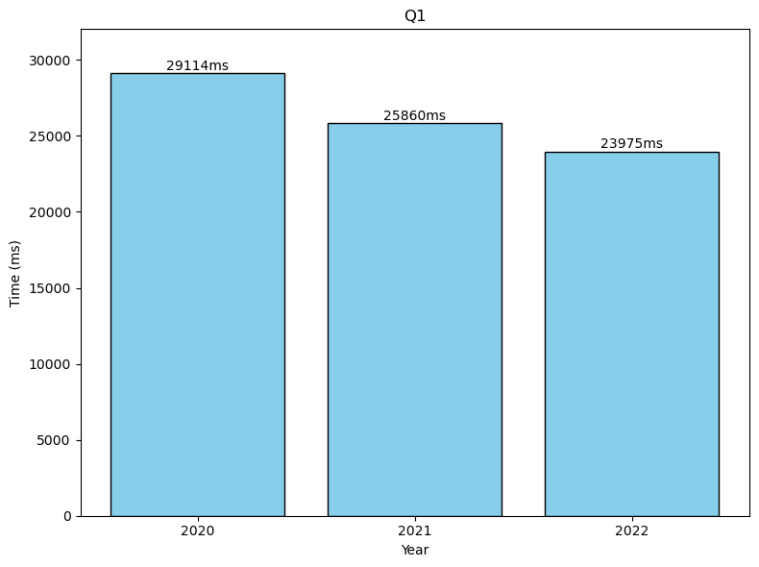
Before Spark re-configuration: 2020:13794 ms
After Spark re-configuration: 2020: 29114ms 2021: 24615 ms 2022: 24584 ms
Q1+ (After reconfiguration): 2020: 26857 ms 2021: 26377 ms
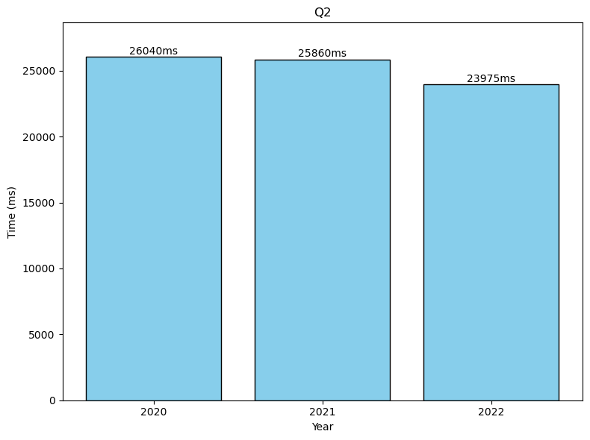
Before Spark re-configuration: 2020: 14285 ms
After Spark re-configuration: 2020: 26040ms 2021: 25860 ms 2022: 23975 ms
Q2+ (After reconfiguration): 2020: 22652 ms 2021: 22359 ms
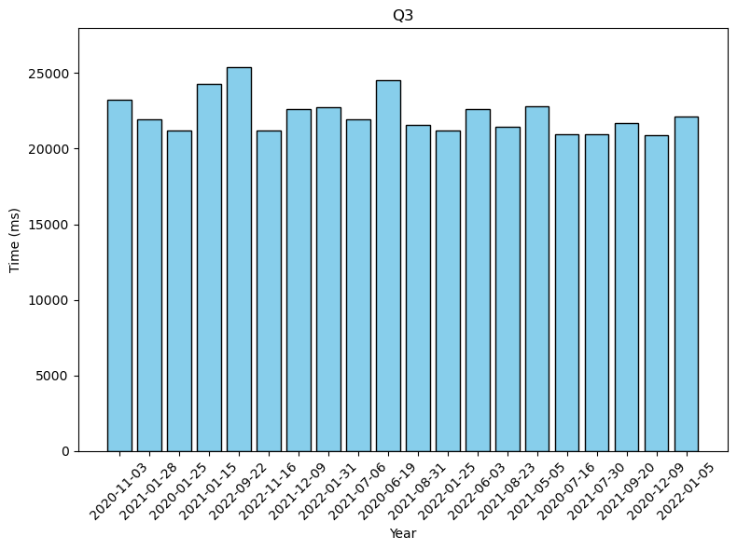
2020-11-03: 23229 2021-01-28: 21951 2020-01-25: 21222 2021-01-15: 24277
2022-09-22: 25423 2022-11-16: 21171 2021-12-09: 22627 2022-01-31: 22733
2021-07-06: 21961 2020-06-19: 24514 2021-08-31: 21590 2022-01-25: 21220
2022-06-03: 22614 2021-08-23: 21464 2021-05-05: 22790 2020-07-16: 20955
2021-07-30: 20935 2021-09-20: 21714 2020-12-09: 20885 2022-01-05: 22122
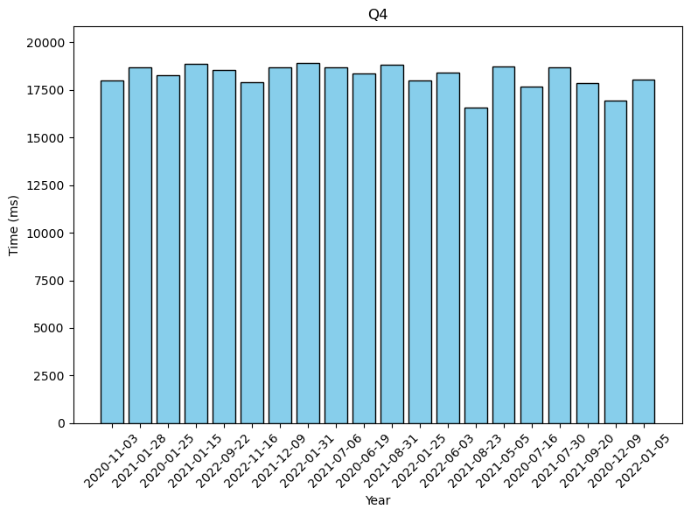
2020-11-03: 18006 2021-01-28: 18708 2020-01-25: 18271 2021-01-15: 18883
2022-09-22: 18574 2022-11-16: 17916 2021-12-09: 18680 2022-01-31: 18940
2021-07-06: 18703 2020-06-19: 18357 2021-08-31: 18807 2022-01-25: 18016
2022-06-03: 18417 2021-08-23: 16565 2021-05-05: 18740 2020-07-16: 17688
2021-07-30: 18705 2021-09-20: 17867 2020-12-09: 16924 2022-01-05: 18041

PuppyGraph
Data were deployed on master machine. PuppyGraph version is 0.106a.

Data Upload
There are some bugs with 0.97a version of PuppyGraph, where running queries will accidentally change the number of nodes in the database. Updating to 0.106a solves this issue. The 0.106a version also automatically counts the running time of a query. To start PuppyGraph process on master node, run the following command:
docker run --network=host -d --name puppy --rm -e DATAACCESS_DATA_CACHE_STRATEGY=adaptive --pull=always puppygraph/puppygraph:0.106
Instead of drawing nodes and edges using PuppyGraph webUI, we can also write the schema json file and upload it to PuppyGraph to create the graph. This schema.json file can be found at /shared/datasets/ontime20-22/schema.json.
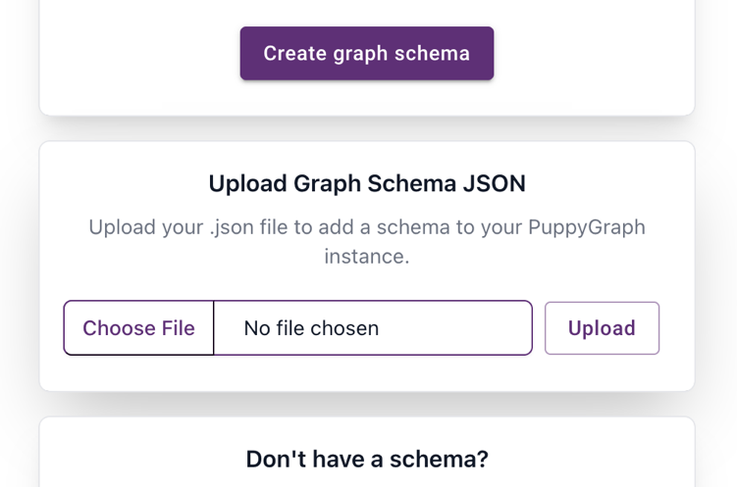

Queries
Since PuppyGraph supports cypher queries, these will be the same as those in the Neo4j section.

Performance Charts
Q1 by PuppyGraph (PG) team: 2020: 516 2021: 511 2022: 620
Q1 (after update from Puppygraph team): 2020: 38 2021: 41 2022: 37
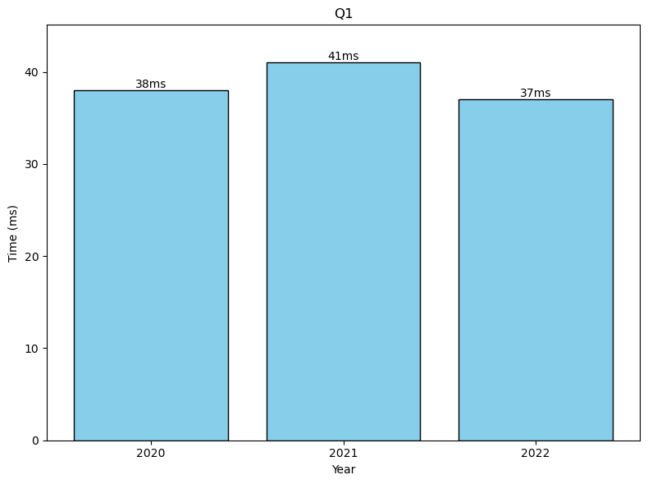
Q1+ by PuppyGraph (PG) team: 2020: 834 2021: 717
Q1+ (after update from Puppygraph team): 2020: 35 2021: 32

Q2 by PuppyGraph (PG) team: 2020: 525 2021: 702 2022: 535
Q2 (after update from Puppygraph team): 2020: 34 2021: 38 2022: 30
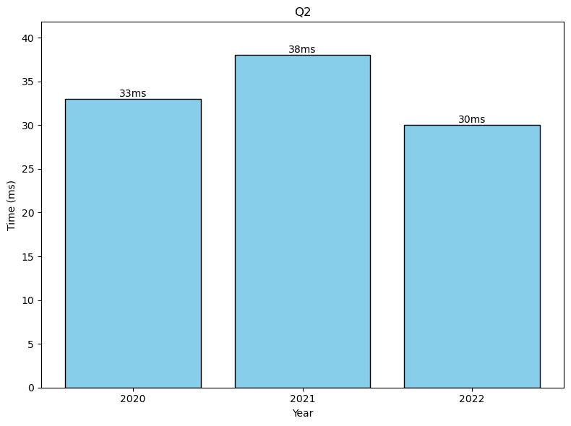
Q2+ by PuppyGraph (PG) team: 2020: 1004 2021: 690
Q2+ (after update from Puppygraph team): 2020: 36 2021: 32

Q3
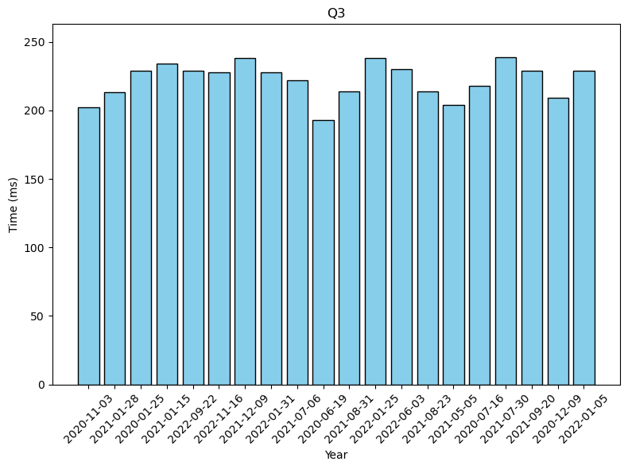
2020-11-03: 202 2021-01-28: 213 2020-01-25: 229 2021-01-15: 234 2022-09-22: 229
2022-11-16: 228 2021-12-09: 238 2022-01-31: 228 2021-07-06: 222 2020-06-19: 193
2021-08-31: 214 2022-01-25: 238 2022-06-03: 230 2021-08-23: 214 2021-05-05: 204
2020-07-16: 218 2021-07-30: 239 2021-09-20: 229 2020-12-09: 209 2022-01-05: 229
Q4
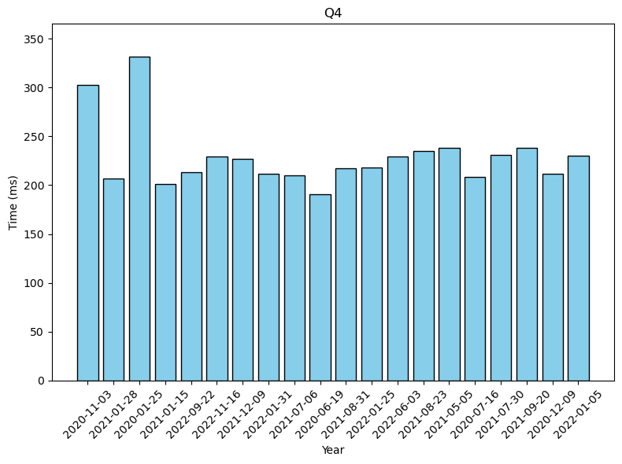
2020-11-03: 303 2021-01-28: 207 2020-01-25: 332 2021-01-15: 201 2022-09-22: 213
2022-11-16: 229 2021-12-09: 227 2022-01-31: 212 2021-07-06: 210 2020-06-19: 191
2021-08-31: 217 2022-01-25: 218 2022-06-03: 229 2021-08-23: 235 2021-05-05: 238
2020-07-16: 208 2021-07-30: 231 2021-09-20: 238 2020-12-09: 212 2022-01-05: 230

