=== Importing Data ===
sudo nano /etc/neo4j/neo4j.conf
dbms.security.auth_enabled=false
to avoid password: you can leave password empty while logging in.

Note: this is actual dataset, not Neo4j sandbox!
We ignore checkin.json for now.

Step 1: Create Business and User nodes
Note: Business has “attributes” and “hours” that are embedded attributes which we ignore for now.

CALL apoc.periodic.iterate(
"CALL apoc.load.json('file:///yelp/yelp_academic_dataset_business.json') YIELD value",
"CREATE (b:Business {
id: value.business_id,
name: value.name,
address: value.address,
city: value.city,
state: value.state,
postal_code: value.postal_code,
latitude: value.latitude,
longitude: value.longitude,
is_open: value.is_open,
categories: value.categories,
rating: value.stars,
review_count: value.review_count
})",
{batchSize: 1000, parallel: true}
)

CALL apoc.periodic.iterate(
"CALL apoc.load.json('file:///yelp/yelp_academic_dataset_user.json') YIELD value",
"CREATE (u:User {
user_id: value.user_id,
name: value.name,
review_count: value.review_count,
yelping_since: value.yelping_since,
friends: value.friends,
useful: value.useful,
funny: value.funny,
cool: value.cool,
fans: value.fans,
elite: value.elite,
average_stars: value.average_stars,
compliment_hot: value.compliment_hot,
compliment_more: value.compliment_more,
compliment_profile: value.compliment_profile,
compliment_cute: value.compliment_cute,
compliment_list: value.compliment_list,
compliment_note: value.compliment_note,
compliment_plain: value.compliment_plain,
compliment_cool: value.compliment_cool,
compliment_funny: value.compliment_funny,
compliment_writer: value.compliment_writer,
compliment_photos: value.compliment_photos
})",
{batchSize: 1000, parallel: true}
)

Step 2: Create (B+) indices on nodes
This is essential for quick insertion of edges, since a review needs to identify its user and its business using their indices (B+ tree).

// For Users
CREATE INDEX user_user_id_index FOR (u:User) ON (u.user_id);

// For Businesses
CREATE INDEX business_id_index FOR (b:Business) ON (b.id);

SHOW INDEXES
// there will be two internal hash indices also, not user created ones.

Step 3: Create “review” related edges
CALL apoc.periodic.iterate(
"CALL apoc.load.json('file:///yelp/yelp_academic_dataset_review.json') YIELD value",
"
MATCH (u:User {user_id: value.user_id})
MATCH (b:Business {id: value.business_id})
CREATE (r:Review {
id: value.review_id,
stars: value.stars,
date: value.date,
text: value.text,
useful: value.useful,
funny: value.funny,
cool: value.cool
})
CREATE (u)-[:WROTE]->(r)
CREATE (r)-[:REVIEWS]->(b)
",
{batchSize: 1000, parallel: false}
)
Note: it takes 10 minutes 37 seconds. Edge insertion takes time even though B+ tree has been built.

Step 4: Create “tip” related edges
CALL apoc.periodic.iterate(
"CALL apoc.load.json('file:///yelp/yelp_academic_dataset_tip.json') YIELD value",
"
MATCH (u:User {user_id: value.user_id})
MATCH (b:Business {id: value.business_id})
CREATE (t:Tip {
text: value.text,
date: value.date,
compliment_count: value.compliment_count
})
CREATE (u)-[:TIPPED]->(t)
CREATE (t)-[:FOR]->(b)
",
{batchSize: 1000, parallel: false}
)

=== Converting Data ===
From the counterpart on the sandbox (not the same though, as the sandbox one has more businesses but only in two cities in Arizona, while we have 1416 cities):
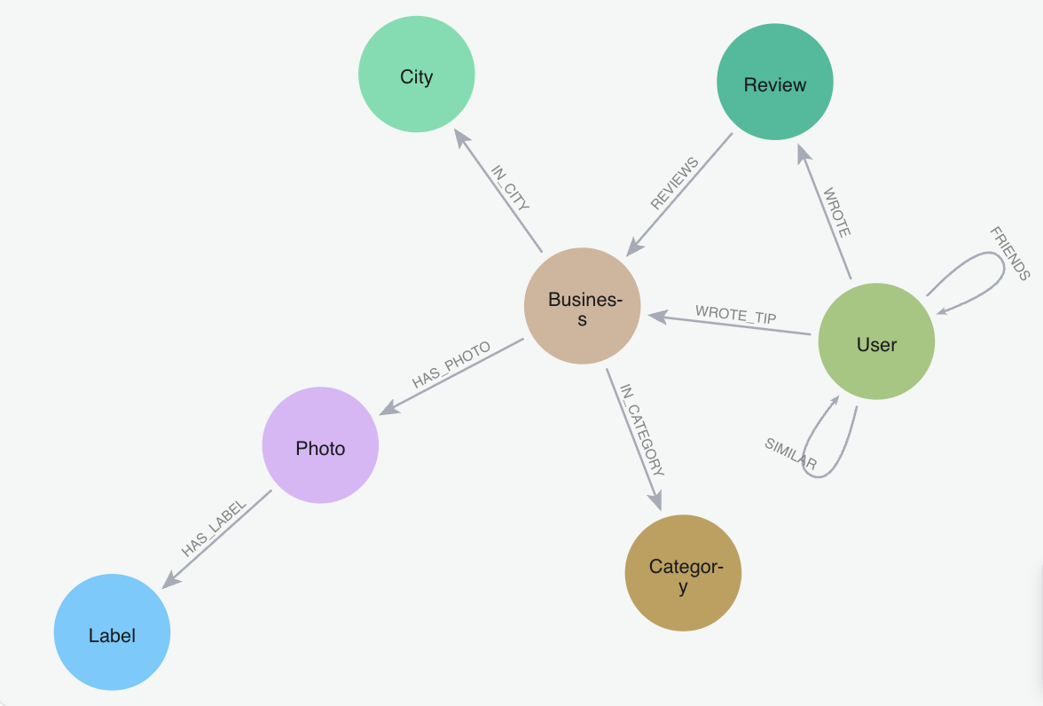

MATCH (b:Business)
RETURN count(DISTINCT b.city) AS num_cities;

MATCH (b:Business)
RETURN b.city, count(*) AS businesses_in_city
ORDER BY businesses_in_city DESC;

MATCH (b:Business)
WHERE b.city = "Philadelphia"
RETURN b.name, b.address, b.rating, b.review_count
ORDER BY b.rating DESC, b.review_count DESC
LIMIT 50;

Conclusion: city filtering is very fast, no need to make cities as nodes

Categories make sense since it is a one-to-many relationship for business-categories.
CALL apoc.periodic.iterate(
"MATCH (b:Business) WHERE b.categories IS NOT NULL RETURN b",
"
WITH b, apoc.text.split(b.categories, ',') AS categoryList
UNWIND categoryList AS rawCategory
WITH b, trim(rawCategory) AS category
MERGE (c:Category {name: category})
CREATE (b)-[:IN_CATEGORY]->(c)
",
{batchSize: 1000, parallel: false}
)
------> (5 min 16 sec)
Friend-edges also make sense:
CALL apoc.periodic.iterate(
"MATCH (u:User) WHERE u.friends IS NOT NULL RETURN u",
"
WITH u, apoc.text.split(u.friends, ', ') AS friendIds
UNWIND friendIds AS friendId
MATCH (f:User {user_id: friendId})
CREATE(u)-[:FRIEND]->(f)
",
{batchSize: 10000, parallel: false}
)
------> (12 min 38 sec)
=== Queries ===
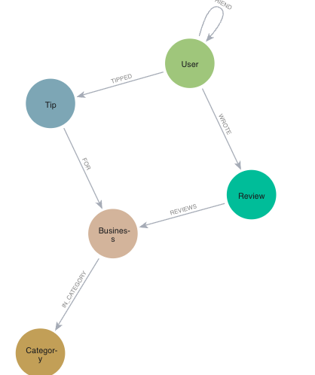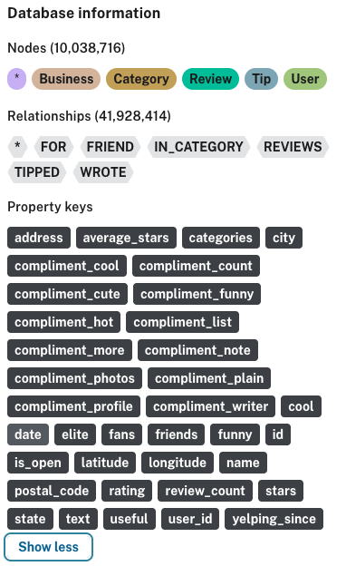

====== FRIEND ======
Find the most frequent names:
MATCH (u:User)
RETURN u.name AS name, count(*) AS occurrences
ORDER BY occurrences DESC
LIMIT 30
------> 1795 ms, most frequent name is John, appearing 18719 times, followed by Michael, 16645 times

Find the friends of all “John”s:
MATCH (:User {name: "John"})-[:FRIEND]->(friend)
RETURN friend.name, friend.user_id
LIMIT 20
------> 56 ms

Count the friends of all “John”s:
MATCH (:User {name: "John"})-[:FRIEND]->(friend)
RETURN count(distinct friend) AS total_friends
------> 3265 ms, 76078 results

How many friends each user has:
MATCH (u:User)-[:FRIEND]->()
RETURN u.name, u.user_id, COUNT(*) AS num_friends
ORDER BY num_friends DESC
LIMIT 50
------> 14.977 s, Steven (Oi1qbcz2m2SnwUeztGYcnQ) has most friends 20604, followed by Niki (WwulXySQN8t2hwqH_yWurA) with 11350 friends

Find mutual friends between Steven and Niki:
MATCH (a:User {user_id: "Oi1qbcz2m2SnwUeztGYcnQ"})-[:FRIEND]->(mutual)<-[:FRIEND]-(b:User {user_id: "WwulXySQN8t2hwqH_yWurA"})
RETURN DISTINCT mutual.name, mutual.user_id
------> 111 ms, 186 results

Who has the most mutual friends with a given user:
MATCH (me:User {user_id: "Oi1qbcz2m2SnwUeztGYcnQ"})-[:FRIEND]->(f:User)
MATCH (other:User)-[:FRIEND]->(f)
WHERE other <> me
RETURN other.name, COUNT(f) AS mutual_count
ORDER BY mutual_count DESC
LIMIT 50
------> 16132 ms

Get 3rd-hop neighbors of a given user:
MATCH (start:User {user_id: "Oi1qbcz2m2SnwUeztGYcnQ"})-[:FRIEND*3]-(neighbor)
WHERE neighbor.user_id <> "Oi1qbcz2m2SnwUeztGYcnQ"
RETURN DISTINCT neighbor.name, neighbor.user_id
------> 177 ms (fast may be because the limit of 5000 in the browser)

MATCH (start:User {user_id: "Oi1qbcz2m2SnwUeztGYcnQ"})-[:FRIEND*3]-(neighbor)
WHERE neighbor.user_id <> "Oi1qbcz2m2SnwUeztGYcnQ"
RETURN count(DISTINCT neighbor) AS three_hop_count
------> 4 min 40 sec, 696120 results

====== FRIEND + Review, Spatial Queries and Indexing ======
For a given user’s friends, find their reviewed businesses along with locations:
MATCH (u:User {user_id: "Oi1qbcz2m2SnwUeztGYcnQ"})-[:FRIEND]->(friend:User)-[:WROTE]->(r:Review)-[:REVIEWS]->(b:Business)
RETURN DISTINCT friend.name AS friend_name,
b.name AS business_name,
b.address, b.city, b.state,
b.latitude, b.longitude
ORDER BY friend_name, business_name
------> 10.306 sec

(Counting result number)
CALL {
MATCH (u:User {user_id: "Oi1qbcz2m2SnwUeztGYcnQ"})-[:FRIEND]->(friend:User)
-[:WROTE]->(r:Review)-[:REVIEWS]->(b:Business)
RETURN DISTINCT
friend.name AS friend_name,
b.name AS business_name,
b.address AS address,
b.city AS city,
b.state AS state,
b.latitude AS latitude,
b.longitude AS longitude
}
RETURN count(*) AS total_results
------> 6841 ms, 336124 results

Find the median of the above locations:
MATCH (u:User {user_id: "Oi1qbcz2m2SnwUeztGYcnQ"})-[:FRIEND]->(:User)-[:WROTE]->(:Review)-[:REVIEWS]->(b:Business)
WHERE b.latitude IS NOT NULL AND b.longitude IS NOT NULL
WITH DISTINCT b.id AS bid, b.latitude AS lat, b.longitude AS lon
RETURN
percentileCont(lat, 0.5) AS median_latitude,
percentileCont(lon, 0.5) AS median_longitude
------> 3976 ms, (lat, lon) = 39.52565056975, -82.64639754999999

Build point index on business locations:
- create a location property
MATCH (b:Business)
WHERE b.latitude IS NOT NULL AND b.longitude IS NOT NULL
SET b.location = point({latitude: b.latitude, longitude: b.longitude})
-------> 1118 ms

- create 2D index on location
CREATE POINT INDEX business_location_index FOR (b:Business) ON (b.location)

SHOW INDEXES

Find all businesses within 5 miles from the specified location:
WITH point({latitude: 39.877788, longitude: -75.69293535784999}) AS center
MATCH (b:Business)
WHERE b.location IS NOT NULL AND point.distance(b.location, center) <= 8046.72 // 5 miles in meters
RETURN b.name, b.address, b.city, b.state, b.latitude, b.longitude, point.distance(b.location, center) AS dist_meters
ORDER BY dist_meters ASC

K-NN Query, find the k=10 nearest businesses to the specified location:
WITH point({latitude: 39.877788, longitude: -75.69293535784999}) AS center
MATCH (b:Business)
WHERE b.location IS NOT NULL
RETURN b.name, b.address, b.city, b.state,
b.latitude, b.longitude,
point.distance(b.location, center) AS dist_meters
ORDER BY dist_meters ASC
LIMIT 10 // Top-k: change 10 to however many neighbors you want

Find all users who commented on the above businesses:
WITH point({latitude: 39.877788, longitude: -75.69293535784999}) AS center
MATCH (b:Business)
WHERE b.location IS NOT NULL AND point.distance(b.location, center) <= 8046.72
MATCH (u:User)-[:WROTE]->(:Review)-[:REVIEWS]->(b)
RETURN DISTINCT u.user_id, u.name
ORDER BY u.name

--- counting version
WITH point({latitude: 39.877788, longitude: -75.69293535784999}) AS center
MATCH (b:Business)
WHERE b.location IS NOT NULL AND point.distance(b.location, center) <= 8046.72
MATCH (u:User)-[:WROTE]->(:Review)-[:REVIEWS]->(b)
RETURN count(DISTINCT u) AS user_count
------> result = 5734

====== Review + Tip ======
Find the total number of reviews + tips for each business, and sort by descending order
MATCH (b:Business)
OPTIONAL MATCH (b)<-[:REVIEWS]-(r:Review)
OPTIONAL MATCH (b)<-[:TIPPED]-(t:Tip)
WITH b, count(DISTINCT r) AS num_reviews, count(DISTINCT t) AS num_tips
RETURN b.name AS business_name, num_reviews, num_tips, (num_reviews + num_tips) AS total
ORDER BY total DESC
------> top 2 businesses: "Acme Oyster House", "Oceana Grill"
(OPTIONAL MATCH is used to include businesses even if they have only reviews or only tips)

Find the rating of "Acme Oyster House":
MATCH (b:Business {name: "Acme Oyster House"})
RETURN b.name, b.rating
------> there are 3 branches

Print all their text reviews and tips:
MATCH (b:Business {name: "Acme Oyster House"})
MATCH (b)<-[:REVIEWS]-(r:Review)
RETURN b.id AS business_id, r.text AS text, 'review' AS type
UNION
MATCH (b:Business {name: "Acme Oyster House"})
MATCH (b)<-[: TIPPED]-(t:Tip)
RETURN b.id AS business_id, t.text AS text, 'tip' AS type
------> there is only reviews, no tips

Find the businesses with both tips and reviews, and return their counts:
MATCH (b:Business)<-[:REVIEWS]-(r:Review)
MATCH (b)<-[:TIPPED]-(t:Tip)
WITH b, count(DISTINCT r) AS num_reviews, count(DISTINCT t) AS num_tips
RETURN b.name AS business_name, num_reviews, num_tips, (num_reviews + num_tips) AS total
ORDER BY total DESC
------> this is empty!!!
(To include only businesses that have both tips and reviews, you should use regular MATCH, not OPTIONAL MATCH)

Find reviews with text containing “disgusting”:
MATCH (r:Review)
WHERE toLower(r.text) CONTAINS "disgusting"
RETURN r.id, r.text
LIMIT 100

Top-rated businesses with sufficient reviews:
MATCH (b:Business)
WHERE b.review_count > 100
RETURN b.name, b.city, b.review_count, b.rating
ORDER BY b.rating DESC, b.review_count DESC
LIMIT 20

Most frequently used words in reviews:
MATCH (r:Review)
WITH split(toLower(r.text), " ") AS words
UNWIND words AS word
WITH word, count(*) AS freq
WHERE size(word) > 3
RETURN word, freq
ORDER BY freq DESC
LIMIT 20
------> 4 min 23 sec, most words are stop words that are not interesting… some make sense like food, good, great
(We only keep words that are longer than 3 characters)

Find businesses with only negative reviews:
MATCH (b:Business)<-[:REVIEWS]-(r:Review)
WITH b, collect(r.stars) AS stars
WHERE ALL(star IN stars WHERE star < 3)
RETURN b.name, stars
ORDER BY size(stars) DESC
------> 42.776 seconds, 1790 results (poor businesses…)

====== GDS (Graph Algorithms) ======
The friend graph should be bidirected (i.e., undirected). Check:
MATCH (u1:User)-[:FRIEND]->(u2:User)
WHERE NOT (u2)-[:FRIEND]->(u1)
RETURN u1.user_id AS from, u2.user_id AS to
LIMIT 10
------> 3 min 38 sec, no records (is an undirected graph!)

Create an in-memory friend-graph to run algorithms
CALL gds.graph.project(
'FriendGraph',
'User',
'FRIEND'
);

PageRank (stream results only)
CALL gds.pageRank.stream('FriendGraph')
YIELD nodeId, score
RETURN gds.util.asNode(nodeId).name AS name, score
ORDER BY score DESC
LIMIT 10;
------> 7751 ms

PageRank (write results back to database)
CALL gds.pageRank.write(
'FriendGraph',
{
writeProperty: 'pagerank'
}
)
YIELD nodePropertiesWritten, ranIterations;
(For procedures: CALL ... YIELD field; different from queries: MATCH ... RETURN field)
------> 14.431 sec, 20 iterations

MATCH (u:User)
RETURN u.name, u.user_id, u.pagerank
ORDER BY u.pagerank DESC
LIMIT 10

Degree Centrality
CALL gds.degree.write(
'FriendGraph',
{ writeProperty: 'degree' }
)
YIELD nodePropertiesWritten;

MATCH (u:User)
RETURN u.name, u.user_id, u.degree
ORDER BY u.degree DESC
LIMIT 10;

Weakly Connected Components (WCC)
CALL gds.wcc.write(
'FriendGraph',
{ writeProperty: 'componentId' }
)
YIELD nodePropertiesWritten, componentCount;
------> 6394 ms

MATCH (u:User)
RETURN u.componentId, count(*) AS size
ORDER BY size DESC
LIMIT 10;

Louvain Community Detection
CALL gds.louvain.write(
'FriendGraph',
{ writeProperty: 'community' }
)
YIELD communityCount, modularity;
------> 42.365 sec

MATCH (u:User)
RETURN u.community, count(*) AS size
ORDER BY size DESC
LIMIT 10;

Clean-Up (drop the above properties)
CALL apoc.periodic.iterate(
"MATCH (u:User) RETURN u",
"REMOVE u.pagerank, u.degree, u.componentId, u.community, u.triangles",
{batchSize: 1000}
)
------> 24.749 sec

Note: if using:
MATCH (u:User)
REMOVE u.pagerank, u.degree, u.componentId, u.community, u.triangles;
Error:
Neo.TransientError.General.MemoryPoolOutOfMemoryError The allocation of an extra 192.0 MiB would use more than the limit 5.1 GiB. Currently using 5.1 GiB. dbms.memory.transaction.total.max threshold reached

Delete the in-memory friend-graph
CALL gds.graph.drop('FriendGraph')
YIELD graphName;

Clear DB (Use with caution):

sudo systemctl stop neo4j

(if you use another DB, replace the default “neo4j” in paths below)
sudo rm -rf /var/lib/neo4j/data/databases/neo4j/*
sudo rm -rf /var/lib/neo4j/data/transactions/neo4j/*

sudo systemctl start neo4j

Reconfigure Disk Space
mkdir -p /shared/worker3
sudo chown -R neo4j:neo4j /shared/worker3 (run on master)
sudo chmod -R 777 /shared/worker3 (run on master)
Update /etc/neo4j/neo4j.conf
>> server.directories.import=/shared/datasets
>> server.directories.data=/shared/worker3
sudo systemctl stop neo4j
(optional) sudo rm -rf /var/lib/neo4j/data/databases/neo4j/*
(optional) sudo rm -rf /var/lib/neo4j/data/transactions/neo4j/*
sudo systemctl start neo4j

--------------------
sudo systemctl restart neo4j
sudo systemctl status neo4j

sudo rm -rf /shared/worker2/databases/neo4j/*
sudo rm -rf /shared/worker2/transactions/neo4j/*

* Note:
Note: somehow master is using /shared/neo4j, while worker1 is using /var/lib/neo4j

