StackOverflow Dataset

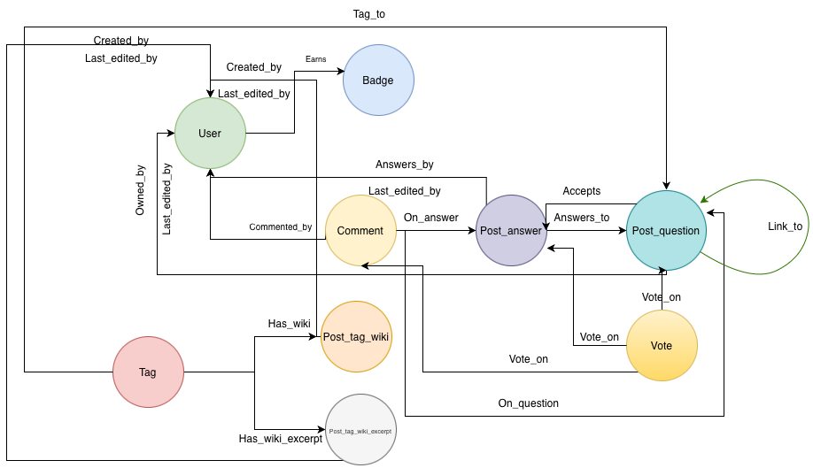

Step 1 — Create Uniqueness Constraints
Before loading any data, create uniqueness constraints on core node identifiers. This prevents duplicate nodes and enables faster MERGE lookups during relationship creation.

CREATE CONSTRAINT user_id_unique IF NOT EXISTS
FOR (u:User) REQUIRE u.user_id IS UNIQUE;

CREATE CONSTRAINT post_question_id_unique IF NOT EXISTS
FOR (pq:Post_question) REQUIRE pq.post_id IS UNIQUE;

CREATE CONSTRAINT post_answer_id_unique IF NOT EXISTS
FOR (pa:Post_answer) REQUIRE pa.post_id IS UNIQUE;

CREATE CONSTRAINT comment_id_unique IF NOT EXISTS
FOR (c:Comment) REQUIRE c.comment_id IS UNIQUE;

CREATE CONSTRAINT tag_id_unique IF NOT EXISTS
FOR (t:Tag) REQUIRE t.tag_id IS UNIQUE;

CREATE CONSTRAINT badge_id_unique IF NOT EXISTS
FOR (b:Badge) REQUIRE b.badge_id IS UNIQUE;

CREATE CONSTRAINT vote_id_unique IF NOT EXISTS
FOR (v:Vote) REQUIRE v.vote_id IS UNIQUE;

CREATE CONSTRAINT post_history_id_unique IF NOT EXISTS
FOR (ph:Post_history) REQUIRE ph.post_history_id IS UNIQUE;

CREATE CONSTRAINT post_tag_wiki_id_unique IF NOT EXISTS
FOR (ptw:Post_tag_wiki) REQUIRE ptw.post_id IS UNIQUE;

CREATE CONSTRAINT post_tag_wiki_excerpt_id_unique IF NOT EXISTS
FOR (ptwe:Post_tag_wiki_excerpt) REQUIRE ptwe.post_id IS UNIQUE;

Step 2 — Load Nodes

2.1 Loading Users

CSV Pre-processing Script
The users.csv file contained quote-escaping issues that prevented Neo4j from parsing it. The script below reads the raw CSV and strips ALL quote characters, newlines, carriage returns, and tabs, then writes a clean file (users_clean.csv) that Neo4j can load without errors.

from __future__ import annotations

import argparse
import csv
import os
import sys
import tempfile
from pathlib import Path

EXPECTED_HEADER = [
"id",
"display_name",
"about_me",
"age",
"creation_date",
"last_access_date",
"location",
"reputation",
"up_votes",
"down_votes",
"views",
"profile_image_url",
"website_url",
]

INTEGER_COLUMNS = {
0: "id",
3: "age",
7: "reputation",
8: "up_votes",
9: "down_votes",
10: "views",
}

NEO4J_INTEGER_MIN = -(2**63)
NEO4J_INTEGER_MAX = 2**63 - 1

def set_csv_field_size_limit() -> None:
"""Use the largest CSV field size supported by this Python build."""
limit = sys.maxsize
while True:
try:
csv.field_size_limit(limit)
return
except OverflowError:
limit //= 10

def clean_cell(value: str, *, strip_backslashes: bool = False) -> str:
# Collapse newlines, carriage returns, tabs, and repeated whitespace so
# each logical CSV record is also one physical line. Keep quotes,
# apostrophes, commas, and backslashes as data; csv.writer will encode them
# correctly according to the standard CSV format understood by Neo4j.
value = " ".join(value.split())
if strip_backslashes:
# Neo4j's default legacy CSV mode treats a backslash immediately
# before a quote as quote escaping, even in otherwise standard CSV.
# Removing backslashes is a lossy compatibility fallback for users
# who cannot set dbms.import.csv.legacy_quote_escaping=false.
value = value.replace("\\", "")
return value

def validate_numeric_cells(row: list[str], record_number: int) -> None:
for index, name in INTEGER_COLUMNS.items():
value = row[index].strip()
if value == "":
continue

try:
number = int(value)
except ValueError as exc:
raise ValueError(
f"record {record_number}: {name} is not an integer: {value!r}"
) from exc

if not NEO4J_INTEGER_MIN <= number <= NEO4J_INTEGER_MAX:
raise ValueError(
f"record {record_number}: {name} is outside Neo4j's "
f"64-bit integer range: {value!r}"
)

def clean_users(
input_path: Path,
output_path: Path,
*,
force: bool,
progress_every: int,
strip_backslashes: bool,
) -> None:
if input_path.resolve() == output_path.resolve():
raise ValueError("input and output paths must be different")
if output_path.exists() and not force:
raise FileExistsError(
f"{output_path} already exists; use --force to replace it after "
"a successful conversion"
)

output_path.parent.mkdir(parents=True, exist_ok=True)
set_csv_field_size_limit()

temporary_name: str | None = None
records = 0
replacement_characters = 0

try:
with input_path.open(
"r", encoding="utf-8", errors="replace", newline=""
) as infile, tempfile.NamedTemporaryFile(
mode="w",
encoding="utf-8",
newline="",
dir=output_path.parent,
prefix=f".{output_path.name}.",
suffix=".tmp",
delete=False,
) as outfile:
temporary_name = outfile.name
reader = csv.reader(infile, strict=True)
writer = csv.writer(
outfile,
quoting=csv.QUOTE_MINIMAL,
lineterminator="\n",
)

try:
header = next(reader)
except StopIteration as exc:
raise ValueError("input CSV is empty") from exc

if header != EXPECTED_HEADER:
raise ValueError(
f"unexpected header ({len(header)} columns): {header!r}"
)
writer.writerow(header)

for row in reader:
records += 1
if len(row) != len(EXPECTED_HEADER):
raise ValueError(
f"record {records} (ending at physical line "
f"{reader.line_num}) has {len(row)} columns; "
f"expected {len(EXPECTED_HEADER)}"
)

validate_numeric_cells(row, records)
replacement_characters += sum(
cell.count("\ufffd") for cell in row
)
writer.writerow(
clean_cell(cell, strip_backslashes=strip_backslashes)
for cell in row
)

if progress_every and records % progress_every == 0:
print(f"Processed {records:,} records...", flush=True)

outfile.flush()
os.fsync(outfile.fileno())

os.replace(temporary_name, output_path)
temporary_name = None
# Neo4j normally runs under a separate service account. Allow that
# account to read the completed CSV while keeping writes owner-only.
output_path.chmod(0o644)

finally:
if temporary_name is not None:
try:
os.unlink(temporary_name)
except FileNotFoundError:
pass

print(f"Complete: wrote {records:,} records to {output_path}")
if replacement_characters:
print(
"Warning: invalid UTF-8 bytes produced "
f"{replacement_characters:,} replacement characters.",
file=sys.stderr,
)

def parse_args() -> argparse.Namespace:
parser = argparse.ArgumentParser(
description=(
"Convert Stack Overflow users.csv to standard, Neo4j-compatible CSV."
)
)
parser.add_argument("input", type=Path, help="source users.csv")
parser.add_argument("output", type=Path, help="destination users_clean.csv")
parser.add_argument(
"--force",
action="store_true",
help="replace an existing output only after conversion succeeds",
)
parser.add_argument(
"--progress-every",
type=int,
default=100_000,
metavar="N",
help="print progress every N records; use 0 to disable (default: 100000)",
)
parser.add_argument(
"--strip-backslashes",
action="store_true",
help=(
"remove backslashes for Neo4j installations that retain legacy "
"backslash quote escaping; this is lossy"
),
)
return parser.parse_args()

def main() -> int:
args = parse_args()
try:
clean_users(
args.input,
args.output,
force=args.force,
progress_every=args.progress_every,
strip_backslashes=args.strip_backslashes,
)
except (csv.Error, OSError, ValueError) as exc:
print(f"Error: {exc}", file=sys.stderr)
return 1
return 0

if __name__ == "__main__":
raise SystemExit(main())

Cypher Load Query
CALL apoc.periodic.iterate(
"LOAD CSV WITH HEADERS FROM 'file:///users_clean.csv' AS row
RETURN row",
"MERGE (u:User {user_id: toInteger(row.id)})
SET u.display_name = row.display_name,
u.about_me = row.about_me,
u.age = toInteger(row.age),
u.creation_date = row.creation_date,
u.last_access_date = row.last_access_date,
u.location = row.location,
u.reputation = toInteger(row.reputation),
u.up_votes = toInteger(row.up_votes),
u.down_votes = toInteger(row.down_votes),
u.views = toInteger(row.views),
u.profile_image_url = row.profile_image_url,
u.website_url = row.website_url",
{batchSize: 50000, parallel: false, retries: 2}
);

2.2 Loading Badges
A shell wrapper runs the Cypher file and sends a Slack notification on completion or failure, allowing the next job to be kicked off immediately.

Shell Command (with Slack Notification)
cypher-shell -a bolt://149.165.152.243:7687 -u neo4j -p '' < q.cypher \
&& curl -X POST -H 'Content-type: application/json' \
--data '{"text":" badges load completed!"}' \
https://hooks.slack.com/services/<WEBHOOK_URL> \
|| curl -X POST -H 'Content-type: application/json' \
--data '{"text":" badges load failed!"}' \
https://hooks.slack.com/services/<WEBHOOK_URL>

Cypher Load Query
CALL apoc.periodic.iterate(
"LOAD CSV WITH HEADERS FROM 'file:///badges.csv' AS row
RETURN row",
"CREATE (b:Badge {badge_id: toInteger(row.id)})
SET b.name = row.name,
b.date = row.date,
b.user_id = toInteger(row.user_id),
b.class = toInteger(row.class),
b.tag_based = CASE WHEN row.tag_based = 'true' THEN true ELSE false END",
{batchSize: 50000, parallel: true, iterateList: true}
);

2.3 Loading Comments

CSV Pre-processing Script
The users.csv file contained quote-escaping issues that prevented Neo4j from parsing it. The script below reads the raw CSV and strips ALL quote characters, newlines, carriage returns, and tabs, then writes a clean that Neo4j can load without errors.

from __future__ import annotations
import argparse
import csv
import os
import re
import sys
import tempfile
from pathlib import Path

EXPECTED_HEADER = [
"id",
"text",
"creation_date",
"post_id",
"user_id",
"user_display_name",
"score",
]

# Column index, column name, whether an empty value is allowed.
INTEGER_COLUMNS = [
(0, "id", False),
(3, "post_id", False),
(4, "user_id", True),
(6, "score", False),
]

NEO4J_INTEGER_MIN = -(2**63)
NEO4J_INTEGER_MAX = 2**63 - 1

BACKSLASHES_BEFORE_QUOTE = re.compile(r'\\+(?=")')
TRAILING_BACKSLASHES = re.compile(r"\\+$")

def set_csv_field_size_limit() -> None:
"""Use the largest CSV field size supported by this Python build."""
limit = sys.maxsize
while True:
try:
csv.field_size_limit(limit)
return
except OverflowError:
limit //= 10

def validate_integer(
value: str,
*,
column: str,
optional: bool,
record_number: int,
) -> None:
value = value.strip()
if value == "":
if optional:
return
raise ValueError(
f"record {record_number}: required integer {column} is empty"
)

try:
number = int(value)
except ValueError as exc:
raise ValueError(
f"record {record_number}: {column} is not an integer: {value!r}"
) from exc

if not NEO4J_INTEGER_MIN <= number <= NEO4J_INTEGER_MAX:
raise ValueError(
f"record {record_number}: {column} is outside Neo4j's "
f"64-bit integer range: {value!r}"
)

def clean_cell(value: str) -> tuple[str, int]:
# Make every logical record one physical line while retaining ordinary
# punctuation and ordinary backslashes used in code, regexes, and paths.
value = " ".join(value.split())

removed = 0

def remove_run(match: re.Match[str]) -> str:
nonlocal removed
removed += len(match.group(0))
return ""

# Remove only backslashes that are dangerous under Neo4j's legacy quote
# parser. Ordinary backslashes elsewhere remain unchanged.
value = BACKSLASHES_BEFORE_QUOTE.sub(remove_run, value)
value = TRAILING_BACKSLASHES.sub(remove_run, value)

return value, removed

def clean_comments(
input_path: Path,
output_path: Path,
*,
force: bool,
progress_every: int,
) -> None:
if input_path.resolve() == output_path.resolve():
raise ValueError("input and output paths must be different")
if output_path.exists() and not force:
raise FileExistsError(
f"{output_path} already exists; use --force to replace it only "
"after a successful conversion"
)

output_path.parent.mkdir(parents=True, exist_ok=True)
set_csv_field_size_limit()

temporary_name: str | None = None
records = 0
affected_records = 0
removed_backslashes = 0
replacement_characters = 0

try:
with input_path.open(
"r", encoding="utf-8", errors="strict", newline=""
) as infile, tempfile.NamedTemporaryFile(
mode="w",
encoding="utf-8",
newline="",
dir=output_path.parent,
prefix=f".{output_path.name}.",
suffix=".tmp",
delete=False,
) as outfile:
temporary_name = outfile.name
reader = csv.reader(infile, strict=True)
writer = csv.writer(
outfile,
quoting=csv.QUOTE_MINIMAL,
lineterminator="\n",
)

try:
header = next(reader)
except StopIteration as exc:
raise ValueError("input CSV is empty") from exc

if header != EXPECTED_HEADER:
raise ValueError(
f"unexpected header ({len(header)} columns): {header!r}"
)
writer.writerow(header)

for row in reader:
records += 1
if len(row) != len(EXPECTED_HEADER):
raise ValueError(
f"record {records} (ending at physical line "
f"{reader.line_num}) has {len(row)} columns; "
f"expected {len(EXPECTED_HEADER)}"
)

for index, column, optional in INTEGER_COLUMNS:
validate_integer(
row[index],
column=column,
optional=optional,
record_number=records,
)

if row[2].strip() == "":
raise ValueError(
f"record {records}: required creation_date is empty"
)

cleaned_row: list[str] = []
removed_in_record = 0
for cell in row:
replacement_characters += cell.count("\ufffd")
cleaned, removed = clean_cell(cell)
cleaned_row.append(cleaned)
removed_in_record += removed

if removed_in_record:
affected_records += 1
removed_backslashes += removed_in_record

writer.writerow(cleaned_row)

if progress_every and records % progress_every == 0:
print(
f"Processed {records:,} records; "
f"modified {affected_records:,} records...",
flush=True,
)

outfile.flush()
os.fsync(outfile.fileno())

os.replace(temporary_name, output_path)
temporary_name = None
# Neo4j normally runs under a separate service account.
output_path.chmod(0o644)

finally:
if temporary_name is not None:
try:
os.unlink(temporary_name)
except FileNotFoundError:
pass

print(f"Complete: wrote {records:,} records to {output_path}")
print(
"Legacy quote compatibility: removed "
f"{removed_backslashes:,} dangerous backslashes from "
f"{affected_records:,} records"
)
if replacement_characters:
print(
"Notice: input contained "
f"{replacement_characters:,} existing Unicode replacement "
"characters.",
file=sys.stderr,
)

def parse_args() -> argparse.Namespace:
parser = argparse.ArgumentParser(
description=(
"Convert Stack Overflow comments.csv to a CSV compatible with "
"Neo4j's default legacy backslash quote mode."
)
)
parser.add_argument("input", type=Path, help="source comments.csv")
parser.add_argument(
"output",
type=Path,
help="destination comments_clean.csv",
)
parser.add_argument(
"--force",
action="store_true",
help="replace an existing output only after conversion succeeds",
)
parser.add_argument(
"--progress-every",
type=int,
default=100_000,
metavar="N",
help="print progress every N records; use 0 to disable (default: 100000)",
)
return parser.parse_args()

def main() -> int:
args = parse_args()
try:
clean_comments(
args.input,
args.output,
force=args.force,
progress_every=args.progress_every,
)
except (csv.Error, OSError, ValueError) as exc:
print(f"Error: {exc}", file=sys.stderr)
return 1
return 0

if __name__ == "__main__":
raise SystemExit(main())

CALL apoc.periodic.iterate(
"LOAD CSV WITH HEADERS FROM 'file:///comments.csv' AS row
RETURN row",
"CREATE (c:Comment {comment_id: toInteger(row.id)})
SET c.text = row.text,
c.creation_date = row.creation_date,
c.post_id = toInteger(row.post_id),
c.user_id = toInteger(row.user_id),
c.user_display_name = row.user_display_name,
c.score = toInteger(row.score)",
{batchSize: 50000, parallel: true, iterateList: true}
);

2.4 Loading Votes
CALL apoc.periodic.iterate(
"LOAD CSV WITH HEADERS FROM 'file:///votes.csv' AS row
RETURN row",
"CREATE (v:Vote {vote_id: toInteger(row.id)})
SET v.creation_date = row.creation_date,
v.post_id = toInteger(row.post_id),
v.vote_type_id = toInteger(row.vote_type_id)",
{batchSize: 50000, parallel: true, iterateList: true}
);

2.5 Loading Post Answers

CSV Pre-processing Script
The posts_answers.csv, posts_questions.csv, and posts_tag_wiki.csv files contained embedded newlines and double-quote characters in the body and title fields. The script below cleans these fields and writes a new file (posts_xxx_clean.csv).

from __future__ import annotations

import argparse
import csv
import json
import os
import re
import sys
import tempfile
import time
from pathlib import Path
from typing import Any

INTEGER_COLUMNS = {
"id",
"accepted_answer_id",
"answer_count",
"comment_count",
"favorite_count",
"last_editor_user_id",
"owner_user_id",
"parent_id",
"post_type_id",
"score",
"view_count",
"count",
"excerpt_post_id",
"wiki_post_id",
"src",
"dst",
"link_type_id",
"post_id",
"related_post_id",
"user_id",
"vote_type_id",
"class",
}

DATE_COLUMNS = {
"community_owned_date",
"creation_date",
"last_access_date",
"last_activity_date",
"last_edit_date",
"date",
}

DATE_PATTERN = re.compile(
r"^[0-9]{4}-[0-9]{2}-[0-9]{2} "
r"[0-9]{2}:[0-9]{2}:[0-9]{2}(?:\.[0-9]+)? UTC$"
)

NEO4J_INTEGER_MIN = -(2**63)
NEO4J_INTEGER_MAX = 2**63 - 1

# Neo4j's default LOAD CSV behavior treats a backslash immediately before a
# quote as quote escaping. These are the only backslashes this script removes.
BACKSLASHES_BEFORE_QUOTE = re.compile(r'\\+(?=")')
TRAILING_BACKSLASHES = re.compile(r"\\+$")
EXAMPLE_LIMIT = 20

def set_csv_field_size_limit() -> None:
limit = sys.maxsize
while True:
try:
csv.field_size_limit(limit)
return
except OverflowError:
limit //= 10

def validate_integer(
value: str,
*,
column: str,
record_number: int,
) -> None:
value = value.strip()
if value == "":
return
try:
number = int(value)
except ValueError as exc:
raise ValueError(
f"record {record_number}: {column} is not an integer: {value!r}"
) from exc
if not NEO4J_INTEGER_MIN <= number <= NEO4J_INTEGER_MAX:
raise ValueError(
f"record {record_number}: {column} is outside Neo4j's "
f"64-bit integer range: {value!r}"
)

def validate_date(
value: str,
*,
column: str,
record_number: int,
) -> None:
value = value.strip()
if value and DATE_PATTERN.fullmatch(value) is None:
raise ValueError(
f"record {record_number}: {column} has an unexpected date "
f"format: {value!r}"
)

def clean_cell(
value: str,
*,
single_line: bool,
) -> tuple[str, int]:
if single_line:
# Optional lossy mode: collapse newlines, tabs, and repeated spaces.
value = " ".join(value.split())

removed = 0

def remove_run(match: re.Match[str]) -> str:
nonlocal removed
removed += len(match.group(0))
return ""

# Remove complete runs so values such as \\\" cannot leave another
# backslash immediately before the quote after a single replacement.
value = BACKSLASHES_BEFORE_QUOTE.sub(remove_run, value)
value = TRAILING_BACKSLASHES.sub(remove_run, value)
return value, removed

def write_json_atomic(path: Path, value: dict[str, Any]) -> None:
temporary = path.with_suffix(path.suffix + ".tmp")
temporary.write_text(
json.dumps(value, indent=2, ensure_ascii=False) + "\n",
encoding="utf-8",
)
os.replace(temporary, path)

def clean_csv(
input_path: Path,
output_path: Path,
*,
force: bool,
progress_every: int,
single_line: bool,
report_path: Path,
) -> None:
if input_path.resolve() == output_path.resolve():
raise ValueError("input and output paths must be different")
if output_path.exists() and not force:
raise FileExistsError(
f"{output_path} already exists; use --force to replace it only "
"after a successful conversion"
)

output_path.parent.mkdir(parents=True, exist_ok=True)
report_path.parent.mkdir(parents=True, exist_ok=True)
set_csv_field_size_limit()

temporary_name: str | None = None
records = 0
affected_records = 0
affected_cells = 0
removed_backslashes = 0
ordinary_backslashes_preserved = 0
replacement_characters = 0
examples: list[dict[str, Any]] = []
started = time.time()

try:
with input_path.open(
"r", encoding="utf-8", errors="strict", newline=""
) as infile, tempfile.NamedTemporaryFile(
mode="w",
encoding="utf-8",
newline="",
dir=output_path.parent,
prefix=f".{output_path.name}.",
suffix=".tmp",
delete=False,
) as outfile:
temporary_name = outfile.name
reader = csv.reader(infile, strict=True)
writer = csv.writer(
outfile,
quoting=csv.QUOTE_MINIMAL,
lineterminator="\n",
)

try:
header = next(reader)
except StopIteration as exc:
raise ValueError("input CSV is empty") from exc

if not header:
raise ValueError("header is empty")
if any(name == "" for name in header):
raise ValueError(f"header contains a blank column: {header!r}")
if len(set(header)) != len(header):
raise ValueError(
f"header contains duplicate columns: {header!r}"
)
writer.writerow(header)

integer_indexes = [
(index, name)
for index, name in enumerate(header)
if name in INTEGER_COLUMNS
]
date_indexes = [
(index, name)
for index, name in enumerate(header)
if name in DATE_COLUMNS
]

for row in reader:
records += 1
if len(row) != len(header):
raise ValueError(
f"record {records} (ending at physical line "
f"{reader.line_num}) has {len(row)} columns; "
f"expected {len(header)}"
)

for index, column in integer_indexes:
validate_integer(
row[index],
column=column,
record_number=records,
)
for index, column in date_indexes:
validate_date(
row[index],
column=column,
record_number=records,
)

cleaned_row: list[str] = []
removed_in_record = 0
for index, cell in enumerate(row):
replacement_characters += cell.count("\ufffd")
original_backslashes = cell.count("\\")
cleaned, removed = clean_cell(
cell,
single_line=single_line,
)
if removed:
affected_cells += 1
if len(examples) < EXAMPLE_LIMIT:
examples.append(
{
"record": records,
"physical_line": reader.line_num,
"column": header[index],
"removed_backslashes": removed,
"original_excerpt": cell[:300],
}
)
removed_in_record += removed
ordinary_backslashes_preserved += (
original_backslashes - removed
)
cleaned_row.append(cleaned)

if removed_in_record:
affected_records += 1
removed_backslashes += removed_in_record

writer.writerow(cleaned_row)

if progress_every and records % progress_every == 0:
print(
f"Processed {records:,} records; "
f"modified {affected_records:,}; "
f"elapsed {time.time() - started:.1f}s",
flush=True,
)

outfile.flush()
os.fsync(outfile.fileno())

os.replace(temporary_name, output_path)
temporary_name = None
output_path.chmod(0o644)

finally:
if temporary_name is not None:
try:
os.unlink(temporary_name)
except FileNotFoundError:
pass

report = {
"input": str(input_path),
"output": str(output_path),
"header": header,
"records": records,
"single_line_mode": single_line,
"affected_records": affected_records,
"affected_cells": affected_cells,
"removed_dangerous_backslashes": removed_backslashes,
"ordinary_backslashes_preserved": ordinary_backslashes_preserved,
"replacement_characters": replacement_characters,
"elapsed_seconds": round(time.time() - started, 1),
"examples": examples,
}
write_json_atomic(report_path, report)

print(f"Complete: wrote {records:,} records to {output_path}")
print(
f"Removed {removed_backslashes:,} dangerous backslashes from "
f"{affected_cells:,} cells in {affected_records:,} records"
)
print(
f"Preserved {ordinary_backslashes_preserved:,} ordinary backslashes"
)
print(f"Report: {report_path}")
if replacement_characters:
print(
"Notice: input contained "
f"{replacement_characters:,} existing Unicode replacement "
"characters.",
file=sys.stderr,
)

def parse_args() -> argparse.Namespace:
parser = argparse.ArgumentParser(
description=(
"Clean any standard CSV for Neo4j LOAD CSV while retaining "
"Neo4j's default legacy backslash quote configuration."
)
)
parser.add_argument("input", type=Path, help="source CSV")
parser.add_argument("output", type=Path, help="clean destination CSV")
parser.add_argument(
"--force",
action="store_true",
help="replace an existing output only after conversion succeeds",
)
parser.add_argument(
"--single-line",
action="store_true",
help=(
"collapse embedded whitespace so each record is one physical "
"line; this changes body/text formatting"
),
)
parser.add_argument(
"--progress-every",
type=int,
default=100_000,
metavar="N",
help="print progress every N records; use 0 to disable",
)
parser.add_argument(
"--report",
type=Path,
help="JSON report path (default: OUTPUT.cleaning.json)",
)
return parser.parse_args()

def main() -> int:
args = parse_args()
report_path = args.report or Path(str(args.output) + ".cleaning.json")
try:
clean_csv(
args.input,
args.output,
force=args.force,
progress_every=args.progress_every,
single_line=args.single_line,
report_path=report_path,
)
except (csv.Error, OSError, UnicodeError, ValueError) as exc:
print(f"Error: {exc}", file=sys.stderr)
return 1
return 0

if __name__ == "__main__":
raise SystemExit(main())

Run the below commands to clean the files:
python clean_posts_csv.py posts_answers.csv posts_answers_clean.csv

python clean_posts_csv.py posts_questions.csv posts_questions_clean.csv

python clean_posts_csv.py posts_tag_wiki.csv posts_tag_wiki_clean.csv

Cypher Load Query
CALL apoc.periodic.iterate(
"LOAD CSV WITH HEADERS FROM 'file:///posts_answers_clean.csv' AS row
RETURN row",
"MERGE (pa:Post_answer {post_id: toInteger(row.id)})
SET pa.title = row.title,
pa.body = row.body,
pa.accepted_answer_id = toInteger(row.accepted_answer_id),
pa.answer_count = toInteger(row.answer_count),
pa.comment_count = toInteger(row.comment_count),
pa.community_owned_date = row.community_owned_date,
pa.creation_date = row.creation_date,
pa.favorite_count = toInteger(row.favorite_count),
pa.last_activity_date = row.last_activity_date,
pa.last_edit_date = row.last_edit_date,
pa.last_editor_display_name = row.last_editor_display_name,
pa.last_editor_user_id = toInteger(row.last_editor_user_id),
pa.owner_display_name = row.owner_display_name,
pa.owner_user_id = toInteger(row.owner_user_id),
pa.parent_id = toInteger(row.parent_id),
pa.post_type_id = toInteger(row.post_type_id),
pa.score = toInteger(row.score),
pa.tags = row.tags,
pa.view_count = toInteger(row.view_count)",
{batchSize: 2000, parallel: true, concurrency: 2}
);

2.6 Loading Post Questions

Cypher Load Query
CALL apoc.periodic.iterate(
"LOAD CSV WITH HEADERS FROM 'file:///posts_questions_clean.csv' AS row
RETURN row",
"MERGE (pq:Post_question {post_id: toInteger(row.id)})
SET pq.title = row.title,
pq.body = row.body,
pq.accepted_answer_id = toInteger(row.accepted_answer_id),
pq.answer_count = toInteger(row.answer_count),
pq.comment_count = toInteger(row.comment_count),
pq.community_owned_date = row.community_owned_date,
pq.creation_date = row.creation_date,
pq.favorite_count = toInteger(row.favorite_count),
pq.last_activity_date = row.last_activity_date,
pq.last_edit_date = row.last_edit_date,
pq.last_editor_display_name = row.last_editor_display_name,
pq.last_editor_user_id = toInteger(row.last_editor_user_id),
pq.owner_display_name = row.owner_display_name,
pq.owner_user_id = toInteger(row.owner_user_id),
pq.parent_id = toInteger(row.parent_id),
pq.post_type_id = toInteger(row.post_type_id),
pq.score = toInteger(row.score),
pq.tags = row.tags,
pq.view_count = toInteger(row.view_count)",
{batchSize: 2000, parallel: true, concurrency: 2}
);

2.7 Loading Tags
CALL apoc.periodic.iterate(
"LOAD CSV WITH HEADERS FROM 'file:///tags.csv' AS row
RETURN row",
"CREATE (t:Tag {tag_id: toInteger(row.id)})
SET t.tag_name = row.tag_name,
t.count = toInteger(row.count),
t.excerpt_post_id = toInteger(row.excerpt_post_id),
t.wiki_post_id = toInteger(row.wiki_post_id)",
{batchSize: 50000, parallel: true, iterateList: true}
);

2.8 Loading Tag Wiki

Cypher Load Query
CALL apoc.periodic.iterate(
"LOAD CSV WITH HEADERS FROM 'file:///posts_tag_wiki_clean.csv' AS row
RETURN row",
"MERGE (ptw:Post_Tag_Wiki {post_id: toInteger(row.id)})
SET ptw.title = row.title,
ptw.body = row.body,
ptw.comment_count = toInteger(row.comment_count),
ptw.creation_date = row.creation_date,
ptw.last_activity_date = row.last_activity_date,
ptw.last_edit_date = row.last_edit_date,
ptw.last_editor_display_name = row.last_editor_display_name,
ptw.last_editor_user_id = toInteger(row.last_editor_user_id),
ptw.owner_display_name = row.owner_display_name,
ptw.owner_user_id = toInteger(row.owner_user_id),
ptw.post_type_id = toInteger(row.post_type_id),
ptw.score = toInteger(row.score)",
{batchSize: 2000, parallel: true, concurrency: 2}
);

2.9 Loading Tag Wiki Excerpt

Cypher Load Query
CALL apoc.periodic.iterate(
"LOAD CSV WITH HEADERS FROM 'file:///posts_tag_wiki_excerpt.csv' AS row
RETURN row",
"MERGE (ptwe:Post_Tag_Wiki_Excerpt {post_id: toInteger(row.id)})
SET ptwe.title = row.title,
ptwe.body = row.body,
ptwe.comment_count = toInteger(row.comment_count),
ptwe.creation_date = row.creation_date,
ptwe.last_activity_date = row.last_activity_date,
ptwe.last_edit_date = row.last_edit_date,
ptwe.last_editor_display_name = row.last_editor_display_name,
ptwe.last_editor_user_id = toInteger(row.last_editor_user_id),
ptwe.owner_display_name = row.owner_display_name,
ptwe.owner_user_id = toInteger(row.owner_user_id),
ptwe.post_type_id = toInteger(row.post_type_id),
ptwe.score = toInteger(row.score)",
{batchSize: 50000, parallel: true}
);

Step 3 — Create Relationships
All relationship creation queries use MERGE to avoid duplicates. Execution times are noted as reference benchmarks.

Comment → User [:Commented_by]
CALL apoc.periodic.iterate(
"
MATCH (c:Comment)
WHERE c.user_id IS NOT NULL
AND c.user_id <> 0
RETURN
c.comment_id AS comment_id,
c.user_id AS user_id
",
"
MATCH (c:Comment {comment_id: comment_id})
MATCH (u:User {user_id: user_id})
MERGE (c)-[:COMMENTED_BY]->(u)
",
{
batchSize: 10000,
parallel: false,
retries: 2
}
);

Vote → Post_answer / Post_question [:Vote_on]
CALL apoc.periodic.iterate(
"
MATCH (v:Vote)
WHERE v.post_id IS NOT NULL
AND v.post_id <> 0
RETURN
v.vote_id AS vote_id,
v.post_id AS post_id
",
"
MATCH (v:Vote {vote_id: vote_id})

OPTIONAL MATCH (pq:Post_question {post_id: post_id})
OPTIONAL MATCH (pa:Post_answer {post_id: post_id})

FOREACH (_ IN CASE WHEN pq IS NULL THEN [] ELSE [1] END |
MERGE (v)-[:VOTE_ON]->(pq)
)

FOREACH (_ IN CASE WHEN pa IS NULL THEN [] ELSE [1] END |
MERGE (v)-[:VOTE_ON]->(pa)
)
",
{
batchSize: 20000,
parallel: false,
retries: 2
}
);

Post_answer → User [:Answers_by]
CALL apoc.periodic.iterate(
"
MATCH (pa:Post_answer)
WHERE pa.owner_user_id IS NOT NULL
AND pa.owner_user_id <> 0
RETURN
pa.post_id AS answer_id,
pa.owner_user_id AS owner_user_id
",
"
MATCH (pa:Post_answer {post_id: answer_id})
MATCH (u:User {user_id: owner_user_id})
MERGE (pa)-[:ANSWERS_BY]->(u)
",
{
batchSize: 20000,
parallel: false,
retries: 2
}
);

Post_answer → User [:Last_edited_by]
CALL apoc.periodic.iterate(
"
MATCH (pa:Post_answer)
WHERE pa.last_editor_user_id IS NOT NULL
AND pa.last_editor_user_id <> 0
RETURN
pa.post_id AS answer_id,
pa.last_editor_user_id AS editor_user_id
",
"
MATCH (pa:Post_answer {post_id: answer_id})
MATCH (u:User {user_id: editor_user_id})
MERGE (pa)-[:LAST_EDITED_BY]->(u)
",
{
batchSize: 20000,
parallel: false,
retries: 2
}
);

Comment → Post_answer [:On_answer]
CALL apoc.periodic.iterate(
"
MATCH (c:Comment)
WHERE c.post_id IS NOT NULL
AND c.post_id <> 0
RETURN
c.comment_id AS comment_id,
c.post_id AS answer_id
",
"
MATCH (c:Comment {comment_id: comment_id})
MATCH (pa:Post_answer {post_id: answer_id})
MERGE (c)-[:ON_ANSWER]->(pa)
",
{
batchSize: 20000,
parallel: false,
retries: 2
}
);

Post_question → Post_answer [:Accepts]
CALL apoc.periodic.iterate(
"
MATCH (pq:Post_question)
WHERE pq.accepted_answer_id IS NOT NULL
AND pq.accepted_answer_id <> 0
RETURN
pq.post_id AS question_id,
pq.accepted_answer_id AS answer_id
",
"
MATCH (pq:Post_question {post_id: question_id})
MATCH (pa:Post_answer {post_id: answer_id})
MERGE (pq)-[:ACCEPTS]->(pa)
",
{
batchSize: 20000,
parallel: false,
retries: 2
}
);

Post_answer → Post_question [:Answers_to]
CALL apoc.periodic.iterate(
"
MATCH (pa:Post_answer)
WHERE pa.parent_id IS NOT NULL
AND pa.parent_id <> 0
RETURN
pa.post_id AS answer_id,
pa.parent_id AS question_id
",
"
MATCH (pa:Post_answer {post_id: answer_id})
MATCH (pq:Post_question {post_id: question_id})
MERGE (pa)-[:ANSWERS_TO]->(pq)
",
{
batchSize: 20000,
parallel: false,
retries: 2
}
);

Comment → Post_question [:On_question]
CALL apoc.periodic.iterate(
"
MATCH (c:Comment)
WHERE c.post_id IS NOT NULL
AND c.post_id <> 0
RETURN
c.comment_id AS comment_id,
c.post_id AS question_id
",
"
MATCH (c:Comment {comment_id: comment_id})
MATCH (pq:Post_question {post_id: question_id})
MERGE (c)-[:ON_QUESTION]->(pq)
",
{
batchSize: 20000,
parallel: false,
retries: 2
}
);

Post_question → User [:Owned_by]
CALL apoc.periodic.iterate(
"
MATCH (pq:Post_question)
WHERE pq.owner_user_id IS NOT NULL
AND pq.owner_user_id <> 0
RETURN
pq.post_id AS question_id,
pq.owner_user_id AS owner_user_id
",
"
MATCH (pq:Post_question {post_id: question_id})
MATCH (u:User {user_id: owner_user_id})
MERGE (pq)-[:OWNED_BY]->(u)
",
{
batchSize: 20000,
parallel: false,
retries: 2
}
);

Post_question → User [:Last_edited_by]
CALL apoc.periodic.iterate(
"
MATCH (pq:Post_question)
WHERE pq.last_editor_user_id IS NOT NULL
AND pq.last_editor_user_id <> 0
RETURN
pq.post_id AS question_id,
pq.last_editor_user_id AS editor_user_id
",
"
MATCH (pq:Post_question {post_id: question_id})
MATCH (u:User {user_id: editor_user_id})
MERGE (pq)-[:LAST_EDITED_BY]->(u)
",
{
batchSize: 20000,
parallel: false,
retries: 2
}
);

Tag → Post_tag_wiki [:Has_wiki]
CALL apoc.periodic.iterate(
"
MATCH (t:Tag)
WHERE t.wiki_post_id IS NOT NULL
AND t.wiki_post_id <> 0
RETURN
t.tag_id AS tag_id,
t.wiki_post_id AS wiki_post_id
",
"
MATCH (t:Tag {tag_id: tag_id})
MATCH (ptw:Post_tag_wiki {post_id: wiki_post_id})
MERGE (t)-[:HAS_WIKI]->(ptw)
",
{
batchSize: 10000,
parallel: false,
retries: 2
}
);

Tag → Post_tag_wiki_excerpt [:Has_wiki_excerpt]
CALL apoc.periodic.iterate(
"
MATCH (t:Tag)
WHERE t.excerpt_post_id IS NOT NULL
AND t.excerpt_post_id <> 0
RETURN
t.tag_id AS tag_id,
t.excerpt_post_id AS excerpt_post_id
",
"
MATCH (t:Tag {tag_id: tag_id})
MATCH (ptwe:Post_tag_wiki_excerpt {
post_id: excerpt_post_id
})
MERGE (t)-[:HAS_WIKI_EXCERPT]->(ptwe)
",
{
batchSize: 10000,
parallel: false,
retries: 2
}
);

Post_tag_wiki → User [:Created_by]
CALL apoc.periodic.iterate(
"
MATCH (ptw:Post_tag_wiki)
WHERE ptw.owner_user_id IS NOT NULL
AND ptw.owner_user_id <> 0
RETURN
ptw.post_id AS wiki_post_id,
ptw.owner_user_id AS owner_user_id
",
"
MATCH (ptw:Post_tag_wiki {post_id: wiki_post_id})
MATCH (u:User {user_id: owner_user_id})
MERGE (ptw)-[:CREATED_BY]->(u)
",
{
batchSize: 10000,
parallel: false,
retries: 2
}
);

Post_tag_wiki → User [:Last_edited_by]
CALL apoc.periodic.iterate(
"
MATCH (ptw:Post_tag_wiki)
WHERE ptw.last_editor_user_id IS NOT NULL
AND ptw.last_editor_user_id <> 0
RETURN
ptw.post_id AS wiki_post_id,
ptw.last_editor_user_id AS editor_user_id
",
"
MATCH (ptw:Post_tag_wiki {post_id: wiki_post_id})
MATCH (u:User {user_id: editor_user_id})
MERGE (ptw)-[:LAST_EDITED_BY]->(u)
",
{
batchSize: 10000,
parallel: false,
retries: 2
}
);

Post_tag_wiki_excerpt → User [:Created_by]
CALL apoc.periodic.iterate(
"
MATCH (ptwe:Post_tag_wiki_excerpt)
WHERE ptwe.owner_user_id IS NOT NULL
AND ptwe.owner_user_id <> 0
RETURN
ptwe.post_id AS excerpt_post_id,
ptwe.owner_user_id AS owner_user_id
",
"
MATCH (ptwe:Post_tag_wiki_excerpt {post_id: excerpt_post_id})
MATCH (u:User {user_id: owner_user_id})
MERGE (ptwe)-[:CREATED_BY]->(u)
",
{
batchSize: 10000,
parallel: false,
retries: 2
}
);

Post_tag_wiki_excerpt → User [:Last_edited_by]
CALL apoc.periodic.iterate(
"
MATCH (ptwe:Post_tag_wiki_excerpt)
WHERE ptwe.last_editor_user_id IS NOT NULL
AND ptwe.last_editor_user_id <> 0
RETURN
ptwe.post_id AS excerpt_post_id,
ptwe.last_editor_user_id AS editor_user_id
",
"
MATCH (ptwe:Post_tag_wiki_excerpt {post_id: excerpt_post_id})
MATCH (u:User {user_id: editor_user_id})
MERGE (ptwe)-[:LAST_EDITED_BY]->(u)
",
{
batchSize: 10000,
parallel: false,
retries: 2
}
);

Tag → Post_question [:Tag_to]
CALL apoc.periodic.iterate(
"
LOAD CSV WITH HEADERS
FROM 'file:///stackoverflow/edge_tag_to_question.csv' AS row

WITH
toIntegerOrNull(row.src) AS tag_id,
toIntegerOrNull(row.dst) AS question_id

WHERE tag_id IS NOT NULL
AND question_id IS NOT NULL

RETURN tag_id, question_id
",
"
MATCH (t:Tag {tag_id: tag_id})
MATCH (pq:Post_question {post_id: question_id})
MERGE (t)-[:TAG_TO]->(pq)
",
{
batchSize: 20000,
parallel: false,
retries: 2
}
);

Post_question → Post_question [:Link_to]
CALL apoc.periodic.iterate(
"
LOAD CSV WITH HEADERS
FROM 'file:///stackoverflow/posts_links.csv' AS row

WITH
toIntegerOrNull(row.id) AS post_link_id,
toIntegerOrNull(row.post_id) AS source_post_id,
toIntegerOrNull(row.related_post_id) AS target_post_id,
toIntegerOrNull(row.link_type_id) AS link_type_id,
row.creation_date AS creation_date

WHERE post_link_id IS NOT NULL
AND source_post_id IS NOT NULL
AND target_post_id IS NOT NULL
AND source_post_id <> 0
AND target_post_id <> 0

RETURN post_link_id, source_post_id, target_post_id,
link_type_id, creation_date
",
"
MATCH (pq1:Post_question {post_id: source_post_id})
MATCH (pq2:Post_question {post_id: target_post_id})

MERGE (pq1)-[r:LINK_TO {post_link_id: post_link_id}]->(pq2)
SET r.link_type_id = link_type_id,
r.creation_date = creation_date
",
{
batchSize: 20000,
parallel: false,
retries: 2
}
);

Users → Badges [:Earned]
CALL apoc.periodic.iterate(
"
MATCH (b:Badge)
WHERE b.user_id IS NOT NULL
AND b.user_id <> 0
RETURN
b.badge_id AS badge_id,
b.user_id AS user_id
",
"
MATCH (b:Badge {badge_id: badge_id})
MATCH (u:User {user_id: user_id})
MERGE (u)-[:EARNED]->(b)
",
{
batchSize: 20000,
parallel: false,
retries: 2
}
);

Neo4j Edge Count Discrepancies

Relationship | Neo4j | TigerGraph / GraphFrames / PuppyGraph | Difference
Accepts | 11,755,050 | 11,755,280 | 230
Created_by | 71,196 | 109,349 | 38,153
Last_edited_by | 22,832,774 | 22,880,943 | 48,169
Total Edges | 782,633,342 | 782,719,894 | 86,552

Root Cause:
All three discrepancies share the same underlying cause: Neo4j's MATCH clause requires both the source and destination nodes to already exist before an edge can be created. When either node is absent due to deleted users, deleted posts, or records filtered out during CSV cleaning Neo4j silently skips that edge. The other three engines are more permissive and either auto-create missing nodes or build edges independently of strict node existence checks.
Specifically, the missing edges fall into two categories. First, user-referenced edges (Created_by and Last_edited_by) are missing because the owner_user_id or last_editor_user_id values point to users that no longer exist in the dataset; these are typically deleted Stack Overflow accounts or the Community bot. Second, the Accepts edges are missing because 230 accepted answers were deleted from Stack Overflow after being accepted and were filtered out during CSV cleaning, leaving the question's accepted_answer_id pointing to a non-existent Post_answer node.
Resolution:
We keep Neo4j at its naturally loaded counts and document these as known discrepancies. Creating stub nodes to artificially match the other engines would inflate node counts and introduce property-less nodes that skew benchmarking results. The total difference of 86,552 edges out of 782,719,894 represents a 0.011% variance, which is negligible for benchmarking purposes.
This is a meaningful finding; it highlights a fundamental behavioral difference in how graph databases handle incomplete datasets during bulk loading, with Neo4j enforcing strict referential integrity while the other engines are more permissive.

Queries
Query 1: User Pairs with Most Question-Answer Interactions

MATCH (a:Post_answer)-[:Answers_to]->(q:Post_question)
MATCH (a)-[:Answers_by]->(answerer:User)
MATCH (q)-[:Owned_by]->(questioner:User)
WHERE answerer.id <> questioner.id
WITH (answerer.id + ':' + questioner.id) AS pair_key,
COUNT(*) AS interaction_count
WHERE interaction_count >= 5
RETURN pair_key, interaction_count
ORDER BY interaction_count DESC
LIMIT 100;

DURATION: 8.6 Min

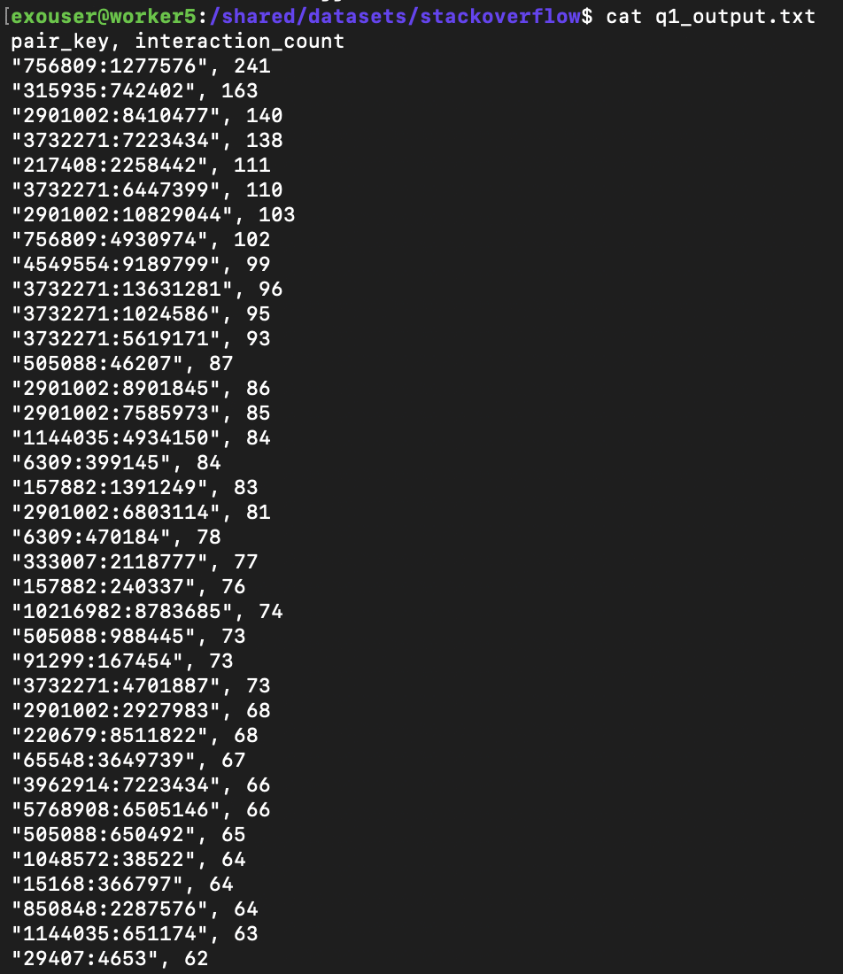

Query 2: Tags with Highest Question-to-Answer Ratio

MATCH (t:Tag)-[:Tag_to]->(q:Post_question)
WITH t, COUNT(q) AS question_count
MATCH (t)-[:Tag_to]->(q2:Post_question)<-[:Answers_to]-(a:Post_answer)
WITH t.tag_name AS tag_name,
question_count,
COUNT(a) AS answer_count
WHERE answer_count > 0
RETURN tag_name,
question_count,
answer_count,
toFloat(question_count) / toFloat(answer_count) AS ratio
ORDER BY ratio DESC
LIMIT 200;

DURATION: 7.4 Min

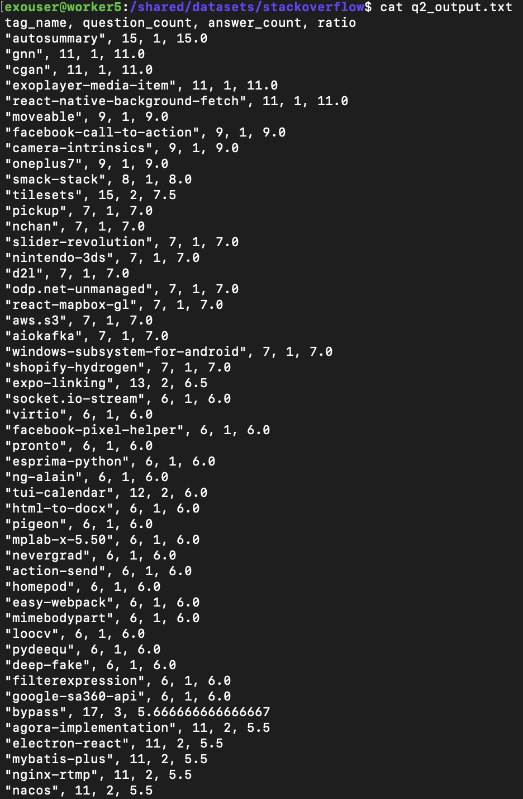
Query 3: Questions with Most Views But No Accepted Answer
MATCH (q:Post_question)
WHERE (q.accepted_answer_id IS NULL OR q.accepted_answer_id = 0)
AND q.view_count IS NOT NULL
RETURN q.post_id AS question_id,
q.view_count AS view_count,
q.answer_count AS answer_count
ORDER BY q.view_count DESC
LIMIT 200;

DURATION: 56 s

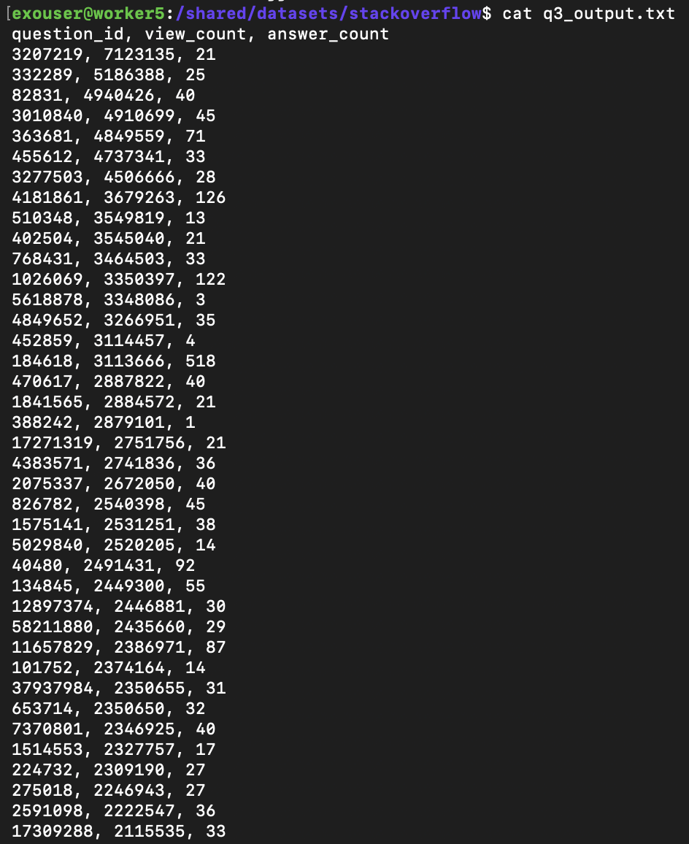
Query 4: Users Who Earn Badges Fastest After Account Creation
MATCH (u:User)-[:Earns]->(b:Badge)
WHERE u.creation_date IS NOT NULL
AND b.date IS NOT NULL
AND u.creation_date <> ''
AND b.date <> ''
WITH u.user_id AS user_id,
u.display_name AS display_name,
MIN(
(toInteger(substring(b.date, 0, 4)) - toInteger(substring(u.creation_date, 0, 4))) * 365 +
(toInteger(substring(b.date, 5, 2)) - toInteger(substring(u.creation_date, 5, 2))) * 30 +
(toInteger(substring(b.date, 8, 2)) - toInteger(substring(u.creation_date, 8, 2)))
) AS min_days
WHERE min_days >= 0
RETURN user_id, display_name, min_days
ORDER BY min_days ASC, toString(user_id) ASC
LIMIT 20;

DURATION: 24.9 Min

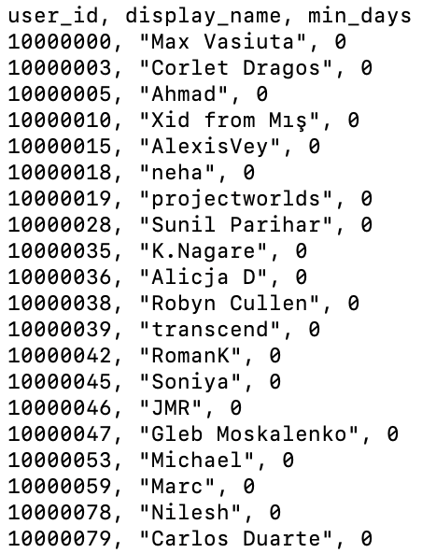
Query 5: Percentage of Questions Answered Over the Years
MATCH (q:Post_question)
WHERE q.creation_date IS NOT NULL
AND q.creation_date <> ''
WITH substring(q.creation_date, 0, 4) AS year_val,
COUNT(q) AS total_questions,
SUM(CASE
WHEN toInteger(q.answer_count) > 0 THEN 1
ELSE 0
END) AS answered_questions
RETURN year_val,
total_questions,
answered_questions,
round(
toFloat(answered_questions) * 100.0 / toFloat(total_questions),
5
) AS answer_rate
ORDER BY year_val ASC;

DURATION: 48 s

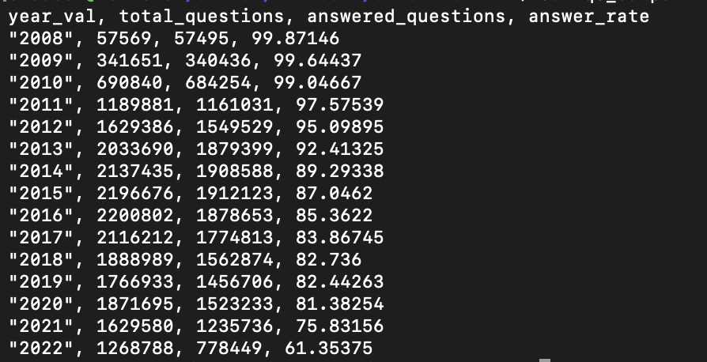
Query 6: Top 10 Easiest Gold Badges to Earn
MATCH (u:User)-[:Earns]->(b:Badge)
WHERE b.class = 1
AND u.creation_date IS NOT NULL
AND b.date IS NOT NULL
AND u.creation_date <> ''
AND b.date <> ''
WITH b.name AS badge_name,
COUNT(DISTINCT u.user_id) AS total_earners,
MIN(
(toInteger(substring(b.date, 0, 4)) - toInteger(substring(u.creation_date, 0, 4))) * 365 +
(toInteger(substring(b.date, 5, 2)) - toInteger(substring(u.creation_date, 5, 2))) * 30 +
(toInteger(substring(b.date, 8, 2)) - toInteger(substring(u.creation_date, 8, 2)))
) AS min_days
WHERE min_days >= 0
RETURN badge_name, total_earners, min_days
ORDER BY total_earners DESC
LIMIT 10;

DURATION: 2.81 Min

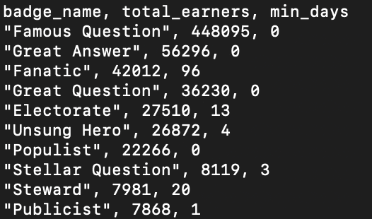
Query 7: Vote Distribution
MATCH (v:Vote)-[:Vote_on]->(q:Post_question)-[:Owned_by]->(u:User)
WITH u, COUNT(v) AS q_votes
OPTIONAL MATCH (v2:Vote)-[:Vote_on]->(a:Post_answer)-[:Answers_by]->(u)
WITH u.user_id AS user_id,
u.display_name AS display_name,
q_votes,
COUNT(v2) AS a_votes
WITH user_id,
display_name,
q_votes + a_votes AS total_votes
WHERE total_votes > 0
RETURN user_id, display_name, total_votes
ORDER BY total_votes DESC
LIMIT 20;

DURATION: 46.28 s

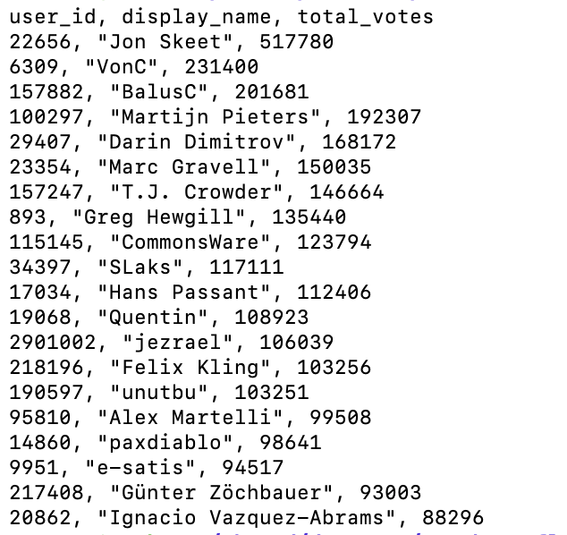
Query 8: Most Linked Questions
MATCH (src:Post_question)-[:Link_to]->(target:Post_question)
WITH target.id AS question_id,
COUNT(src) AS link_count
WHERE link_count > 0
RETURN question_id, link_count
ORDER BY link_count DESC
LIMIT 20;

DURATION: 9.8 Min

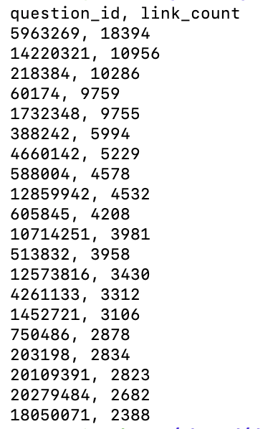

Query 9: Users Who Comment Most
MATCH (c:Comment)-[:Commented_by]->(u:User)
WITH u.user_id AS user_id,
u.display_name AS display_name,
COUNT(c) AS total_comments
WHERE total_comments > 0
RETURN user_id, display_name, total_comments
ORDER BY total_comments DESC
LIMIT 20;

DURATION: 7.38 Min

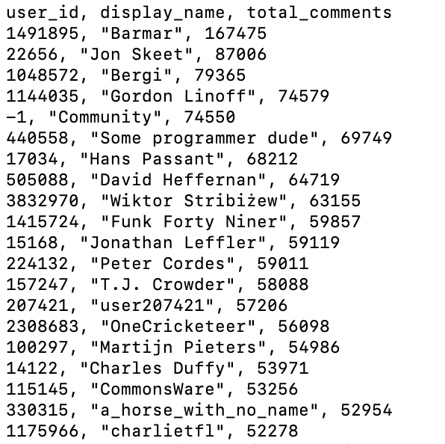
Query 10: Most Accepted Answers
MATCH (q:Post_question)-[:Accepts]->(a:Post_answer)-[:Answers_by]->(u:User)
WITH u.user_id AS user_id,
u.display_name AS display_name,
COUNT(a) AS accepted_count
WHERE accepted_count > 0
RETURN user_id, display_name, accepted_count
ORDER BY accepted_count DESC
LIMIT 20;

DURATION: 3.92 Min

