GENOME MOVIE LENS DATASET

Create constraints to enforce uniqueness on core node identifiers (item_id, user_id, tag_id, etc.), ensuring data integrity and enabling efficient lookups and matching during batch inserts and query execution.

CREATE CONSTRAINT movie_id_unique IF NOT EXISTS
FOR (m:Movie) REQUIRE m.item_id IS UNIQUE;

CREATE CONSTRAINT user_id_unique IF NOT EXISTS
FOR (u:User) REQUIRE u.user_id IS UNIQUE;

CREATE CONSTRAINT tag_id_unique IF NOT EXISTS
FOR (t:Tag) REQUIRE t.tag_id IS UNIQUE;

CREATE CONSTRAINT review_id_unique IF NOT EXISTS
FOR (r:Review) REQUIRE r.review_id IS UNIQUE;

CREATE CONSTRAINT survey_id_unique IF NOT EXISTS
FOR (s:Survey) REQUIRE s.survey_id IS UNIQUE;

CREATE CONSTRAINT director_name_unique IF NOT EXISTS
FOR (d:Director) REQUIRE d.name IS UNIQUE;

CREATE CONSTRAINT actor_name_unique IF NOT EXISTS
FOR (a:Actor) REQUIRE a.name IS UNIQUE;

Movie Node
CALL apoc.periodic.iterate(
'CALL apoc.load.json("file:///movielens/genome_2021/raw/metadata.json")',
'
MERGE (m:Movie {item_id: toInteger(value.item_id)})
SET m.title = value.title,
m.avgRating = toFloat(value.avgRating),
m.imdbId = value.imdbId,
m.directedBy = value.directedBy,
m.starring = value.starring
',
{batchSize: 1000, parallel: true}
)
Started streaming 1 record after 73 ms and completed after 3,791 ms.

User Node + RATED edge (User Movie)
CALL apoc.periodic.iterate(
'CALL apoc.load.json("file:///movielens/genome_2021/raw/ratings.json")',
'
MERGE (u:User {user_id: toInteger(value.user_id)})
WITH u, value
MATCH (m:Movie {item_id: toInteger(value.item_id)})
MERGE (u)-[r:RATED]->(m)
SET r.rating = toFloat(value.rating)
',
{batchSize: 1000, parallel: false}
)
Started streaming 1 record after 46 ms and completed after 24 minutes 30 seconds.

Tags Node
CALL apoc.periodic.iterate(
'CALL apoc.load.json("file:///movielens/genome_2021/raw/tags.json")',
'
MERGE (t:Tag {tag_id: toInteger(value.id)})
SET t.tag = value.tag
',
{batchSize: 1000, parallel: true}
)
Started streaming 1 record after 7 ms and completed after 125 ms.

HAS_TAG edge (Movie Tag)
CALL apoc.periodic.iterate(
'CALL apoc.load.json("file:///movielens/genome_2021/raw/tag_count.json")',
'
MATCH (m:Movie {item_id: toInteger(value.item_id)})
MATCH (t:Tag {tag_id: toInteger(value.tag_id)})
MERGE (m)-[r:HAS_TAG]->(t)
SET r.count = toInteger(value.num)
',
{
batchSize: 1000,
parallel: false
}
)
Started streaming 1 record after 8 ms and completed after 5,914 ms.

Review node + HAS_REVIEW edge (Movie Review)
CALL apoc.periodic.iterate(
'CALL apoc.load.json("file:///movielens/genome_2021/raw/reviews.json")',
'
MATCH (m:Movie {item_id: toInteger(value.item_id)})
CREATE (r:Review {
review_id: toInteger(value.review_id),
text: value.txt
})
MERGE (m)-[:HAS_REVIEW]->(r)
',
{batchSize: 1000, parallel: false}
)
Started streaming 1 record after 33 ms and completed after 1 minute 57 seconds.

Survey Node and edges
CALL apoc.periodic.iterate(
'CALL apoc.load.json("file:///movielens/genome_2021/raw/survey_answers.json") YIELD value',
'
MERGE (u:User {user_id: toInteger(value.user_id)})
WITH u, value

MATCH (m:Movie {item_id: toInteger(value.item_id)})
MATCH (t:Tag {tag_id: toInteger(value.tag_id)})

CREATE (s:Survey {
survey_id: toInteger(value.survey_id),
score: toInteger(value.score)
})

MERGE (u)-[:ANSWERED]->(s)
MERGE (s)-[:ABOUT_MOVIE]->(m)
MERGE (s)-[:ABOUT_TAG]->(t)
',
{batchSize: 1000, parallel: false}
)

Director Node & Directed edge (Director Movie)

CALL apoc.periodic.iterate(
'
MATCH (m:Movie)
WHERE m.directedBy IS NOT NULL AND trim(m.directedBy) <> ""
RETURN m.item_id AS movie_id, trim(m.directedBy) AS director_name
',
'
MERGE (d:Director {name: director_name})
WITH d, movie_id
MATCH (m:Movie {item_id: toInteger(movie_id)})
MERGE (d)-[:DIRECTED]->(m)
',
{batchSize: 1000, parallel: false}
)
Started streaming 1 record after 81 ms and completed after 24,115 ms
Actor Node & ACTED_IN edge (Actor Movie)

CALL apoc.periodic.iterate(
'
MATCH (m:Movie)
WHERE m.starring IS NOT NULL AND trim(m.starring) <> ""
RETURN m, split(m.starring, ",") AS actors
',
'
UNWIND actors AS actorName
WITH m, trim(actorName) AS name
WHERE name <> ""
MERGE (a:Actor {name: name})
MERGE (a)-[:ACTED_IN]->(m)
',
{batchSize: 1000, parallel: false}
)

Started streaming 1 record after 18 ms and completed after 11,506 ms.

=== Graph===

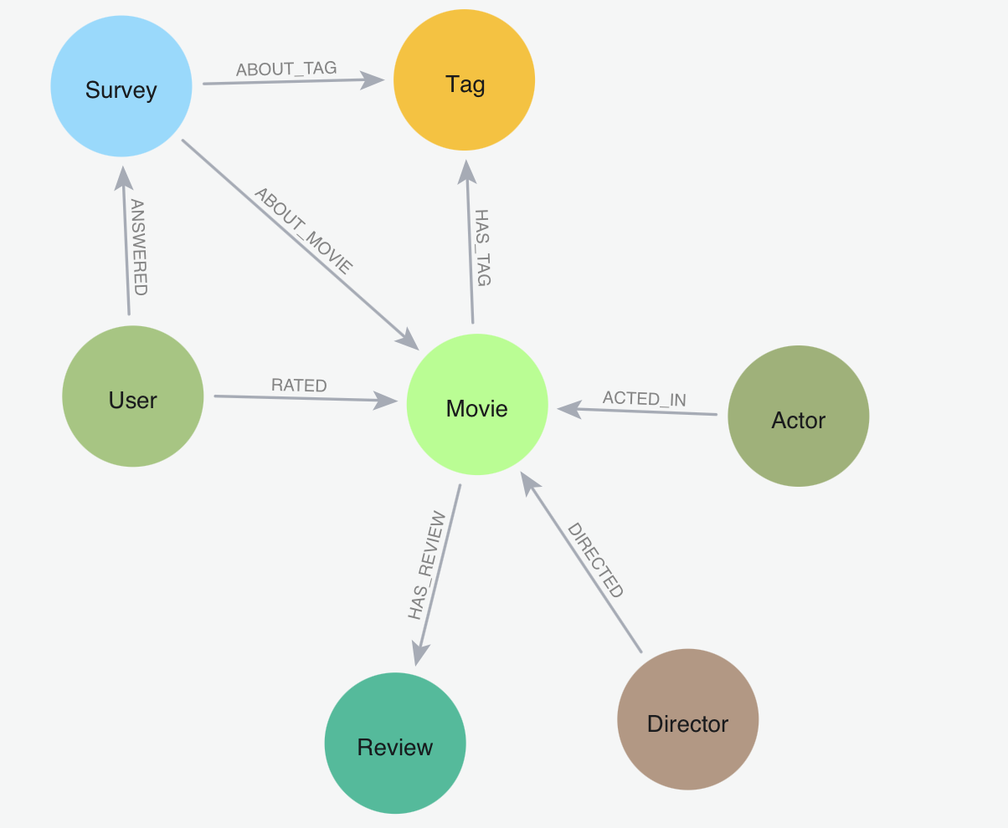

===QUERIES===
=== DIRECTOR, ACTOR, MOVIE===

Top 10 Directors by Average Movie Rating (Filtering to avoid bias from 1-hit wonders, so considering movies >= 3):

MATCH (d:Director)-[:DIRECTED]->(m:Movie)
WHERE m.avgRating IS NOT NULL
WITH d.name AS Director, round(avg(m.avgRating), 2) AS AvgRating, count(m) AS Movies
WHERE Movies >= 3
RETURN Director, AvgRating, Movies
ORDER BY AvgRating DESC
LIMIT 10

Started streaming 10 records after 228 ms and completed after 480 ms.
-----> “Darren Wilson” with rating 4.8, followed by “B. S. Johnson” with rating 4.38

Directors with the Most Movies Above 4.0 Rating (Not just average, how many great movies have they made? Considered minimum of 2 movies)

MATCH (d:Director)-[:DIRECTED]->(m:Movie)
WHERE m.avgRating >= 4.0
WITH d.name AS Director, count(m) AS HighRatedMovies
WHERE HighRatedMovies >= 2
RETURN Director, HighRatedMovies
ORDER BY HighRatedMovies DESC
LIMIT 10

Started streaming 10 records after 113 ms and completed after 206 ms.
-----> "Ladislav Smoljak" with 18 high rated movies

Top 10 Actors by Number of Movies Acted In

MATCH (a:Actor)-[:ACTED_IN]->(m:Movie)
RETURN a.name AS Actor, count(m) AS TotalMovies
ORDER BY TotalMovies DESC
LIMIT 10

Started streaming 10 records after 55 ms and completed after 1,053 ms.
-----> "Eric Roberts" with 171 movies followed by "Christopher Lee" with 166 movies

Top Actors by Average Rating of Movies (Which actors are most associated with successful movies?)

MATCH (a:Actor)-[:ACTED_IN]->(m:Movie)
WHERE m.avgRating IS NOT NULL
WITH a.name AS Actor, round(avg(m.avgRating), 2) AS AvgRating, count(m) AS TotalMovies
WHERE TotalMovies >= 3
RETURN Actor, AvgRating, TotalMovies
ORDER BY AvgRating DESC
LIMIT 10

Started streaming 10 records after 17 ms and completed after 644 ms.
-----> "Dewshane Williams" with rating 5.0 and total movies 3

Top Actor-Director Pairs by Number of Collaborations

MATCH (d:Director)-[:DIRECTED]->(m:Movie)<-[:ACTED_IN]-(a:Actor)
RETURN d.name AS Director, a.name AS Actor, count(m) AS Collaborations
ORDER BY Collaborations DESC
LIMIT 10

Started streaming 10 records after 119 ms and completed after 1,103 ms.
-----> Director "Chuck Jones" and actor "Mel Blanc" with 60 collaborations

Actor-Director Collaboration Quality (Which pairs consistently produce great movies?)

MATCH (d:Director)-[:DIRECTED]->(m:Movie)<-[:ACTED_IN]-(a:Actor)
WHERE m.avgRating IS NOT NULL
WITH d.name AS Director, a.name AS Actor, count(m) AS Collabs, round(avg(m.avgRating), 2) AS AvgRating
WHERE Collabs >= 3
RETURN Director, Actor, Collabs, AvgRating
ORDER BY AvgRating DESC
LIMIT 10

Started streaming 10 records after 113 ms and completed after 1,552 ms.
-----> Director "John Stimpson" and actor "Tom Kemp" of total collabs 3 with avg rating 4.79

Top Actor Groups That Consistently Produce High-Rated Movies

MATCH (a1:Actor)-[:ACTED_IN]->(m:Movie)<-[:ACTED_IN]-(a2:Actor),
(a3:Actor)-[:ACTED_IN]->(m)
WHERE a1.name < a2.name AND a2.name < a3.name AND a1 <> a3 AND m.avgRating IS NOT NULL
WITH a1.name AS Actor1, a2.name AS Actor2, a3.name AS Actor3, collect(m.title) AS Movies,
count(DISTINCT m) AS MovieCount, round(avg(m.avgRating), 2) AS AvgRating
WHERE MovieCount >= 3
RETURN Actor1, Actor2, Actor3, MovieCount, AvgRating, Movies
ORDER BY AvgRating DESC
LIMIT 10

Started streaming 10 records after 228 ms and completed after 14,286 ms.

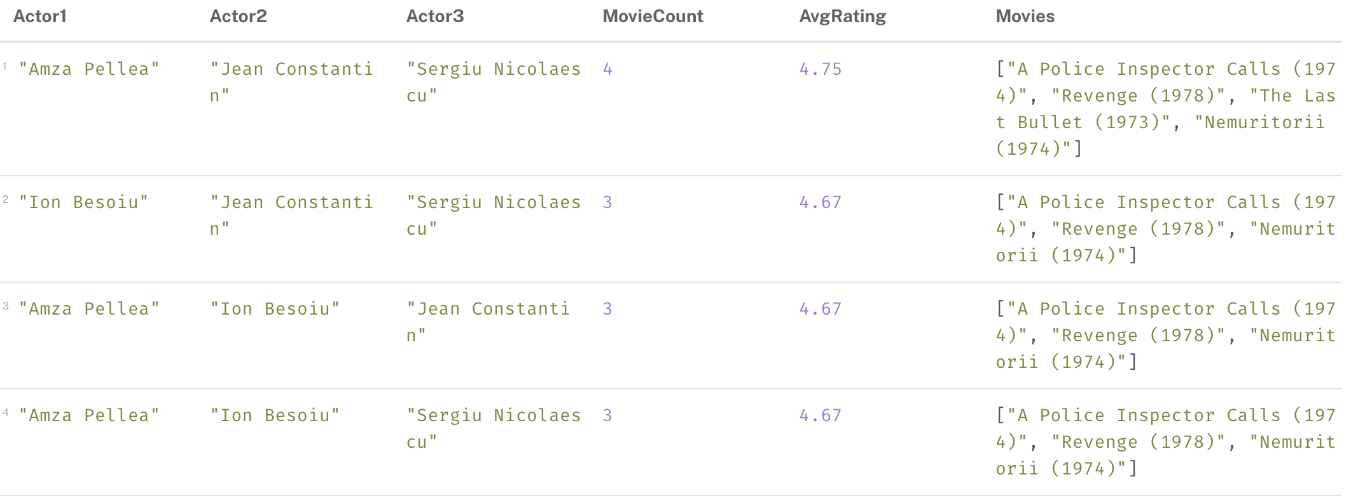

Actors Frequently Appearing in High-Rated Movies with Different Directors (Highlights high-performing, collaborative actors trusted by many top directors.)

MATCH (a:Actor)-[:ACTED_IN]->(m:Movie)<-[:DIRECTED]-(d:Director)
WHERE m.avgRating >= 4.0
WITH a.name AS Actor, count(DISTINCT d.name) AS UniqueTopDirectors, count(DISTINCT m) AS TopRatedMovies
WHERE TopRatedMovies >= 3
RETURN Actor, UniqueTopDirectors, TopRatedMovies
ORDER BY UniqueTopDirectors DESC, TopRatedMovies DESC
LIMIT 10
Started streaming 10 records after 391 ms and completed after 673 ms.

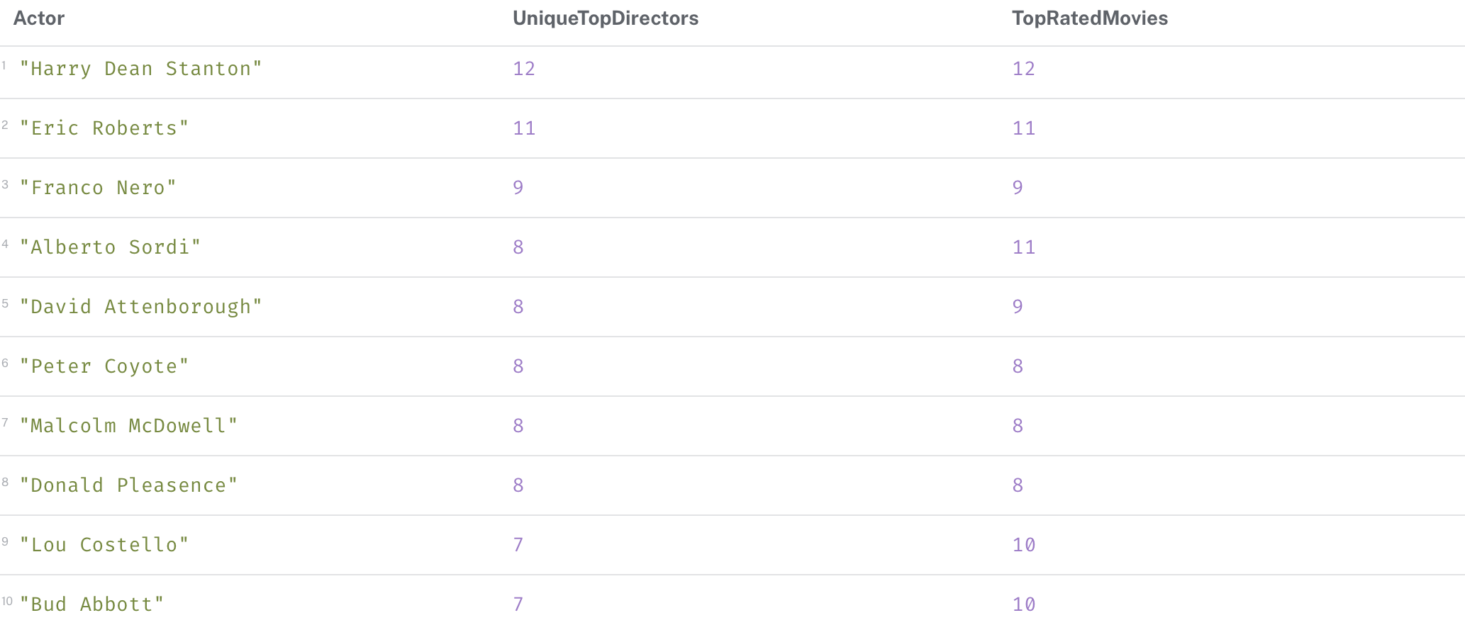

===USER + RATING====
Top 10 Most Active Users by Rating Count

MATCH (u:User)-[:RATED]->(m:Movie)
RETURN u.user_id AS UserID, count(*) AS RatedMovies
ORDER BY RatedMovies DESC
LIMIT 10

Started streaming 10 records after 2 ms and completed after 29,612 ms.
-----> user id ‘347565’ with 34377 ratings, followed by user id ‘414405’ with 9327 ratings

Users Who Rate Harshly (Lowest Average Rating)

MATCH (u:User)-[r:RATED]->(m:Movie)
WHERE r.rating IS NOT NULL
WITH u.user_id AS UserID, count(r) AS TotalRatings, round(avg(r.rating), 2) AS AvgRating
WHERE TotalRatings >= 5
RETURN UserID, AvgRating, TotalRatings
ORDER BY AvgRating ASC
LIMIT 10

Started streaming 10 records after 3 ms and completed after 55,506 ms.
-------> user id 930000 with avg rating 0.5 among total of 16 ratings followed by user id 520972
with 0.5 rating of total 20 ratings

Most Similar Users Based on Ratings for the Same Movies (Find pairs of users with overlapping movie preferences. (Collaborative filtering foundation))

MATCH (u1:User)-[r1:RATED]->(m:Movie)<-[r2:RATED]-(u2:User)
WHERE u1 <> u2 AND abs(r1.rating - r2.rating) <= 1
WITH u1.user_id AS User1, u2.user_id AS User2, count(m) AS SharedMovies
WHERE SharedMovies >= 5
RETURN User1, User2, SharedMovies
ORDER BY SharedMovies DESC
LIMIT 10

Not running in cypher, getting disconnected from Neo4j.

Users Whose Ratings Most Closely Match Movie Averages

MATCH (u:User)-[r:RATED]->(m:Movie)
WHERE m.avgRating IS NOT NULL AND r.rating IS NOT NULL
WITH u.user_id AS UserID,
count(r) AS RatingCount,
round(avg(abs(r.rating - m.avgRating)), 3) AS AvgDeviation
WHERE RatingCount >= 5
RETURN UserID, RatingCount, AvgDeviation
ORDER BY AvgDeviation ASC
LIMIT 10

Started streaming 10 records after 142 ms and completed after 51,671 ms.

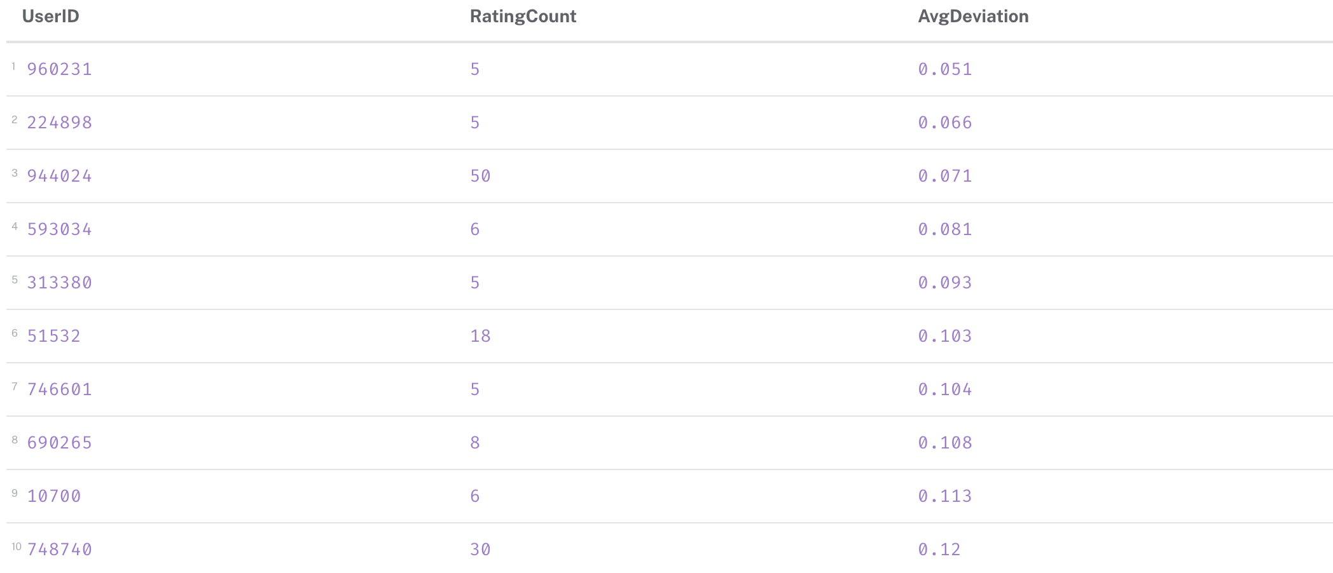

AvgDeviation is the average difference between what a user rated a movie and what the average rating for that movie is (from all users).
For example, User 944024 rated 50 movies, and on average their rating was only 0.071 stars different from each movie’s average rating. That’s highly consistent.

===REVIEW===

Movies with the Most Reviews

MATCH (m:Movie)-[:HAS_REVIEW]->(r:Review)
RETURN m.title AS Movie, count(r) AS ReviewCount
ORDER BY ReviewCount DESC
LIMIT 10

Started streaming 10 records after 95 ms and completed after 4,876 ms.
-----> Movie "Lord of the Rings: The Fellowship of the Ring, The (2001)" has 5122 reviews, followed by "Dark Knight, The (2008)" with 5115 reviews

High-Rated Movies That Also Have Many Reviews

MATCH (m:Movie)-[:HAS_REVIEW]->(r:Review)
WHERE m.avgRating IS NOT NULL
WITH m.title AS Movie, m.avgRating AS Rating, count(r) AS ReviewCount
WHERE ReviewCount >= 10 AND Rating >= 4.0
RETURN Movie, Rating, ReviewCount
ORDER BY ReviewCount DESC
LIMIT 10

Started streaming 10 records after 131 ms and completed after 2,545 ms.
-----> "Lord of the Rings: The Fellowship of the Ring, The (2001)" with 4.09616 rating and 5122 reviews, followed by "Dark Knight, The (2008)" With 4.18379 rating and 5115 reviews

Directors Whose Movies Collect the Most Reviews

MATCH (d:Director)-[:DIRECTED]->(m:Movie)-[:HAS_REVIEW]->(r:Review)
RETURN d.name AS Director, count(r) AS TotalReviews
ORDER BY TotalReviews DESC
LIMIT 10

Started streaming 10 records after 105 ms and completed after 1,485 ms.
------>"Steven Spielberg" with 23714 review count, followed by "Christopher Nolan" with 21986 review count

Most frequently used words in reviews:

MATCH (r:Review)
WHERE r.text IS NOT NULL
UNWIND apoc.text.split(toLower(r.text), "\\W+") AS word
WITH word
WHERE size(word) > 3 AND NOT word IN ["this", "that", "with", "from", "have", "your", "just", "what", "when", "they", "were", "then", "there", "would", "which", "could", "really"]
RETURN word, count(*) AS freq
ORDER BY freq DESC
LIMIT 20

Started streaming 20 records after 197 ms and completed after 8 minutes 41 seconds.

Average Review Length per Movie (Which movies received the most detailed (or terse) reviews?)

MATCH (m:Movie)-[:HAS_REVIEW]->(r:Review)
WITH m.title AS Movie, avg(size(r.text)) AS AvgLength, count(r) AS ReviewCount
WHERE ReviewCount >= 5
RETURN Movie, round(AvgLength, 2) AS AvgReviewLength, ReviewCount
ORDER BY AvgReviewLength DESC
LIMIT 10

Started streaming 10 records after 192 ms and completed after 11,020 ms.
-----> "Garbage Warrior (2007)" with AvgReviewLength 4239.0 and ReviewCount 9

Movies Most Frequently Called "Boring", "Disgusting", etc.

MATCH (m:Movie)-[:HAS_REVIEW]->(r:Review)
WHERE toLower(r.text) CONTAINS 'boring'
OR toLower(r.text) CONTAINS 'disgusting'
OR toLower(r.text) CONTAINS 'waste'
OR toLower(r.text) CONTAINS 'terrible'
OR toLower(r.text) CONTAINS 'bad'
WITH m.title AS Movie, count(*) AS NegativeMentions
RETURN Movie, NegativeMentions
ORDER BY NegativeMentions DESC
LIMIT 10

Started streaming 10 records after 246 ms and completed after 37,820 ms.
-----> "Star Wars: Episode VII - The Force Awakens (2015)" with 2118 NegativeMentions, followed by "Batman v Superman: Dawn of Justice (2016)" with 1703 NegativeMentions

===SURVEY + TAG===

Top Tags by Frequency in Surveys (Which tags are evaluated most often by users?)

MATCH (:Survey)-[:ABOUT_TAG]->(t:Tag)
RETURN t.tag AS Tag, count(*) AS SurveyCount
ORDER BY SurveyCount DESC
LIMIT 10

Started streaming 10 records after 58 ms and completed after 784 ms.
------> "comedy" with 616 survey count, followed by "sci-fi" with 579 survey count

Tags Most Frequently Scored Highly in Surveys (Which tags do users consistently agree are applicable to movies (score ≥ 4)?)

MATCH (s:Survey)-[:ABOUT_TAG]->(t:Tag)
WHERE s.score >= 4
RETURN t.tag AS Tag, count(*) AS HighScoreCount
ORDER BY HighScoreCount DESC
LIMIT 10

Started streaming 10 records after 2 ms and completed after 45 ms.
------> "comedy" with 279 survey HighScoreCount, followed by "sci-fi" with 259 HighScoreCount

Movies With Most Tagged Survey Feedback (Which movies have been analyzed most often in surveys?)

MATCH (s:Survey)-[:ABOUT_MOVIE]->(m:Movie)
RETURN m.title AS Movie, count(*) AS SurveyMentions
ORDER BY SurveyMentions DESC
LIMIT 10

Started streaming 10 records after 48 ms and completed after 143 ms.
-----> "Matrix, The (1999)" with 380 SurveyMentions, "Fight Club (1999)" With 263 SurveyMentions

Best Tags per Movie by Survey and Tag_Count

MATCH (m:Movie)-[ht:HAS_TAG]->(t:Tag)
MATCH (s:Survey)-[:ABOUT_MOVIE]->(m)
MATCH (s)-[:ABOUT_TAG]->(t)
WITH m.title AS Movie, t.tag AS Tag,
sum(ht.count) AS TagApplications,
avg(s.score) AS AvgSurveyScore,
count(s) AS SurveyMentions
WHERE TagApplications > 5 AND SurveyMentions >= 5
RETURN Movie, Tag, TagApplications, round(AvgSurveyScore, 2) AS AvgSurveyScore, SurveyMentions
ORDER BY AvgSurveyScore DESC, SurveyMentions DESC
LIMIT 20

Started streaming 20 records after 96 ms and completed after 487 ms.

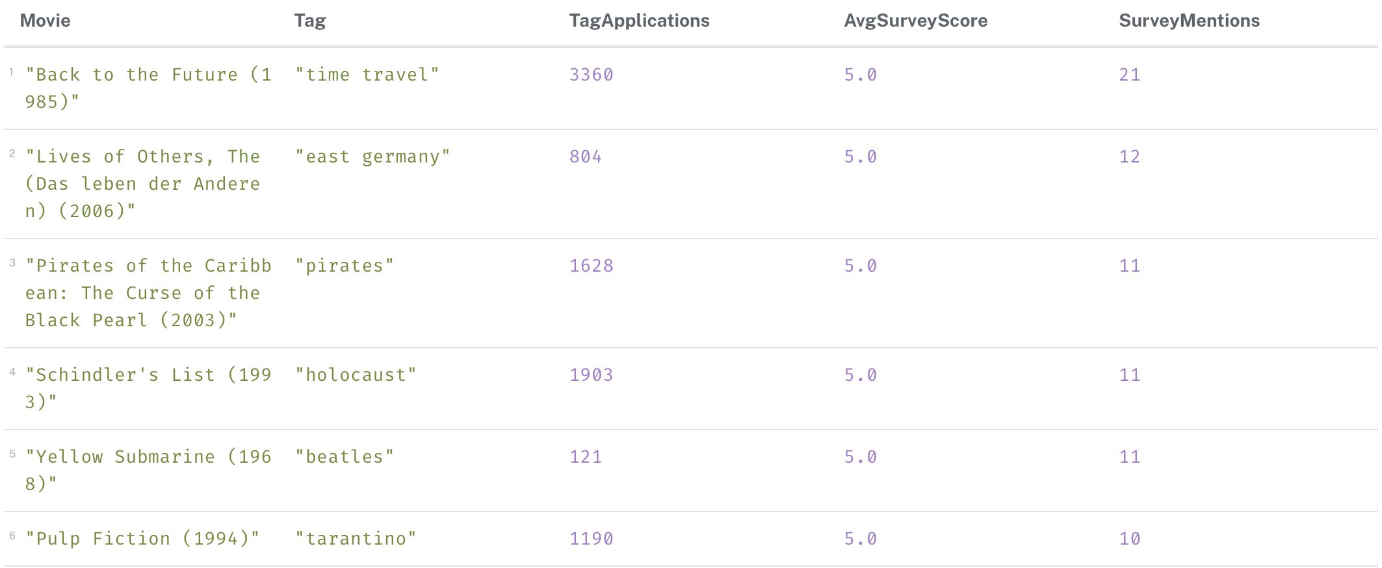

Users Who Participated in the Most Surveys

MATCH (u:User)-[:ANSWERED]->(s:Survey)
RETURN u.user_id AS User, count(s) AS TotalSurveys
ORDER BY TotalSurveys DESC
LIMIT 10

Started streaming 10 records after 55 ms and completed after 116 ms.
-----> user id 754076 with 246 surveys, user id 704376 With 246

Tag-Movie Associations with High Confidence (Which movie-tag pairs were most confidently agreed upon by users?)

MATCH (s:Survey)-[:ABOUT_MOVIE]->(m:Movie), (s)-[:ABOUT_TAG]->(t:Tag)
WHERE s.score >= 4
RETURN m.title AS Movie, t.tag AS Tag, count(*) AS HighScoreCount
ORDER BY HighScoreCount DESC
LIMIT 10

Started streaming 10 records after 96 ms and completed after 189 ms.

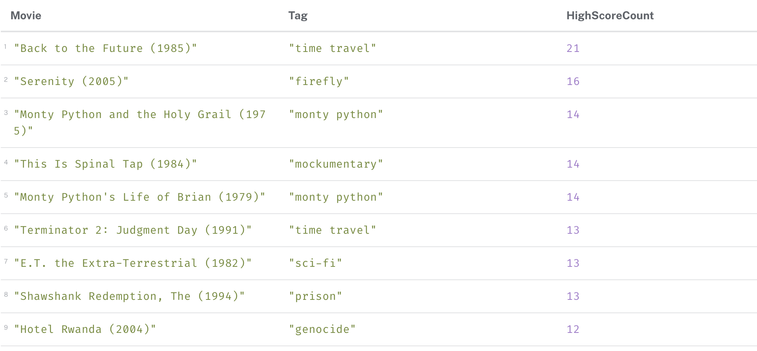

Users Who Did NOT Participate in Any Survey

MATCH (u:User)
WHERE NOT (u)-[:ANSWERED]->(:Survey)
RETURN u.user_id AS UserID
LIMIT 20

Started streaming 20 records after 174 ms and completed after 176 ms.

Users With Highest Survey Agreement Accuracy (Measures users whose survey scores closely align with consensus (like those who gave 5 when others did too)).

MATCH (u:User)-[:ANSWERED]->(s:Survey)-[:ABOUT_TAG]->(t:Tag)
WITH u.user_id AS User, t.tag AS Tag, s.score AS UserScore
MATCH (s2:Survey)-[:ABOUT_TAG]->(t)
WHERE s2.score IS NOT NULL
WITH User, Tag, UserScore, avg(s2.score) AS Consensus
WITH User, avg(abs(UserScore - Consensus)) AS AvgDeviation, count(*) AS Count
WHERE Count >= 10
RETURN User, round(AvgDeviation, 2) AS AvgTagDisagreement, Count
ORDER BY AvgTagDisagreement ASC
LIMIT 10

Running forever, not returning any results

